Jessica Altieri, Certified Wine and Water Sommelier, Brings Expert Craft to Four Seasons Resort Palm Beach

Cultivating memorable wine experiences at the newly renovated Five-Star, Five-Diamond address
November 1, 2018, Palm Beach, U.S.A.

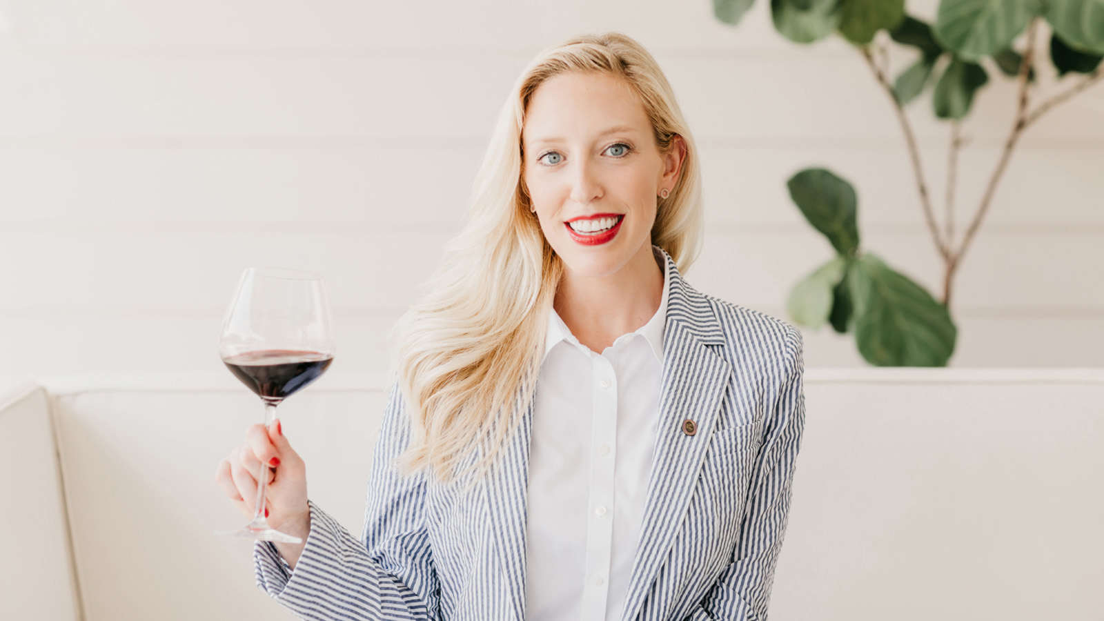
After nearly a decade spent travelling to international wine regions, developing relationships with iconic wine brands, winemakers and vintners, and building wine lifestyle audiences across social media, Jessica Altieri is bringing her knowledge and passion to the newly renovated Four Seasons Resort Palm Beach as the Resort’s Wine and Water Sommelier.
Upon joining the team, Altieri promptly set about fashioning a new wine program to pair with the Resort’s new dining experiences: Florie’s restaurant and bar in partnership with acclaimed Argentine-Italian Chef Mauro Colagreco, and the Resort’s oceanfront restaurant Seaway; as well as new offerings to enjoy poolside or beachfront.
“I want to create interactive, out-of-the-box offerings that Palm Beach has yet to experience, all while opening our guests’ eyes and palates to the wonders of wine,” says Altieri.
Similarly enthusiastic about her role on the restaurant floor, Altieri adds that “wine is just a conversation waiting to happen.” She loves to interact with guests, learn more about their travels, and share her own tales.
Born and raised in Chicago, Altieri was inspired by food and beverage early on, relishing in big Italian meals with her family on Sundays. After studying journalism, she started out as a sports reporter and then freelanced for big media companies before deciding to study abroad. After seeing a Master Sommelier on a television program, she immediately knew what she really wanted to do and relocated to San Jose, California to study at the Court of Master Sommeliers. After earning certification, she launched an online wine-centric digital media network, dubbed “Wine Channel TV with Just Jess.” Successes kept coming as Altieri moved into video and digital storytelling, podcasts, and wrote a book.
She also expanded her focus, studying in Germany to earn certification as a Water Sommelier, making her part of a highly exclusive group of tasting professionals. Educated on the properties of water and the elements that affect it, Altieri is also developing water tasting experiences featuring rare fine water sourced from the purest of icebergs.
Happy to be settled in southern Florida, Altieri says the one big thing she wants to accomplish for Four Seasons is to bring in younger generations and "show them how to sip luxury. It’s about more than just wine. It’s about an experience that they can’t get anywhere else. My goal is to make their time here so unique and memorable, they can’t wait to come back.”
To make reservations at Four Seasons Resort Palm Beach, call 1 561 582 2800 or book online.

RELATED

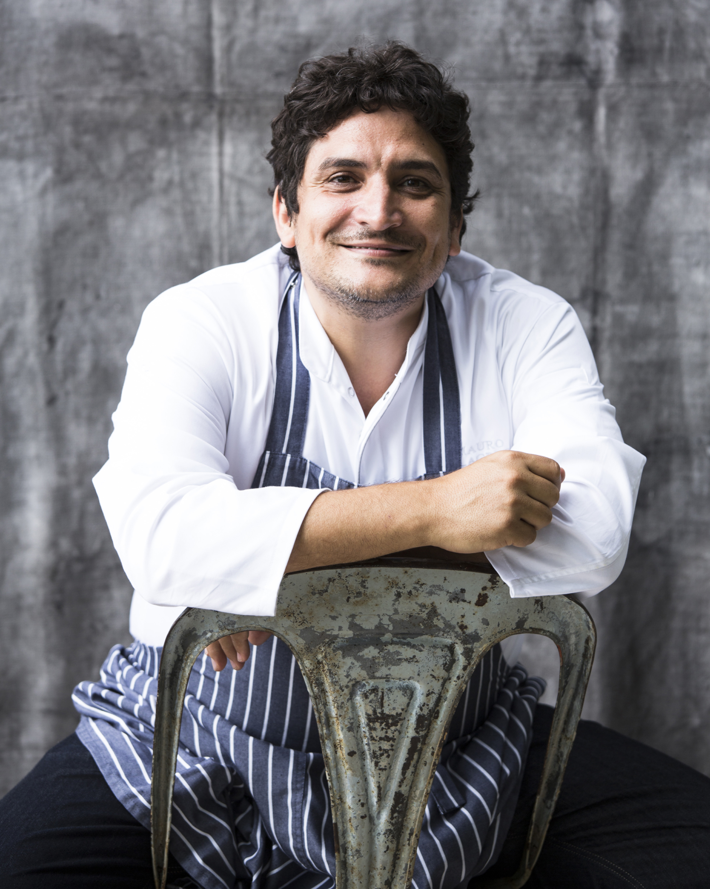 | October 11, 2018, Palm Beach, U.S.A.  Internationally Acclaimed Chef Mauro Colagreco Partners with Four Seasons Resort Palm Beach to Open Florie's, His First US Restaurant  https://publish.url/palmbeach/hotel-news/2018/new-flories-restaurant.html
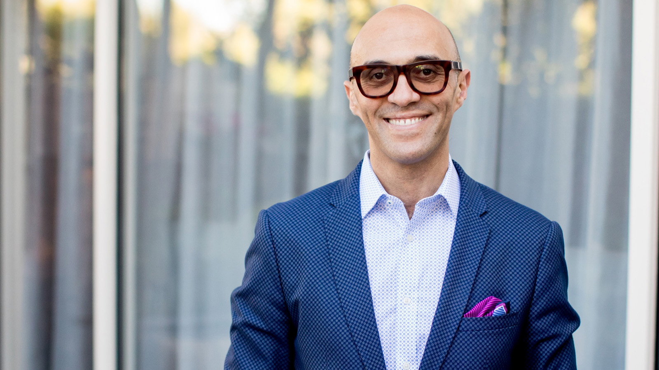 | July 12, 2018, Palm Beach, U.S.A.  Mohamed Elbanna Promoted to Senior General Manager with Four Seasons Hotels and Resorts  https://publish.url/palmbeach/hotel-news/2018/mohamed-elbanna-promotion.html

PRESS CONTACTS

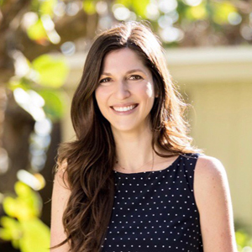 | Laurie Herrick  Director of Public Relations and Communications  2800 South Ocean Boulevard  Palm Beach  U.S.A.  laurie.herrick@fourseasons.com  1 (561) 493-5549

