Experience a Summer to Remember at Four Seasons Resort and Residences Jackson Hole

Newly renovated rooms, seasonal spa specials and outside activities set the stage for summer fun
June 29, 2022, Jackson Hole, U.S.A.

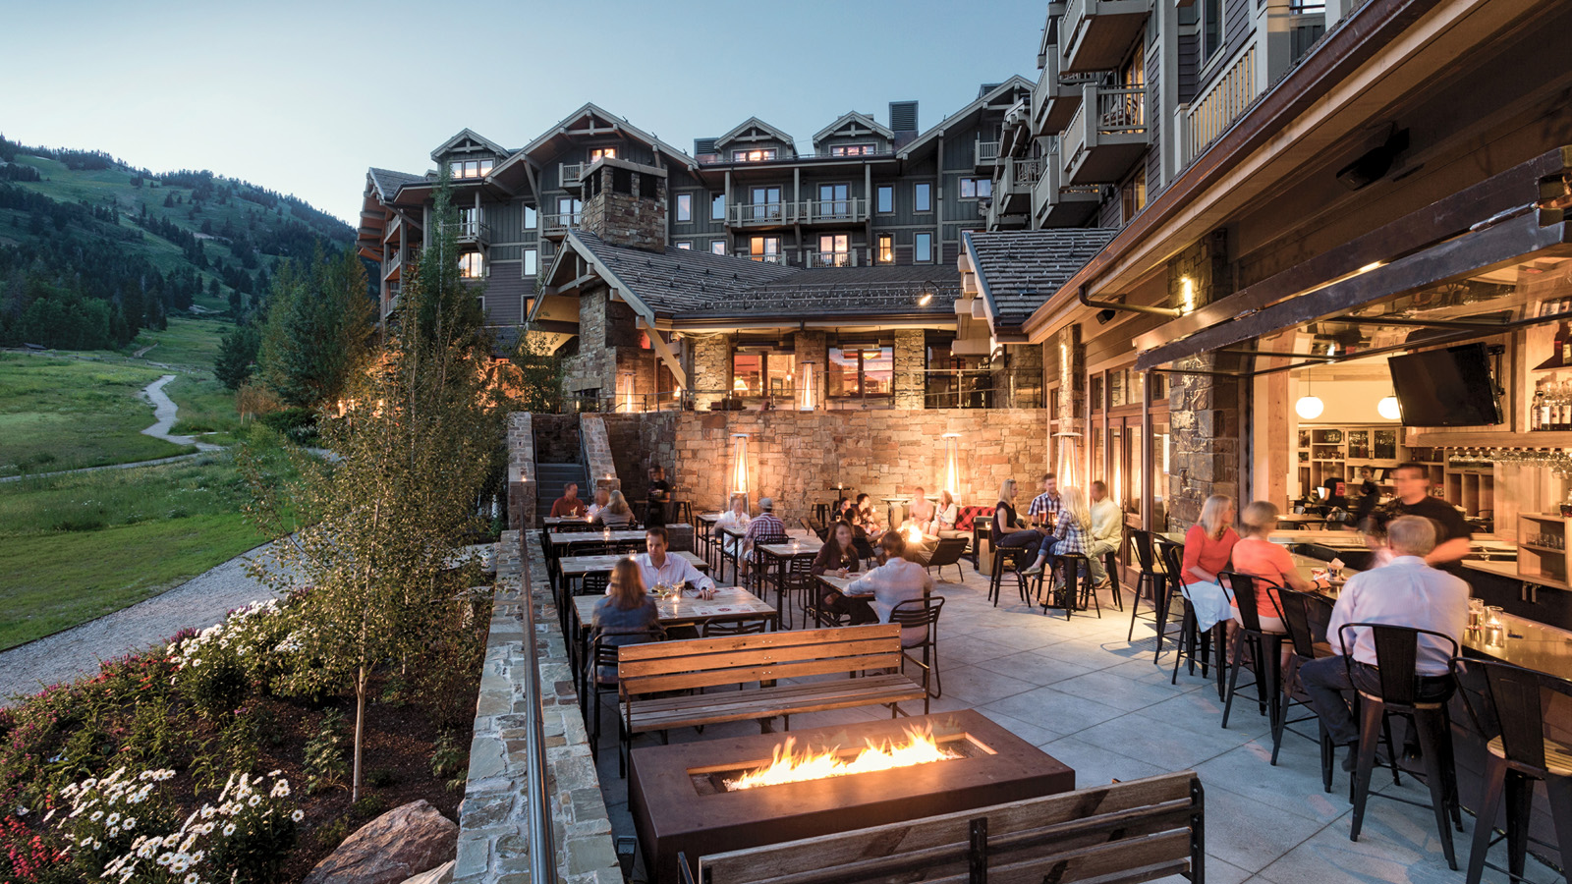 | 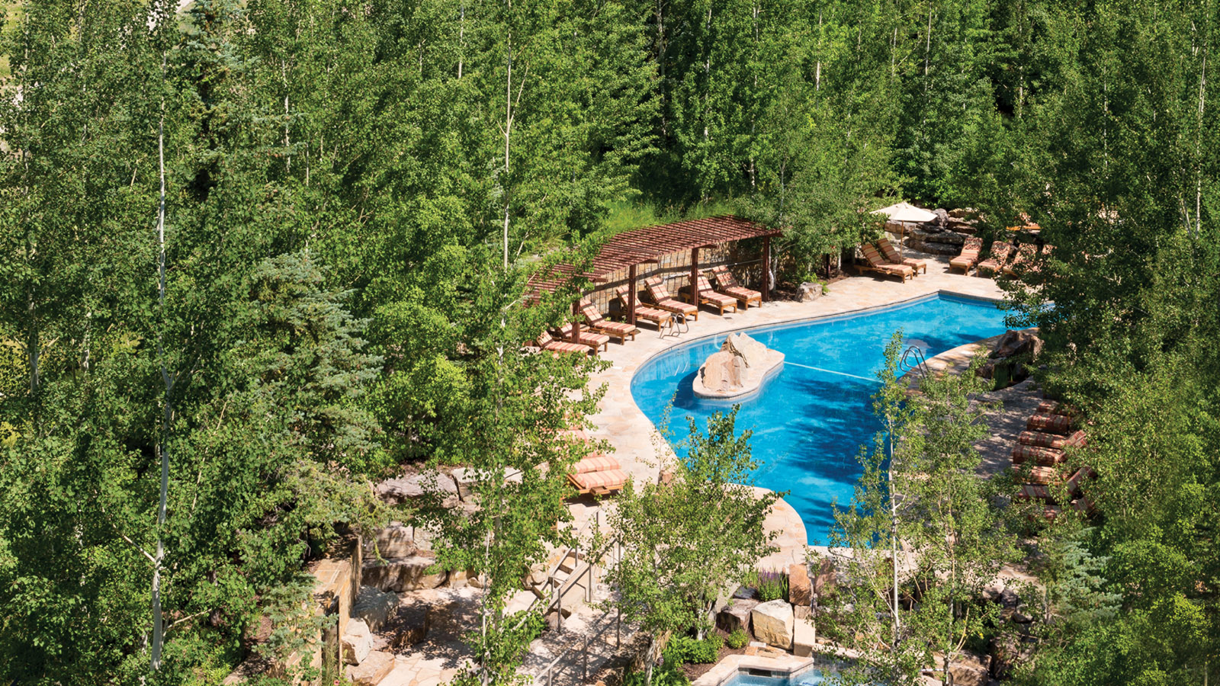 | 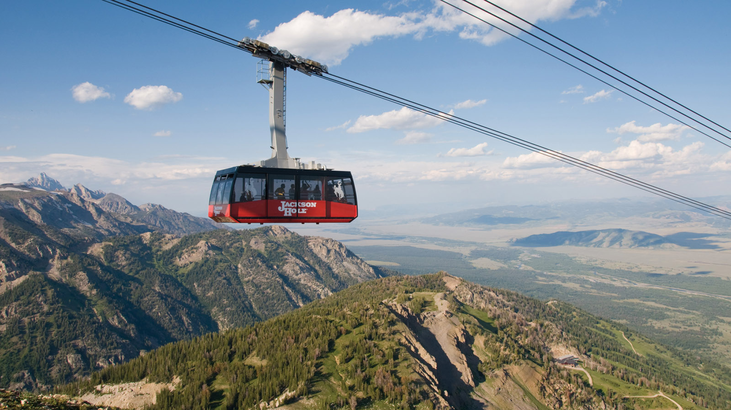
This summer, opt outside with a summer of adventure at the newly renovated Four Seasons Resort and Residences Jackson Hole, recently recognized as the #1 Resort in Wyoming according to U.S. News & World Report.
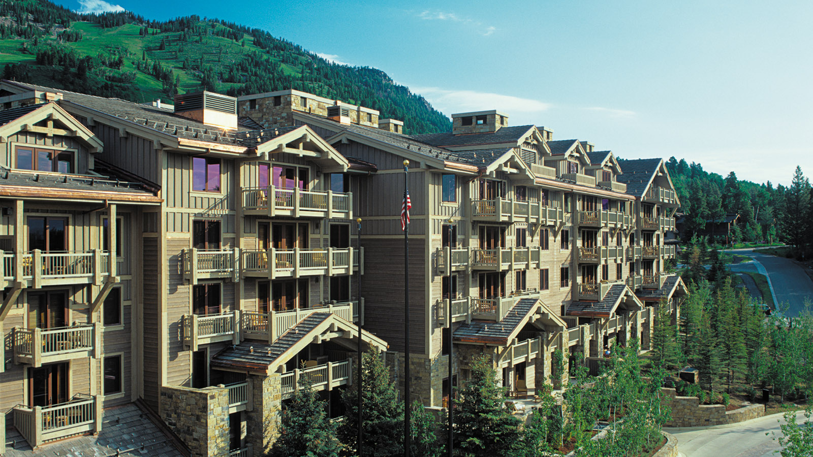 | 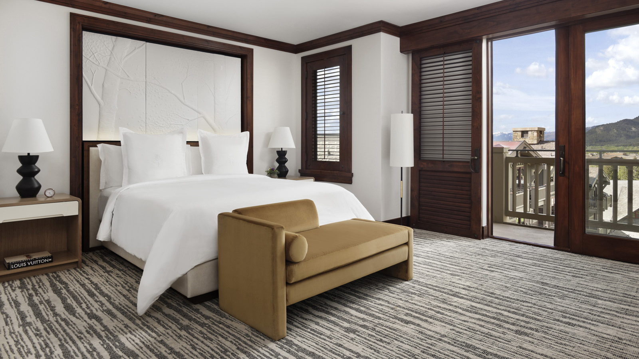
Newly Renovated Rooms and Suites
Four Seasons Resort and Residences Jackson Hole welcomes the summer 2022 season with the debut of a full-scale guest room and suite renovation, inspired by the natural grandeur of its dramatic mountain setting. Designed by Wimberly Interiors, the newly refreshed guest rooms, suites and public hallways enhance the luxury mountain experience with natural elements set against a subtle earth tone palette. The renovation included all new vanities and mirrors, furniture, artwork, beds, lighting, wall coverings, carpet and private bar. A well-defined work area allows guests to remain productive, with top-of-the-line new technology for communication and entertainment. The latest renovations build upon recent enhancements in Westbank Grill and Ascent Lounge within the past five years.
The Spa
Four Seasons Resort and Residences Jackson Hole introduces the Forest Meadow Renewing Body Polish in The Spa. This exfoliating, creamy salt scrub with spirulina and magnesium leaves skin soft and glowing. Magnesium is vital to muscle function and energy generation in the body. Refreshing notes of organic rosemary, pink grapefruit and thyme combine to gently refresh dull and tired skin, while juniper and red marine algae stimulate the lymphatic system and rebuild the moisture barrier. The 60-minute treatment is offered for USD 260.
All Things Culinary

RELATED

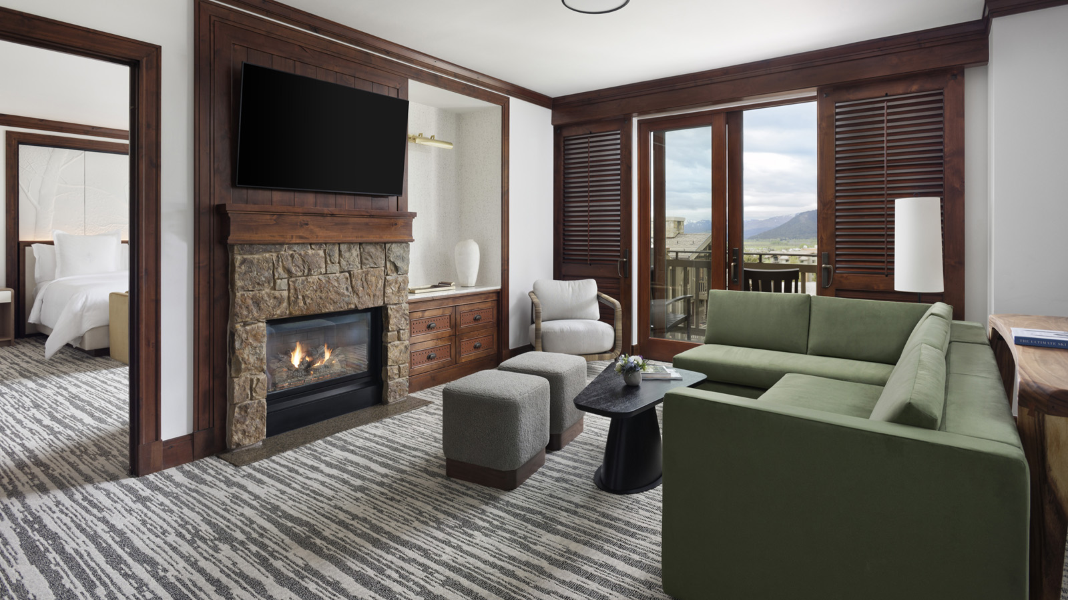 | June 15, 2022, Jackson Hole, U.S.A.  Four Seasons Resort and Residences Jackson Hole Completes Resort Renovation to Kick Off Summer 2022 Season  https://publish.url/jacksonhole/hotel-news/2022/newly-renovated-rooms-and-suites.html
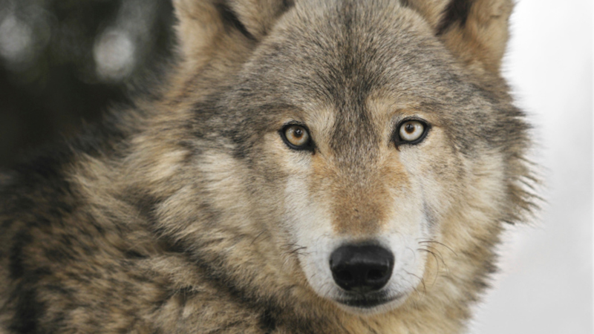 | June 8, 2022, Jackson Hole, U.S.A.  Immersive Encounter with Yellowstone Wolf Population Launches This Fall at Four Seasons Resort and Residences Jackson Hole  https://publish.url/jacksonhole/hotel-news/2022/day-with-wolves.html

PRESS CONTACTS

Kim Cole APR
Director of Public Relations
7680 Granite Loop Road, PO Box 544
Teton Village
USA
kim.cole@fourseasons.com

+1 480 980 8773

