Four Seasons Resort Palm Beach Celebrates Quarter Century Long Recognition of Highest Honours by Forbes Travel Guide

Enduring legacy of Five Star ratings for Resort and Spa, with special mention of flagship restaurant
February 19, 2023, Palm Beach, U.S.A.

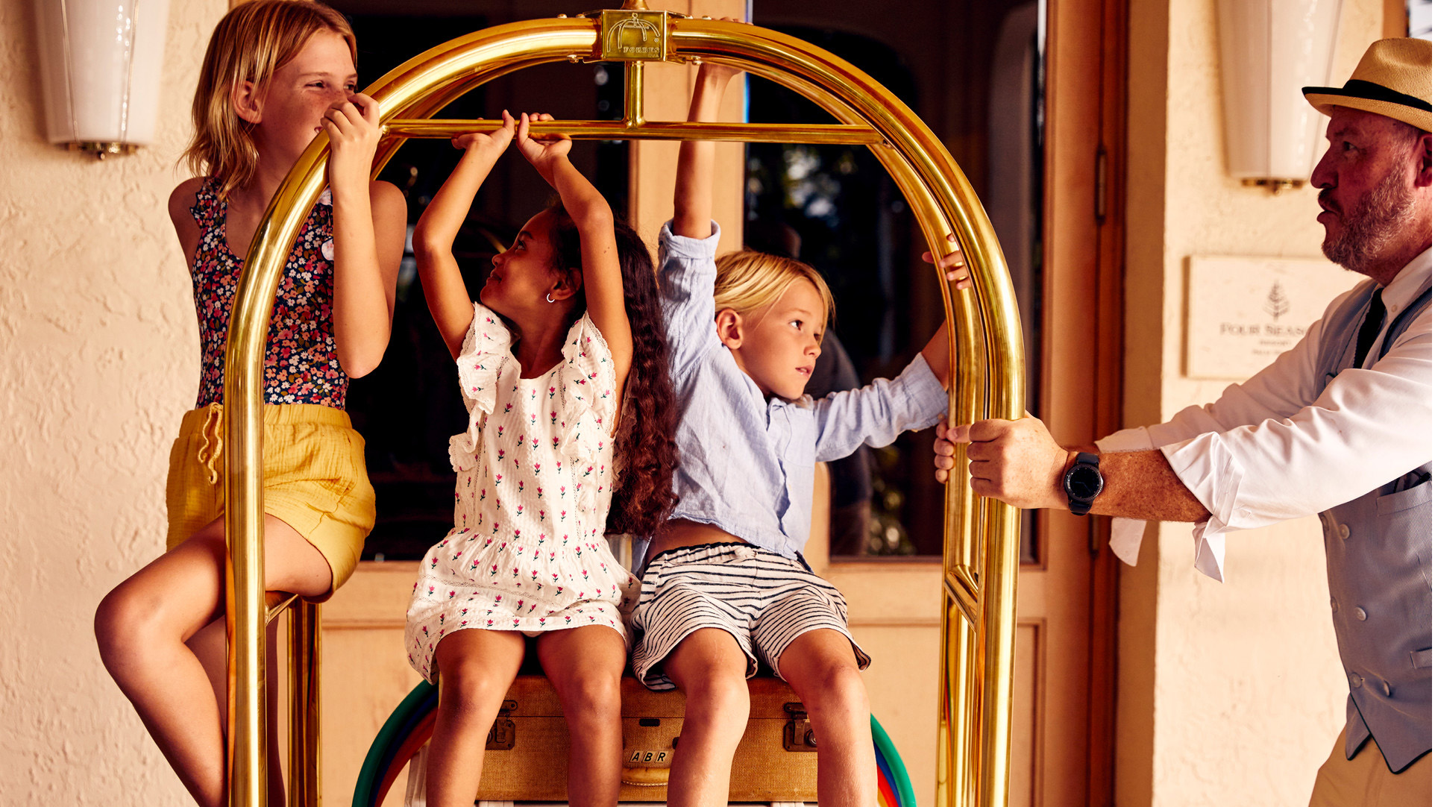
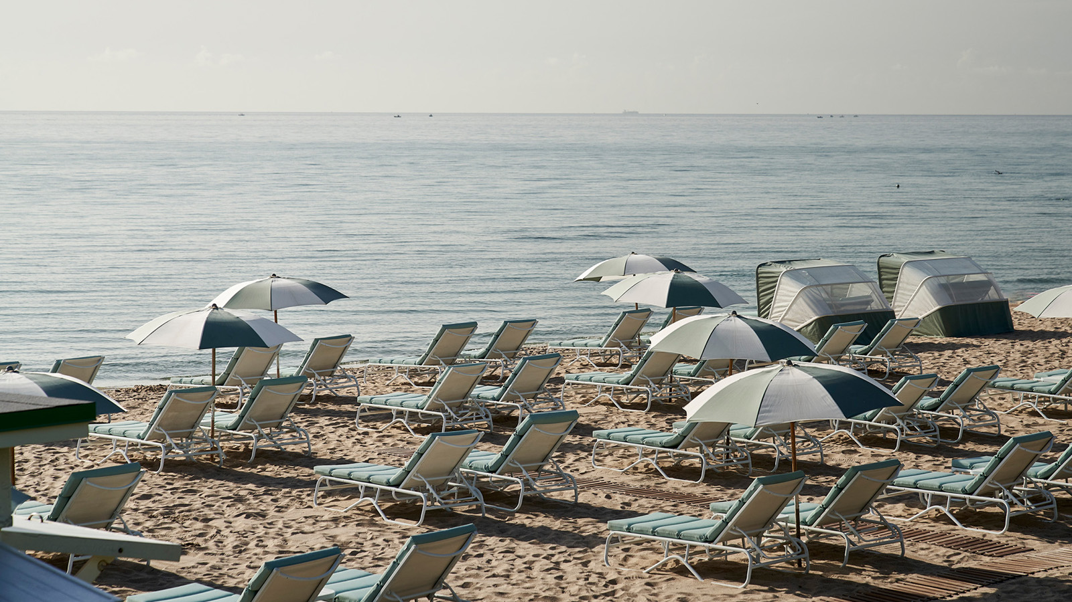
On the 65th anniversary of the world-renowned Forbes Travel Guide Star Awards, Four Seasons Resort Palm Beach celebrates a milestone achievement with twenty-five consecutive years as a Five Star resort and seven consecutive years as a Five Star spa. The recognition maintains the Resort’s longtime standing as the only on Palm Beach Island with a double Five Star rating, while adding Florie’s by Mauro Colagreco to the list of Recommended restaurants for its consistently excellent service and facilities.
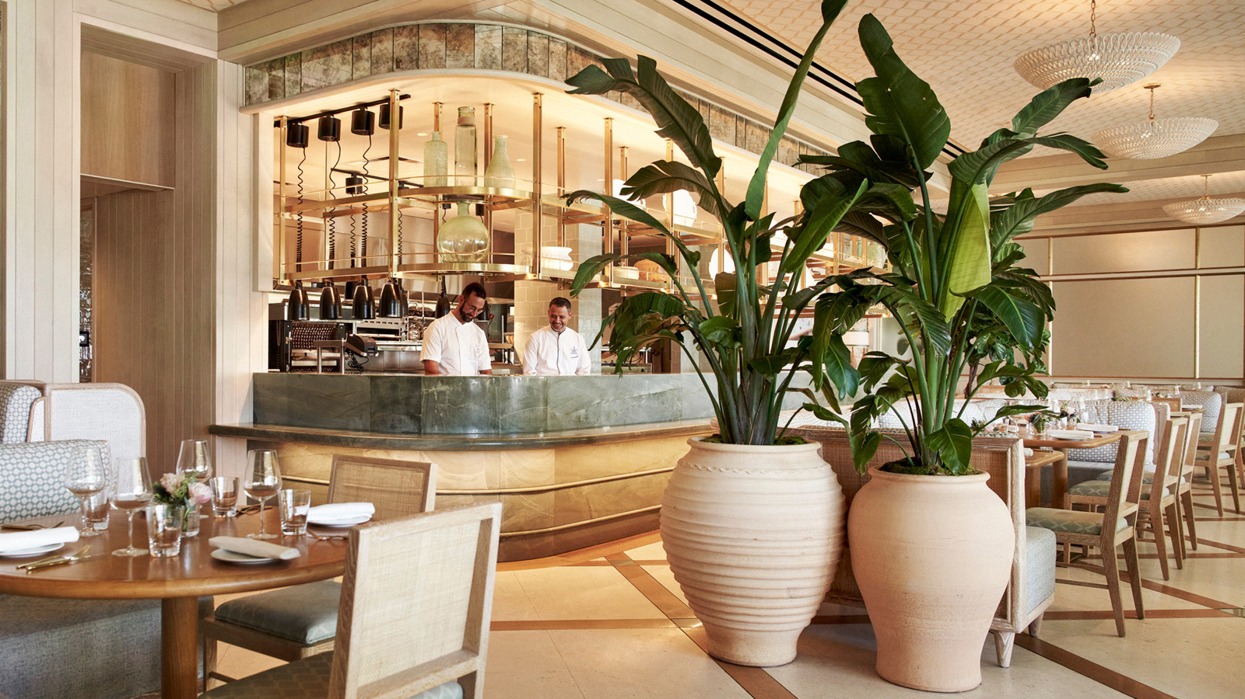
“Receiving the Forbes Five-Star distinction for the 25th consecutive year and recognition for our flagship restaurant Florie’s by Mauro Colagreco fills me with immense pride to work alongside each individual who made this possible,” says Mohamed Elbanna, Regional Vice President and General Manager at Four Seasons Resort Palm Beach. “Behind every memorable moment is a heartfelt passion to make a connection and leave a lasting impression, whether soaking in sunny oceanside hospitality or taking in the thoughtful touches in their guest rooms, our guests can feel that each detail is delivered with love.”
The driving force behind the Resort’s decades long distinction can be found in the tenured talent whose Four Seasons careers span as long as 33 years with the brand. Though the Palm Beach property is widely known for its oceanfront amenities, the award shines a light on a commitment to delivering extraordinary service, which starts at the heart of the dedicated team at Four Seasons Resort Palm Beach. The Star Rating system by the global authority emphasizes Service, which assumes seventy percent of the rating, while the Quality and Conditions of the Facilities determine 30 percent.
With picturesque pools and six acres (2.5 hectares) of private beachfront, a stay at Four Seasons Resort Palm Beach is everything a relaxed Florida vacation should be. Its home nestled along the iconic Palm Beach Island provides infinite moments to connect in an intimate oasis where the world-class amenities are just steps away from the 207 guest rooms and suites. Each experience at the Resort thoughtfully articulates an authentic Palm Beach experience inspired by the destination’s heritage and charm whether dining at Florie’s by Mauro Colagreco, the flagship restaurant and bar in partnership with the chef behind three-Michelin starred Mirazur, where the cuisine celebrates Florida’s bounty, while bespoke seasonal offerings such as Polo in Paradise with America’s leading polo player allow guests an immersive way to experience a Palm Beach favourite pastime.

RELATED

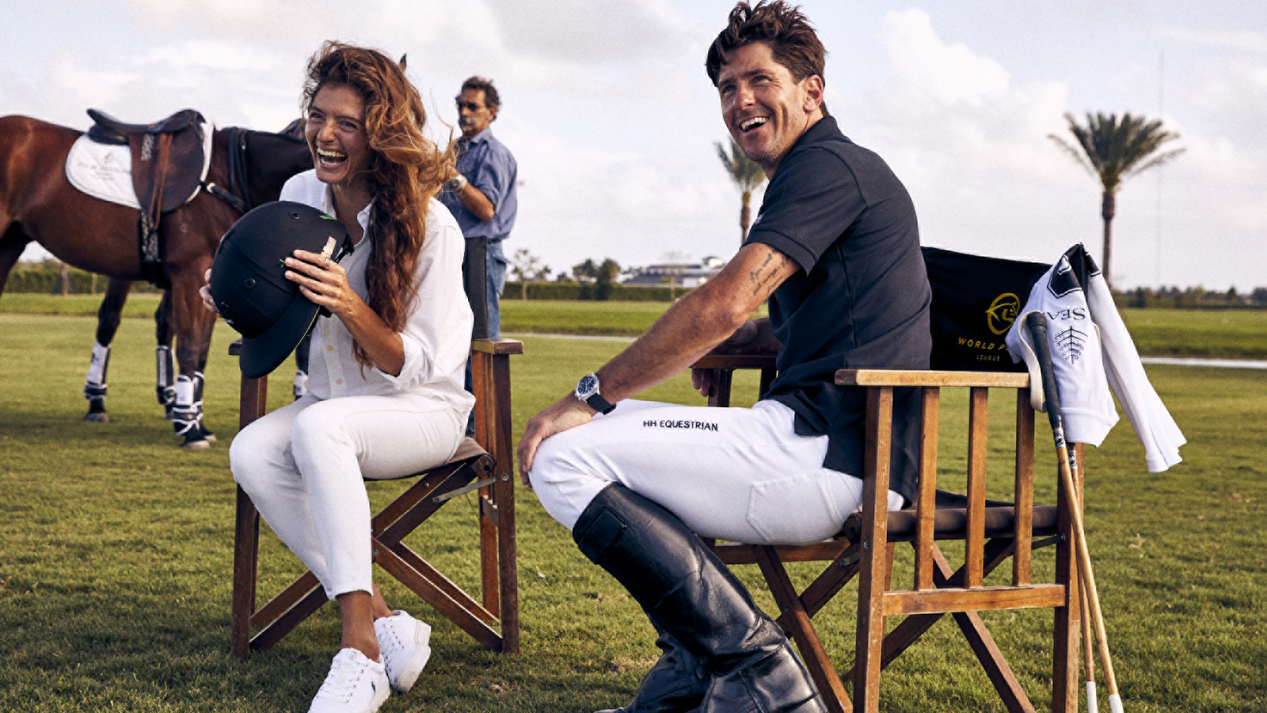 | February 16, 2023, Palm Beach, U.S.A.  Polo Experiences with Top Ranked Player Launches New High Goal Season with Four Seasons Resort Palm Beach  https://publish.url/palmbeach/hotel-news/2023/polo-season-experiences.html
January 25, 2023, Palm Beach, U.S.A.
Epicurean Wishes and Spa Day Dreams Realized at Four Seasons Resort Palm Beach This Valentine’s Weekend
https://publish.url/palmbeach/hotel-news/2023/valentines-day.html

PRESS CONTACTS

Eileen Sturgis
Public Relations and Communications Manager
2800 South Ocean Boulevard
Palm Beach
USA
eileen.sturgis@fourseasons.com

+1 561 493 5549

Laurie Herrick
Regional Director of Public Relations and Communications
2800 South Ocean Boulevard
Palm Beach
USA
laurie.herrick@fourseasons.com

