Make Mid-Autumn Festival Extra Special with Mooncakes from Four Seasons Hotel Kuala Lumpur

Give loved ones the gift of joy and magic, wrapped up in delectable parcels of pastry
July 20, 2020, Kuala Lumpur, Malaysia

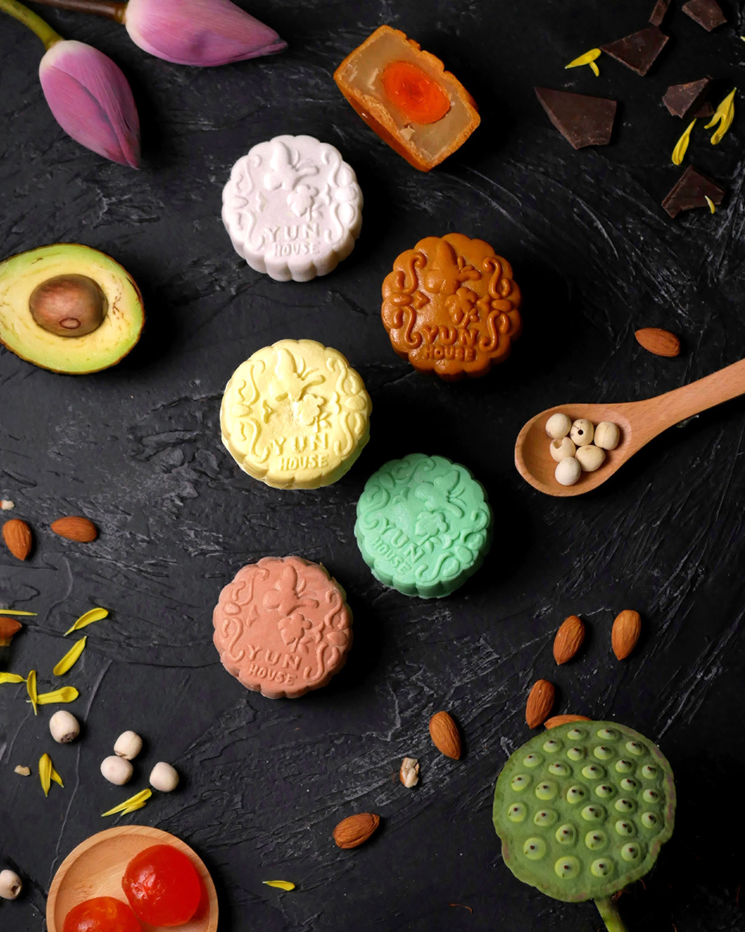
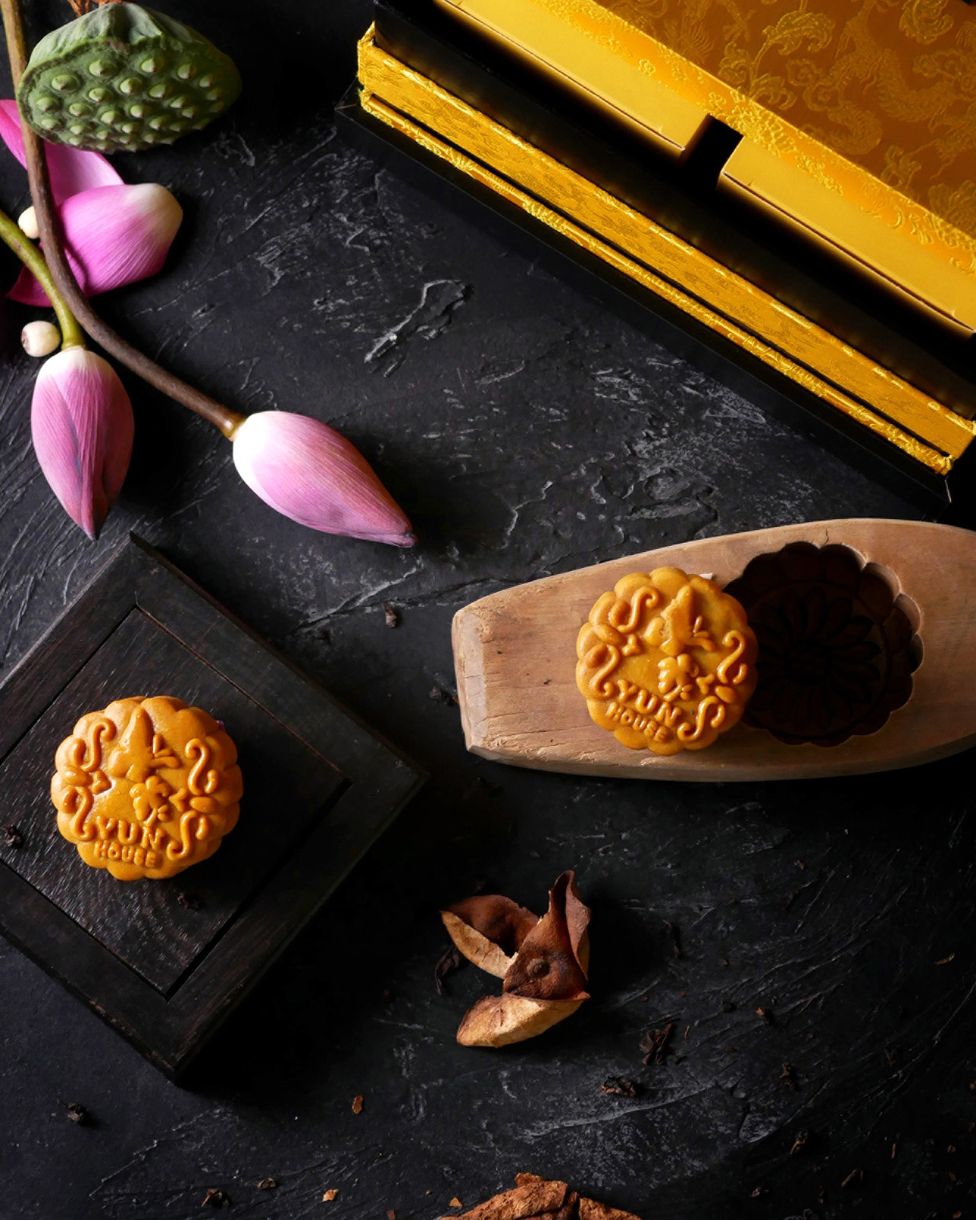 | 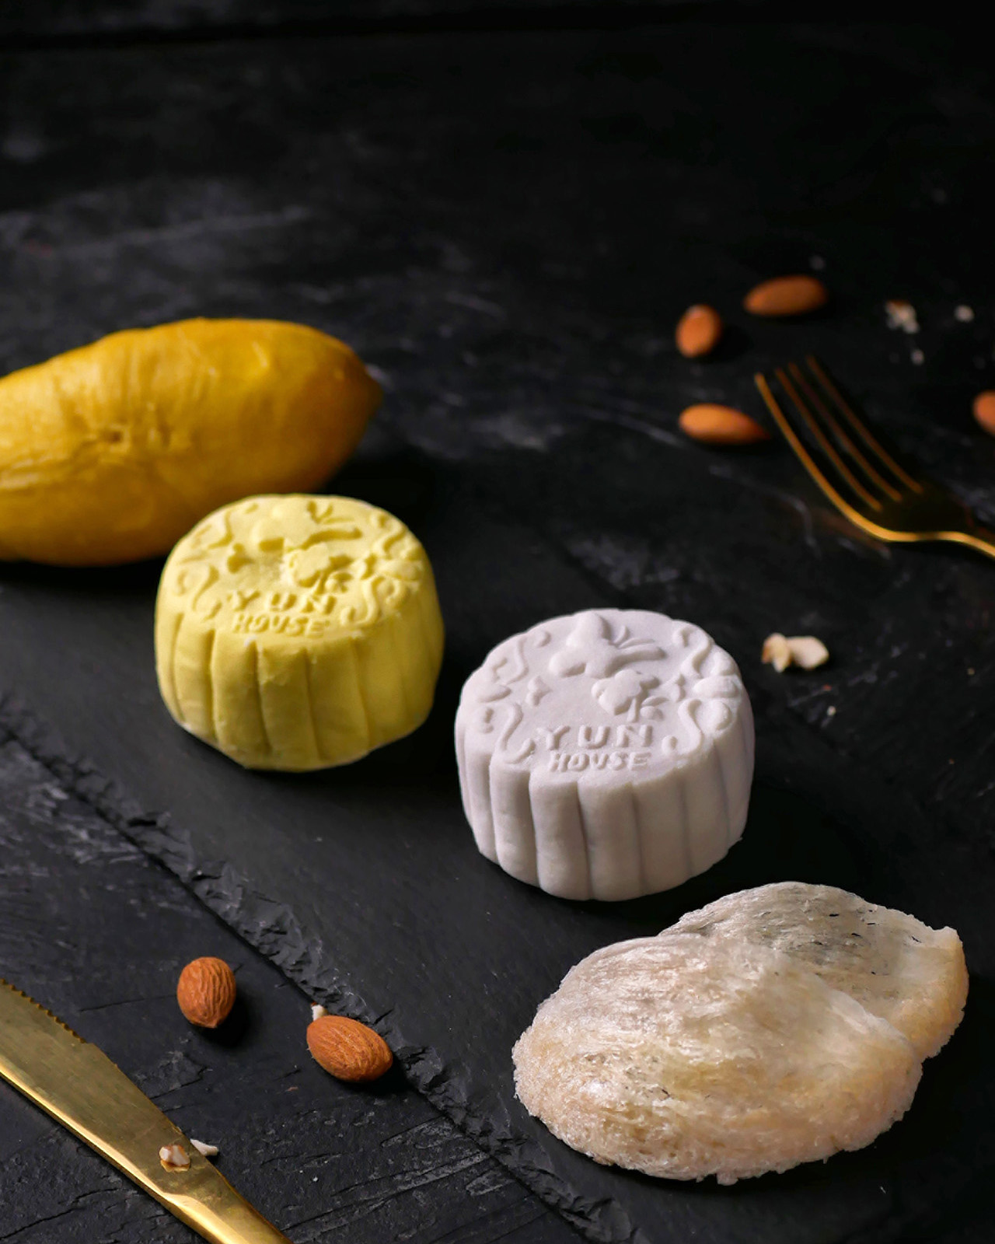 | 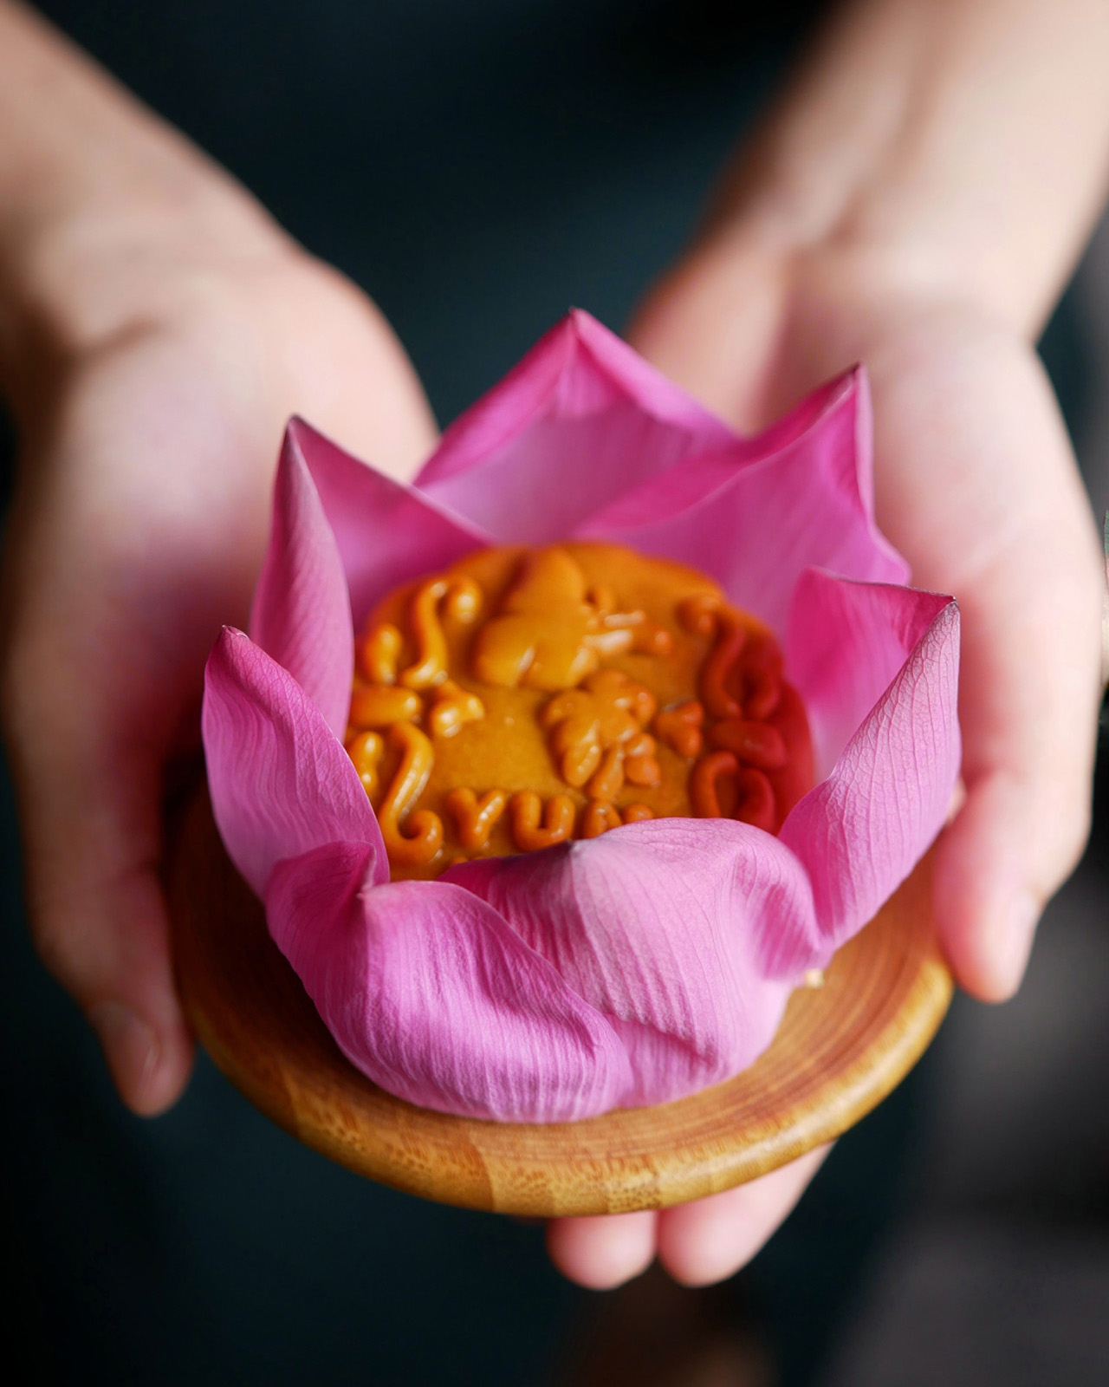
This Mid-Autumn Festival, celebrate precious relationships with handcrafted mooncakes from Four Seasons Hotel Kuala Lumpur. The Yun House team proudly presents a curated selection of intricate mooncakes of unique flavours for celebrations with family and friends.
Choose from an array of homemade Snow Skin Mooncakes, including indulgent flavours such as bird’s nest with almond cream, musang king durian and brandy chocolate. These delicate treats are crafted under the expert eye of Chef Jimmy Wong. The Specialty Tea Mooncake is infused with the unique taste of Yun House’s signature tea blend.
Baked Mooncakes are also on the menu, with coveted fillings such as pu er tea paste with tangerine skin, and all-time classics such as white lotus seed paste and red bean paste. Some varieties feature an egg yolk, a symbol of the harvest moon and a sign of good fortune. The mooncakes come in a custom gift box, available in single- and double-decker editions.
One of the most important events in Chinese culture, the Mid-Autumn Festival is celebrated when the full moon is at its brightest, towards the end of summer. Families and friends get together to share their favourite mooncakes and appreciate the luminous beauty of the night sky, a ritual that signifies unity and happiness. As Chef Jimmy Wong notes, “The Mooncake Festival has always been a beloved occasion in Malaysia – and this year, more so than ever.”
The signature mooncakes at Four Seasons are priced between MYR 38 and 55 per piece, with special offers for Lifestyle Members and corporate orders. Free delivery within 10 kilometres (6.2 miles) is available with a minimum purchase of three boxes.
The Mooncake Menu at Four Seasons Hotel Kuala Lumpur is available for order until October 1 2020. To reserve a box, call +603 2382 8640 or get in touch via the Four Seasons App.

RELATED

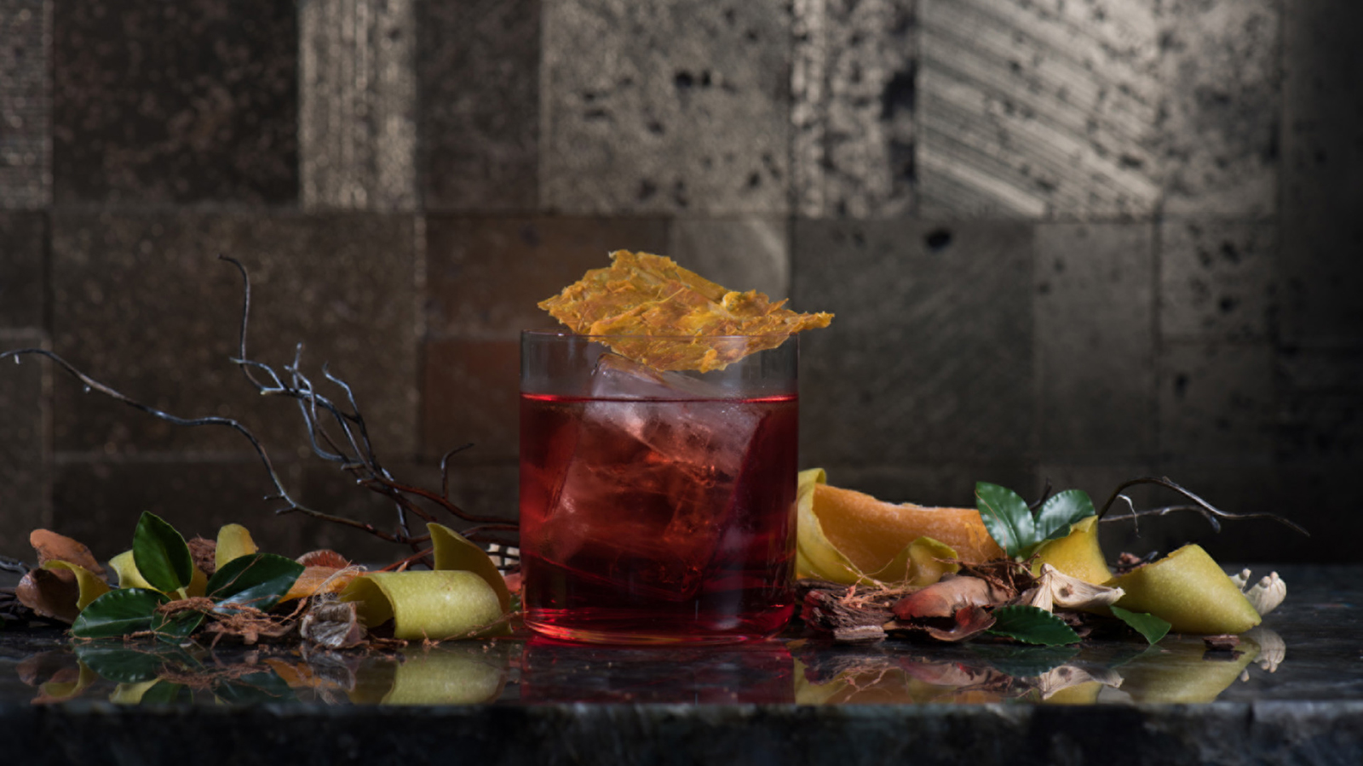 | June 29, 2020, Kuala Lumpur, Malaysia  Bar Trigona at Four Seasons Hotel Kuala Lumpur Unveils a Brand New Menu  https://publish.url/kualalumpur/hotel-news/2020/new-menu-at-bar-trigona.html
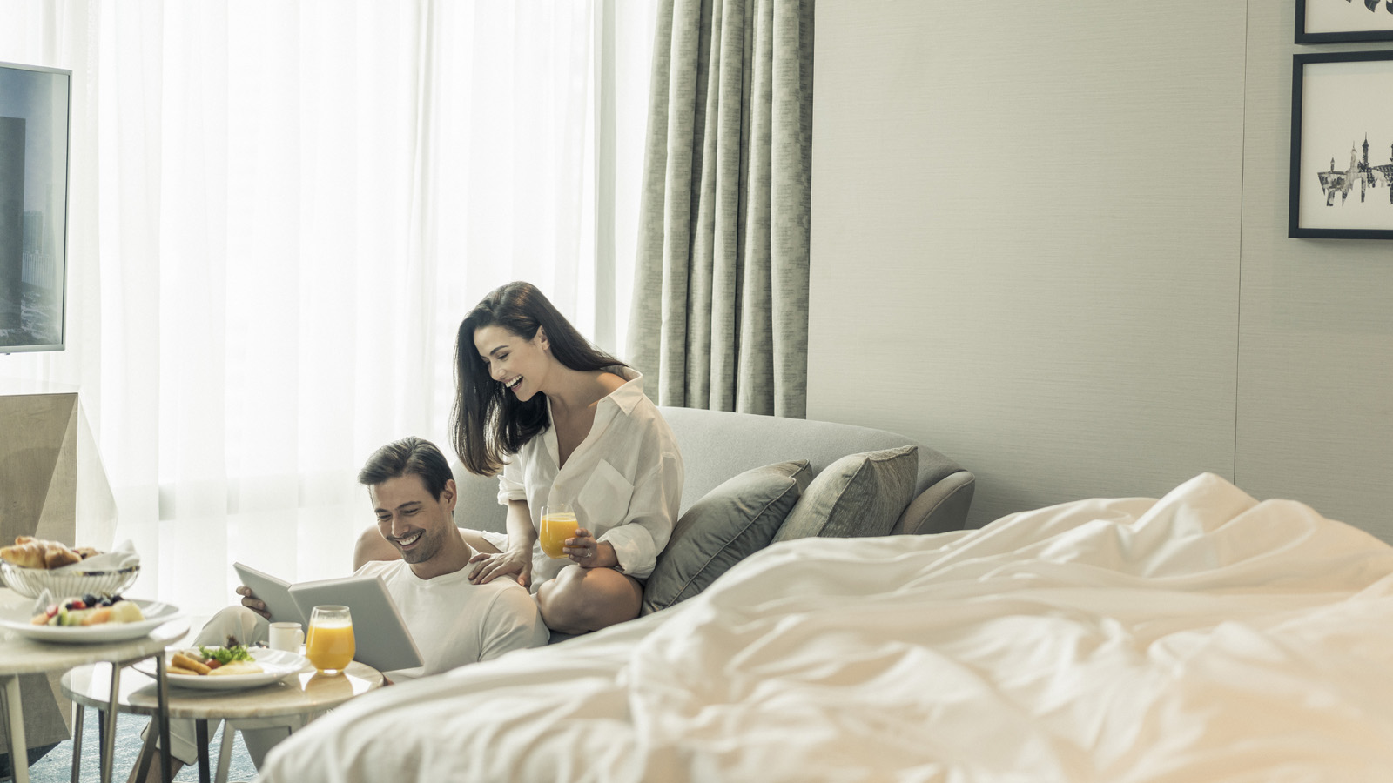 | May 19, 2020, Kuala Lumpur, Malaysia  Restart 2020 with a Staycation at Four Seasons Hotel Kuala Lumpur  https://publish.url/kualalumpur/hotel-news/2020/restart-staycation-package.html

PRESS CONTACTS

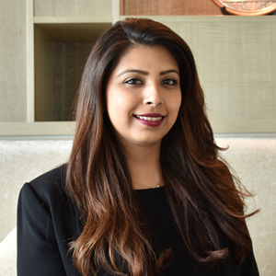 | Kanchana Ganglani  Director of Public Relations  145 Jalan Ampang  Kuala Lumpur  Malaysia  kanchana.ganglani@fourseasons.com  +6(03) 2382 8740

