Four Seasons Hotels and Resorts Unveils Plans for New Hotel and Private Residences in Minneapolis

Together with United Properties, new high-end mixed-use development to open on Nicollet Mall
June 12, 2019, Toronto, Canada

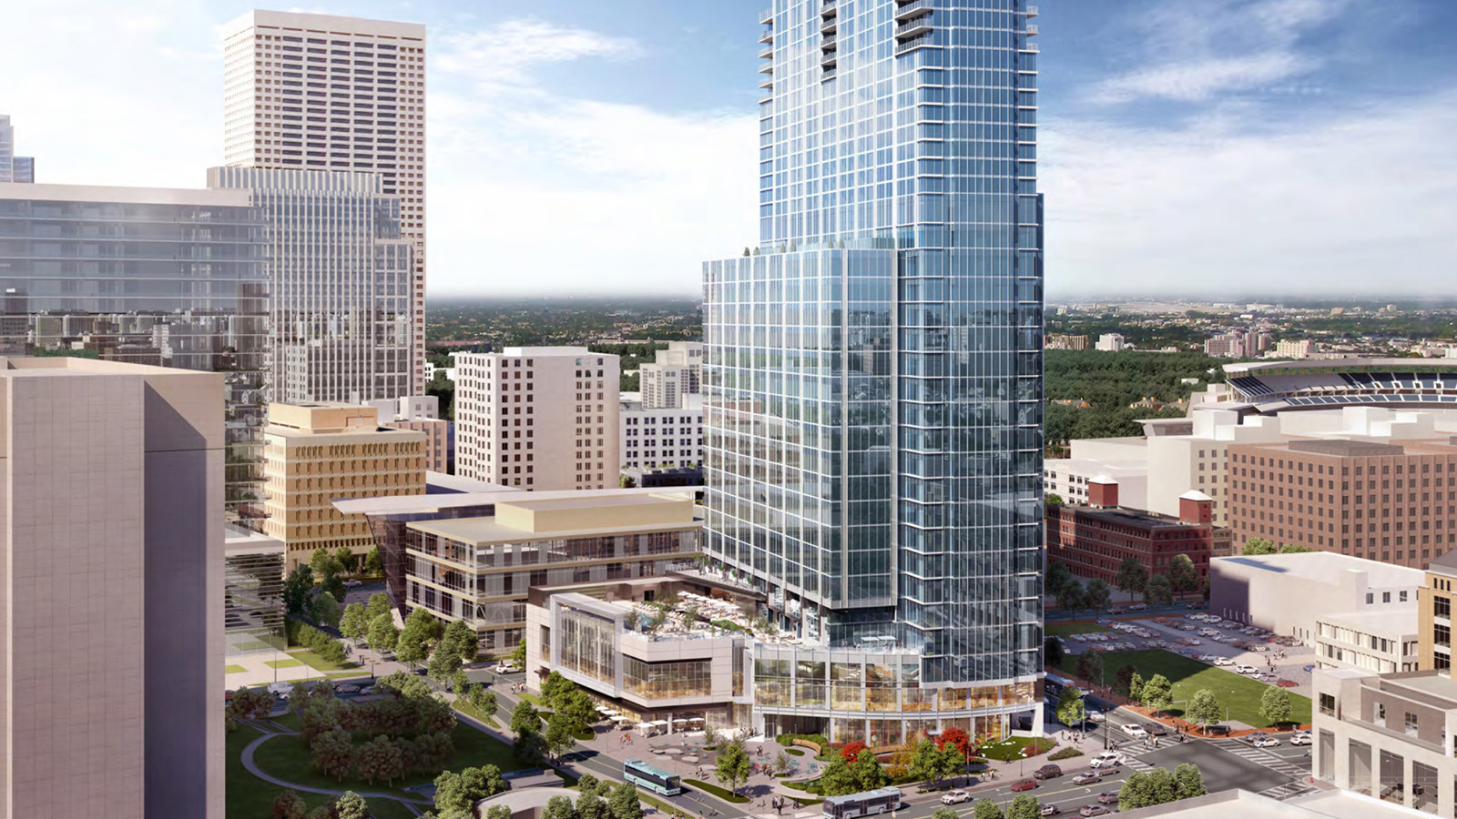
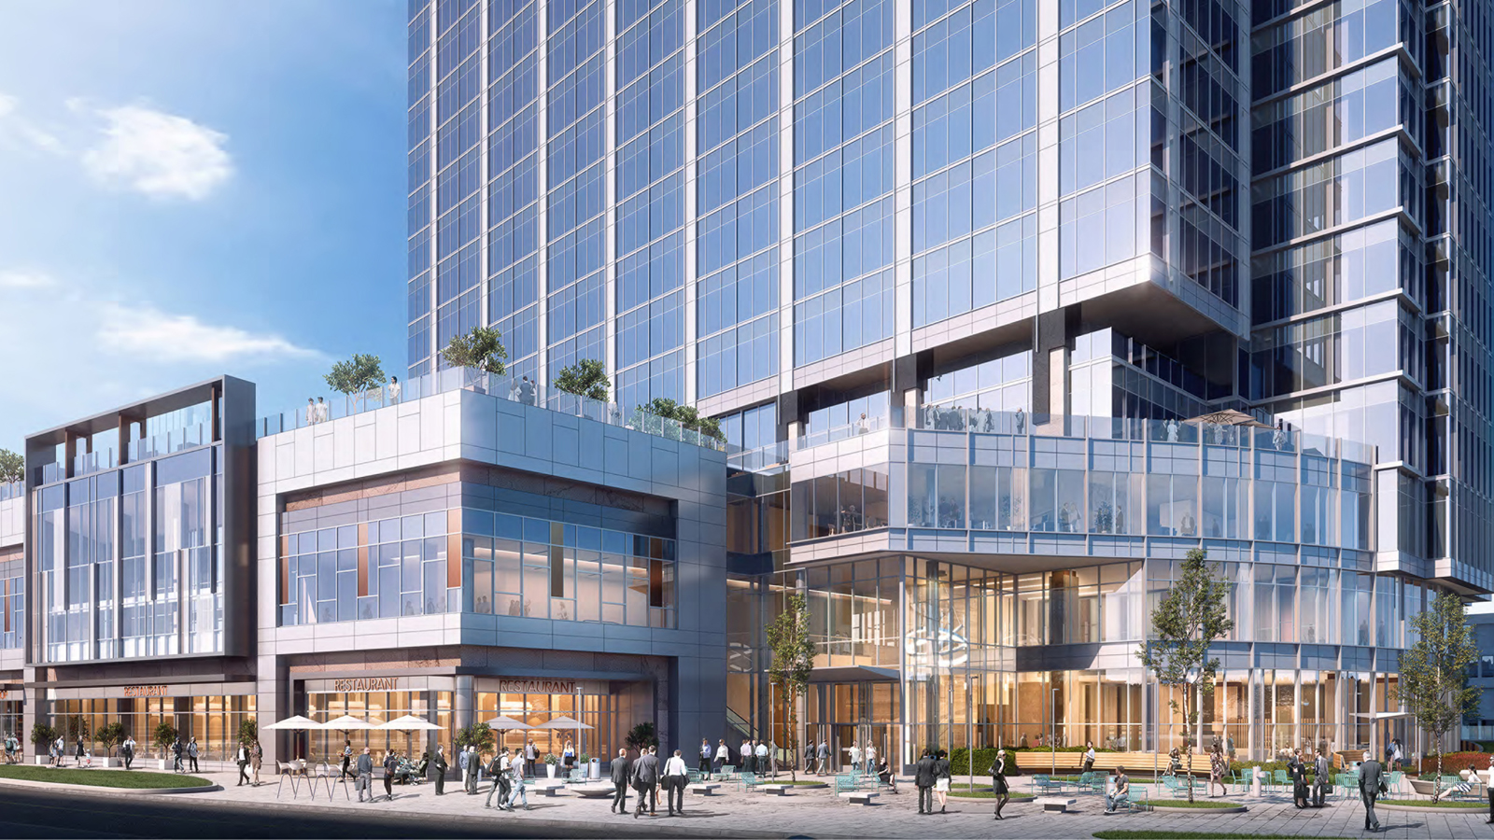 | 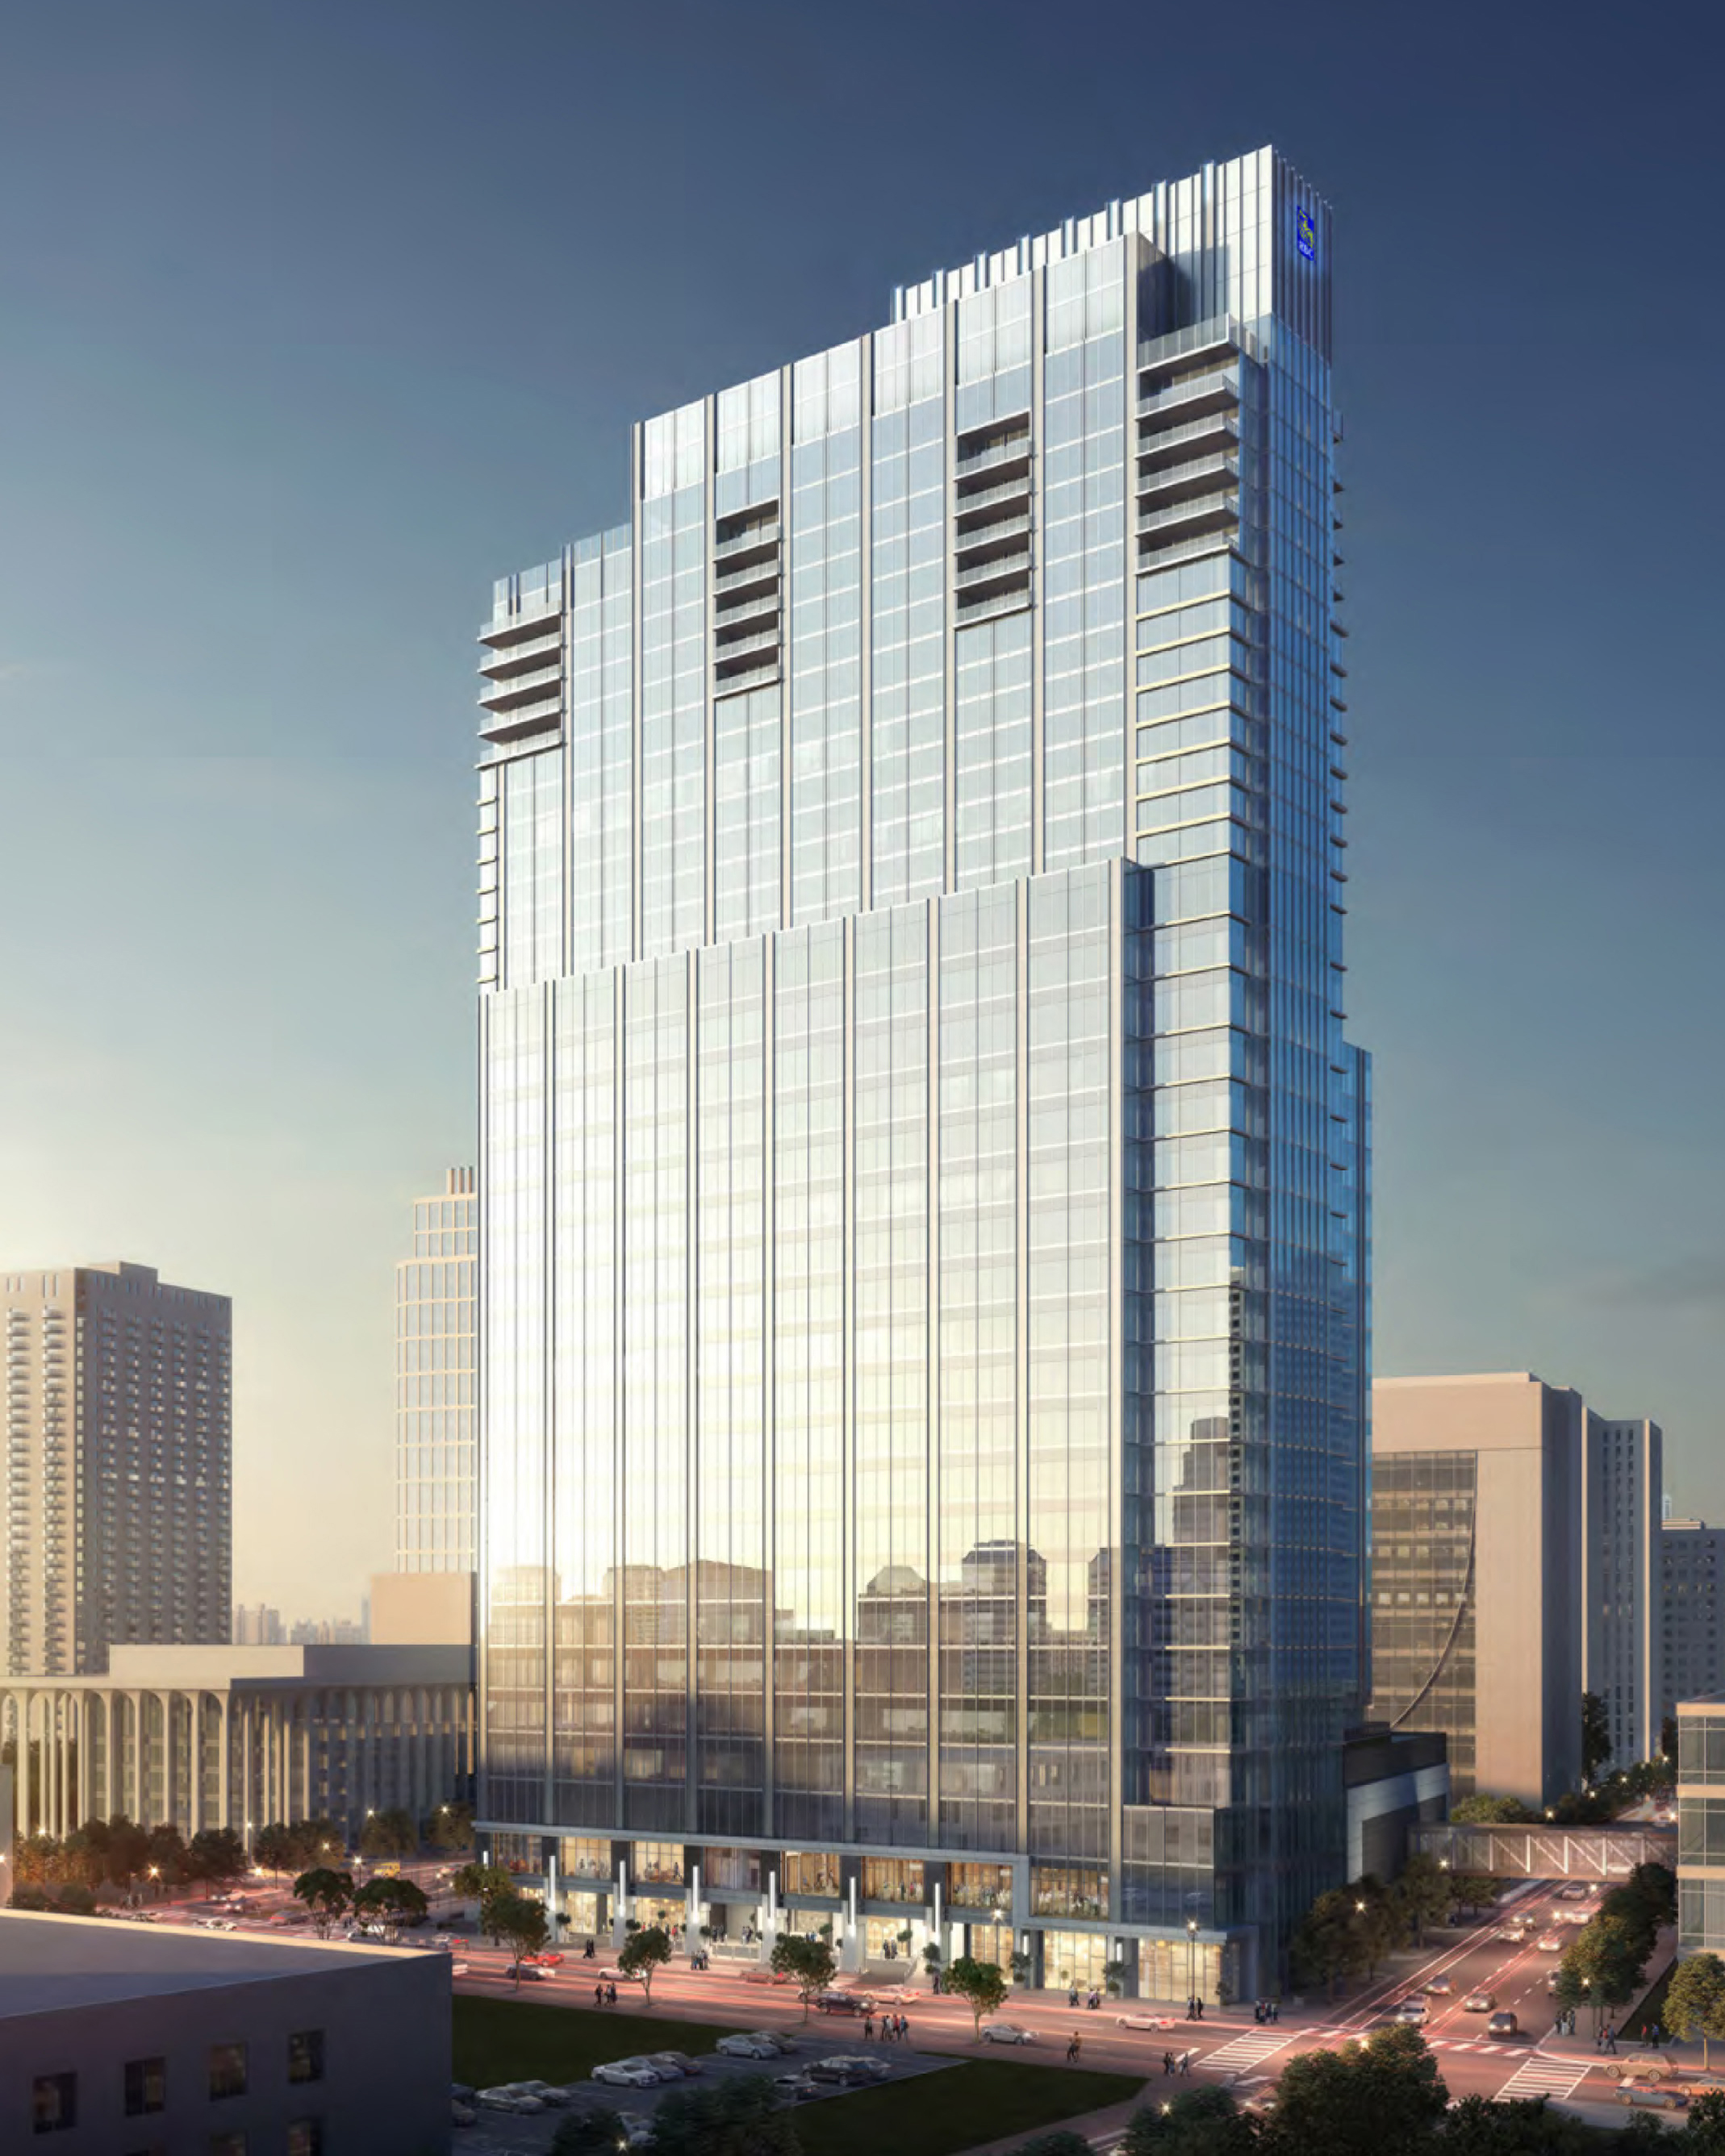
Four Seasons Hotels and Resorts, the world’s leading luxury hospitality company, in partnership with United Properties, a leading commercial property development and investment company in Minnesota and Colorado, today announced plans for Four Seasons Hotel and Private Residences Minneapolis, expected to open in early 2022 at RBC Gateway.
The new 34-storey building will be situated at the convergence of business and leisure in Minneapolis, at the top of Nicollet Mall, the city’s pedestrian thoroughfare. A few short blocks from the Mississippi River, the mixed use complex will also serve as RBC Wealth Management’s US headquarters.
Those looking for more leisure activities will enjoy the vicinity to Minneapolis’ North Loop neighbourhood, filled with history, arts, culture, dining, entertainment and more. Formerly an industrial warehouse area, and located within the Minneapolis Historic District and National Register of Historic Places, the North Loop now boasts a local farmers market; Target Field, the home of the Minnesota Twins Major League Baseball team; art galleries, music and entertainment venues; and so much more.
“Minneapolis is a booming corporate hub in the Midwest, and has a vibrant leisure, cultural and arts scene, and we look forward to creating a place for locals and visitors alike to come together while raising the standard of luxury and service in the city,” says Bart Carnahan, Executive Vice President, Global Business Development and Portfolio Management, Four Seasons Hotels and Resorts. “Our partners at United Properties have envisioned a new luxury focal point in Minneapolis, and we look forward to helping them bring that vision to life.”
The 222 room Four Seasons Hotel will also feature a restaurant and bar, and one of the largest pool decks in the city, overlooking the city’s downtown. A spa complex, open to both Hotel guests and day visitors, is also planned, along with extensive event spaces. On the uppermost floors of the building, 34 fully serviced Four Seasons Private Residences will boast impressive city and Mississippi River views.
“This new property sits on the best location in the city, with historic roots on the site of the former Nicollet Hotel, and in the centre of the excitement and bustle of downtown Minneapolis,” says Bill Katter, President and Chief Investment Officer of United Properties Development. “Our partnership with Four Seasons allows us to elevate this exceptional project to new heights, delivering the signature hospitality and luxury lifestyle experience that Four Seasons is known for around the world.”
The project is being designed by Smallwood, Reynolds, Stewart, Stewart and Associates, who have global projects and operations ranging from architecture, landscape and interior design, in hospitality, public spaces, education, government and beyond.
About United Properties
United Properties has been creating deep roots in the commercial real estate industry for 100 years. The company imagines new possibilities in real estate to help strengthen communities and create lasting legacies. United Properties provides market expertise for ground-up development, redevelopment and acquisitions of value-add and stable investments. The company invests in and develops office, industrial, retail, mixed-use and senior housing properties. United Properties is owned by the Pohlad Companies and is headquartered in Minneapolis, with an office in Denver.

RELATED

September 1, 2021, Toronto, Canada
Four Seasons Awards and Accolades
https://publish.url/news-releases/awards-and-accolades-for-four-seasons-hotels-and-resorts.html

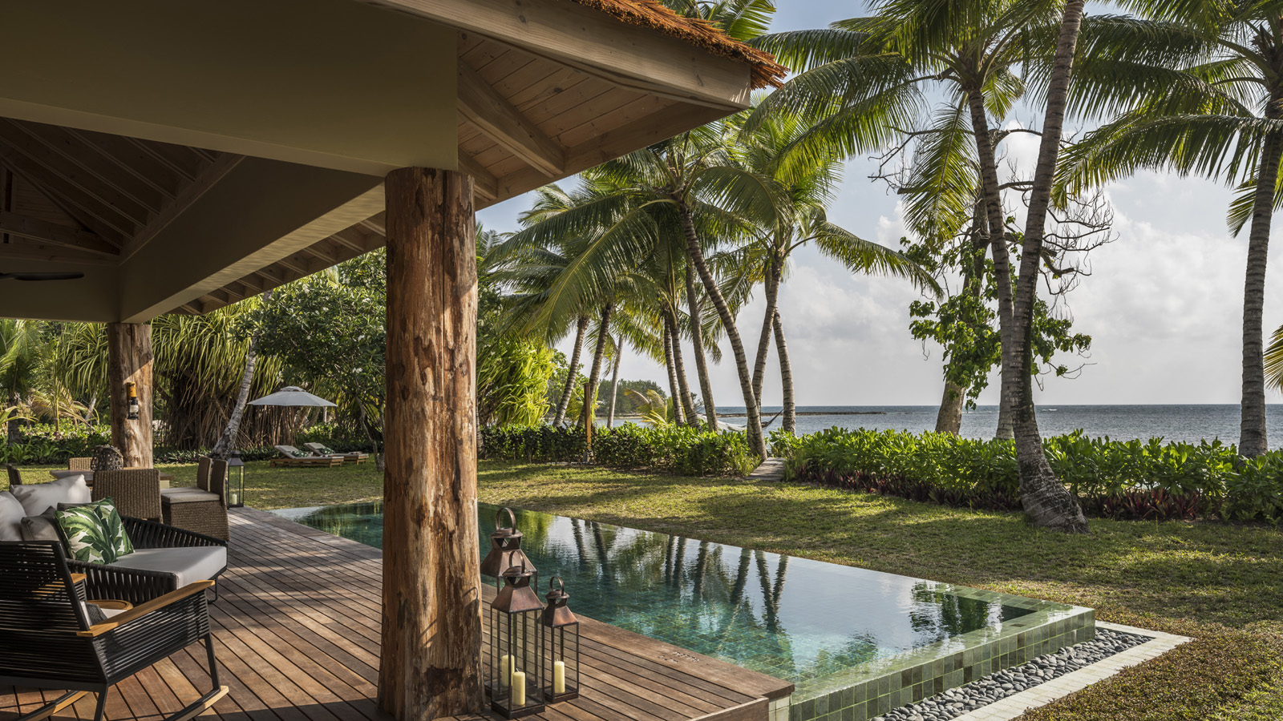 | July 14, 2021, Toronto, Canada  فورسيزونز تدعو المسافرين لإعادة التواصل مع العالم: من الرغبة في السفر Wanderlust إلى ضرورة السفر Wandermust  https://publish.url/news-releases/2021/wandermust-5.html

PRESS CONTACTS

Sarah Tuite
Vice President, Corporate Public Relations
1165 Leslie Street
Toronto
Canada
prsm@fourseasons.com

+1 416 441 4350

