Five Ways to Welcome the Year of the Tiger

January 7, 2022, London at Ten Trinity Square

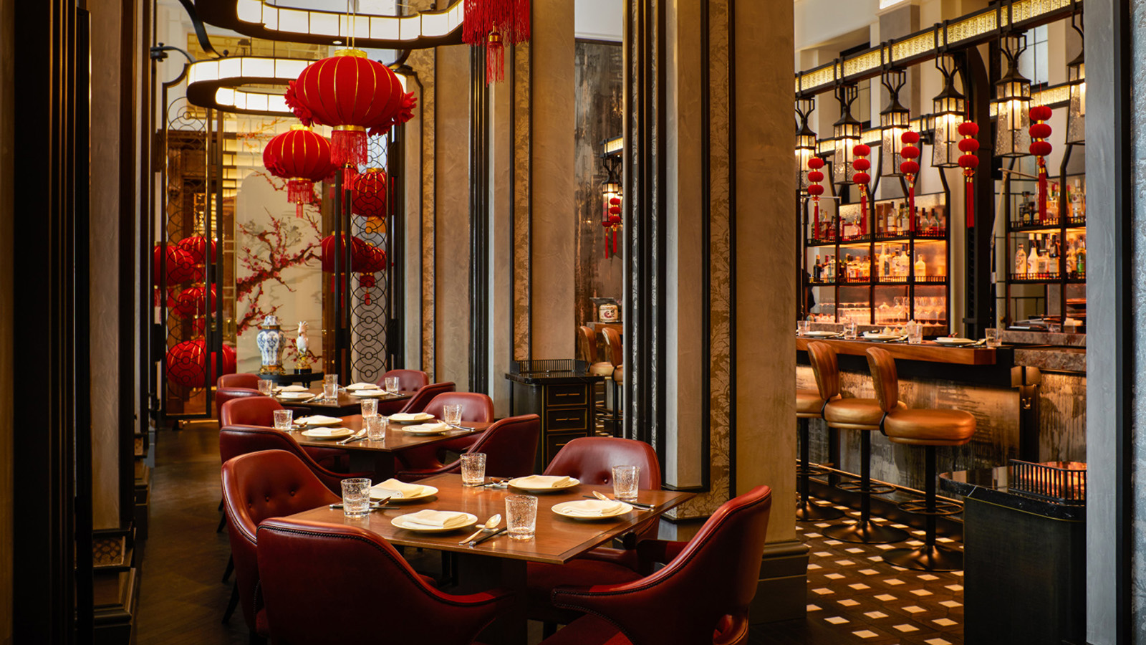
Mark an auspicious beginning to the Year of the Tiger with these authentic traditions from Executive Chef Tony Truong at Mei Ume at Four Seasons Hotel London at Ten Trinity Square, who shares his “must dos” on how to really celebrate Chinese New Year.
Good Luck - Hui Chun
Hui chun is a traditional decoration that you will find on many people’s front doors. They are usually written by hand on red and gold coloured paper, which symbolises good luck. These are marked with messages of good fortune such as happiness, prosperity and long life.
Ward Off Bad Luck - Handing Out Red Envelopes
During Chinese New Year, money is located inside a red envelope and presented at family gatherings during this annual festival. The red envelopes are a symbol to ward off bad luck and evil spirits. The amount of money inside the envelope usually ends with an even number, as even digits are associated with reunion and pairing.
Prosperity - Hosting a Family Gathering Dinner
A Chinese New Year dinner is also known as “reunion dinner.” It is often referred as the most important meal of the year, as it symbolises unity, ending the year together and starting the year together with prosperity.
Joy - Chinese Candy Box
A common custom for each family in China, this candy box usually holds up to eight varieties of dried fruits and sweets. This candy box symbolises sweetness and joy to kick start the year.
Giving Gold - Eating Mandarin During the Festival
This citrus fruit symbolises wealth as the mandarin word kam sounds similar to gold. According to traditions, the gesture of gifting mandarin oranges to one another also means “giving gold,” which represents wishing well to the recipient
On January 31, 2022, Mei Ume will welcome the Year of the Tiger with specially crafted tasting and a la carte menus. Available until February 11, 2022, the menu will showcase traditional and auspicious dishes eaten at the reunion dinner on Chinese New Year, alongside intricate festive décor. For details including reservations information, click here.

RELATED

January 7, 2022, London at Ten Trinity Square
Mei Ume at Four Seasons Hotel London at Ten Trinity Square Welcomes the Year of the Tiger with Celebration Menu
https://publish.url/tentrinity/hotel-news/2022/lunar-new-year-at-mei-ume.html

November 10, 2021, London at Ten Trinity Square
La Dame de Pic London Launches “The Coconut” at Four Seasons Hotel London at Ten Trinity Square
https://publish.url/tentrinity/hotel-news/2021/the-coconut-at-la-dame-de-pic-london.html

PRESS CONTACTS

Grace Roome
Public Relations Manager
10 Trinity Square
London
UK
Grace.Roome@fourseasons.com

+44 (0) 203 297 9232

