Filippo Peroni Takes Centre Stage at Il Foyer

June 1, 2011, Milan, Italy

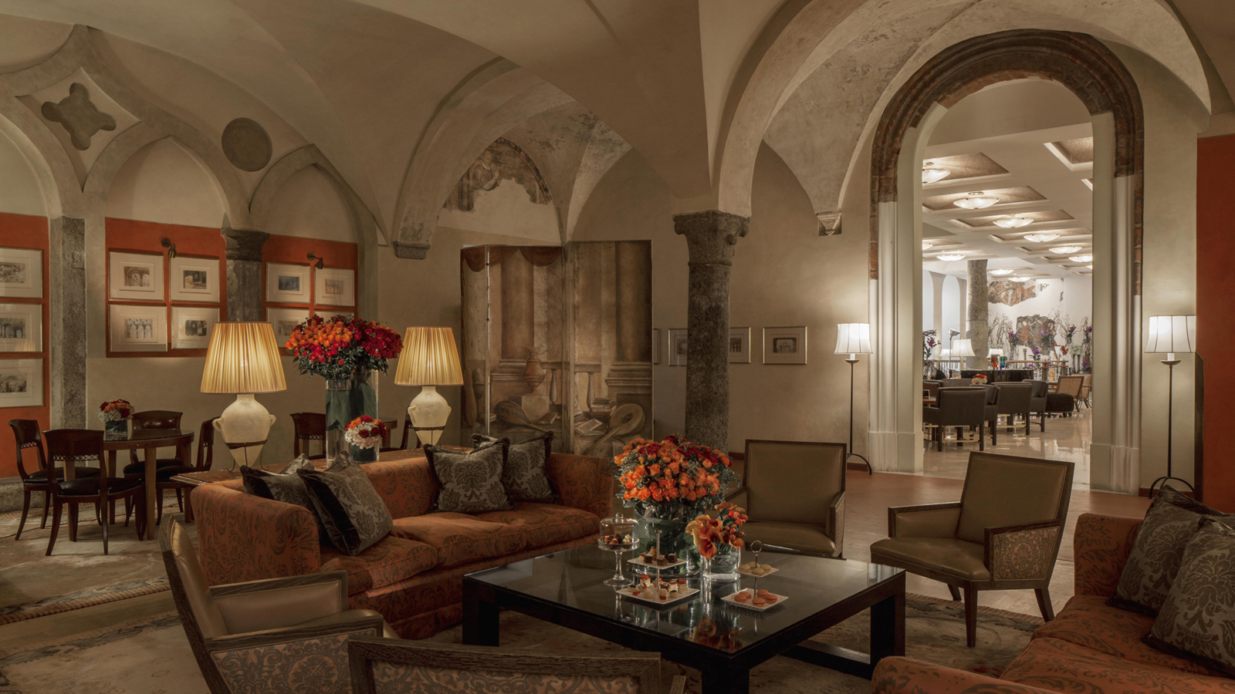
Serious opera fans will immediately recognize – and thrill at the sight of – the original sketches by Filippo Peroni (1809–1878) that decorate the walls of the cosy Il Camino Room in Il Foyer at Four Seasons Hotel Milano.
Once the sacristy of the convent church, it’s now a favourite meeting place before or after performances at Teatro alla Scala, where Peroni was chief set designer and costumer from 1849 to 1867. About 600 of his sketches survived, including the collection at Four Seasons.

RELATED

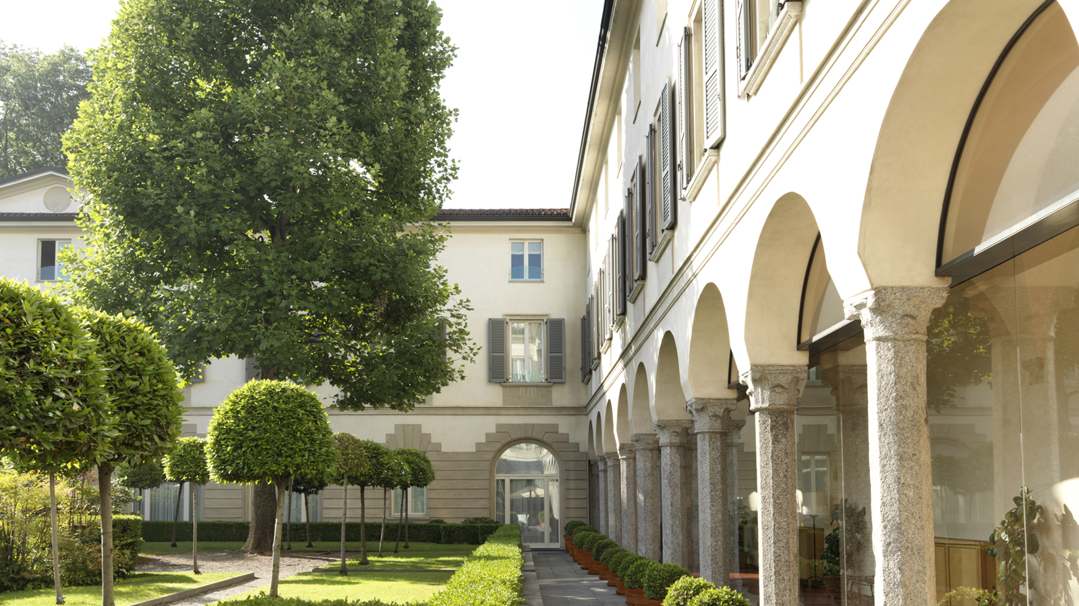 | May 22, 2018, Milan, Italy  Four Seasons Hotel Milano Celebrates Global Wellness Day  https://publish.url/milan/hotel-news/2018/global-wellness-day.html
May 22, 2018, Milan, Italy
Four Seasons Hotel Milano festeggia il Global Wellness Day con un programma di benessere e un pranzo salutare nel giardino dell’Hotel a sostegno dell’AIRC
https://publish.url/it/milan/hotel-news/2018/global-wellness-day-2.html

PRESS CONTACTS

Caroline Mennetrier
Director of PR and Marketing Communication
Via Gesù 6/8
Milano
Italy
caroline.mennetrier@fourseasons.com

+39 02 7708 1795

