Four Seasons Greater China Collection Launches the “Great Group & Meeting Value” Offer

May 11, 2020, Beijing, China

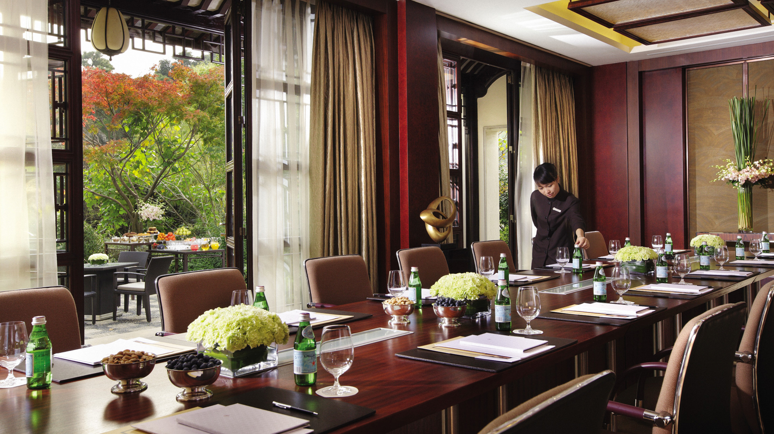
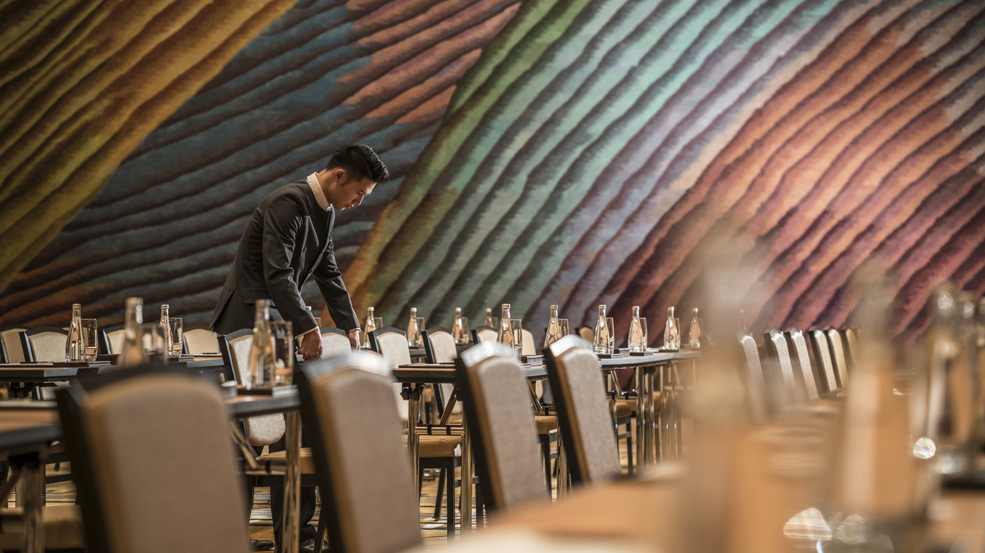
Four Seasons Greater China Collection just launched its Great Group & Meeting Value offer that has been tailored to provide unforgettable group events, meetings, conferences and evening functions.
With hotels and an urban resort located in major China gateway cities, meeting planners and organisers can choose from the range of elegant function rooms and spacious guest rooms available at each property, enjoying legendary Four Seasons comfort, service and hospitality for less.
Twin Offer includes:
- One complimentary guest room or accommodation upgrade to the next room category based on minimum paid rooms per night
- Complimentary function room based on catering spend
Outside of the meeting room, Four Seasons puts forward some of the most exciting attractions, UNESCO World Heritage sites and entertainment that China has to offer. Guests can enjoy on-site Michelin-starred dining in Hong Kong, Macau, Guangzhou and Beijing, and rejuvenate with therapeutic treatments at some of the finest spas in Asia. From wandering through the UNESCO “City of Design” in Shenzhen to an exploration of the beautiful mountains and temples of Hangzhou, or a night out at the Italian-style street in Tianjin, each destination offers unique opportunities for recreation and group activities.
No matter which destination, Four Seasons has the finger on the pulse of business in China, making it the choice address for seamless and memorable events.
The promotion is valid until December 31, 2020 and is only applicable for in-house groups of 10 rooms and above. Subject to space and date availability, and for new bookings only. Terms and conditions subject to specific property. Some benefits may not be available at every hotel. To learn more about the Great Group & Meeting Value offer, click here.

RELATED

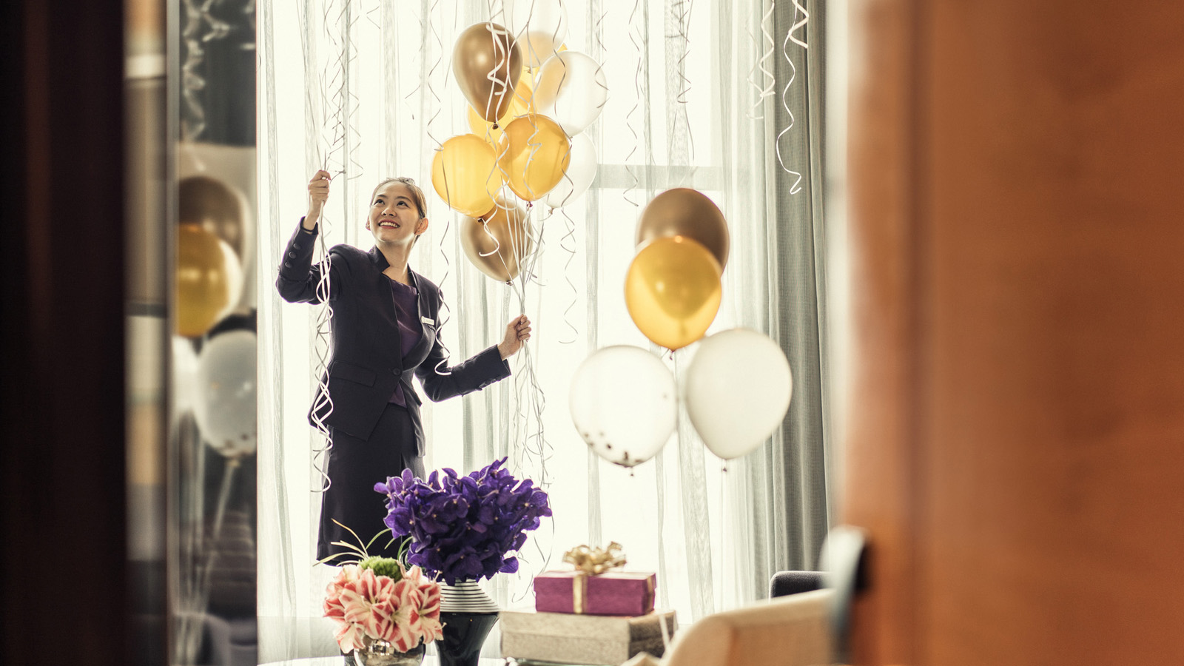 | August 4, 2020, Hong Kong, China  香港四季酒店呈献优逸住宿优惠  https://publish.url/zh/hongkong/hotel-news/2020/stay-and-dine-package-3.html
August 4, 2020, Hong Kong, China
香港四季酒店呈獻優逸住宿優惠
https://publish.url/zh_hant/hongkong/hotel-news/2020/stay-and-dine-package-2.html

PRESS CONTACTS

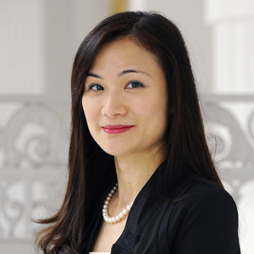 | Vivian Koh  Director, Public Relations and Content, Asia-Pacific  Tourism Court, 1 Orchard Spring Lane #04-01  Singapore  Singapore  vivian.koh@fourseasons.com  +65 6739 5806
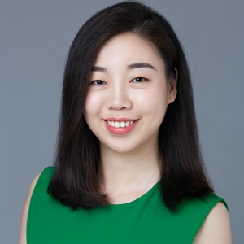 | Emilie Zhang  Director of Public Relations and Communications  48 Liang Ma Qiao Road Chaoyang District  Beijing  China  emilie.zhang@fourseasons.com  +86 10 5695 8706
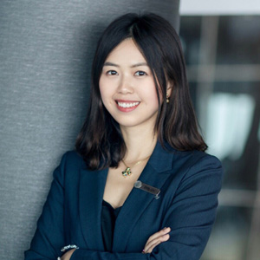 | Ditty Liu  Director of Public Relations  5 Zhujiang West Road, Pearl River New City, Tianhe District  Guangzhou  China  ditty.liu@fourseasons.com  86 (20) 8883-3901
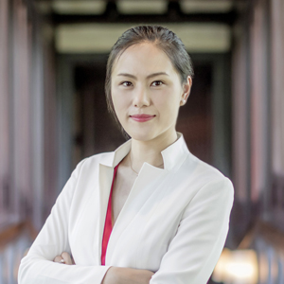 | Cecilia Xu  Assistant Director of Public Relations  5 Lingyin Road  Hangzhou  China  cecilia.xu@fourseasons.com  +86 571 8829 8888
Chu Wong
Director of Public Relations
8 Finance Street, Central
Hong Kong
China
chu.wong@fourseasons.com

(852) 3196 8306

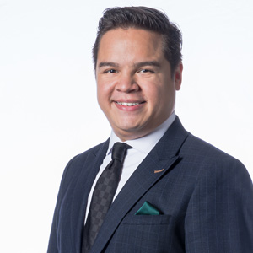 | Cristiano Nantes  Digital Marketing and Communications Assistant Manager, Public Relations  Estrada da Baía de N. Senhora da Esperança, S/N  Macau  China  cristiano.nantes@fourseasons.com  (853) 8112 8834
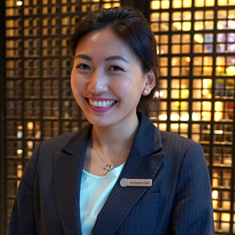 | Andreana Soh  Director of Public Relations and Communications  138 Fuhua Third Road, Futian District  Shenzhen  China  andreana.soh@fourseasons.com  +86 755 8826 8831
Lucy Zhang
Director of Public Affairs
138 Chifeng Road
Tianjin
China
lucy.zhanglx@fourseasons.com

+86 22 2716 6187

