Six of the Best: Four Seasons Hotel Seoul Shares its Top Picks for an Unforgettable Summer in the City

May 10, 2023, Seoul, Korea

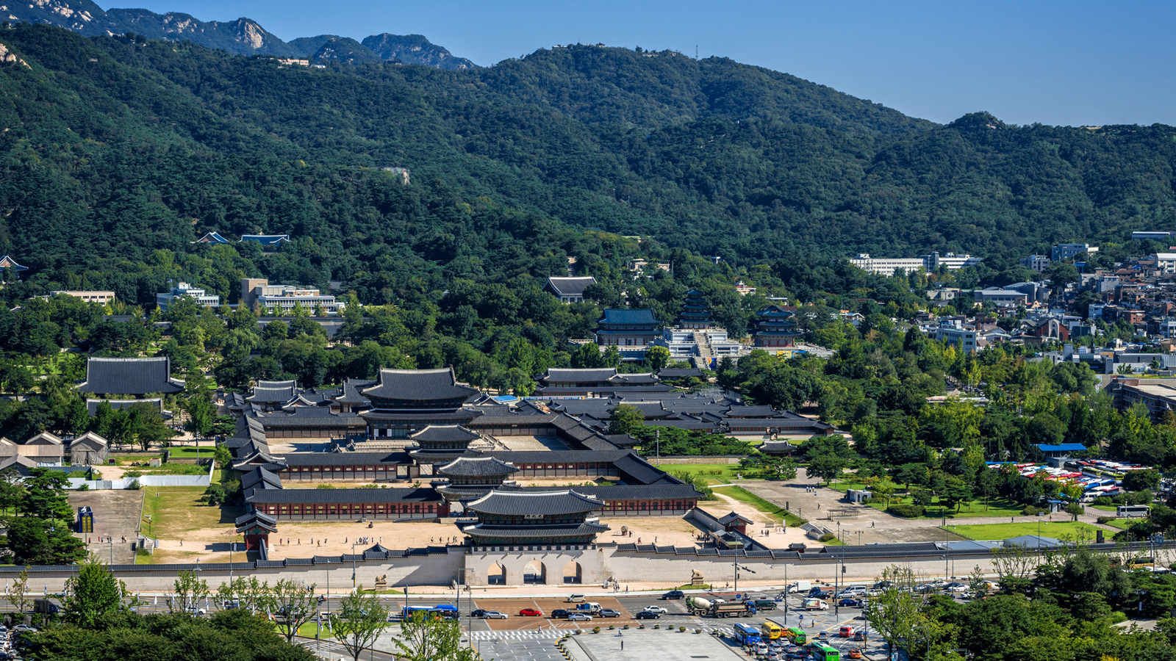
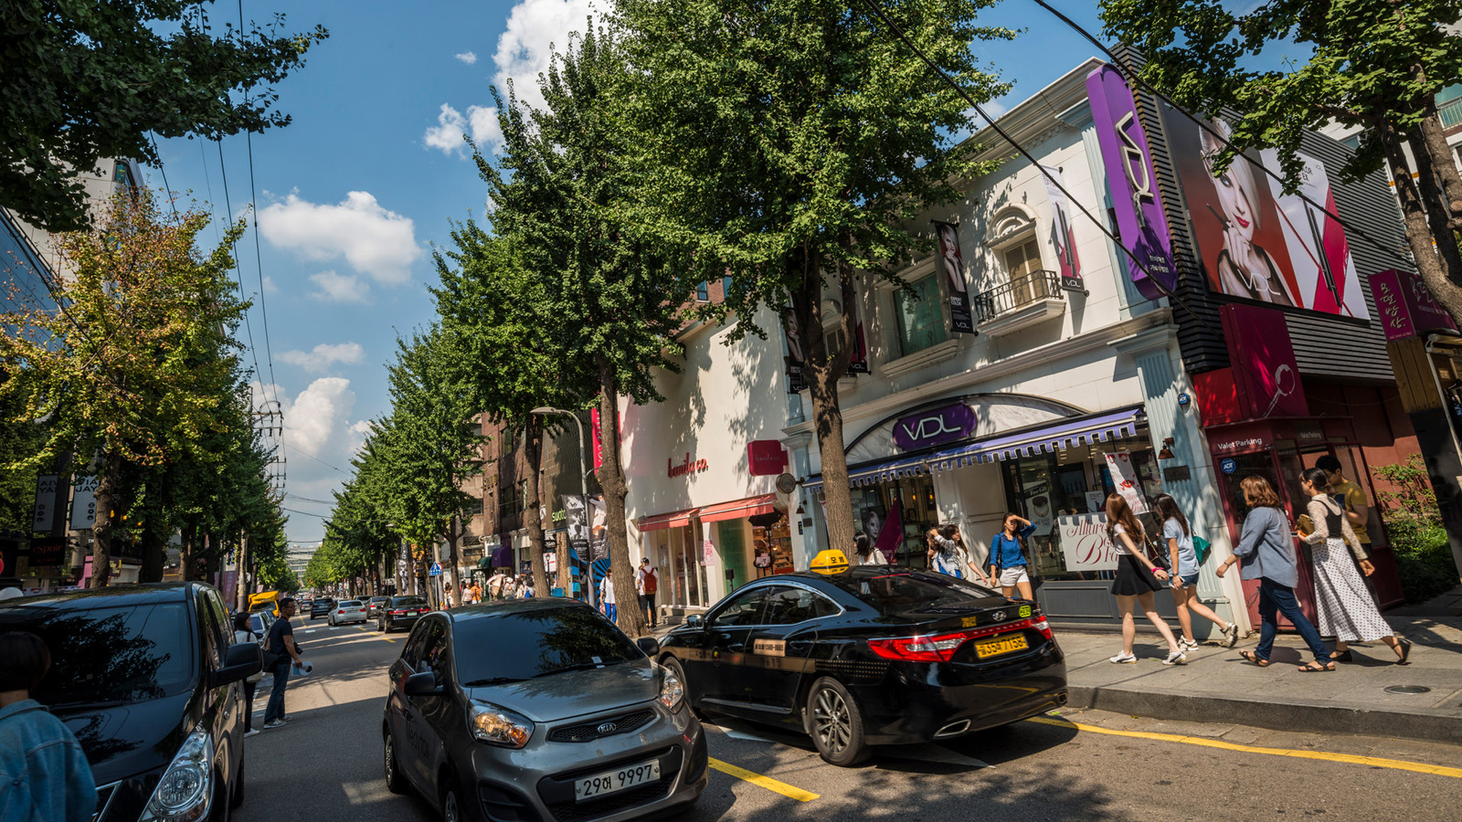 | 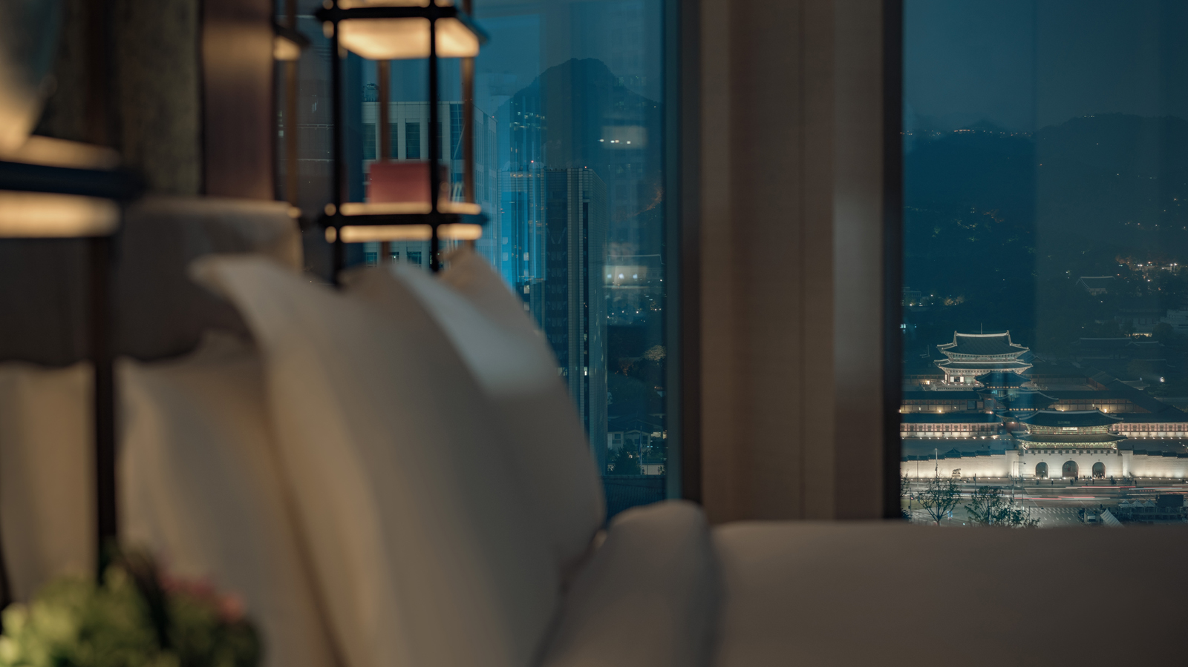 | 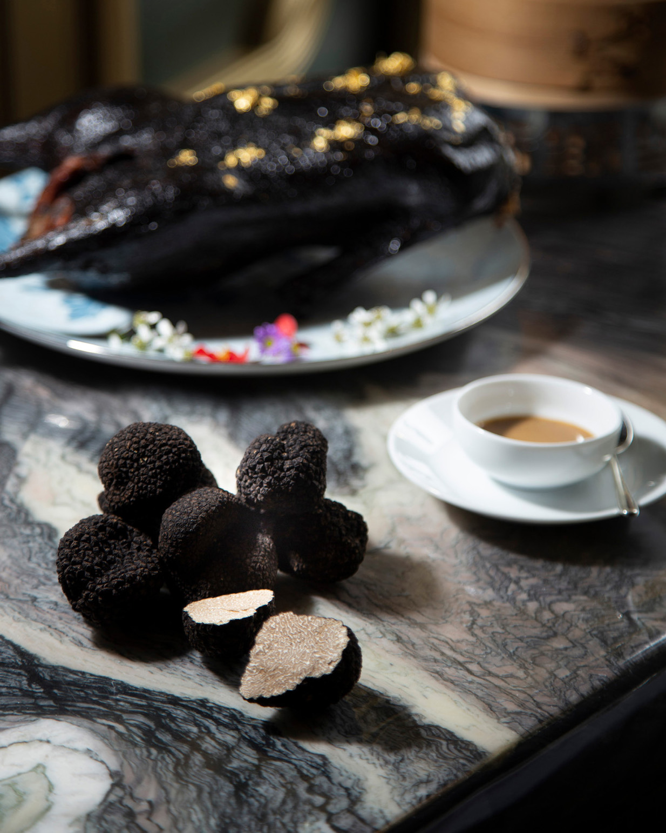
From arts to culture, gastronomy, wellness and style, summer in Seoul is a vibrant showcase of colour, creativity and inspiration. Dive into our pick of the finest offerings and events taking place in and around Four Seasons Hotel Seoul throughout the summer season.
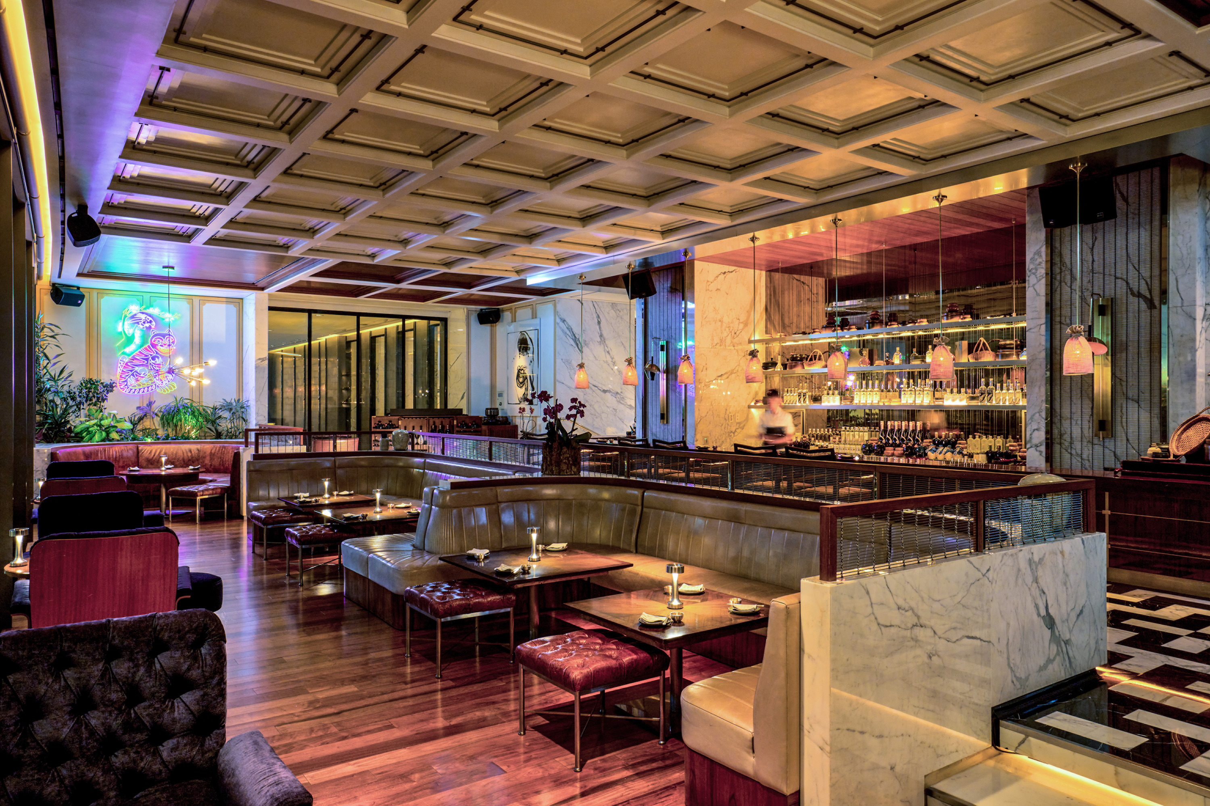 | 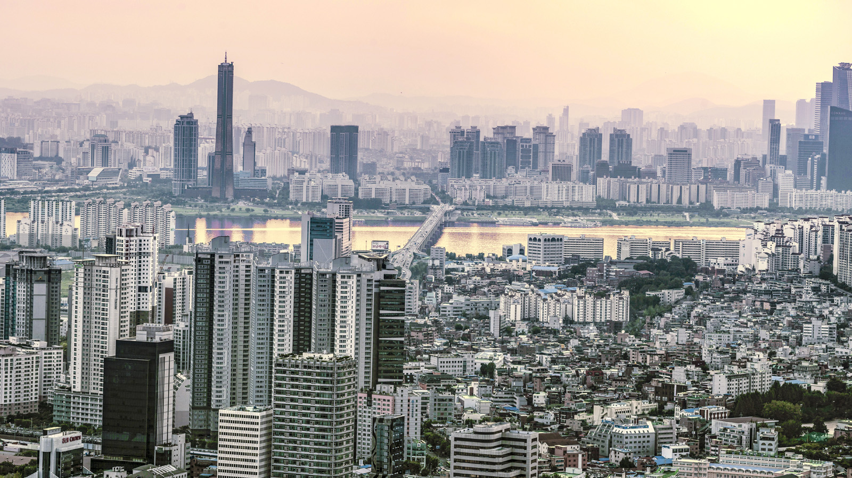 | 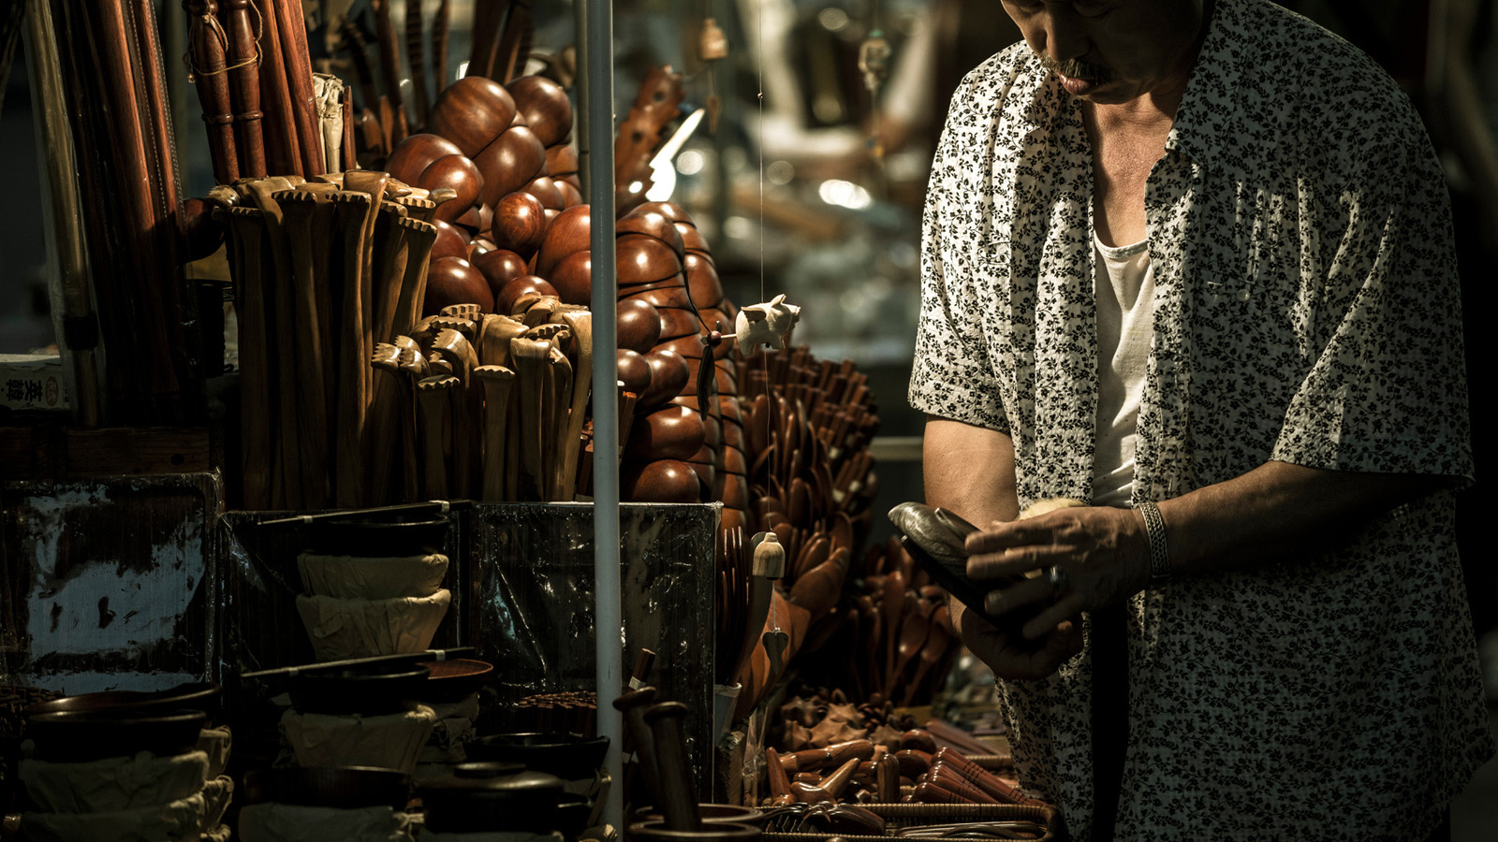
Experience the moonlit magic of Seoul
Balmy summer nights see Seoul abuzz with culture and creativity. Returning after a four-year hiatus, the Hangang Moonlight Market is set to cast its spell on the city once again. Set in Banpo Hangang Park on the banks of the iconic Han River, this bustling night-time market brings together unique arts and crafts by local artisans with a delicious array of Korean and international cuisines and live performances. Don’t miss the spectacular moonlight fountain show at the nearby Banpo Bridge – the world’s longest bridge fountain – which illuminates the night sky with a dazzling rainbow-coloured display. Hangang Moonlight Market, May 7 to June 11, from 4:00 to 9:00 pm on Sundays.
Tuck into Seoul-ful flavour
Savour a vibrant taste of Seoul this summer at OUL: the hip late-night bar on the second floor of Four Seasons Hotel Seoul. Serving up a dynamic concoction of heritage and innovation, artful mixology inspired by the city’s long culture of liquor crafting and fermentation is complemented by bar bites and live DJs every Tuesday to Saturday evening. For a buzzing day-to-eve experience, head to the up-and-coming hotspot of Euljiro: a cool enclave of hipster bars, kitsch cafes and artsy hang-outs. Also within walking distance of the Hotel, the Pojangmacha (outdoor food stalls) of Jongno-ro (Sajik-ro) are a must for local dining.
Indulge in mouth-watering Michelin-starred cuisine
Seoul’s fine-dining scene is second-to-none, with a sumptuous selection of Michelin-starred restaurants. Top summer picks include Jungsik, headed by Chef Yim Jung-sik - whose inventive modern interpretations of delicacies such as gimbap and bibimbap have won worldwide acclaim - and Mingles, a minimal-chic Gangnam gem showcasing a bright fusion of Korean and European flavours. For a glamorous taste of 1920s Shanghai, head to Yu Yuan at Four Seasons Seoul for a stunning take on Cantonese and regional Chinese cuisine, including Ming Dynasty favourite Beijing Duck served traditionally and artfully reimagined by Chef Koo Kwok Fai in Yu Yuan signature dish, Black Truffle Beijing Duck.
Discover a futuristic fashion haven at the Hyundai Seoul
Dive into Seoul’s cutting-edge summer trends at the futuristic Hyundai Seoul. Opened in 2021, it’s the city’s largest retail centre, filled with a stylish selection of forward-focused fashion and design spanning 12 floors and nearly 600 stores. Fusing natural elements with pioneering interior design and technology, it’s also an inspirational destination in its own right, home to an indoor Sounds Forest and a Waterfall Garden filled with trees and live botanicals, as well as its own art gallery and cultural space, ALT.1.
Immerse in trends, arts and style in Cheongdam-dong
Ride the cultural crest of Hallyu (The Korean Wave) with a visit to the Cheongdam-dong area of Gangnam. Wander the K-Star Walk and Hallyu K-Star Road - home to the biggest K-Pop companies, GangnamDols, and restaurants and attractions frequented by popular hallyu stars. For on-trend style of a different kind, the striking modern architecture of Cheongdam-dong Street is home to galleries, high-end boutiques and the flagship stores of luxury brands. Spend a summer’s day taking in showstopping designs by architects such as Frank Gehry and Christian de Portzamparc and the inspirational artworks of Gallery EM and PKM Trinity Gallery.
Indulge in summertime rejuvenation
From time-honoured therapies to cutting-edge modern beauty, Seoul offers every imaginable way to nourish mind, body and soul. In collaboration with luxury skincare brand The History of Whoo, Four Seasons Hotel Seoul presents Timeless Beauty – a rejuvenating stay inspired by legendary Korean empresses, including a luxurious facial and Korean sauna experience, alongside tickets to nearby historical palaces. Just a few minutes’ drive from the Hotel, the 14th-century Jogyesa Temple offers a serene sanctuary of pure calm within the city’s dynamic summertime buzz.

RELATED

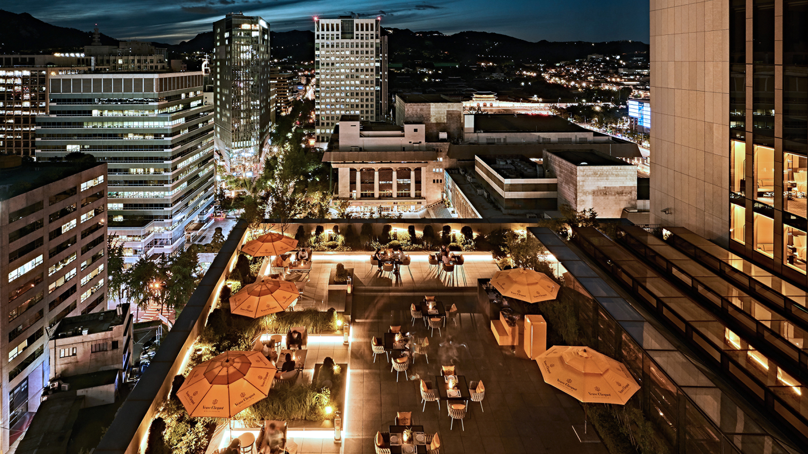 | April 28, 2023, Seoul, Korea  포시즌스 호텔 서울, 야외 라운지 바 ‘가든 테라스’ 오픈  https://publish.url/kr/seoul/hotel-news/2023/garden-terrace-opening-for-summer.html
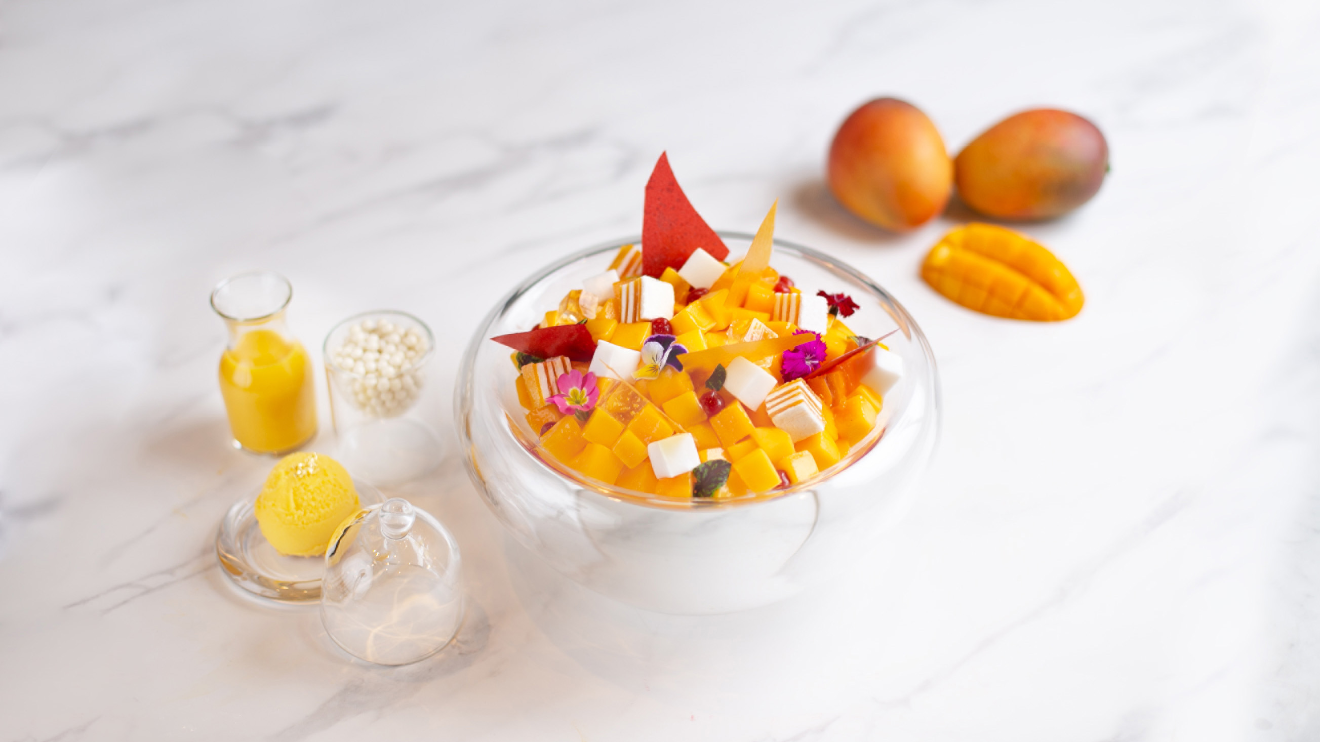 | April 6, 2023, Seoul, Korea  It’s Bingsu Season! Four Seasons Hotel Seoul Showcases Korea’s Favourite Dessert in All its Captivating Glory  https://publish.url/seoul/hotel-news/2023/seasonal-bingsu-menu-2.html

PRESS CONTACTS

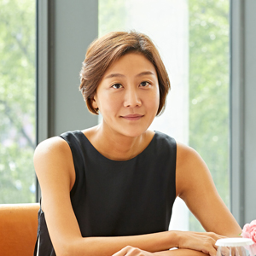 | Inyoung Moon  Director of Public Relations and Communications  97 Saemunan-ro, Jongno-gu  Seoul  Korea  inyoung.moon@fourseasons.com  82 2 6388 5044
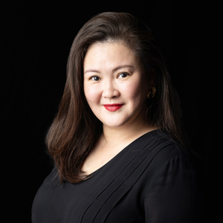 | Kelly Wong  Director of Marketing  97 Saemunan-ro, Jongno-gu  Seoul  Korea  kelly.wong@fourseasons.com  82 2 6388 5001

