Six Hands Work Together to Create Dramatic Dining Experience at Four Seasons Hotel Beijing

Three Four Seasons masters bring their creative flair to Four Seasons Beijing for one night only
October 28, 2019, Beijing, China

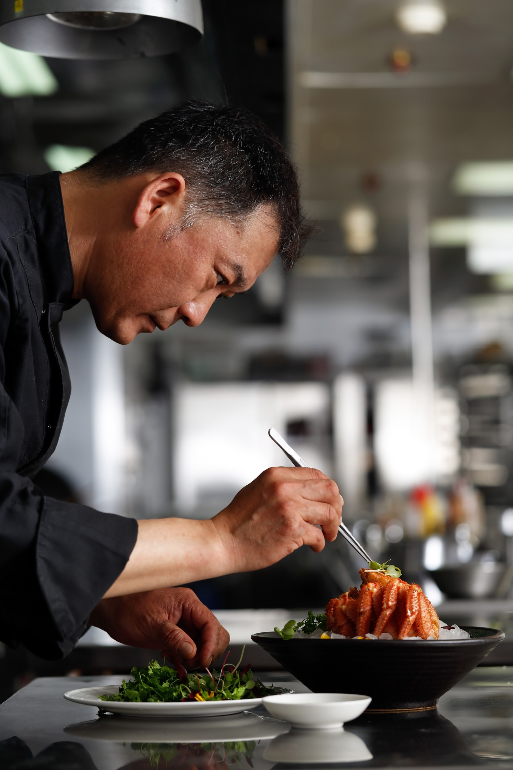
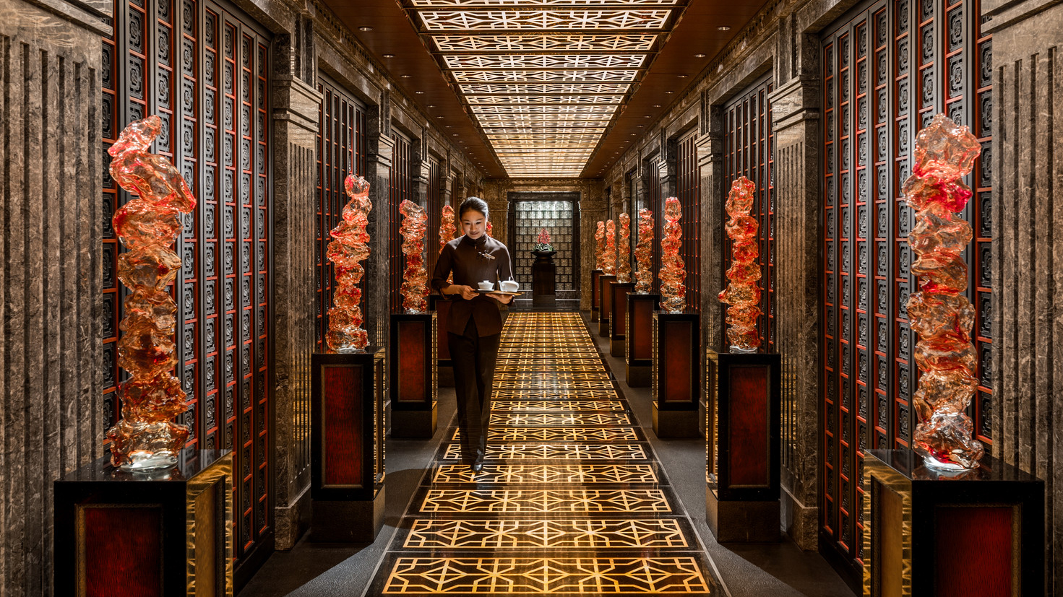 |  | 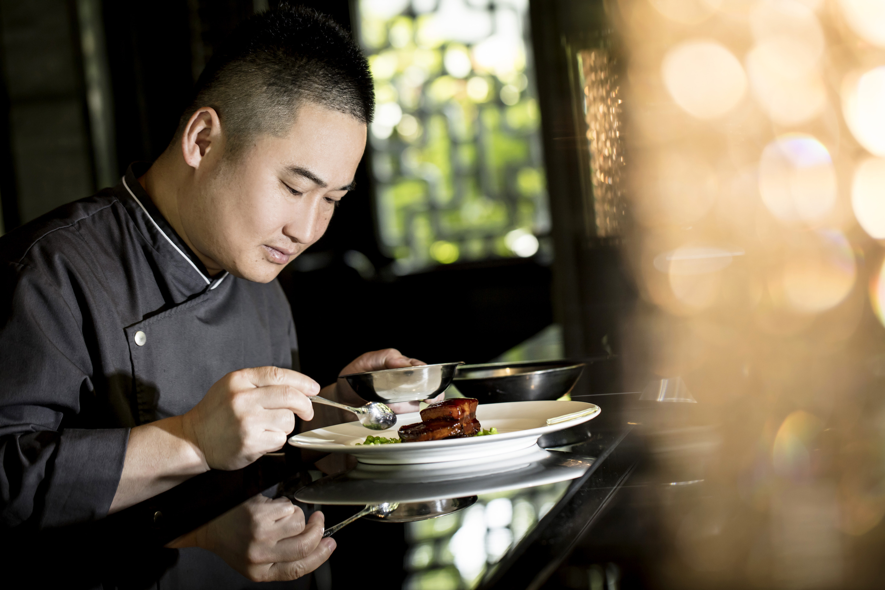
Innovation. Flavour. Tradition: The three key ingredients brought to the table by three Four Seasons chefs in an exclusive one-night-only Chinese dining event set to light up Four Seasons Hotel Beijing.
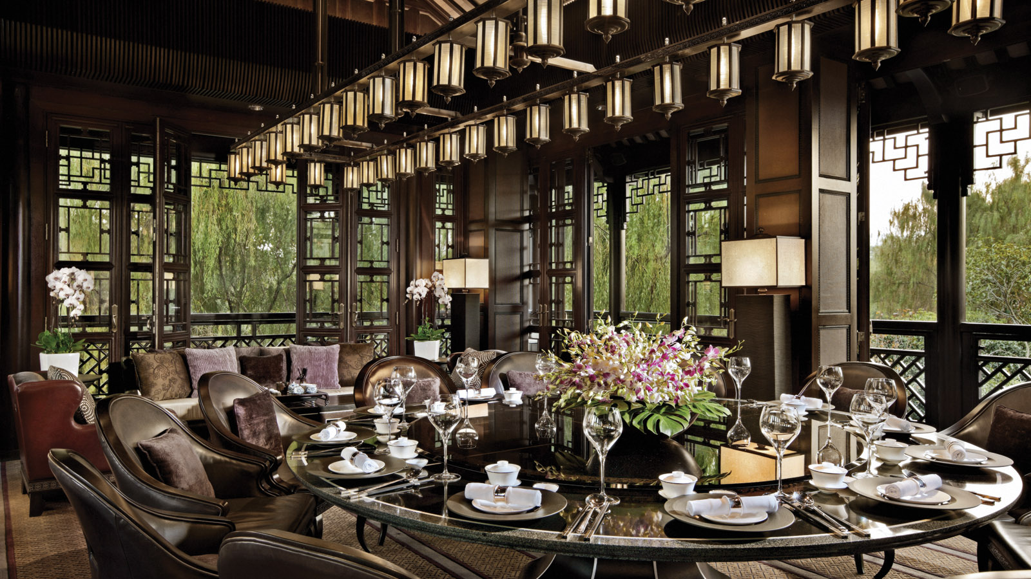 |  | 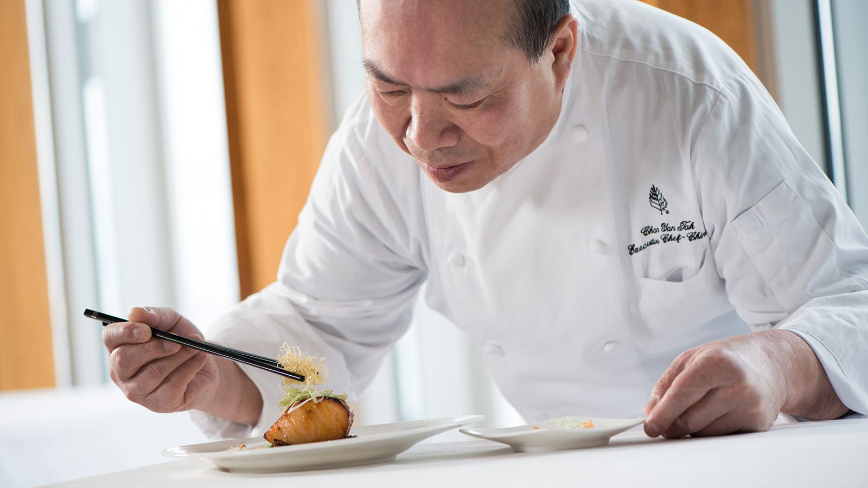
Thursday, November 7, 2019 will see six hands coming together in the Hotel’s award-winning kitchen to create an eight-course tasting menu rich with seasonal flavours and China’s culinary heritage.
Gourmands are invited to take their place among the opulent red decor of Cai Yi Xuan, the cutting-edge Chinese Restaurant at Four Seasons Hotel Beijing. A thrilling culinary adventure follows, with dishes crafted by the Hotel’s own Chef Li Qiang and two guest chefs: Michelin-starred Chef Chan Yan Tak from Lung King Heen at Four Seasons Hotel Hong Kong, and Chef Wang Yong from Jin Sha at Four Seasons Hotel Hangzhou at West Lake.
Together, these culinary masters will be hosting an exclusive one-off event that brings together, for the first time, the creative wizardry of three of China’s greatest gastronomes.
Artfully navigating national cuisines, nuanced flavours and novelty ingredients in a menu that features the likes of marinated goie gras with aged Shaoxing rice wine brine, alongside wheat grass salad with almond flakes, the result is unique and unifying, rare and revolutionary.
With a deep reverence for Chinese nature and culture, Chef Li’s seeks to evoke a feeling of home and family through his thoughtful interpretation of barbequed wagyu beef with honey sauce, and walnut cream osmanthus and chestnut cake.
Hong Kong born and bred – and China’s first chef to be awarded three Michelin stars – Chef Tak is all about humility and humanity, creativity and community; brought to life in his menu contributions of double-boiled chicken soup with fig, snow fungus and sea whelk, plus star garoupa and abalone roll.
Last but by no means least, street food lover and travel enthusiast Chef Wang draws inspiration from each and every encounter, translating his experiences into dishes that are both complex and comforting, evident in snow crab meat wrapped in bean curd sheet, and braised pork belly and abalone, green pea with olive oil.
Commenting on the event, host Chef Li Qiang shares: “It’s exciting for me in particular to welcome such esteemed chefs into the Cai Yi Xuan kitchen and to offer such a rare experience to guests. Our ethos at Cai Yi Xuan has always been to innovate the traditional and our Six Hands menu draws on all the best aspects of our rich cultural heritage while allowing each chef to shine. We want to bring people together round the table to share something special – something memorable.”
Meaning “the art of dining” in Chinese, Cai Yi Xuan is the perfect place to host such an exciting culinary event with its warm convivial feel and impeccable service. Part of the annual Taste by Four Seasons, it is one of a series of lifestyle, dining and art events across the Four Seasons Hotels in Asia Pacific.

RELATED

October 28, 2019, Beijing, China
尋味·三城·四季
https://publish.url/zh_hant/beijing/hotel-news/2019/six-hands-dinner-3.html

October 28, 2019, Beijing, China
寻味·三城·四季
https://publish.url/zh/beijing/hotel-news/2019/six-hands-dinner-2.html

PRESS CONTACTS

Emilie Zhang
Director of Public Relations and Communications
48 Liang Ma Qiao Road Chaoyang District
Beijing
China
emilie.zhang@fourseasons.com

+86 10 5695 8706

