Best of Istanbul: Four Seasons Concierges' Top 10 Recommendations in the City of Two Continents

April 29, 2015, Istanbul, Turkey

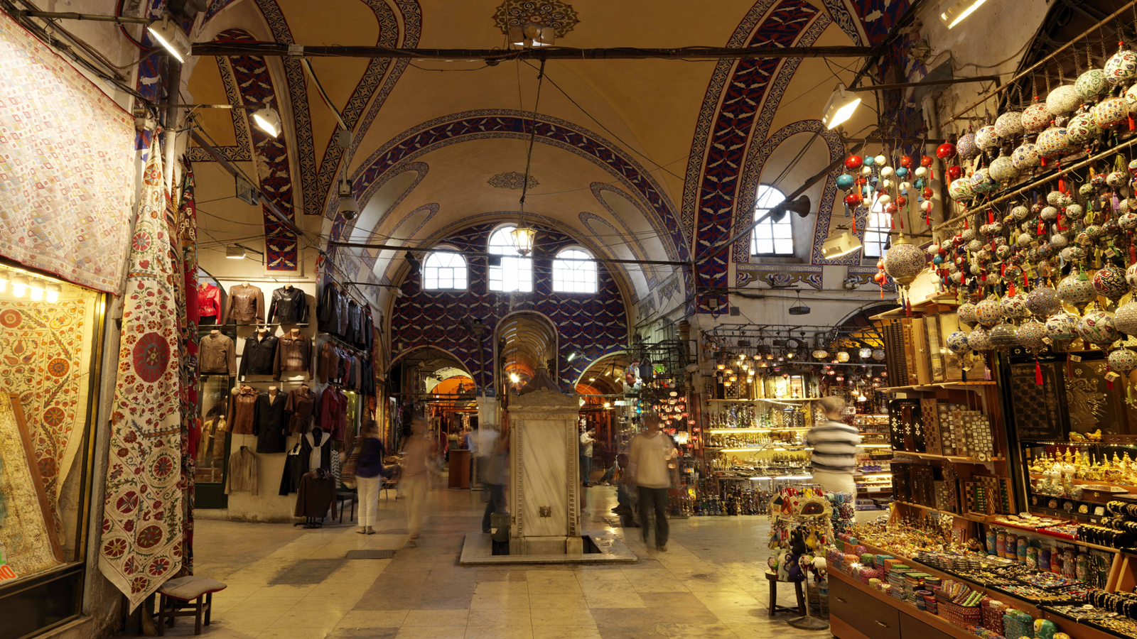
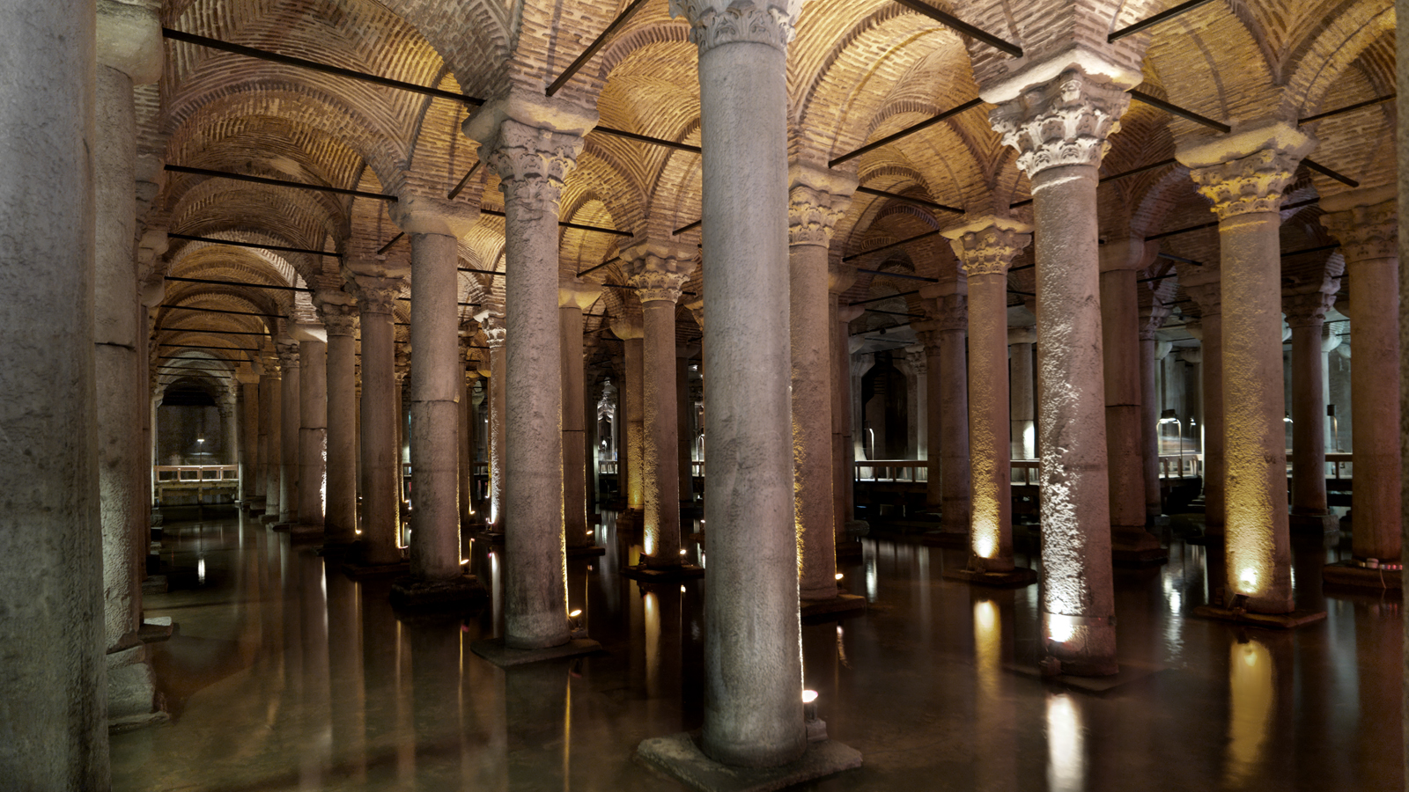 | 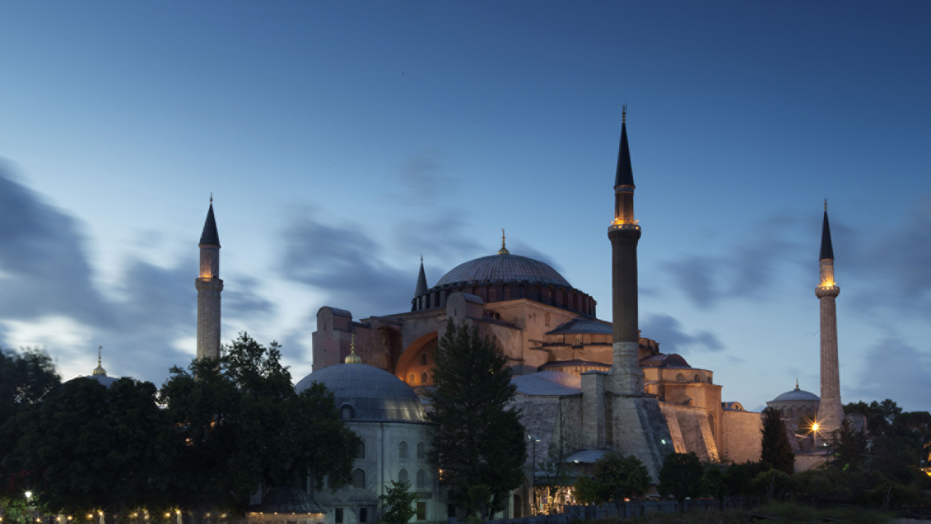 | 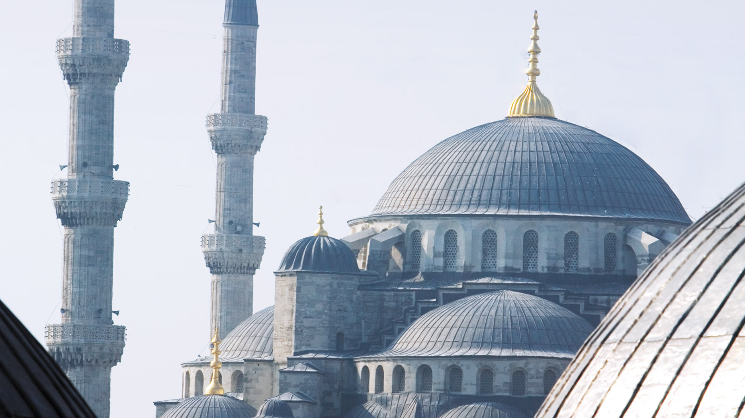
A fusion of age-old glories and a cool, contemporary 21st-century culture, Istanbul is the last stop in Europe and the first stop in Asia. Guests of
Four Seasons
Hotel Istanbul at Sultanahmet in the Old Town and
Four Seasons
Hotel Istanbul at the Bosphorus have the chance to travel in time by visiting below sites just steps away from each other.
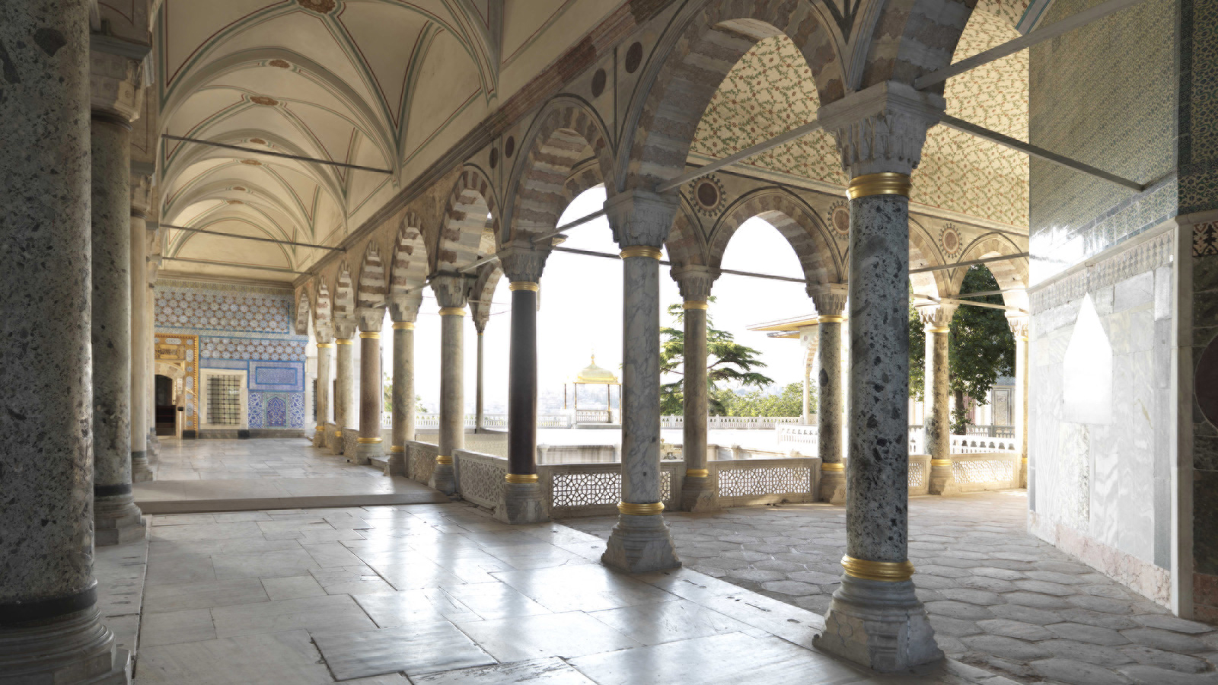 | 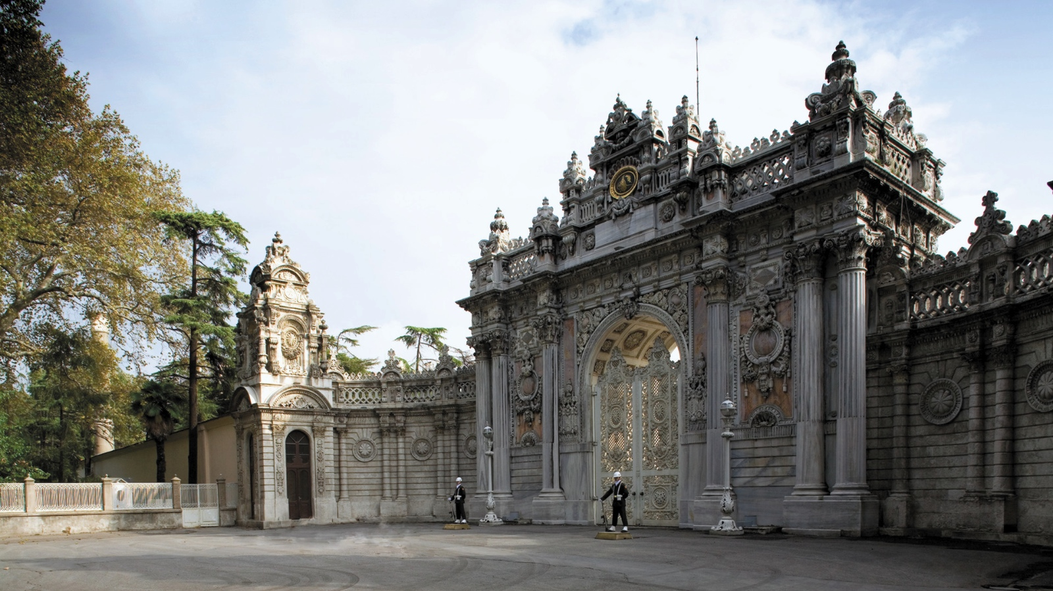 | 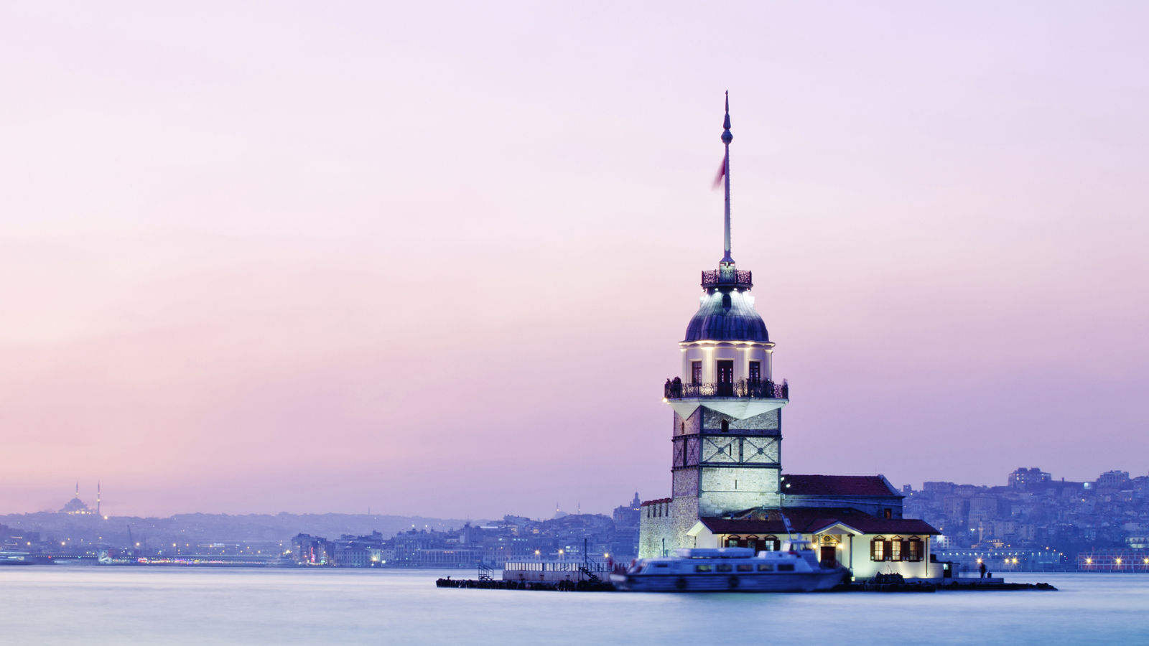
- Visit Spice Bazaar & Covered Bazaar: Home to the Grand Bazaar, the largest covered market in the world, Istanbul boasts a vibrant and unforgettable shopping scene. More than 4,000 shops on 58 streets feature goods and fine crafts from all over Turkey and beyond, and the Grand Bazaar is one big Aladdin’s cave.
- Go underground at the Basilica Cistern: The Basilica Cistern is the largest of the ancient underground water cisterns found across Istanbul.
- Visit Hagia Sophia: One of the most visited museums and most prominent monuments in the world in terms of art and the history of architecture, Hagia Sophia should be at the top of your to-see list for Istanbul. Do not miss the upstairs gallery to catch the best views and to glimpse the surviving mosaics, in particular the golden mosaic of the Virgin and Child in the apse.
- Visit the Blue Mosque: Also known as the Sultan Ahmed Mosque, the Blue Mosque’s two most striking features are its 6 minarets and blue domed exterior.
- Get a taste of royal life at Topkapi Palace: Topkapi Palace is the largest royal residence in Istanbul and it served as the main residence to the Ottoman Sultans for almost 400 years.
- Visit Dolmabahçe Palace: Home to the last six sultans of the Ottoman Empire, Dolmabahçe is the largest palace in Turkey.
- Enjoy the view from Galata Tower: Located in Beyoğlu, the views from the outer balcony of the tower are breathtaking.
- Go to the Maiden’s Tower: Built on a small islet located at the southern entrance of Bosphorus, Kız Kulesi was used as a surveillance tower during the siege of Constantinople in 1453.
- Visit Istanbul Modern Museum:. Housed in a recently renovated two-story warehouse, it was the first modern arts museum to open in the city. Admission is free every Thursday, enabling tourists to see its expansive photography gallery, cinema hall, and new media art area.
- Take a Taste of Istanbul Tour: For a total experience you can take advantage of the special offer "Taste of Istanbul" package and enjoy a private, full-day tour with the knowledgeable guide and take in the sights and sounds of this unique city like a true local.

RELATED

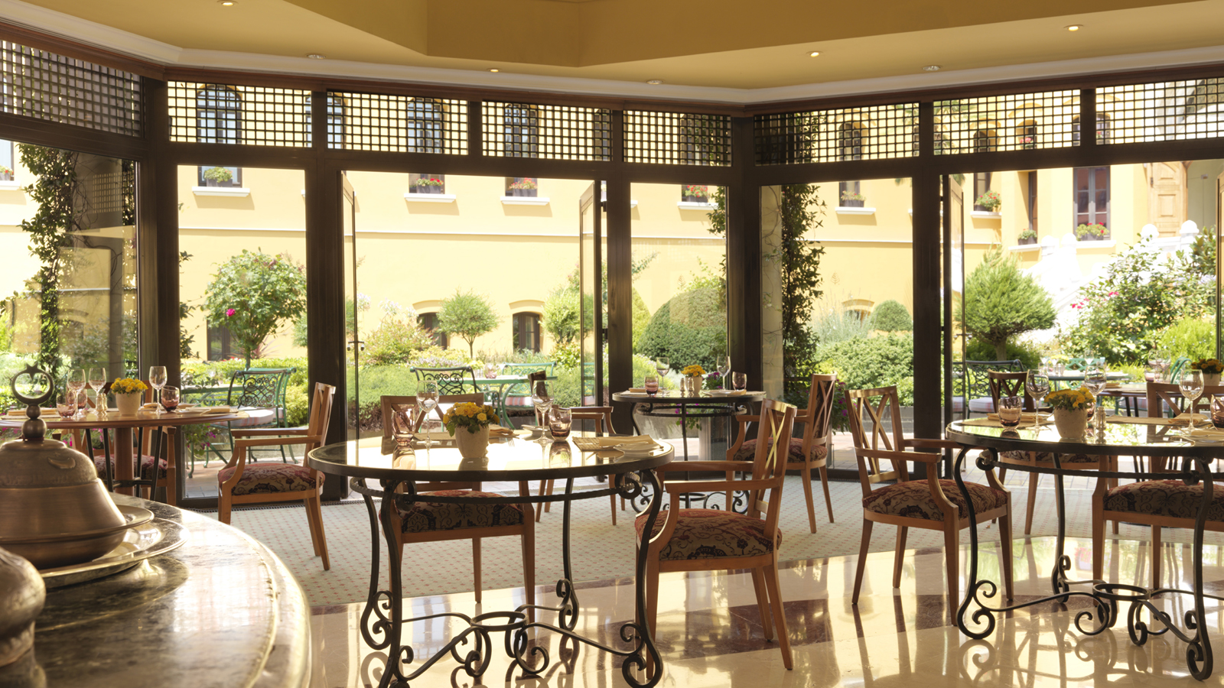 | March 14, 2019, Istanbul at Sultanahmet, Turkey  Discover the Flavours of Kars at Four Seasons Hotel Istanbul at Sultanahmet  https://publish.url/istanbul/hotel-news/2019/kars-cuisine-week.html
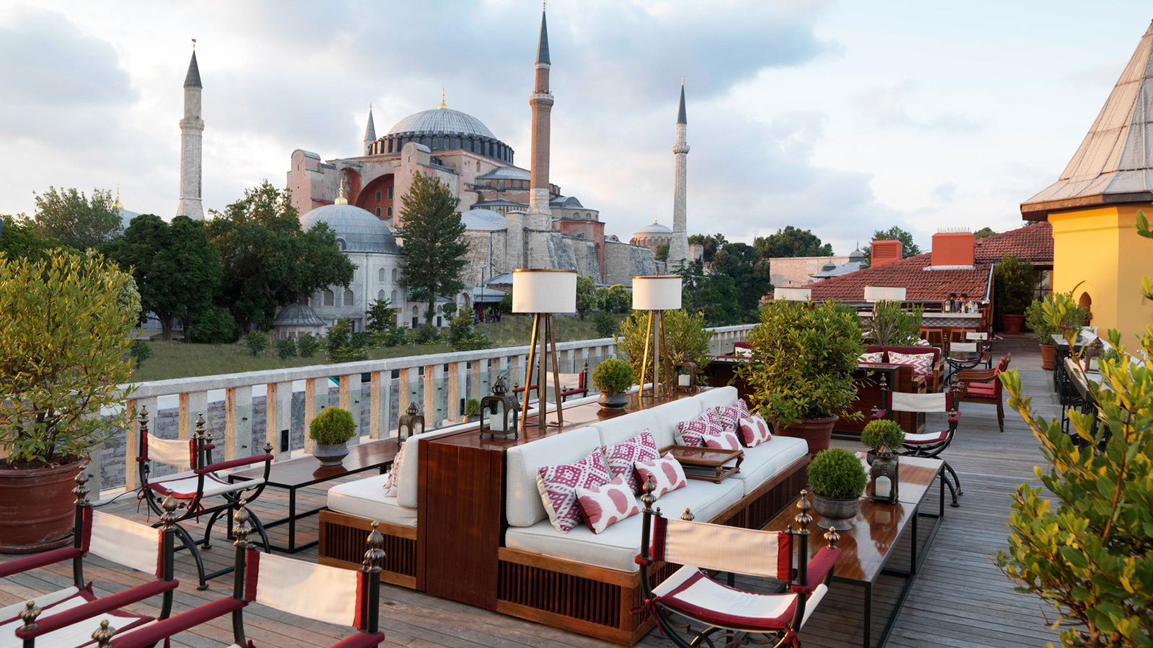 | February 11, 2019, Istanbul, Turkey  Hotéis Four Seasons em Istambul apresentam novidades para redescobrir a cidade de duas maneiras diferentes  https://publish.url/br/istanbul/hotel-news/2019/discover-istanbul.html

PRESS CONTACTS

Sibel Benli
Director of Public Relations and Communications
Çırağan Cad. No. 28
Istanbul
Turkey
sibel.benli@fourseasons.com

90 (212) 381 41 35

