Saks Fifth Avenue and Four Seasons Hotel St. Louis Collaborate to Offer a Posh Holiday Package

This December, enjoy luxurious overnight accommodations, festive décor and a personalised shopping experience
October 28, 2021, St. Louis, U.S.A.

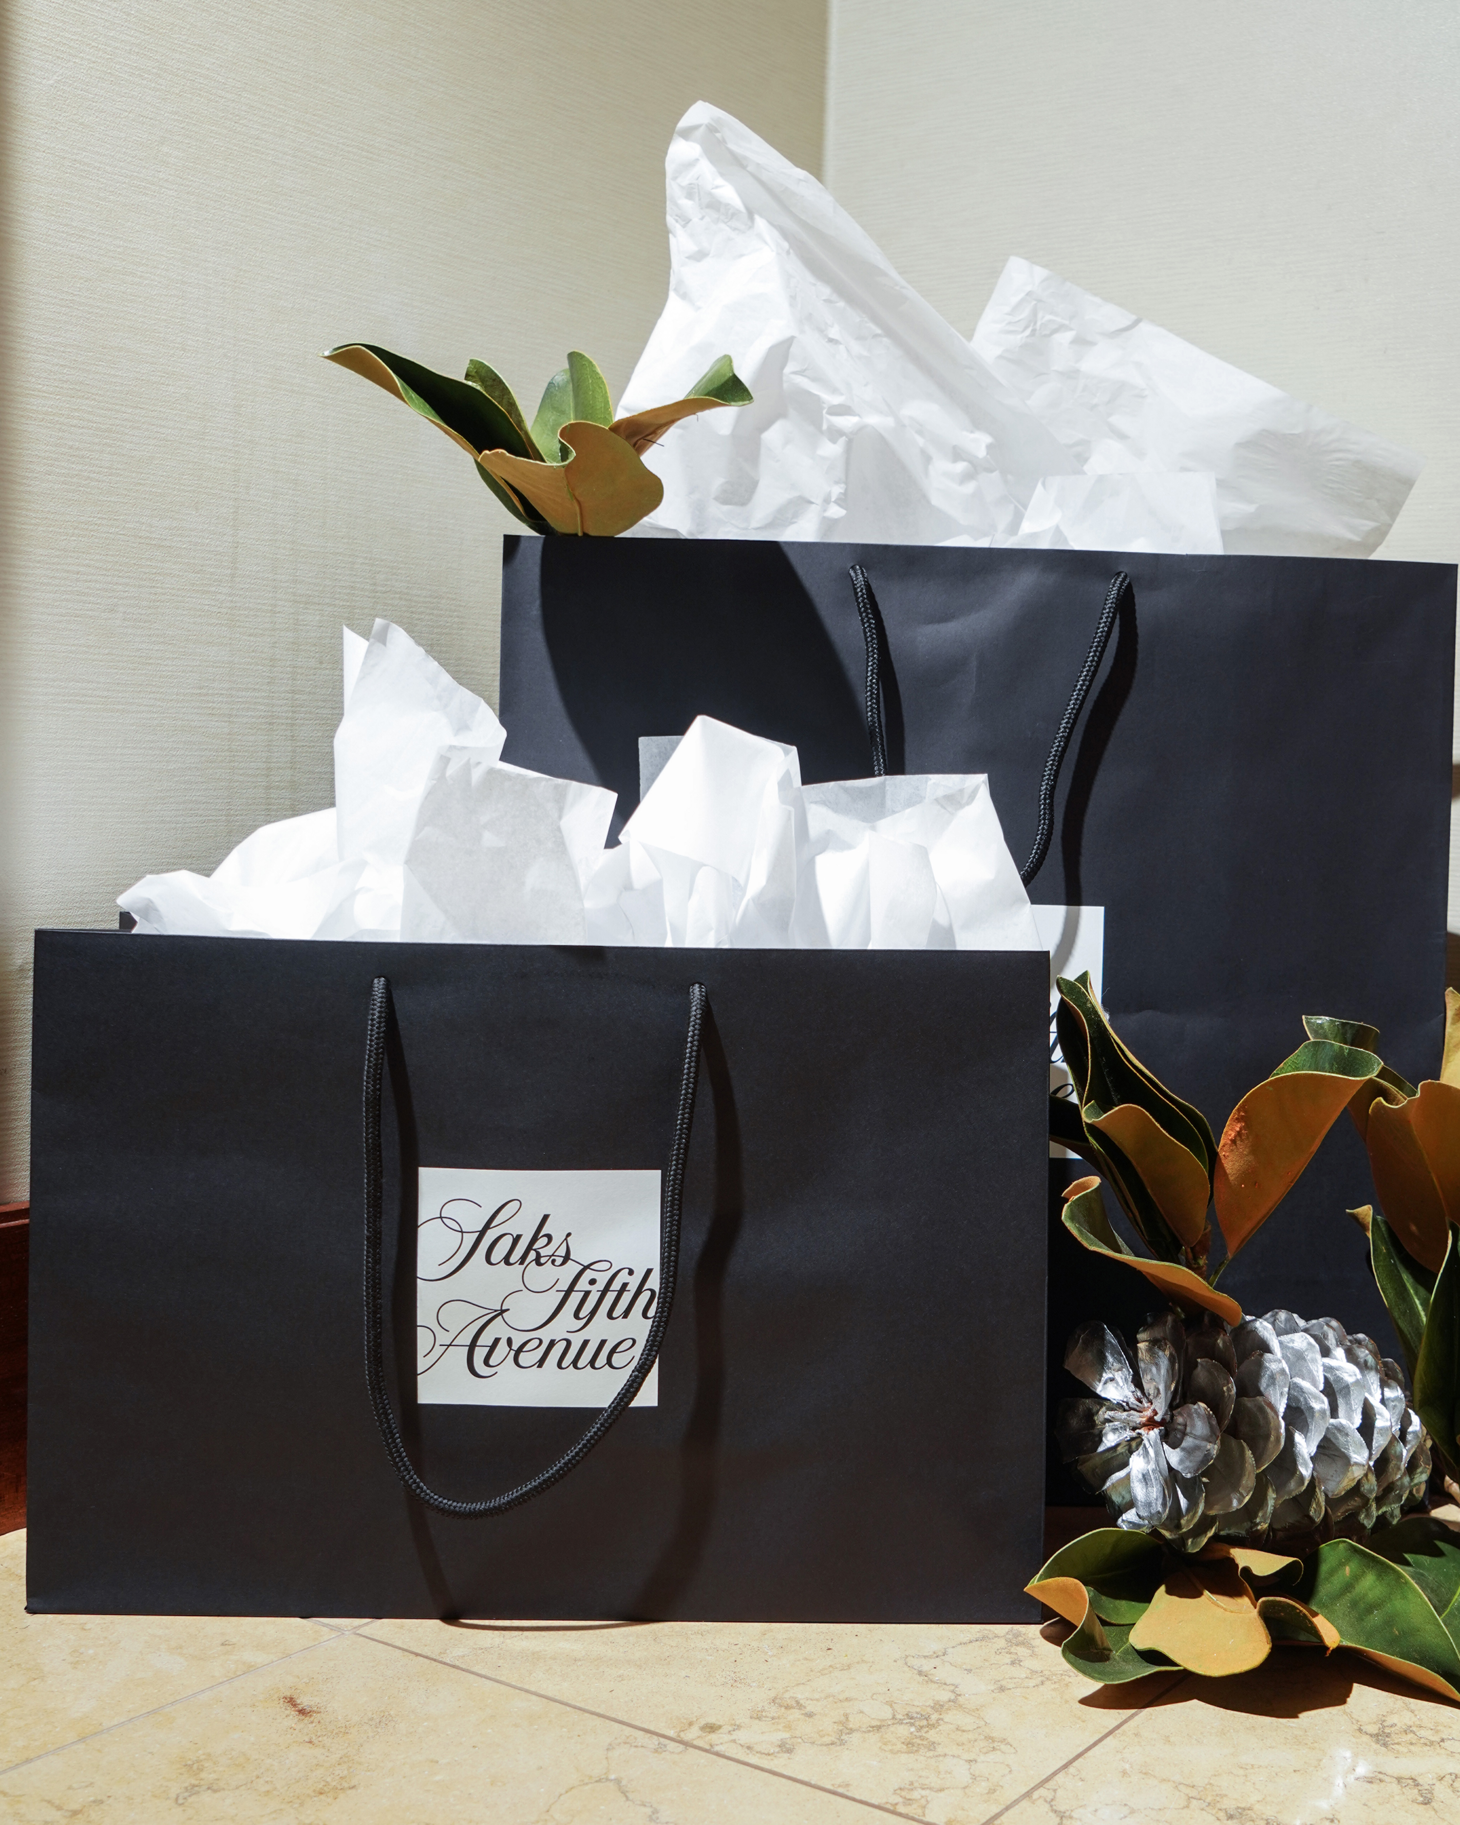
Four Seasons Hotel St. Louis, an urban retreat located in the heart of downtown, and Saks Fifth Avenue St. Louis announce their partnership for the holiday season. The companies have collaborated to offer Hotel guests a curated overnight experience in one of the Hotel’s spacious Luxury Suites throughout the month of December 2021.
A magical atmosphere permeates a 1,600 square foot (150 square metre) Luxury Suite, where dazzling, light-filled decorations adorn the contemporary guest room nestled on the 18th floor of the Hotel. Known for their iconic holiday window and store displays, Saks Fifth Avenue St. Louis’ visual merchandising team will outfit the suite and its comfortable furnishings with holiday décor that fills the entryway, sitting area, dining area, bedroom and more.
Cosy up on the couch; sip champagne and overlook the Gateway Arch and downtown skyline, or snap holiday photos near one of the decorated trees within the suite.
“This December, we’re putting a bit of magic back in the holiday season. In partnership with Four Seasons Hotel St. Louis, we are excited to offer a chance to enjoy festive décor with luxurious hospitality, while providing an exclusive holiday shopping experience,” says Saks Fifth Avenue General Manager Brittani Vigne.
Book the overnight Saks Suite package and receive the following:
- A festively decorated 1,600 square foot (150 square metre) Luxury Suite overlooking the Gateway Arch (king bedded room with sofa bed in the living room, dining table, wet bar, luxurious bathroom, powder room and spacious walk-in closet)
- Champagne and chocolate welcome amenity
- USD 50 breakfast credit available through in-room dining
- Private in-store styling consultation in the Fifth Avenue Club with champagne welcome
- A Saks Fifth Avenue USD 50 gift card, toward USD 300 full-price purchase

RELATED

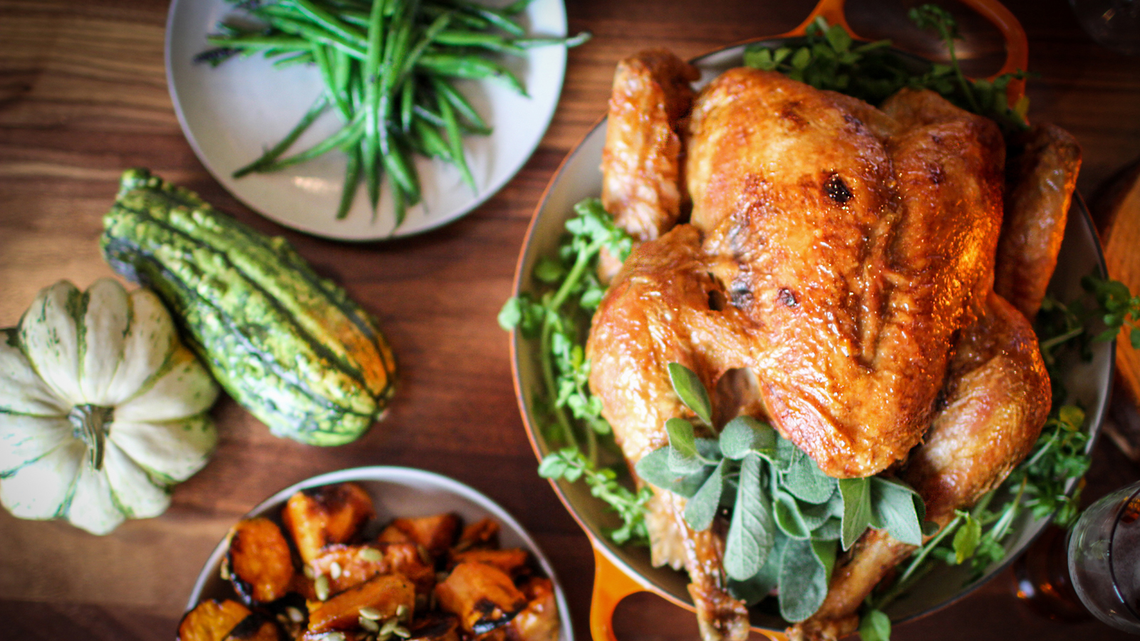 | October 13, 2021, St. Louis, U.S.A.  Four Seasons Hotel St. Louis and Cinder House Offer an Artfully Prepared Thanksgiving Feast  https://publish.url/stlouis/hotel-news/2021/thanksgiving.html
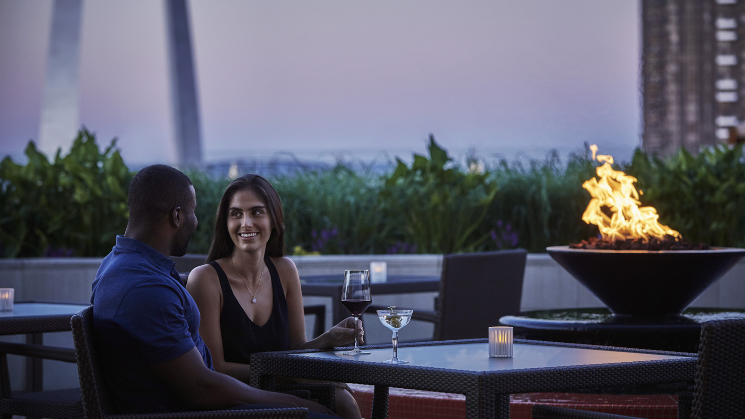 | October 4, 2021, St. Louis, U.S.A.  Reconnect and Rediscover: Four Seasons Hotel St. Louis Invites Couples to Nurture Their Connection with a Very Special Spa Retreat  https://publish.url/stlouis/hotel-news/2021/couples-spa-retreat.html

PRESS CONTACTS

Chloe Caylor
Director of Public Relations and Communications
999 North 2nd Street
St Louis
USA
Chloe.Caylor@fourseasons.com

+1 (314) 881-2021

