Discover an Elevated Spring Break Vacation at Four Seasons Resort Orlando

Splash into family fun at the five-acre water park, savour Michelin-starred dining and enjoy Disney connectivity
February 16, 2023, Orlando at Walt Disney World Resort, U.S.A.

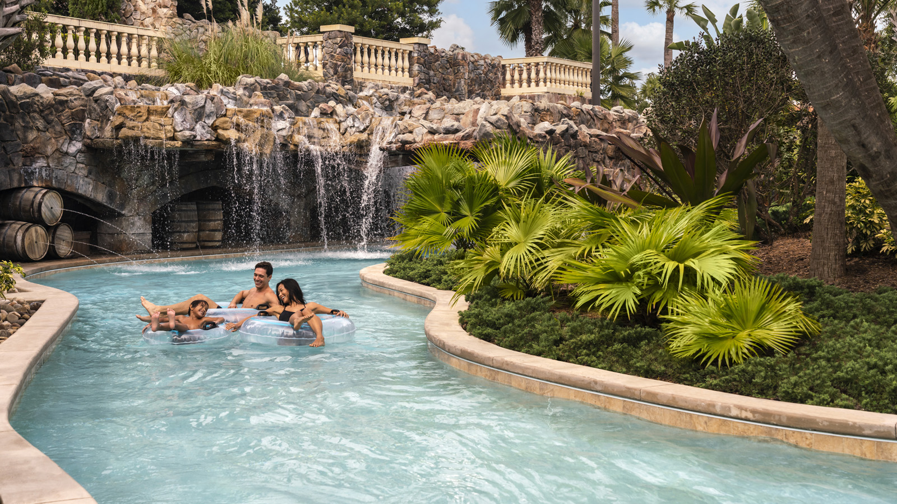
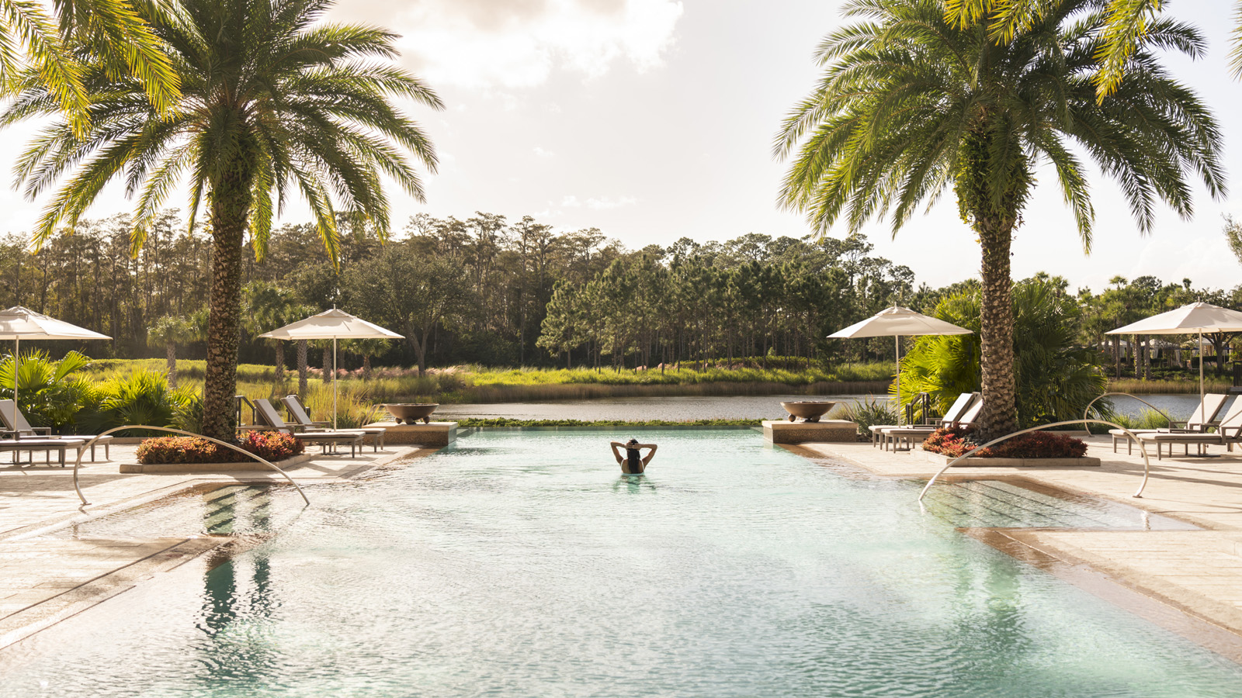 | 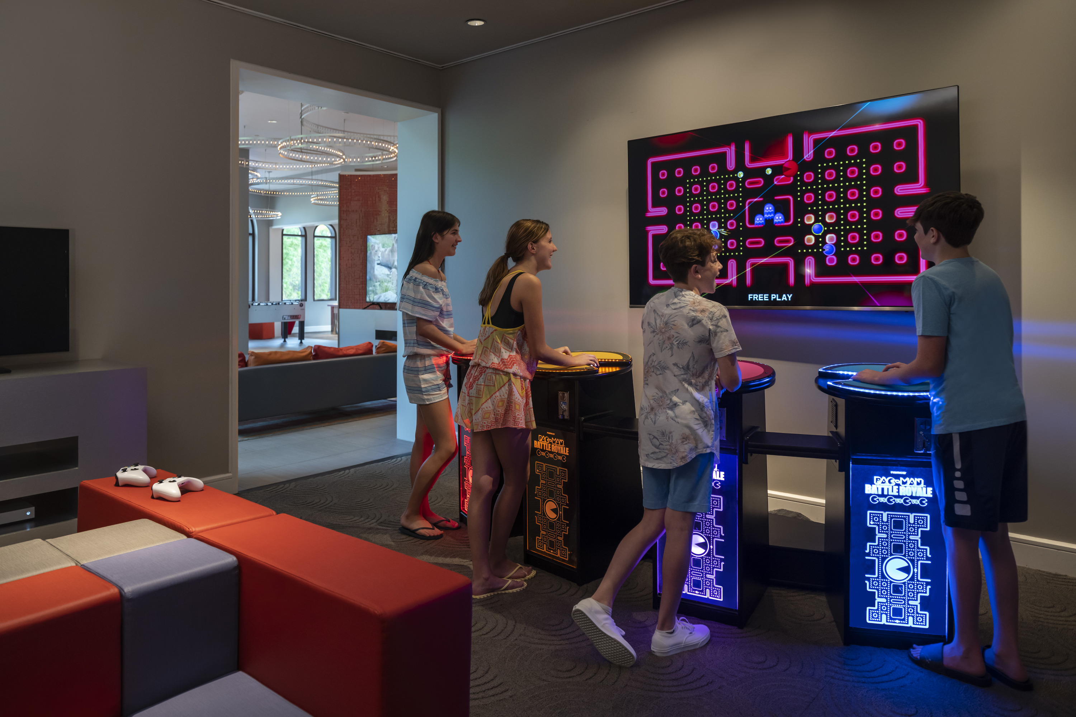 | 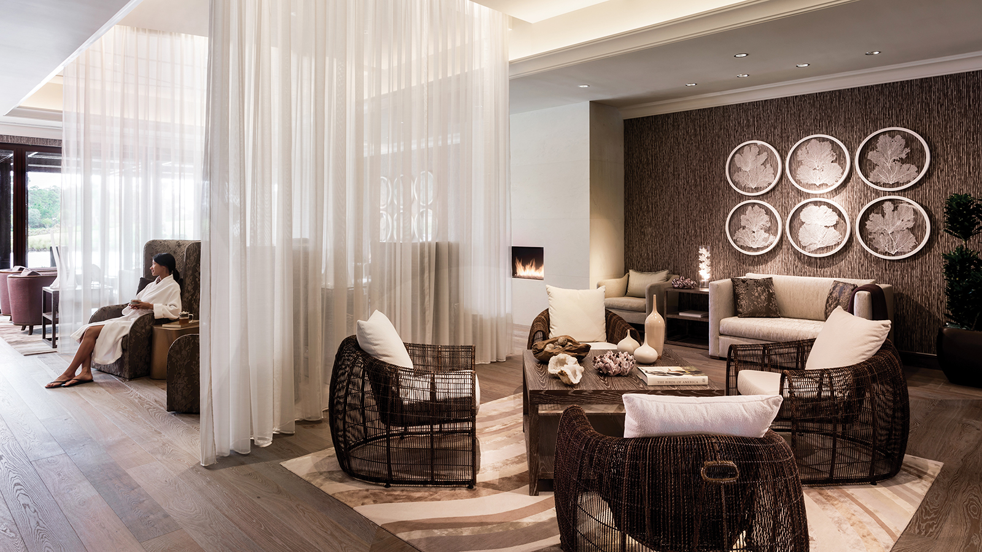
Spring break is just around the corner, and the warm spring sunshine and heated five-acre (two hectare) waterpark beckons families to enjoy an unforgettable getaway at Four Seasons Resort Orlando at Walt Disney World Resort. Recognized as the #1 Best Hotel and #1 Best Resort in Walt Disney World according to U.S. News & World Report, marking the ninth consecutive year of being awarded a top ranking, the Resort offers incredible activities for kids of all ages and rejuvenating relaxation for parents. Nestled within 26 sprawling acres (10.5 hectares) of lush Florida woodlands and tranquil lakeside scenery, in addition to the waterpark with lazy river, splash zone, and water slides, Four Seasons Orlando features an all-day complimentary kids club, the only adult pool within Walt Disney World Resort, Michelin-starred rooftop Capa Steakhouse and much more.
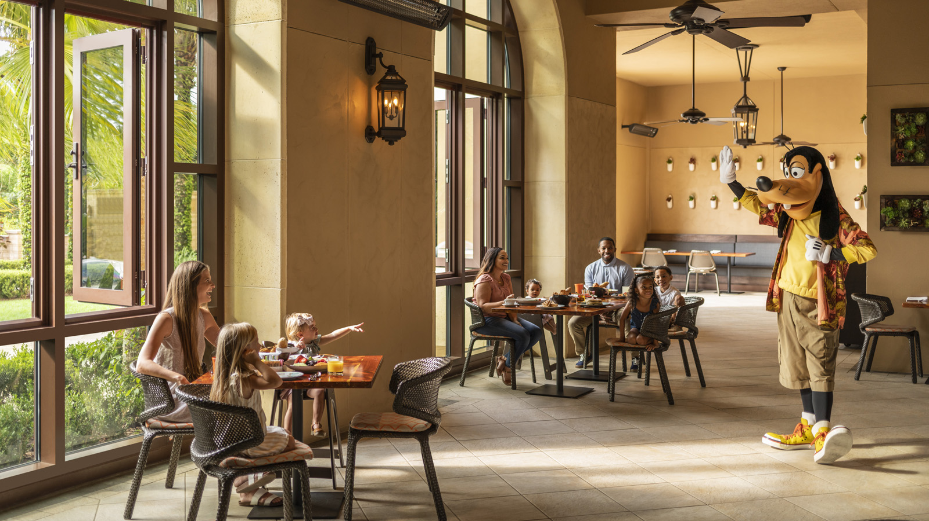 | 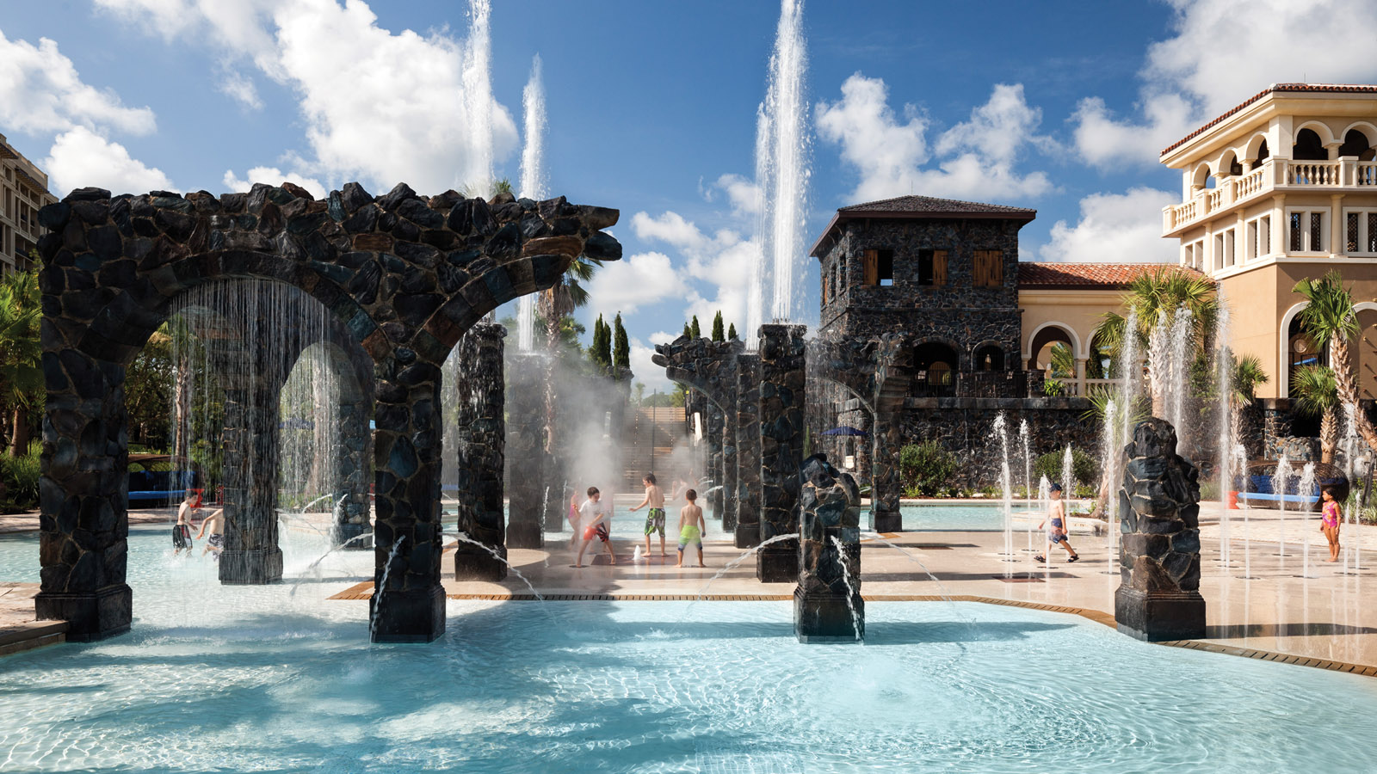 | 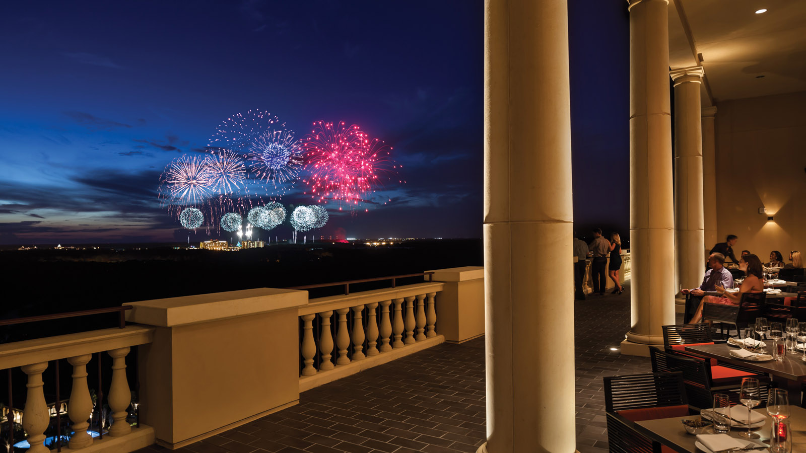
Fun In The Sun
Guests of all ages will enjoy discovering Explorer Island, the Resort’s expansive water park featuring a winding lazy river with cascading waterfalls, a gradually sloping zero entry family pool, an interactive splash zone, two exhilarating water slides and more. Teens will stay entertained at The Hideout featuring the latest gaming systems such as virtual reality, multi-player PAC-MAN, interactive video table games and more. A multi-purpose turf court and basketball court provide even more options for active recreation, as well as table tennis, billiards, and foosball found at the Ruinous Mansion - serving as homebase for Kids For All Seasons, the Resort’s complimentary kids camp available daily for children ages 4 to 12.
Children will have a blast at Kids For All Seasons, with a packed day of twice daily supervised swimming and indoor and outdoor activities designed by Sarah Peltier, Director of Recreation. Peltier brings an always-sunny and imaginative disposition to craft fun and creative activities. “It’s always a rewarding experience to create special memories for our little guests,” says Peltier. In addition to traditional poolside entertainment such as air brush tattoos, hair wraps, and balloon artistry, Kids For All Seasons offers daily activations including family game nights, dive-in movies at the family pool and much more. Teens will enjoy special evening activities such as night time scavenger hunts throughout Explorer Island, karaoke at The Hideout, and pickleball tournaments.
Peltier, being the oldest of 13 siblings from a blended household, stresses the importance of balancing family time when on vacation. She says, “Quality time spent together is precious, and giving each family member the freedom to recharge with their own Resort experiences makes the rest of the vacation journey that much more enjoyable.”
Other fee-based activities are also offered, such as Explorer Island Takeover from 5:00 to 8:00 pm and Teen Island Takeover from 8:00 to 11:00 pm on Saturday nights, where parents can drop off kids for a few hours, to enjoy a romantic dinner.
Relax and Restore
While kids are entertained at Kids For All Seasons, parents can retreat to the 18-treatment room spa, offering a wide array of innovative treatments including Ayurvedic Healing, Vibrational Sound Therapy, IV and IM Vitamin Vitality treatments, and private meditation sessions in the Somadome, a cocoon of healing lights and sounds utilizing binaural beats, colour therapy and energy medicine with magnets and crystal therapy. The Spa offers expansive indoor and outdoor relaxation lounges including a co-ed tranquillity terrace, solarium with zero-gravity wave loungers, steam rooms and al fresco whirlpools where guests can unwind pre or post treatment, or at any time during their resort stay. “The purpose of vacation is to leave feeling rested and rejuvenated, and we give guests the opportunity to do just that within the sanctuary of our Spa,” says Derek Hofmann, Senior Director of Spa.
More relaxation awaits at the aptly named Oasis pool, exclusive for guests ages 21 and up. The chic, infinity-edge pool is lined with swaying palms, private cabanas and loungers, complete with poolside cocktail service.
For those who wish to stay active during their spring getaway, the Resort offers three Har-Tru tennis courts and a variety of clinics, as well as a 24-hour fitness centre featuring Peloton bikes, on-demand digital classes, and daily complimentary live fitness classes ranging from yoga to boot camp. Private instruction is also available, including personal Pilates reformer sessions guided by the Resort’s talented fitness instructors.
Golfers will love the 18-hole championship golf course at Four Seasons Golf and Sports Club Orlando. Whether seeking challenging play fit for professionals or family fun on the Par 3 six-hole short course and 18-hole putting course, guests are sure to enjoy an incomparable golf experience within the picturesque setting of the Tom Fazio-designed course, a certified Audubon Sanctuary featuring varying elevations, abundant wildlife and protected wetlands.
In addition to enjoying the immaculate spring weather outdoors, guests can retreat to the Resort and enjoy shopping signature trunk shows with designer appearances at Wardrobe, the Resort’s luxury boutique featuring designer apparel and fine jewellery.
Culinary Experiences
After a day spent poolside or exploring the nearby Walt Disney World Theme Parks, there’s no better way to refuel than with a Michelin-starred dinner at the rooftop Capa Steakhouse. Helmed by Capa Chef Malyna Si, the only female chef overseeing a Michelin-starred restaurant in Central Florida, the 17th floor restaurant features Spanish-influenced cuisine with a delectable array of tapas, locally-sourced seafood and wood-fired prime cuts including the pluma Iberico pork loin Si sourced from Extremadura, a prime 12-ounce bone-in filet, and a 16-ounce bone-in New York strip, both from Creekstone Farms in Kansas. There’s also a 12-ounce Delmonico and a 16-ounce short rib, both PlatinumX wagyu level certified, a level above prime, from Jackman Ranch in Texas. Si takes pride in offering an elevated menu with unique and rare dishes, saying, “The practicality of my role is that everybody has to eat; the beauty of being a chef lies in the boundless possibilities to create.”
In addition to these mouthwatering options, there are several signature dishes that are not to be missed, including the pan con tomate small plate, the bacon-wrapped and marcona-almond stuffed datiles, and the cinammon sugar-dusted churros de Madrid. The incredible cuisine is matched only by Capa’s stunning ambiance, featuring two outdoor terraces with views of the Walt Disney World Resort fireworks spectaculars.
At Ravello, the Resort’s modern Italian-restaurant that was also included in the Michelin Guide Miami, Orlando and Tampa, guests will delight in authentic Italian cuisine crafted by Executive Chef Fabrizio Schenardi, a native of Torino, Italy. Delicious pastas and pizza doughs are prepared with flour imported straight from Italy, and Fabrizio’s homemade limoncello is the perfect way to end any Italian feast. Plus, Ravello welcomes special guests every Thursday and Saturday morning, as well as select Tuesdays, for Good Morning Breakfast with Goofy & His Pals.
With six different on-site dining establishments featuring global flavours from a diverse culinary team, guests are sure to find something to satisfy every palate.
The Most Magical Place on Earth
There is no better time for guests to experience the magic of the 50th Anniversary of Walt Disney World Resort, coming to an end March 31, 2023. However, guests can enjoy the excitement of the Disney Theme Parks all spring long with many on-site conveniences, including access to the Resort’s lobby level Disney Planning Center. Staffed by a Disney Cast Member, the Disney Planning Center team offers complimentary assistance with all Disney needs, including assisting guests with purchasing Park tickets conveniently on site, making Disney Park Pass and Disney dining reservations, and much more. Guests can venture to the nearby Disney Theme Parks with complimentary transportation in a luxury motor coach, and enjoy even more time to experience the Walt Disney World 50th Anniversary celebration with 30 minutes Early Park Entry to any Theme Park of choice daily.
For reservations click here or call 1 800 267 3046.

RELATED

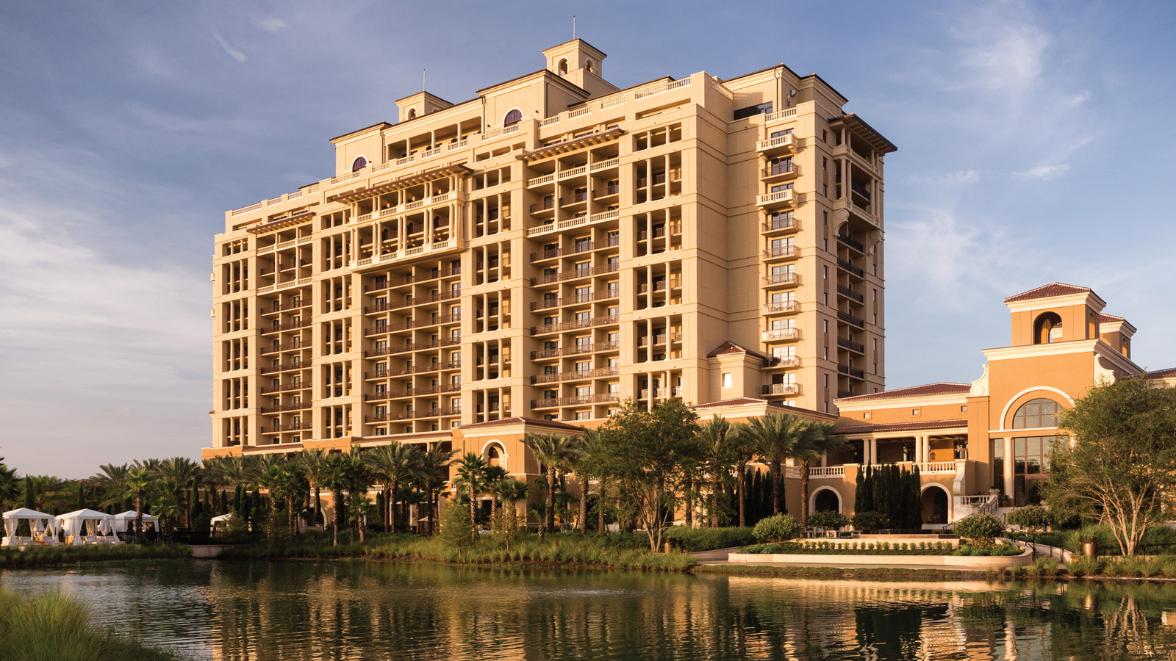 | February 7, 2023, Orlando at Walt Disney World Resort, U.S.A.  Four Seasons Resort Orlando Named Best Hotel and Best Resort in Walt Disney World in 2023 U.S. News & World Report Best Hotels Rankings  https://publish.url/orlando/hotel-news/2023/best-resort-at-walt-disney-world.html
February 3, 2023, Orlando at Walt Disney World Resort, U.S.A.
Celebrate Valentine’s Day with Indulgences at Four Seasons Resort Orlando
https://publish.url/orlando/hotel-news/2023/valentines-day.html

PRESS CONTACTS

Dana Berry
Director of Public Relations
10100 Dream Tree Boulevard
Orlando
USA
dana.berry@fourseasons.com

1 407 313 7777

Nicole Abinajem
Public Relations Manager
10100 Dream Tree Boulevard
Orlando
USA
nicole.abinajem@fourseasons.com

1 407 313 6742

