Escape to a Private Culinary Valentine’s Weekend Retreat at Four Seasons Hotel Silicon Valley

January 15, 2021, Palo Alto, Silicon Valley, U.S.A.

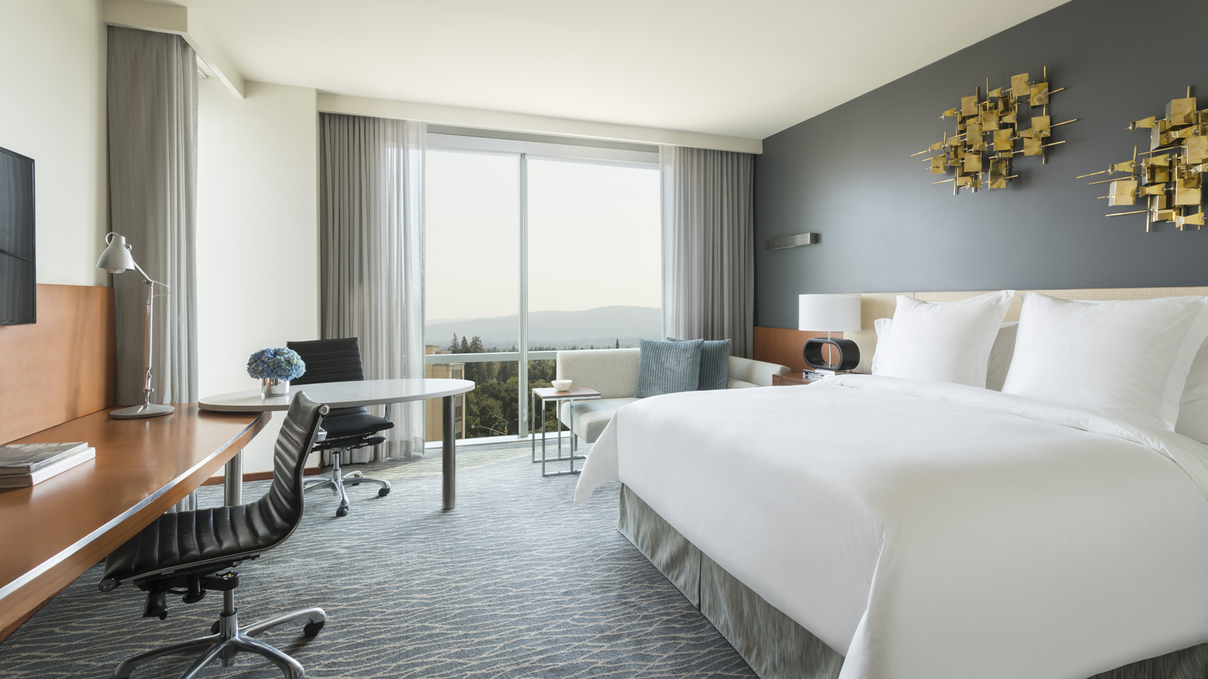
Discover a private romantic retreat with Four Seasons Hotel Silicon Valley at East Palo Alto. Whether celebrating a milestone or looking for a quiet occasion to unwind on Valentine’s Day weekend, experience a guest room transformed into an exclusive dining journey for two, and other amenities with a Valentine’s Weekend Retreat package.
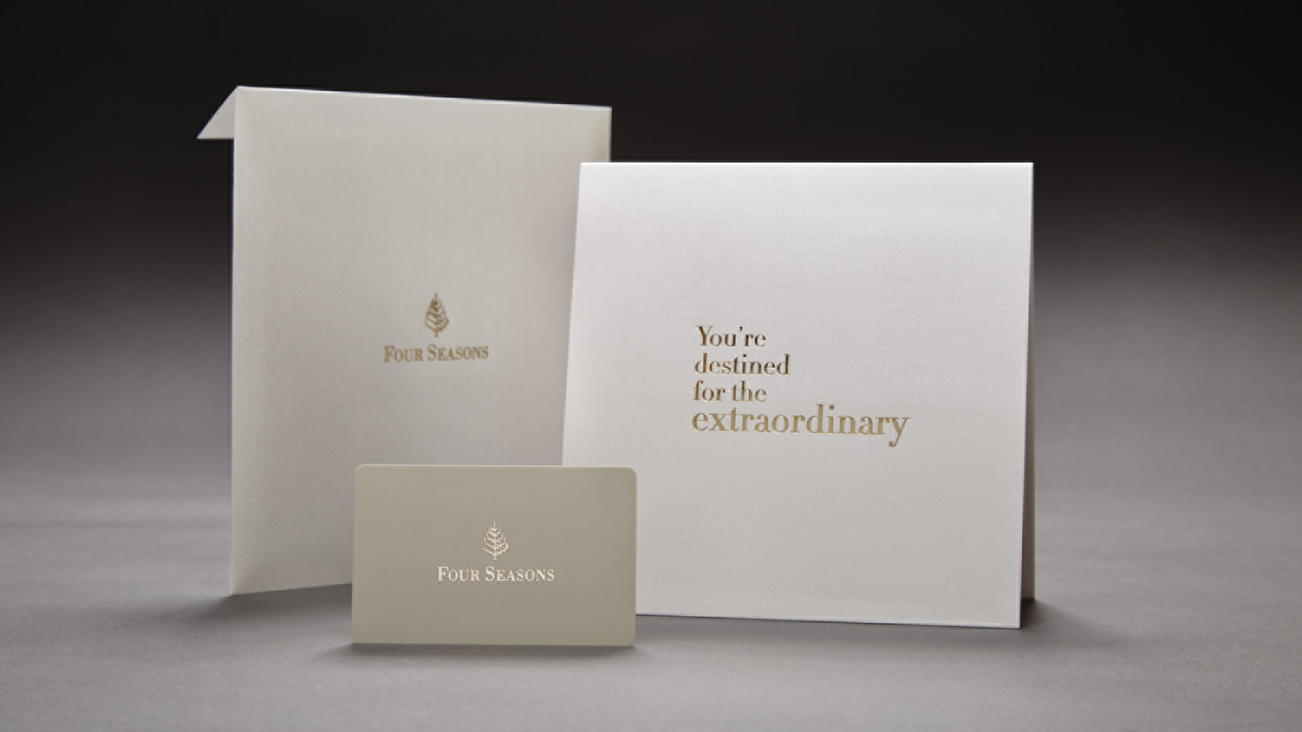
Understanding travellers’ needs for peace of mind and flexibility when planning for future travel, should guests who book the Valentine’s Weekend Retreat and not be able to travel, they will receive the value of the package in a beautifully wrapped Four Seasons Gift Card, providing a thoughtful and carefree Valentine treat for a loved one.
Chef Martín Morelli has also created a decadent meal to-go to for those who wish to celebrate at home.
Valentine’s Day Retreat Package
Couples will discover a modern sanctuary set for an in-room private dining experience for two. Chef Martín Morelli has crafted a memorable three-course menu, taking the getaway to the next level with rustic Italian-Californian farm-to-table cuisine.
Beginning with chocolate truffles and a bottle of prosecco upon arrival, later in the evening dinner will be delivered in style - a truffle and pear salad; pan-roasted beef tenderloin and spinach cannelloni; and finally a decadent cheese plate and chocolate covered strawberries.
The next morning, views of the Santa Cruz mountains or the San Francisco Peninsula are framed by floor-to-ceiling windows, perfect to enjoy the continental breakfast box of seasonal fruit, freshly baked croissants, and fresh brewed coffee or tea.
Each guest room features full marble bathrooms with deep soaking tubs, while an upgrade to a suite provides extra space and access to Plum, an on-demand wine-by-the-glass machine that instantly allows guests enjoy a perfect glass of wine.
Within the Hotel, enjoy a day by the rooftop pool in a private cabana; get energised at the Fitness Studio or Tonal Capsules, new private fitness studios featuring the patented all-in-one digital weight system. With multiple outdoor trails and extensive shopping nearby, the area has endless opportunities to explore.
Available February 13 or February 14, 2021, this special package also includes complimentary overnight parking and early check-in and late check-out for added time with a special someone.
Reservations are required and can be made online, by calling 650 566 1200 or by emailing reservations.pal@fourseasons.com.
Valentine’s Day Dinner At-Home
Chef Martín’s curated menu fit for a special meal at home includes an appetiser, salad, entrée, dessert and bottle of prosecco. Enhance the evening with a bouquet of seasonal flowers or upgrade the prosecco to champagne.
The four-course menu begins with a smoked salmon rillettes and charcuterie plate; followed by a truffle and pear salad; spinach and ricotta cannelloni; before finishing with chocolate covered strawberries and truffles.
Order via Eventbrite for a surprise dinner for two for USD 190 that can be enjoyed February 13 or February 14, 2021.

RELATED

January 14, 2021, Palo Alto, Silicon Valley, U.S.A.
Experience Private Fitness and Virtual Training with the Exclusive Tonal Capsules at Four Seasons Hotel Silicon Valley
https://publish.url/siliconvalley/hotel-news/2021/tonal-capsule-fitness.html

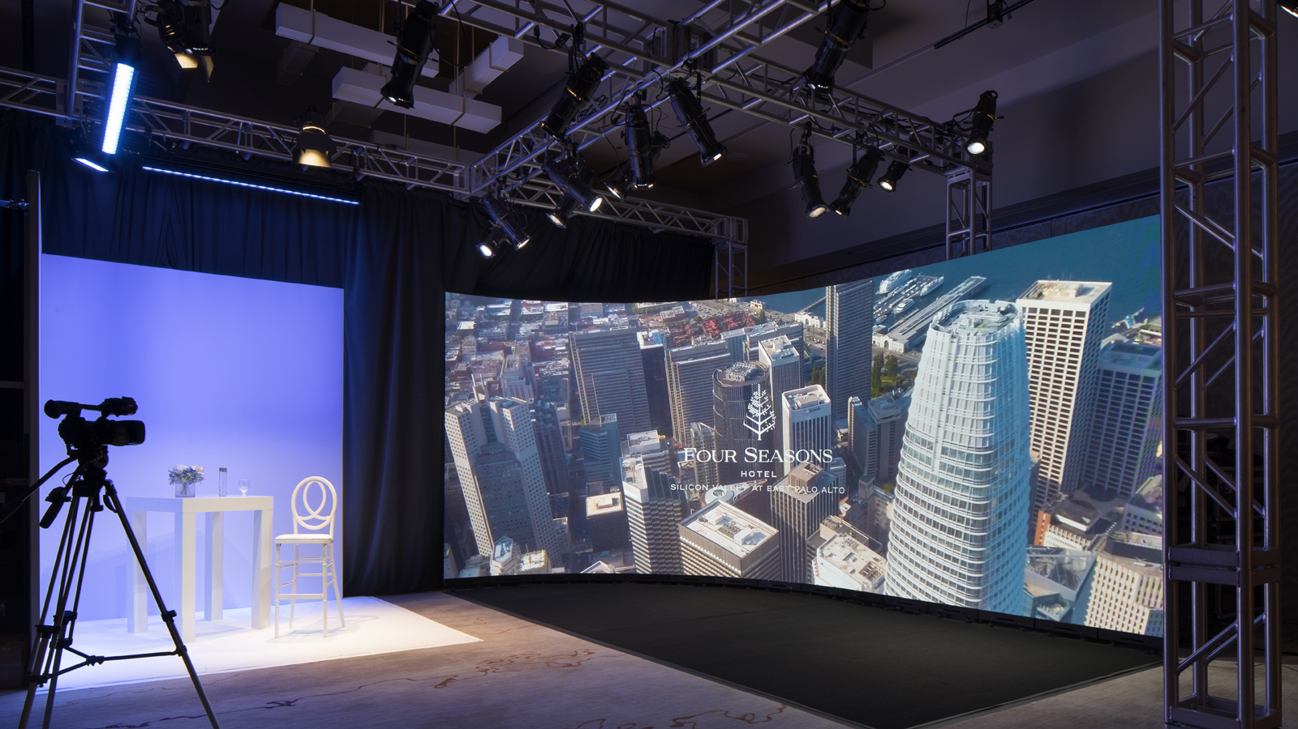 | November 23, 2020, Palo Alto, Silicon Valley, U.S.A.  Virtual Events Studio Debuts at Four Seasons Hotel Silicon Valley  https://publish.url/siliconvalley/hotel-news/2020/virtual-events-studio.html

PRESS CONTACTS

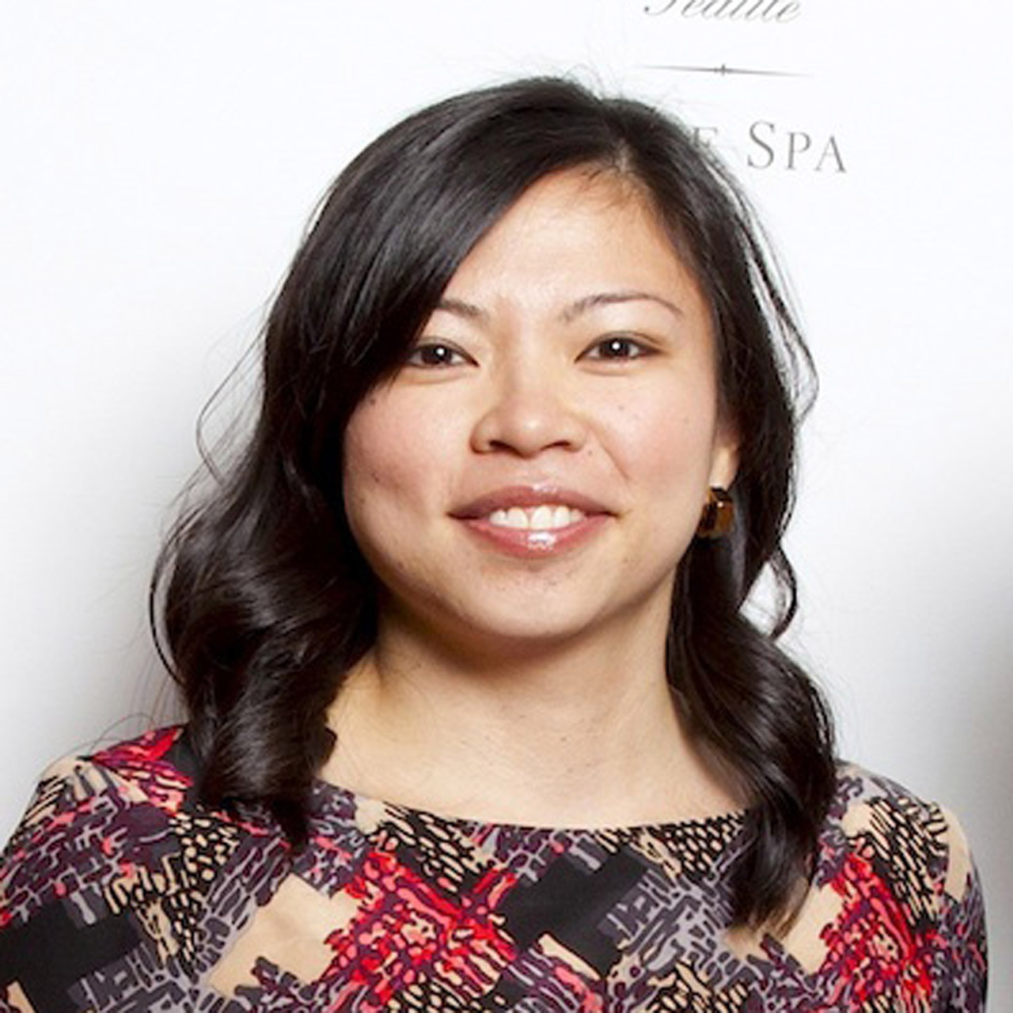 | Meg Paynor  PR Consultant  2050 University Avenue  East Palo Alto  USA  meg@paynorpr.com  +1 206 913 3848

