Say “I Do” to The Guest List – An Intimate Guide to Wedding Inspiration Presented by Four Seasons Resort Oahu at Ko Olina

Resort debuts #WeddingWednesday virtual learning series for A to Z wedding planning
September 15, 2020, Hawaii, Oahu, U.S.A.

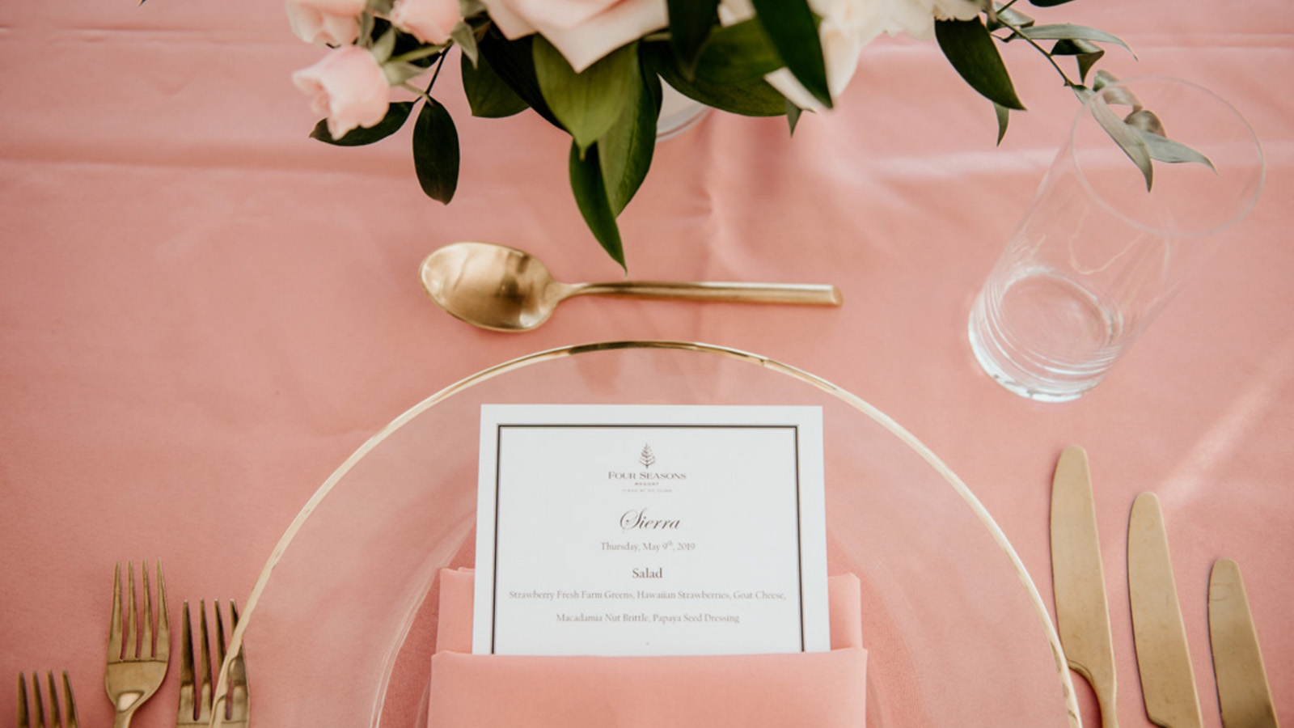
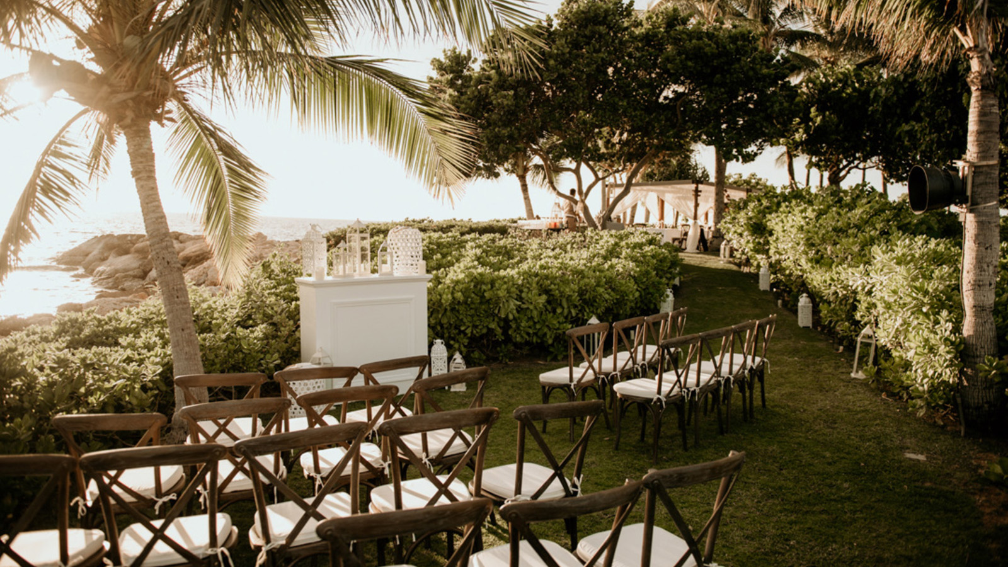 | 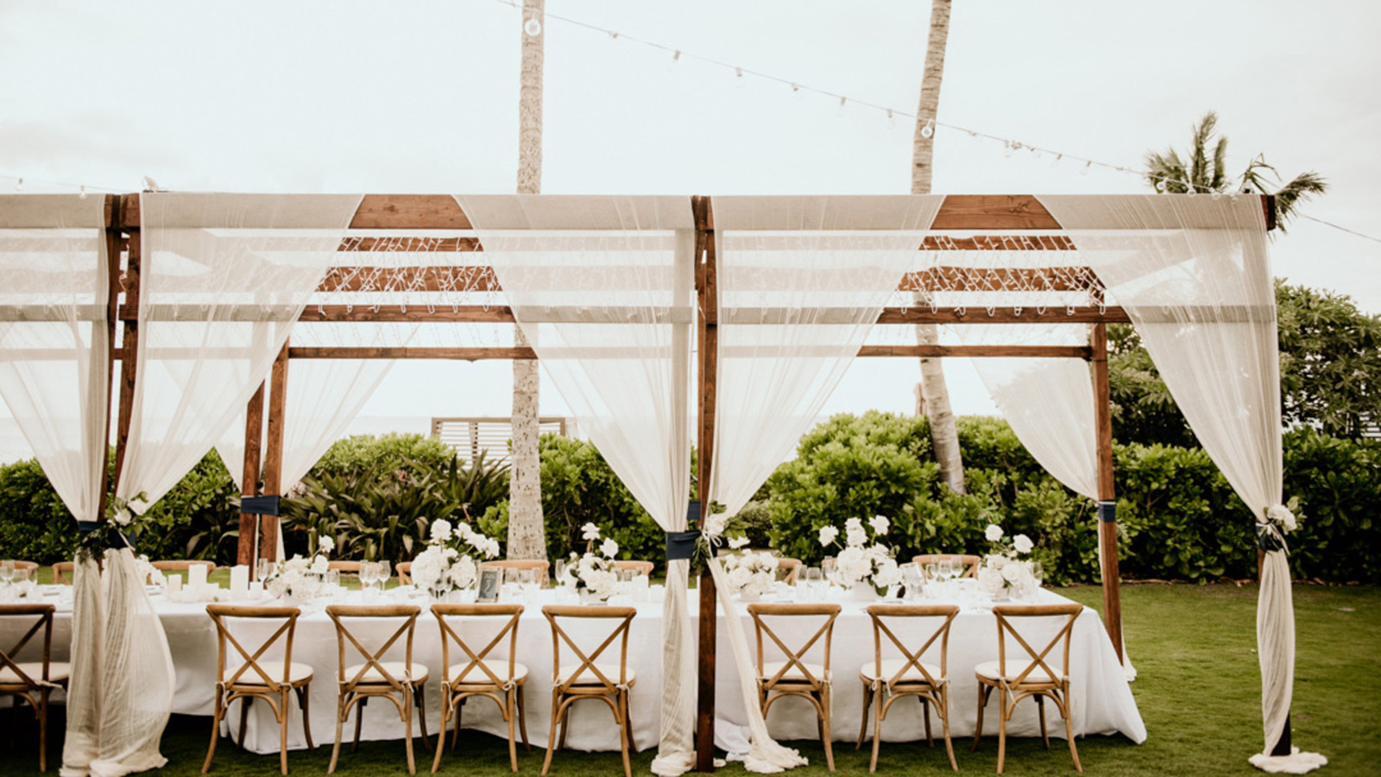 | 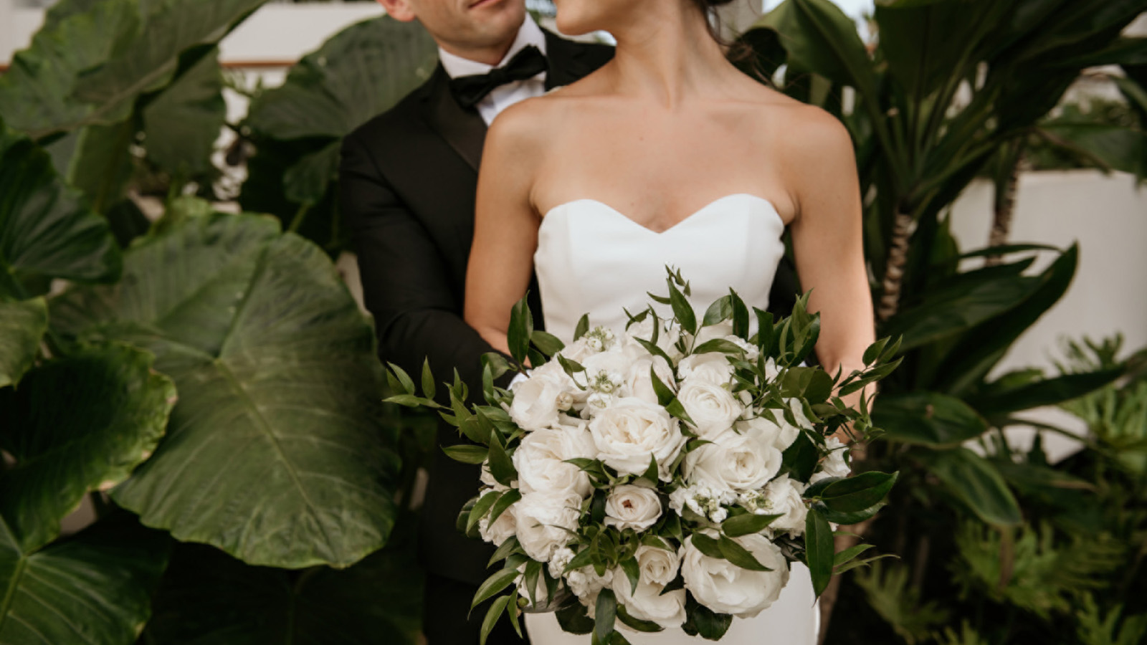
Four Seasons Resort Oahu at Ko Olina debuts The Guest List – An Intimate Guide to Wedding Inspiration for the modern couple. Hosted by a collection of the industry’s most creative minds, the bi-weekly virtual learning series will explore all things weddings with a desire to inspire the most unforgettable special occasions. The curated series will feature a range of important wedding planning topics to consider, such as selecting the perfect venue and engagement photos, floral design, website planning and coordinating leisure activities for destination guests. Follow the Resort’s special events Instagram handle, @FSOahuEvents, and learn the answers to all the wedding “dos and don’ts” when The Guest List debuts on Wednesday, September 16, 2020 at 9:00 am HST via Instagram Live.
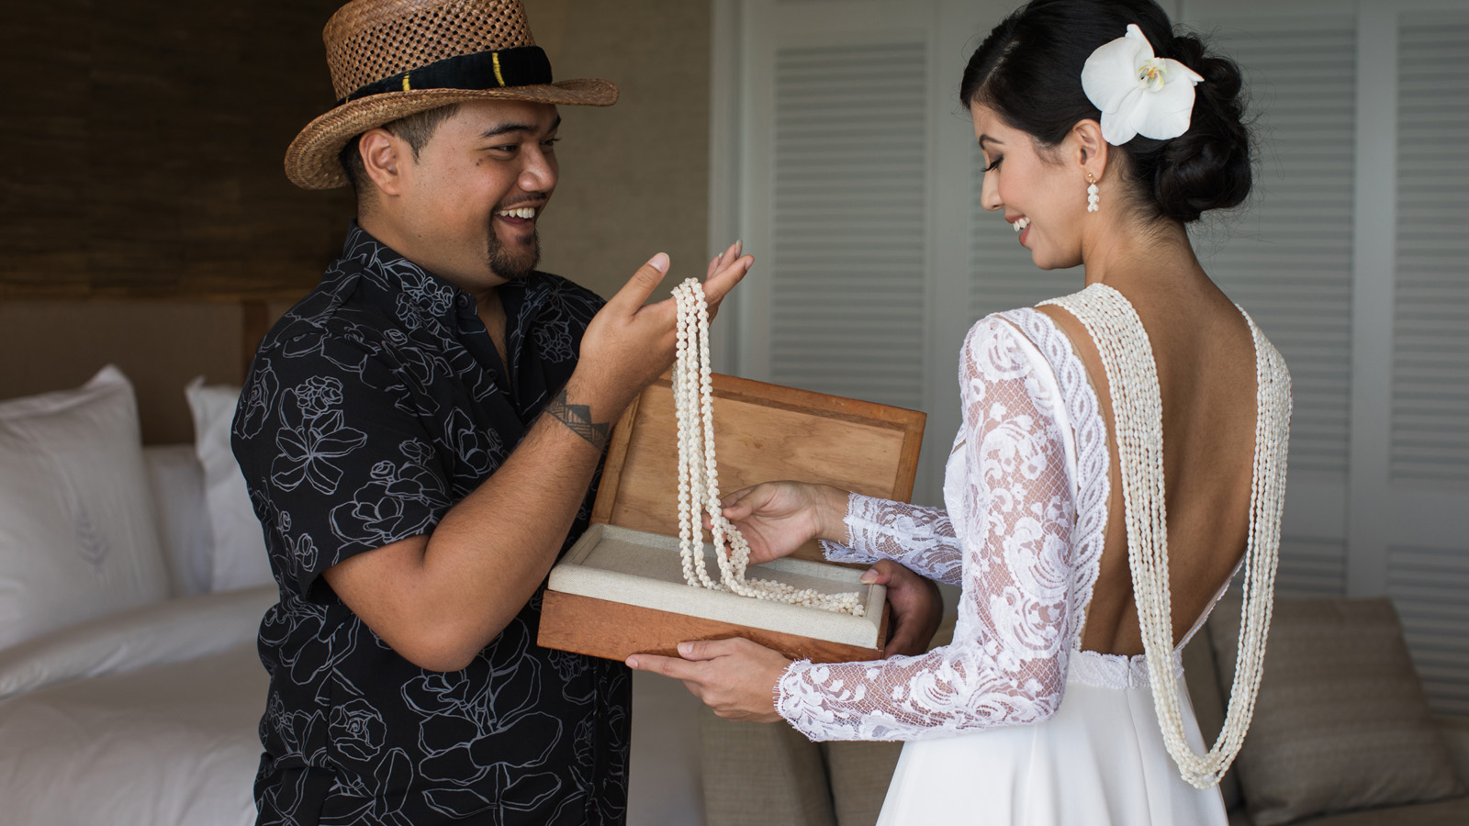 | 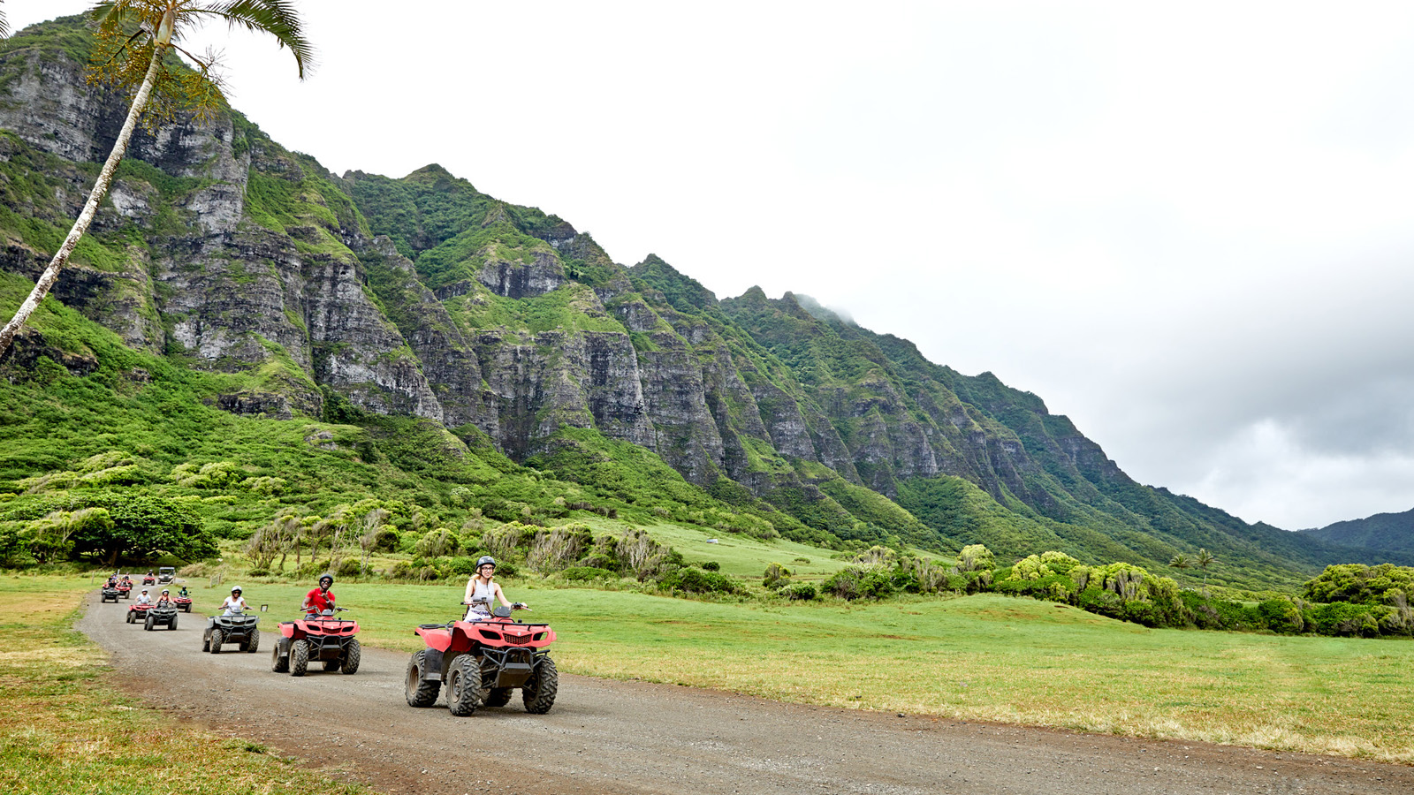 | 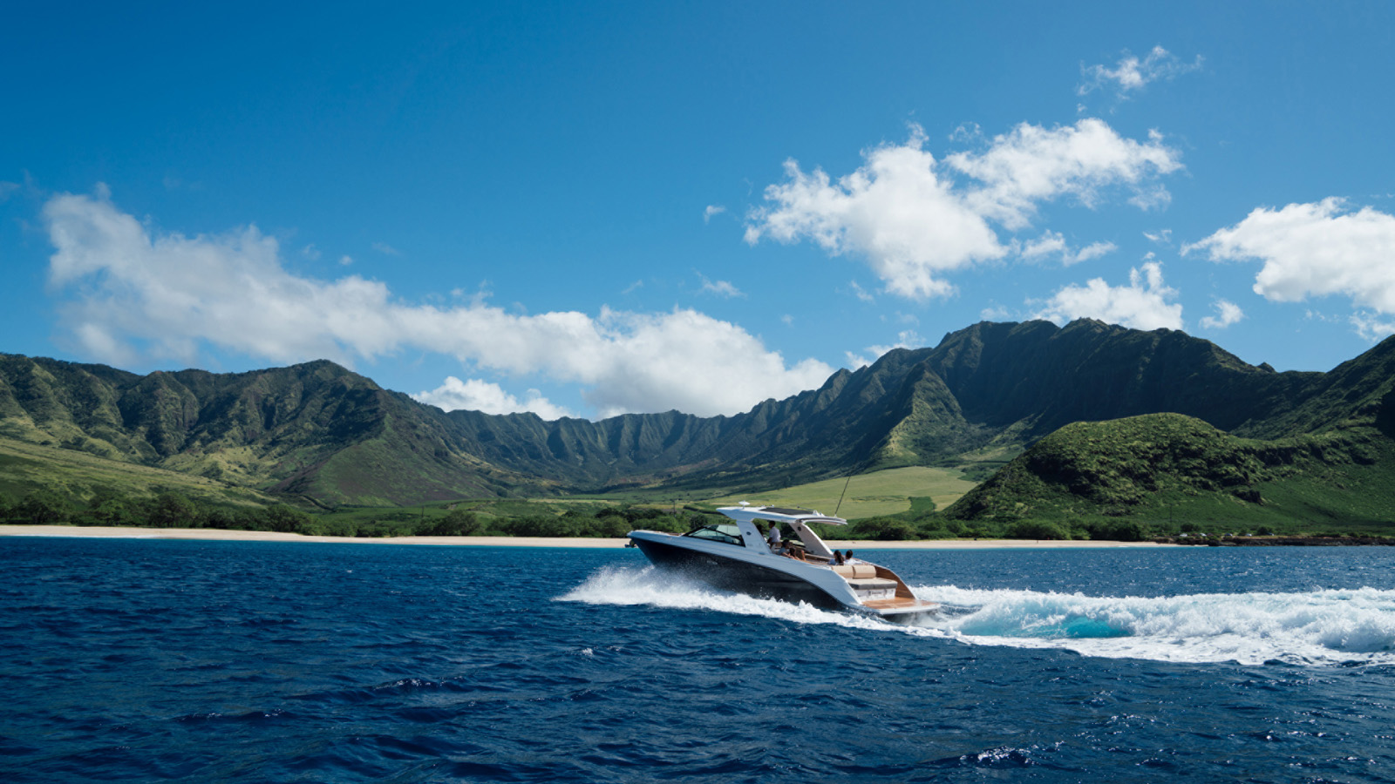
“Whether planning a large event or an intimate wedding for two, Hawaii has long been a highly sought-after destination for wedding couples and offers endless inspiration anchored by our beautiful natural surroundings and unique cultural traditions,” says Amanda Douglas, Director of Catering and Conference Services. “Planning a wedding is no easy feat and there are endless details to consider. The Guest List aims to share our expertise, along with tapping into insider tips and trends from our exclusive partners – ranging from floral designers and photographers to gifting concierges - with the goal of infusing inspiration and creative ideas, along with a reminder to have fun, to bring a dream wedding to life.”
The Guest List’s upcoming schedule includes:
- Wednesday, September 16 @ 9:00 am HST – Location, Location, Location: Choosing the perfect venue.
- Wednesday, September 30 @ 9:00 am HST – The Wedding Planner: Selecting the right planner for you
- Wednesday, October 7 @ 9:00 am HST – The Micro Wedding Phenomenon: Everything you need to know to make your wedding a big little event
- Wednesday, October 14 @ 9:00 am HST – Oh snap! Selecting the photographer to make you shine
Located on Oahu’s sun-drenched and unspoiled western coastline, Four Seasons Resort Oahu is set within the exclusive and private resort community of Ko Olina, covering 642 acres (260 hectares) and fronting an expansive and pristine white-sand beach anchored by four protected lagoons teeming with marine life. The Resort presents a world of redefined luxury that rivals the senses. It is an inspiring backdrop for unforgettable events – from exchanging vows on the beach to walking down the aisle in the Resort’s sun-lit Wedding Chapel overlooking the Pacific Ocean, happily ever after begins at Four Seasons Resort Oahu.
To learn more about The Guest List or to begin planning a wedding or honeymoon in paradise, visit Four Seasons Resort Oahu at Ko Olina or contact the Resort’s wedding specialists online @FSOahuEvents or by calling 1 800 819 5053.

RELATED

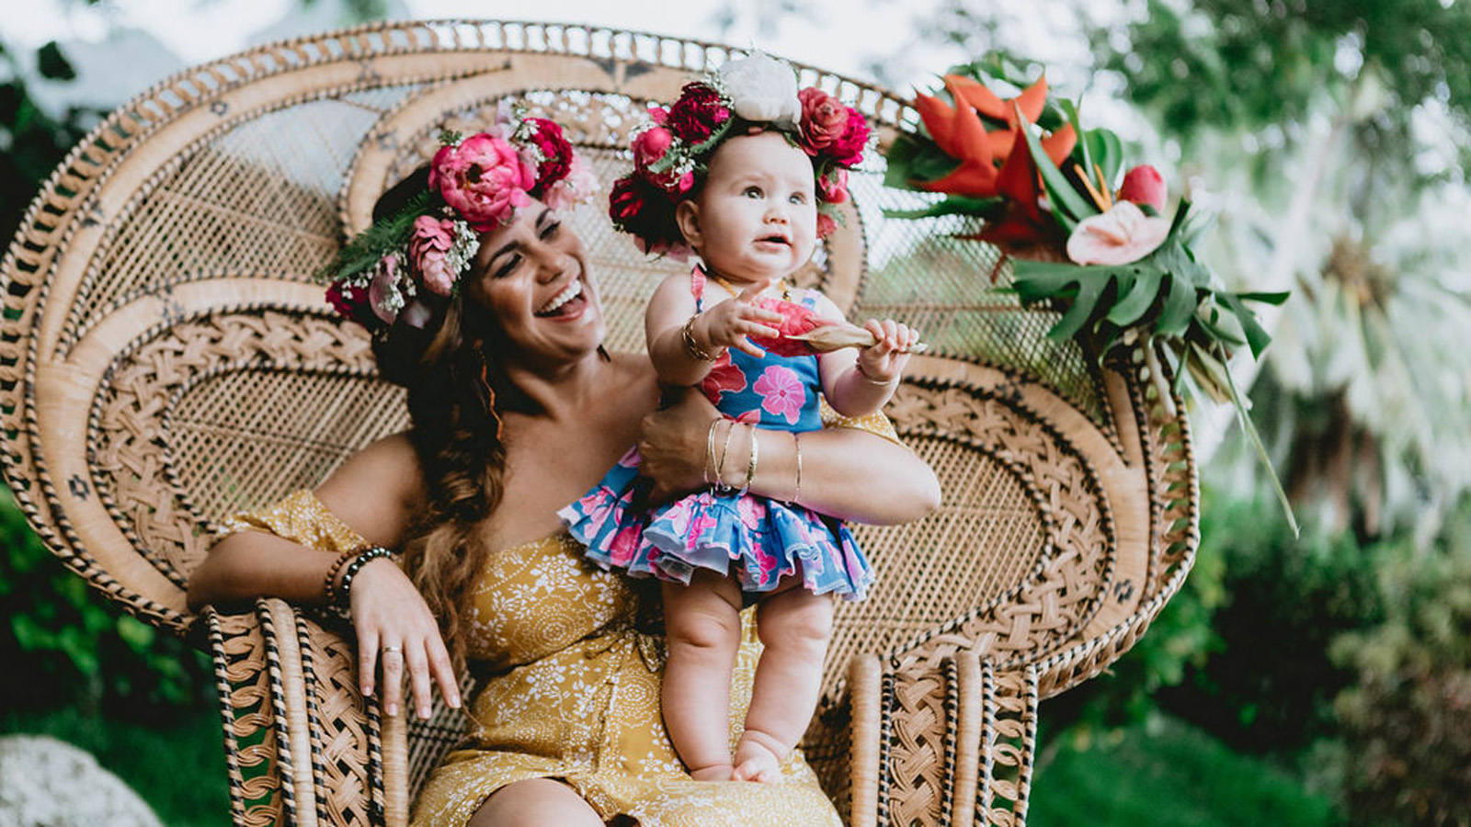 | June 25, 2020, Hawaii, Oahu, U.S.A.  Grammy-Nominated Producer and Singer-Songwriter Kimié Miner Joins The Coconut Wire Virtual Master Class Series from Four Seasons Resort Oahu at Ko Olina  https://publish.url/oahu/hotel-news/2020/song-writing-master-class.html
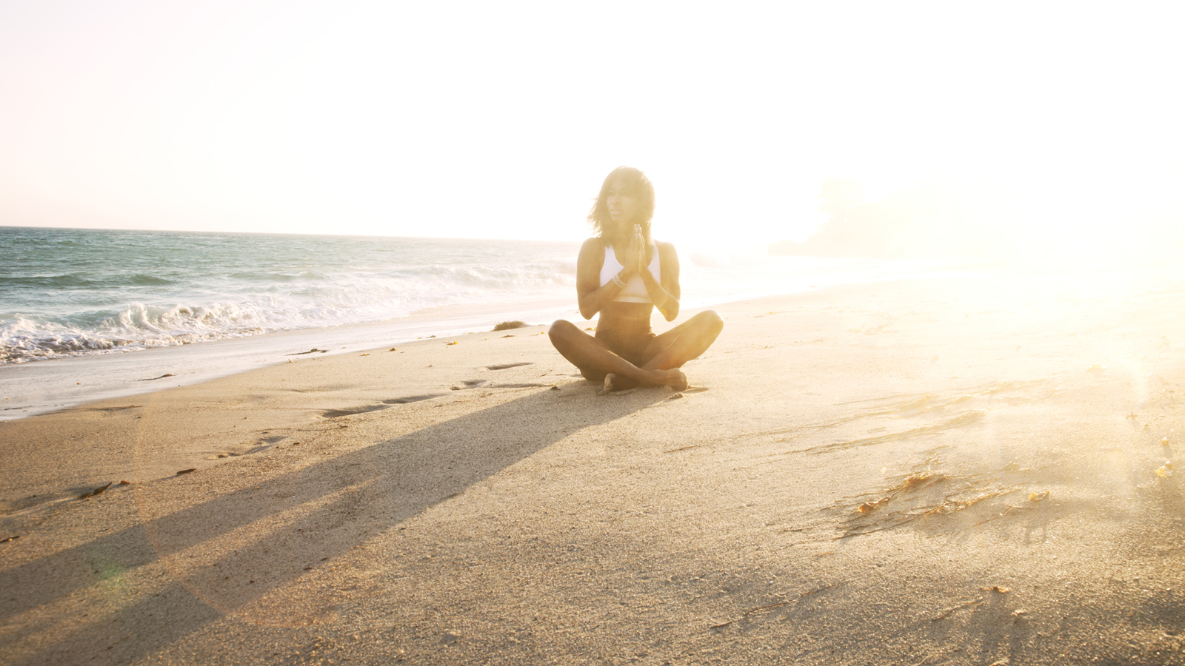 | June 3, 2020, Toronto, Canada  Four Seasons Resorts Hawaii and Four Seasons Resort Bora Bora Bring Global Wellness Day, June 13, 2020 into Homes of Guests Across the World  https://publish.url/news-releases/2020/global-wellness-day-pacific-islands.html

PRESS CONTACTS

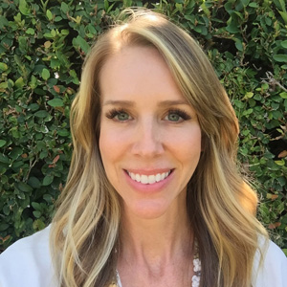 | Michelle Edwards  Director of Public Relations and Marketing Communications  92-1001 Olani Street  Kapolei  USA  michelle.edwards@fourseasons.com  +1 808 679 3364

