Reconnect This Ramadan at Four Seasons Hotel Tunis

April 13, 2021, Tunis

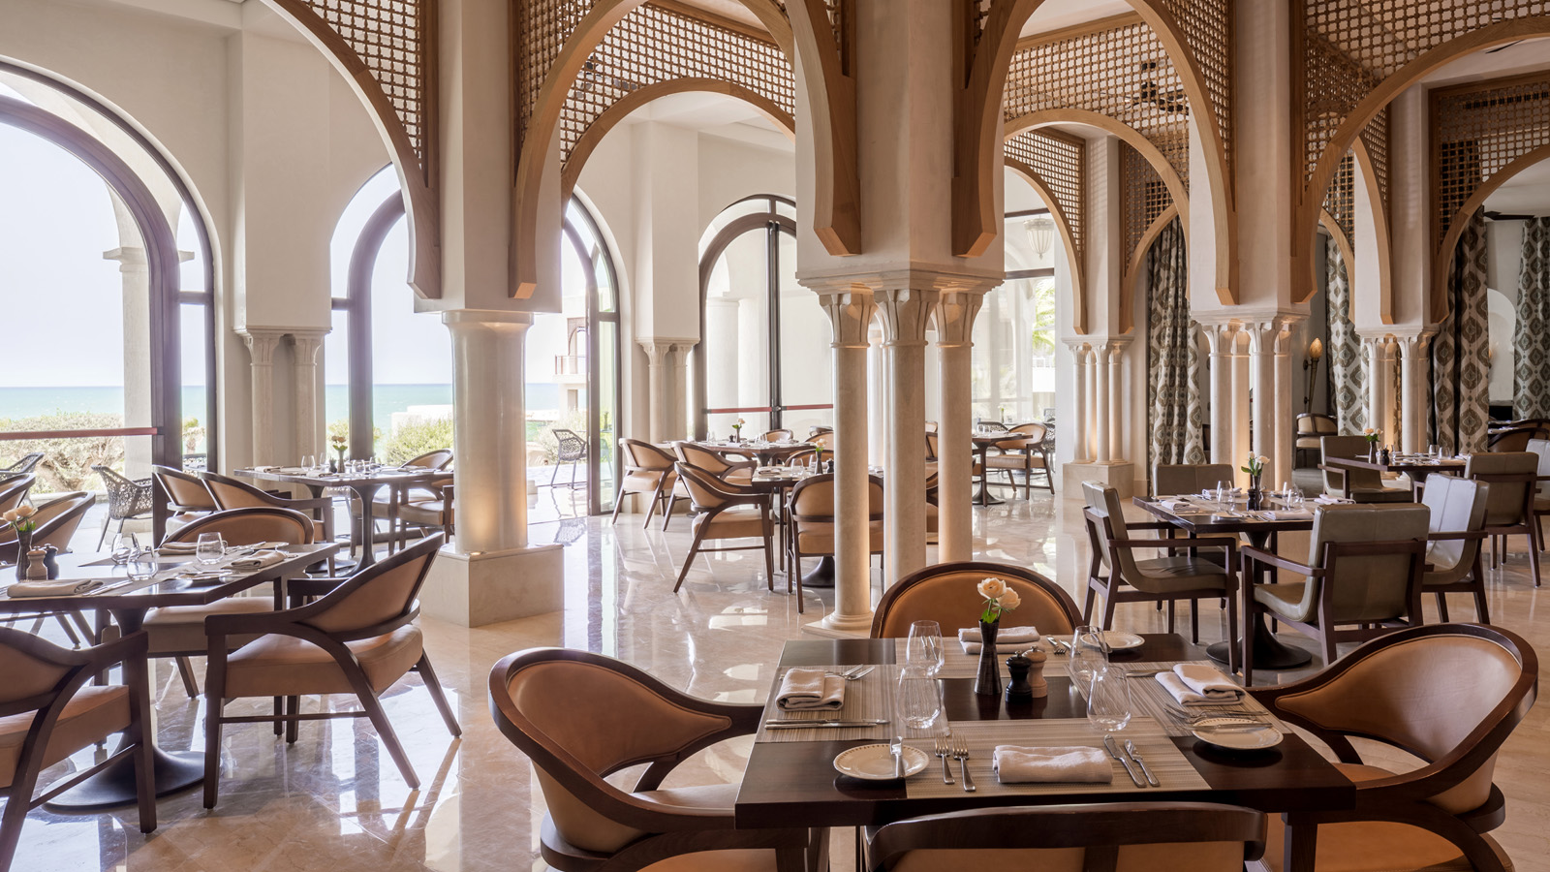
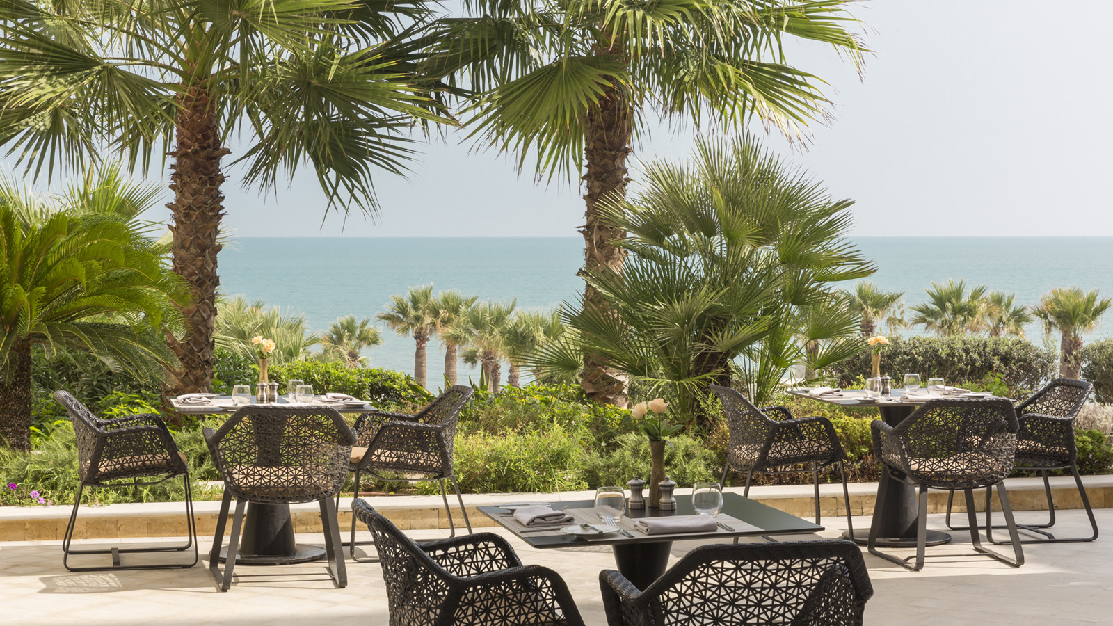 | 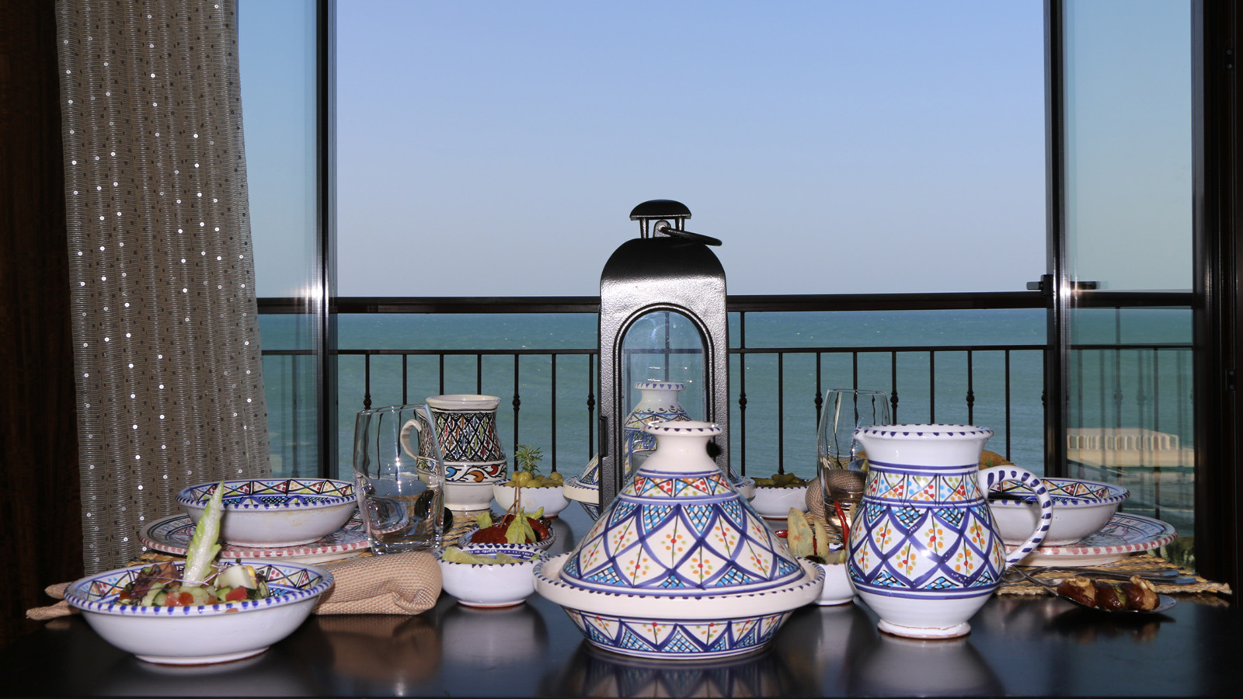 | 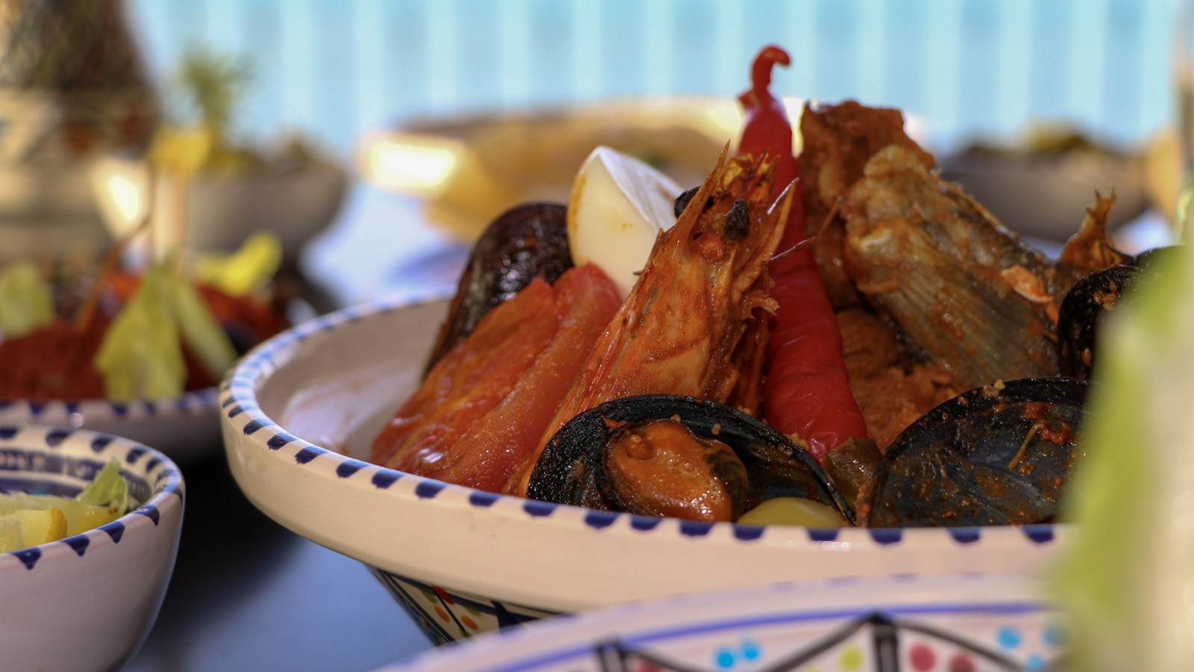
Four Seasons Hotel Tunis invites guests to celebrate the Holy Month and make time to create memorable moments with their loved ones while experiencing the best of dining, wellness and stay experiences.
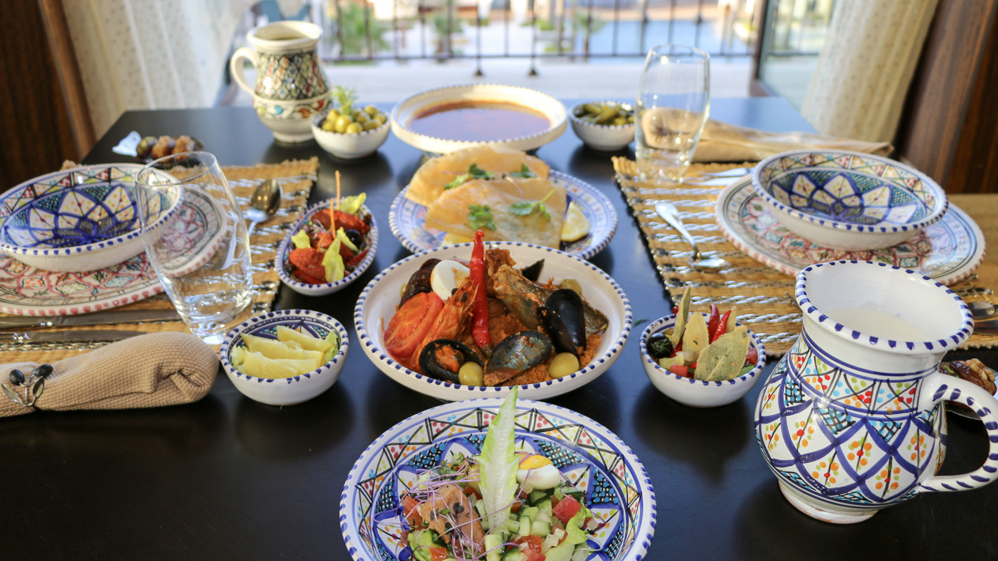 | 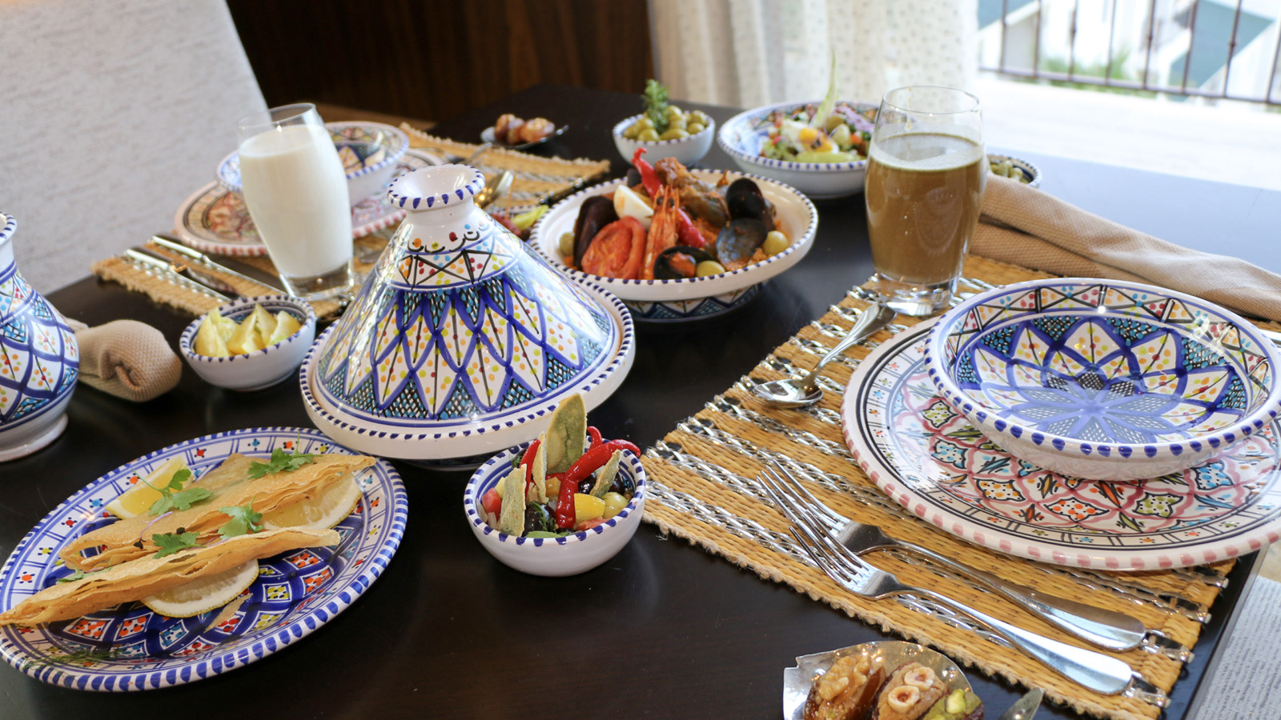
AZUR Restaurant
AZUR Restaurant will host guests to celebrate the festive spirit of Ramadan and enjoy a traditional atmosphere with friends and family.
Executive Chef Alessandro Fontanessi and his talented team created the ideal setting for Iftar and a unique culinary experience, offering the best of traditional and international dishes through rich live stations to satisfy all tastes.
Iftar at AZUR will leave guests amazed not only by the exceptional gastronomic experience, but also with the pleasant atmosphere from the arabesque decoration and Tunisian chinaware to oriental music and entertainment that will be in place to exceed all expectations.
Being located on the seafront of the Mediterranean, guests will enjoy the breath-taking view of the sunset while savouring a well-crafted Turkish coffee or Tunisian tea.
Ramadan Package
This year Four Seasons Hotel Tunis is offering guests the opportunity to unwind and enjoy a memorable stay in the comfort of pure luxury, and celebrating the spirit of the Holy Month with friends and family by booking the Ramadan Package that includes a daily Iftar for two.
The Ramadan Package can be booked online or by calling the Hotel directly at +216 31 260 000.
The Spa:
Rejuvenate and indulge into a relaxing experience in the Spa to cleanse the body and enjoy the phenomenal indoor pool and whirlpool.
During the Holy Month, can can enjoy the Spa’s special promotions:
- My Spa by Guerlain: A 60-minute massage from Guerlain with an extension of 30 minutes with compliments.
- My Spa by Jardin Amazygh: A 60-minute massage Tunis Bespoke and a foot exfoliation with compliments.

RELATED

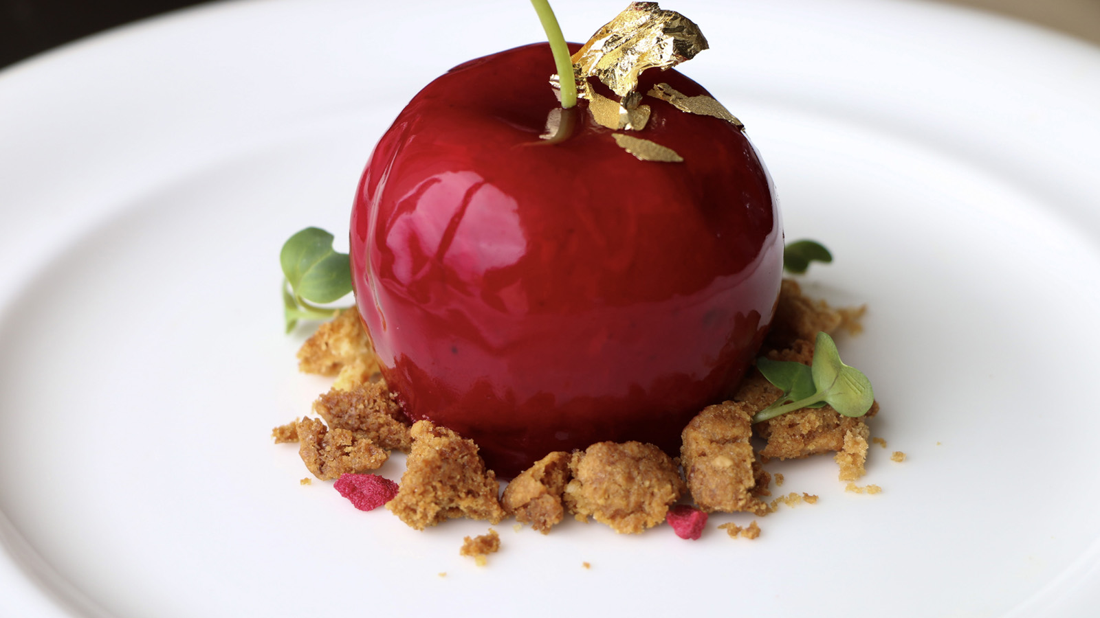 | February 4, 2021, Tunis  Valentine’s Season at Four Seasons Hotel Tunis  https://publish.url/tunis/hotel-news/2021/valentines-day.html
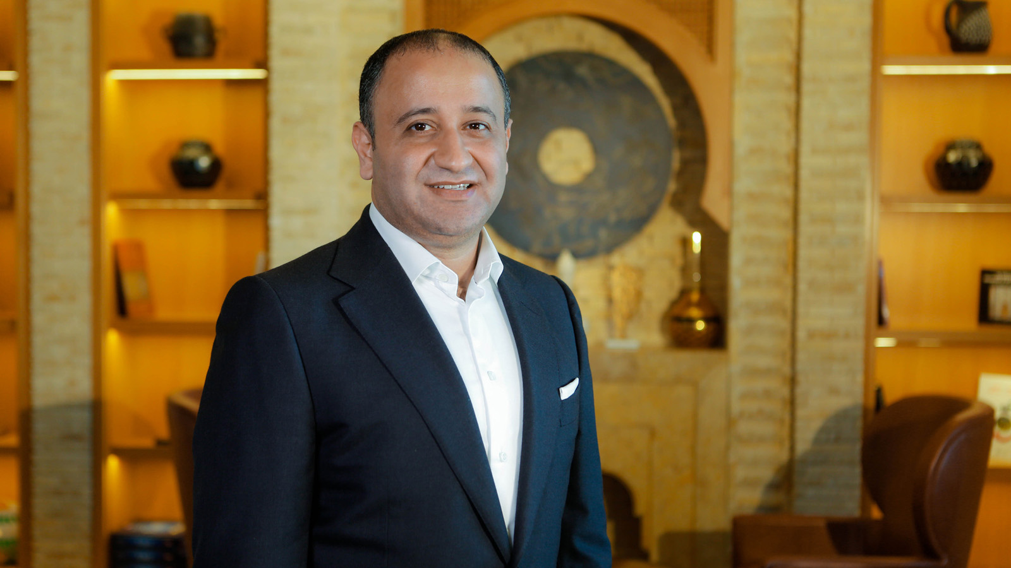 | February 14, 2020, Tunis  Hamza Sehili Appointed Hotel Manager at Four Seasons Hotel Tunis  https://publish.url/tunis/hotel-news/2020/new-hotel-manager-hamza-sehili.html

PRESS CONTACTS

Arij Ben Othmen
Public Relations and Marketing Communications Manager
Zone Touristique Cap Gammarth
La Marsa, Tunis
Tunisia
arij.benothmen@fourseasons.com

+216 58 555 776

