Four Seasons Hotel Seoul Brings a Vibrant Taste of La Dolce Vita with New Italian Lunch Delight Set Menu at Boccalino

March 3, 2023, Seoul, Korea

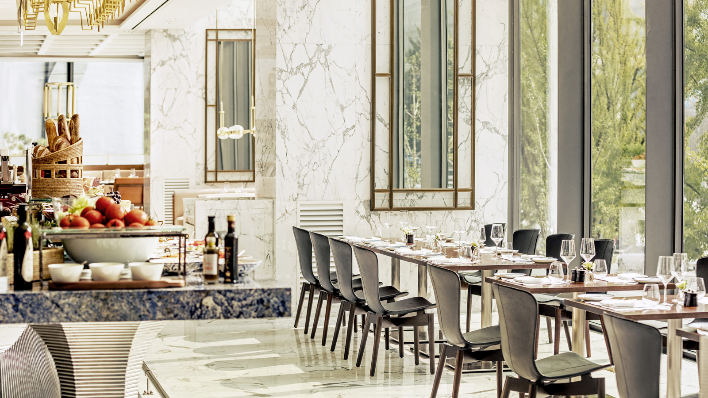
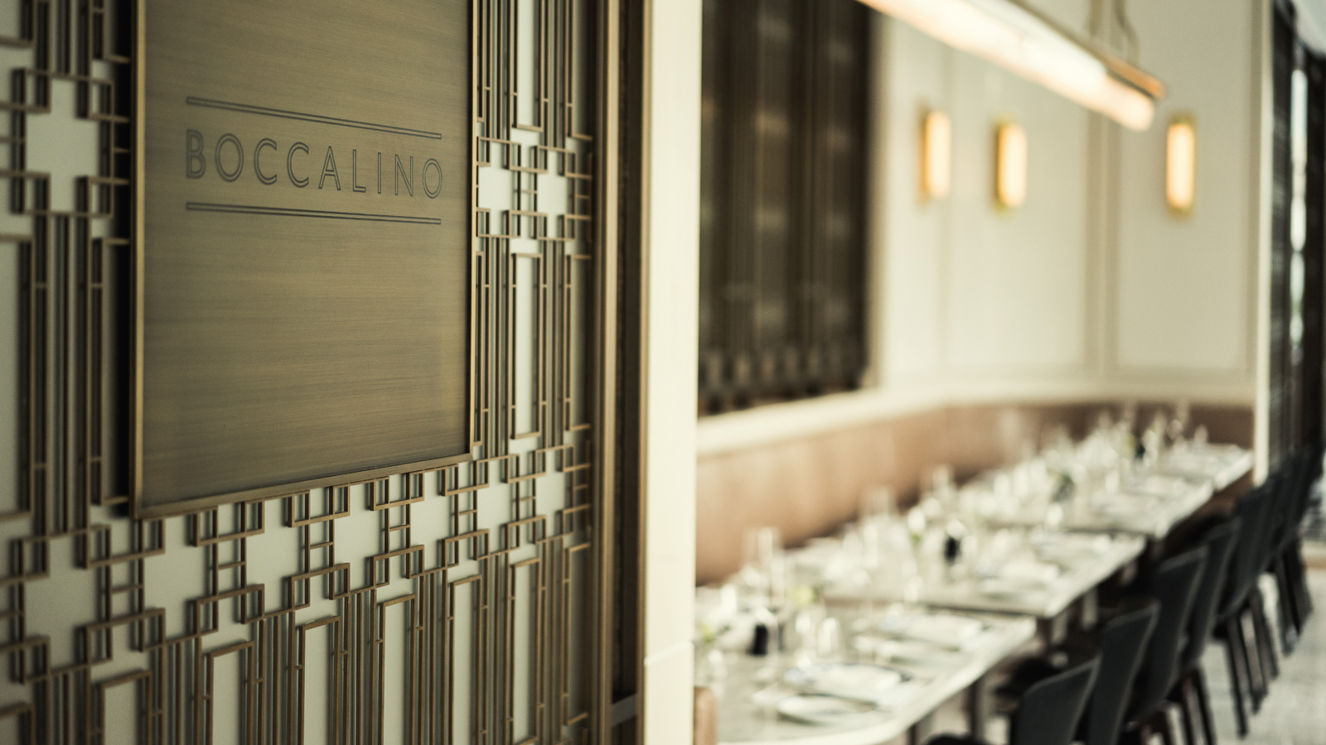 | 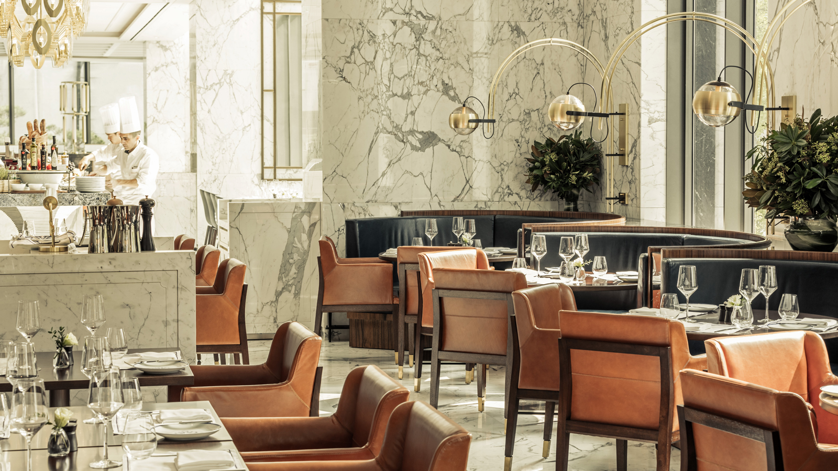 | 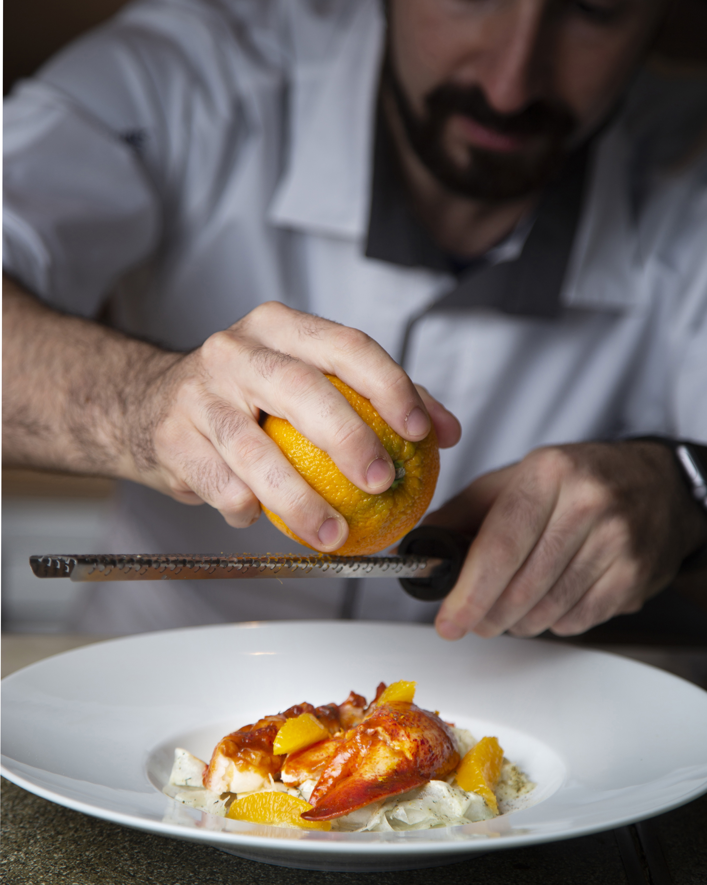

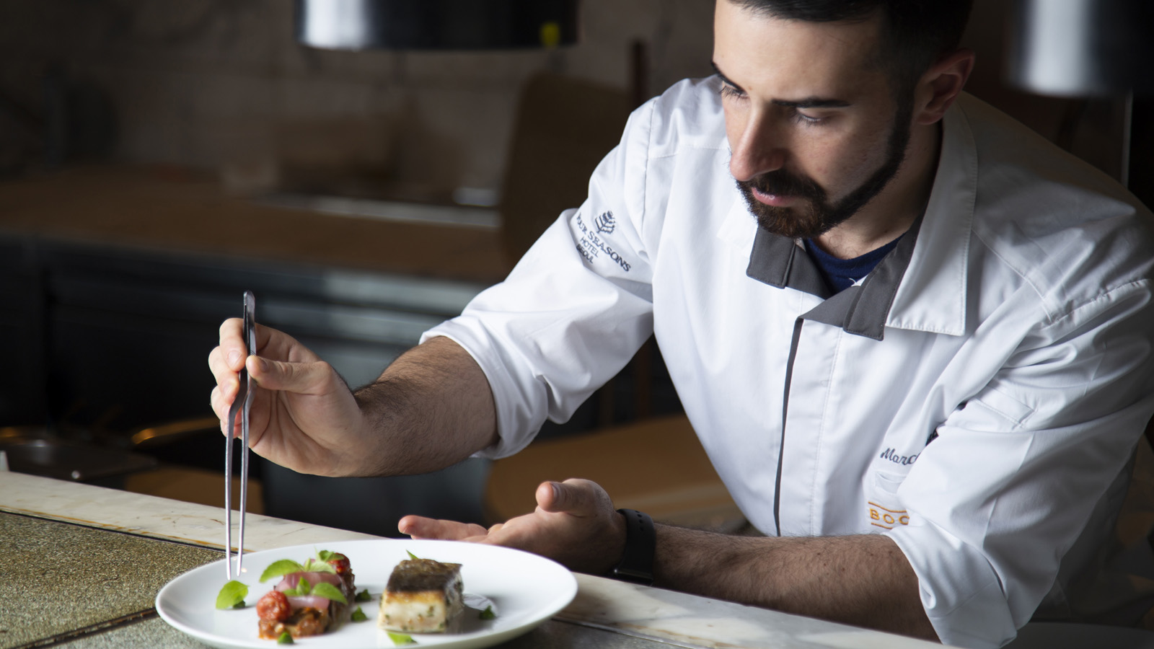

RELATED

March 3, 2023, Seoul, Korea
‘가성비&가심비 갑’ 고품격 이탈리안 다이닝 즐기기
https://publish.url/kr/seoul/hotel-news/2023/set-lunch-at-boccalino-2.html

February 24, 2023, Seoul, Korea
Four Seasons Hotel Seoul Celebrates International Women's Day with Gratitude and Gifts
https://publish.url/seoul/hotel-news/2023/international-womens-day.html

PRESS CONTACTS

Inyoung Moon
Director of Public Relations and Communications
97 Saemunan-ro, Jongno-gu
Seoul
Korea
inyoung.moon@fourseasons.com

82 2 6388 5044

Kelly Wong
Director of Marketing
97 Saemunan-ro, Jongno-gu
Seoul
Korea
kelly.wong@fourseasons.com

82 2 6388 5001

