Mei Ume to Celebrate Mid-Autumn Festival with Lunar Installation, Celebratory Menu and Mooncakes

July 18, 2022, London at Ten Trinity Square

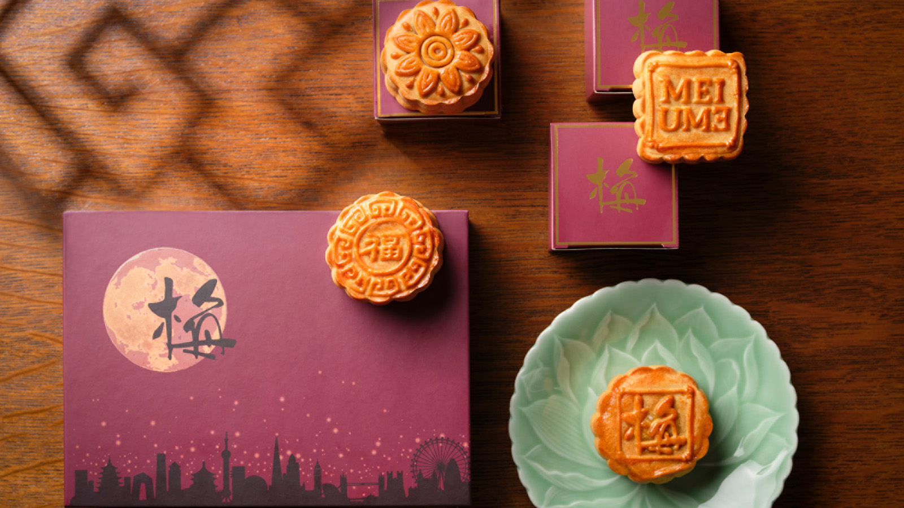
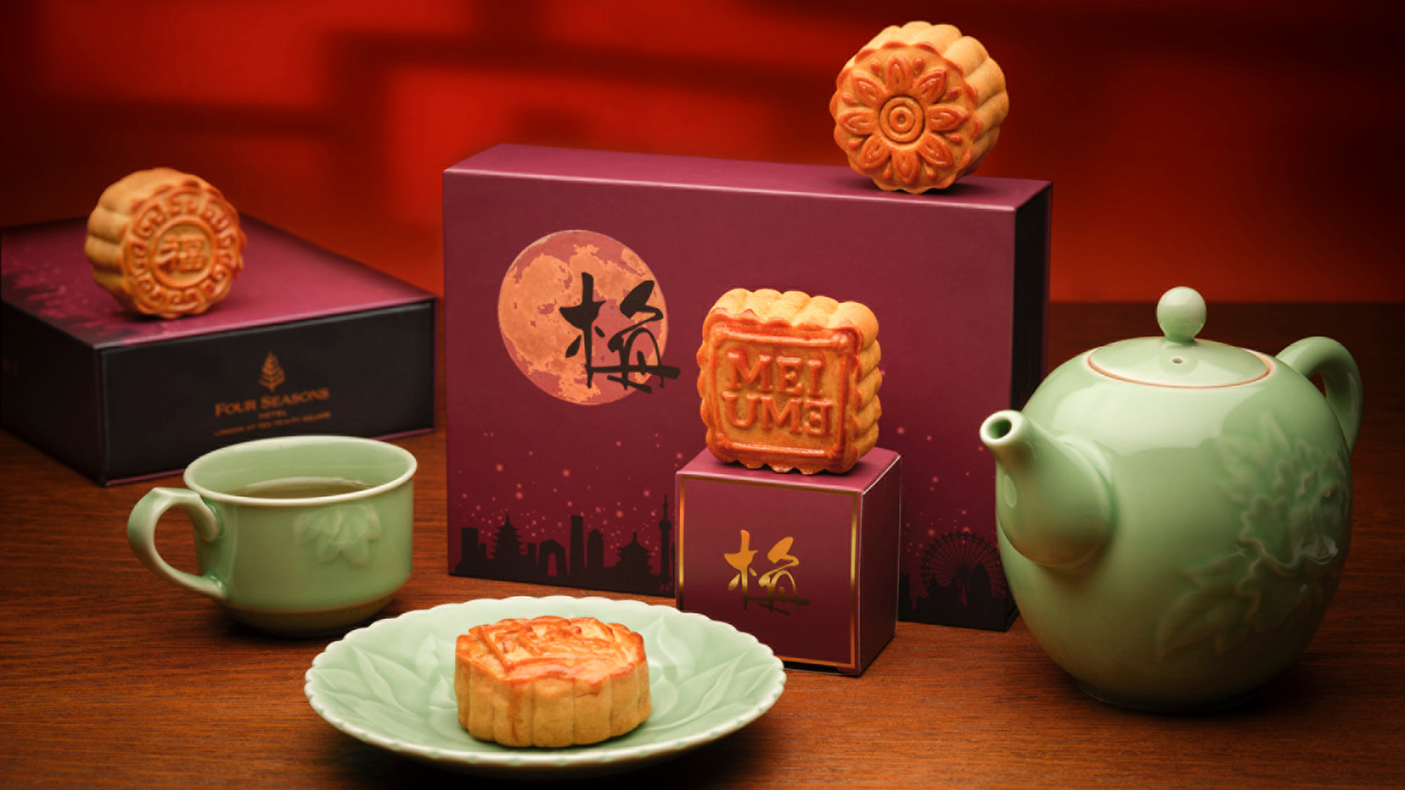 | 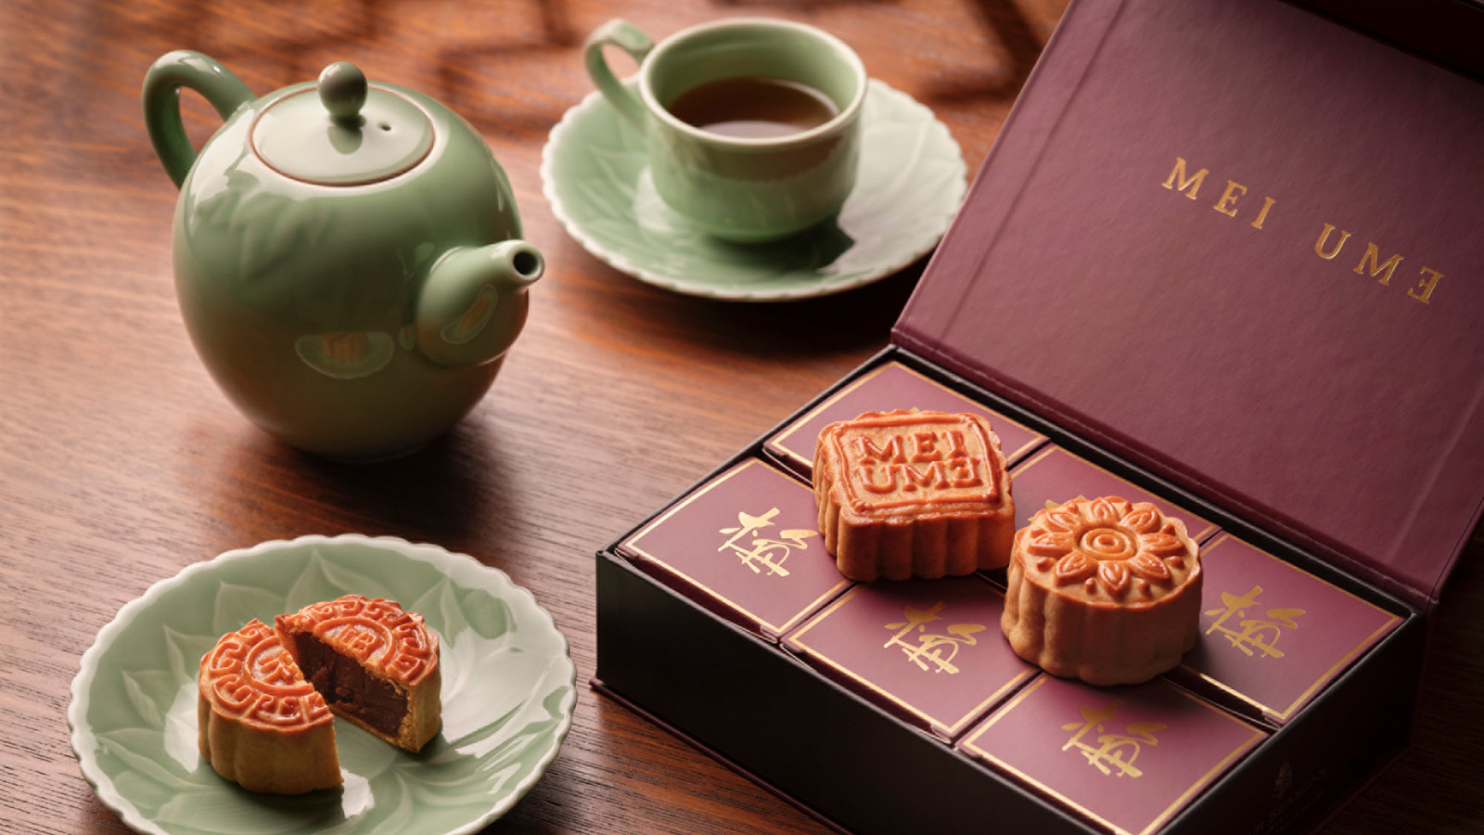 | 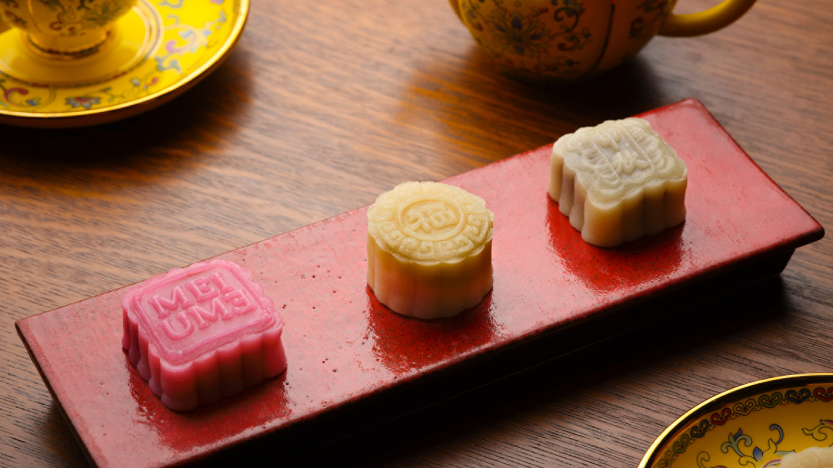
This September, Mei Ume, the Chinese and Japanese restaurant at Four Seasons Hotel London at Ten Trinity Square will celebrate Mid-Autumn Festival with the launch of its festive menu and intricately hand-crafted mooncakes. One of the most important dates in the Chinese calendar, the festival celebrates the harvest moon, with families and communities gathering for celebrations of feasting and toasting, culminating in the final day of the festival on September 10, 2022.
In honour of the auspicious festival, from August 23 to September 10, 2022, Mei Ume’s dining room will boast a glowing moon installation, surrounded by red and gold lanterns, symbolic of the season’s new moon and new beginnings. Filling the restaurant with a soft, ethereal light, the installation will encourage diners to come together beneath and rejoice in each other’s company, feasting on a special menu of Chinese dishes traditionally eaten during the festival to celebrate an abundant harvest and symbolise gratitude and togetherness.
The Mid-Autumn menu will begin with edamame, miso soup and deep-fried Teochew prawn and crabmeat rolls with salted egg yolk, followed by a selection of assorted sashimi and nigiri and the “dim sum trinity” of lobster har gau, crabmeat dumpling and deep-fried prawn dumpling. Taking centre stage, guests can opt for a 130 gram 150-day aged angus beef fillet or a 130 gram Kagoshima A3 wagyu beef, both served gently seared with black bean sauce and steamed jasmine rice.
Mooncakes, an emblem of the festival traditionally exchanged between friends and families on the eve of the harvest moon, will be available as part of the menu as well as available to purchase as a gift in a beautifully decorated East-meets-West style box. Four different iterations of the delicate pastries, both traditional mooncakes and snow-skinned mochi, showcase flavours of autumn including red bean; white lotus seed with salted egg yolk; rose jam; and completing the quartet, chestnut.
The Mid-Autumn Festival Menu will be available at Mei Ume from August 23 to September 10, 2022 for GBP 168 per person (wagyu option) or GBP 124 per person (angus beef option), for a two person minimum.
Snowskin mochi mooncakes will be available for dine in only and are available as part of the Mid-Autumn menu or for GBP 11 if dining a la carte menu.
Traditional mooncakes are priced at GBP 58 for six and can be pre-ordered online for collection from August 23 to September 10, 2022.
Mei Ume is open 12:00 noon – 2:00 pm Tuesday–Friday, 6:00-9:30 pm Tuesday-Saturday. Call +44 (20) 3297 3799 and follow at @meiumelondon.

RELATED

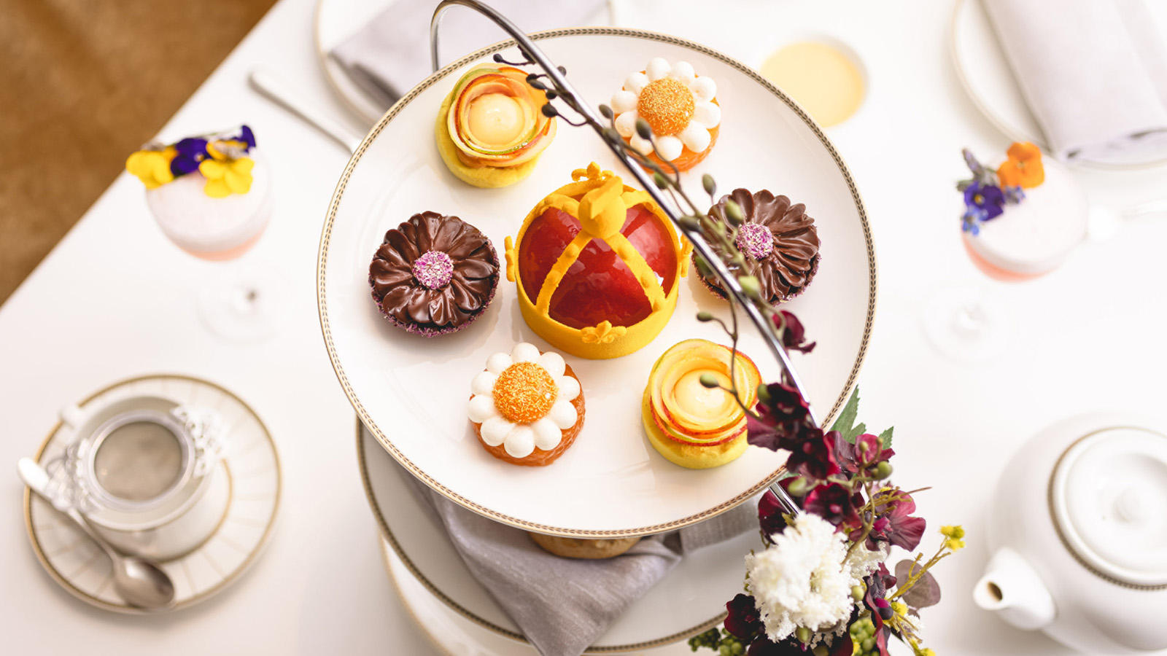 | August 3, 2022, London at Ten Trinity Square  The Spa at Four Seasons Hotel London at Ten Trinity Square Offers Ten Trini’Tea Spa Day  https://publish.url/tentrinity/hotel-news/2022/afternoon-tea-and-spa-package.html
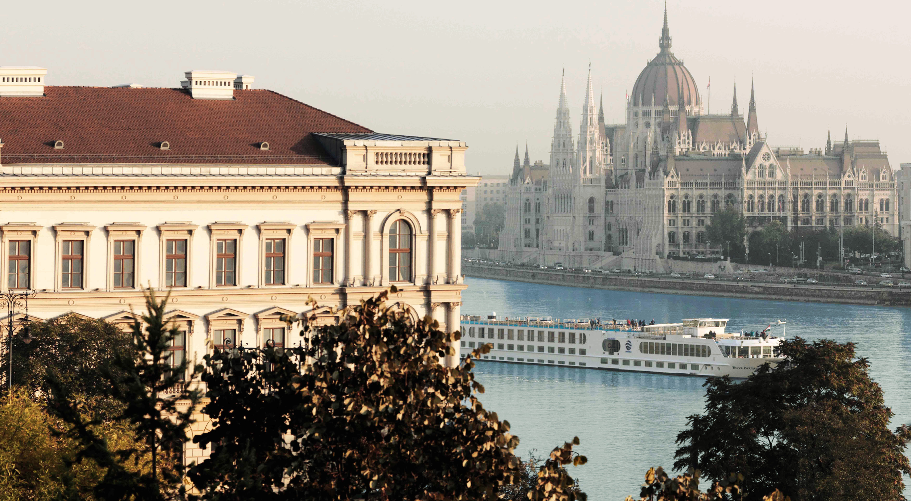 | June 7, 2022, Toronto, Canada  استمتع بالمناظر الطبيعية الخلاّبة مع فورسيزونز واكتشف ثمان رحلات بريّة مميزة تغمر الحواس  https://publish.url/news-releases/2022/scenic-routes-in-europe-4.html

PRESS CONTACTS

Grace Roome
Public Relations Manager
10 Trinity Square
London
UK
grace.roome@fourseasons.com

+44 (0) 203 297 9232

