Inspirations to Take Home, by Four Seasons Hotel Kuala Lumpur

Nurture the silver lining with these suggestions from the team at Four Seasons
May 12, 2020, Kuala Lumpur, Malaysia

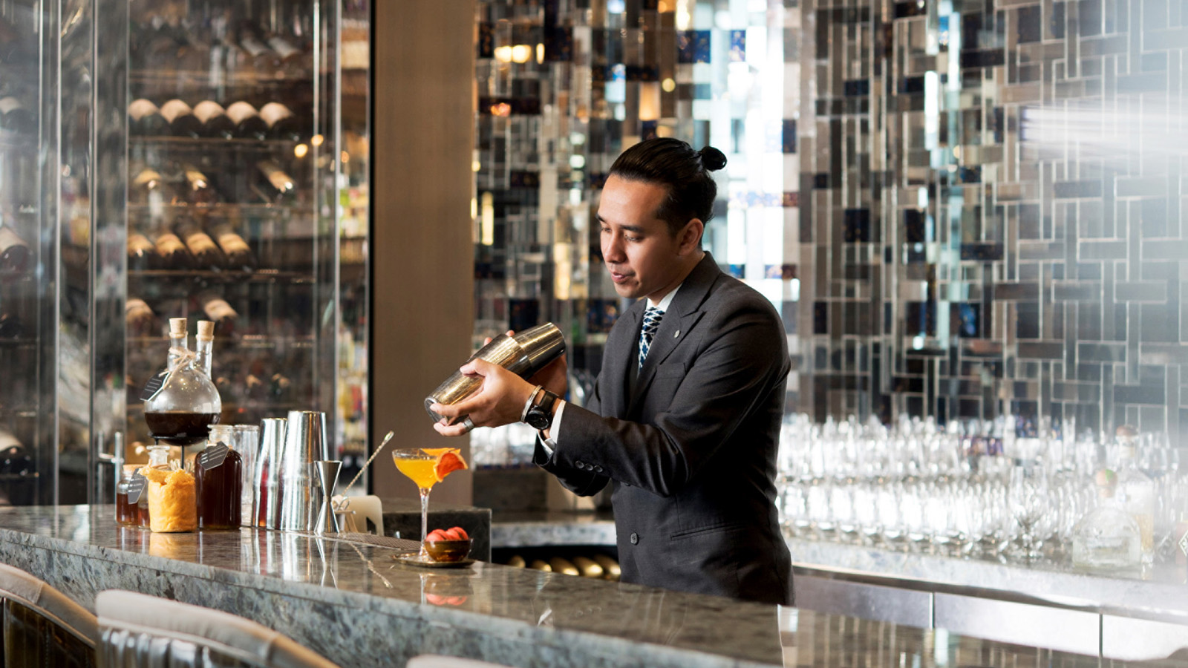
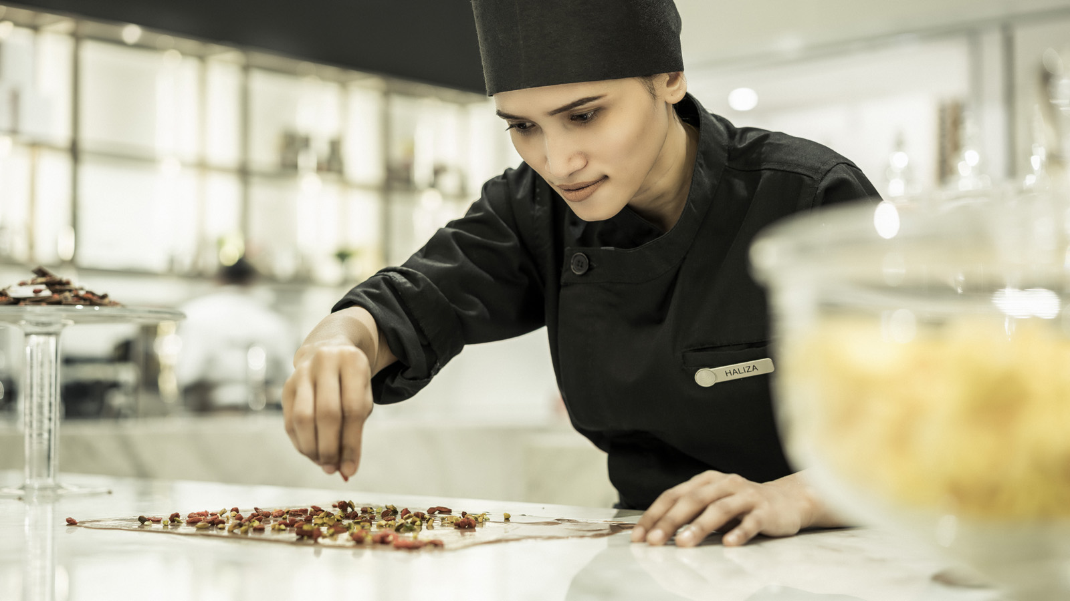 |  | 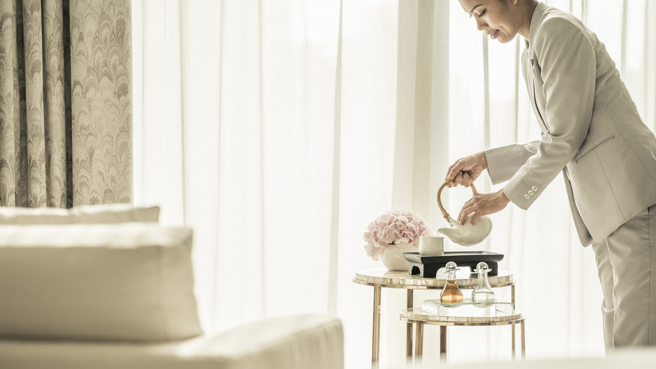
With the world taking a collective pause, why not make the most of being homebound? Team members at Four Seasons Hotel Kuala Lumpur share their favourite ways to spark joy, stay healthy and keep occupied during these unprecedented times – from meaningful moments of connection and healing, to DIY cocktails to liven up quiet evenings.
Moments of Wellbeing
Weaving small doses of self-care through the day is a great way to stay uplifted and energized. Sarah Radford, the Senior Sales Manager, takes a short break every few hours to practice a different yoga pose. “Warrior II is an easy yet powerful stretch that relieves backaches and stimulates healthy digestion, which is important if you’re sitting around a lot more than usual,” she notes. “More experienced practitioners can try the Bow Pose to strengthen the body and improve posture, and the Wheel Pose to increase spinal flexibility and strengthen the lungs.” Sarah ends the day with a few minutes of rest in Child’s Pose to work out kinks and unwind.
Meanwhile, Imbi Sarv, the Director of Sales, is focusing on optimism. Joined by her young son, she has been fostering feelings of gratitude and solidarity through small actions, such as lighting a candle in appreciation of Mother Earth. As Imbi explains, “Of course, we’re all trying to eat healthy and exercise, but it’s also important to heal the spirit.”
Speaking of holistic wellbeing, The Spa at Four Seasons will be welcoming guests back later this summer. With an array of restorative treatments, this urban haven certainly deserves a place on future bucket-lists. Restore healthy radiance to skin with advanced beauty technologies such as Mesotherapy, or rebalance with natural therapies such as the Rotan Manau Herbal Tungku Massage. Over at the well-equipped Fitness Centre, personal trainers will be available to help guests get back in shape after the long lockdown.
Daily Rituals for Joy
With all the extra hours at home, there’s never been a better time to find fresh inspiration and initiate joy-giving rituals. Kanchana Ganglani, Director of Public Relations, has rediscovered the art of cross-stitching. Whether weaving a dream pattern or simply focusing on the precision of each stitch, this time-honoured craft calms the mind and centres the energies. “It’s the perfect antidote to stress, and it helps me get into the right frame of mind,” explains Kanchana.
Meanwhile, Public Relations Executive Noey AbdHamid loves to brighten up her morning with sweet treats – homemade crepes, ice-cream and the best coffee she can find. “I like to make myself a big, beautiful breakfast,” she smiles. “It’s my way of taking care of myself and it sets the perfect tone for the rest of the day.” For Natasya Falina Rahman, the Digital Marketing Manager, her go-to cup of comfort is a rose-tinted concoction made with almond milk, vanilla and rose essence – a soothing drink that keeps her calm and grounded.
With a brand-new delivery and takeaway menu from the Hotel, residents of Kuala Lumpur can now share timeless Malaysian dishes with the family during Holy Month, enjoy international delights for lunch while working from home, or make weekends special with Chinese specialties from Yun House.
Guests can also return to their favourite rituals at the Hotel – be it meeting friends for an afternoon tea at The Lounge, wrapping up business over dinner at Curate, or rejuvenating with weekly treatments at the Spa.
A Splash of Glamour
Aficionados may not be able to visit Bar Trigona for its crafted cocktails and panoramic views for now, but they can still channel its spirit from home. Starting today, DIY cocktail packages are available for delivery and takeaway.
Resident mixologist Shadrach Shan has been shaking up a cocktail or two in his kitchen, “a great way to make an evening at home feel special.” Here, he shares a simplified recipe for TrigoNangka Bees Knees:
- 45 ml Nasty Nangka gin
- 20 ml fresh lemon juice
- 15 ml Trigona honey
Mix all three ingredients, pour over a couple of ice-cubes and voila! The DIY cocktail is ready to be Instagrammed and sipped.
The award-winning team of Bar Trigona, including Head Bartender Ashish Sharma, is sharing more DIY specials over at Instagram – follow for updates.
Follow on Facebook, Instagram or #FSConnectsatHome to see what else Four Seasons Hotel Kuala Lumpur team members are up to at home. Get in touch at reservations.kualalumpur@fourseasons.com or to book a stay online at this luxurious urban sanctuary.

RELATED

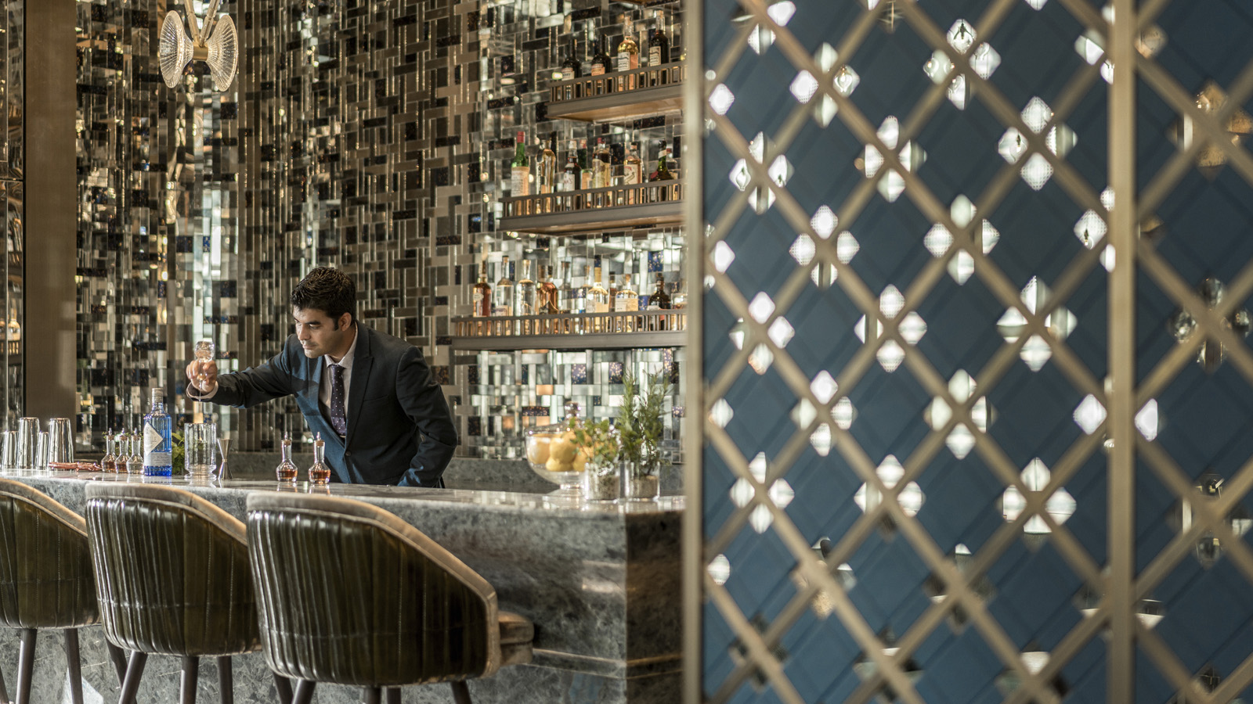 | April 23, 2020, Kuala Lumpur, Malaysia  Raise a Toast (Again!) to Asia’s Most Sustainable Bar at Four Seasons Hotel Kuala Lumpur  https://publish.url/kualalumpur/hotel-news/2020/bar-trigona-asias-most-sustainable-bar.html
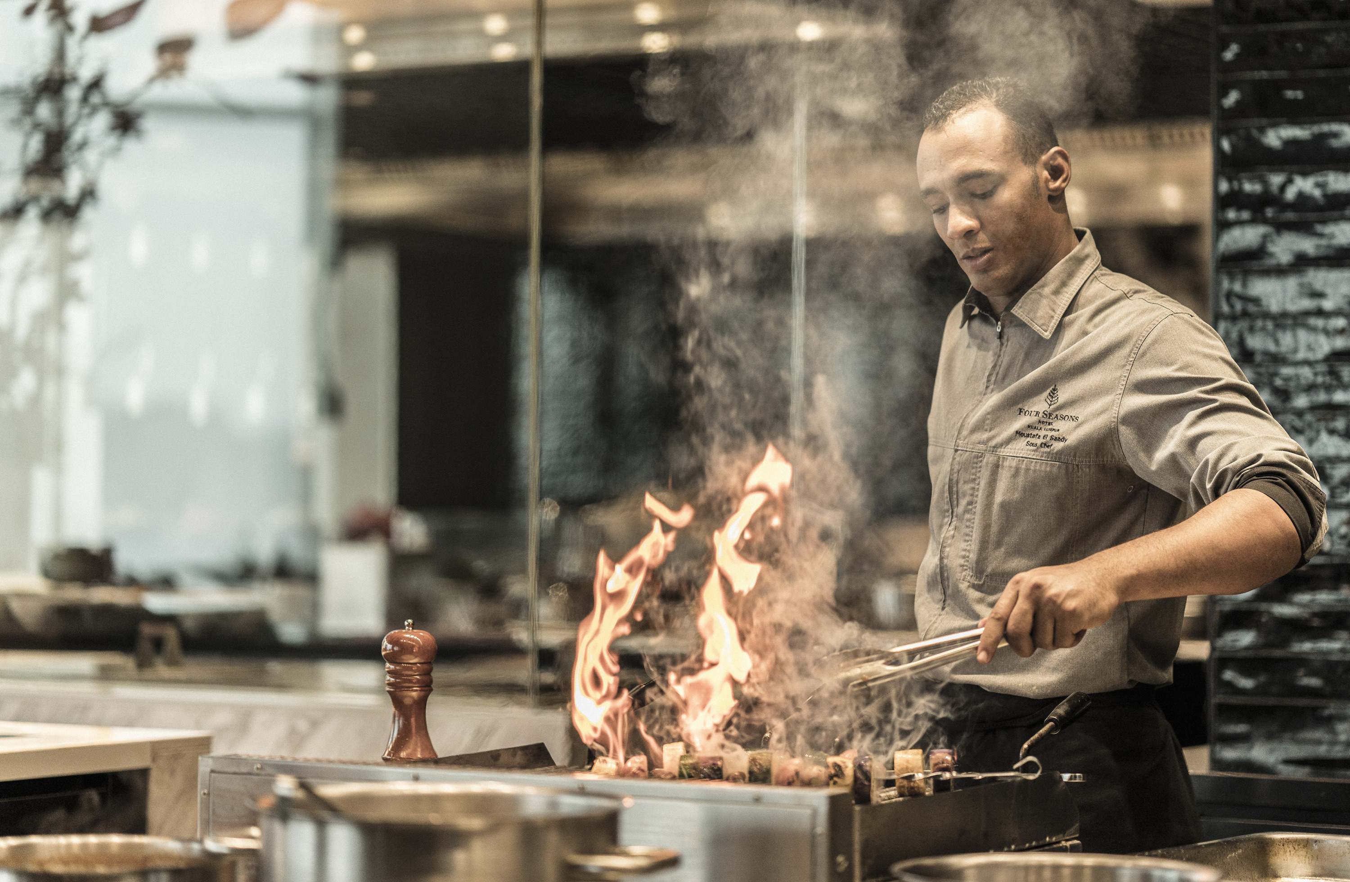 | April 20, 2020, Kuala Lumpur, Malaysia  From the Kitchens of Four Seasons Hotel Kuala Lumpur to Your Doorstep  https://publish.url/kualalumpur/hotel-news/2020/takeout-and-delivery.html

PRESS CONTACTS

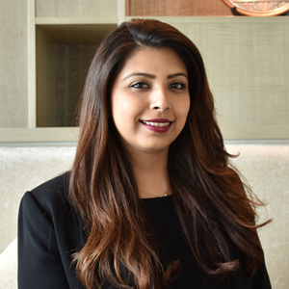 | Kanchana Ganglani  Director of Public Relations  145 Jalan Ampang  Kuala Lumpur  Malaysia  kanchana.ganglani@fourseasons.com  +6(03) 2382 8740

