Jordanian Saa’d Al Fawadleh Promoted to Executive Chef at Four Seasons Hotel Amman

May 15, 2018, Amman, Jordan

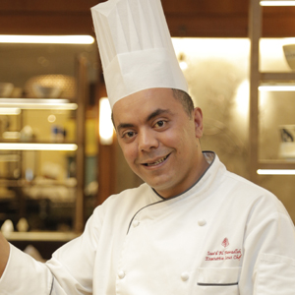
Four Seasons
Hotel Amman announces the promotion of Saa’d Al Fawadleh to Executive Chef, responsible for overseeing all of the Hotel's food and beverage operations that include Olea Restaurant, The Foyer Lounge and Five Grill & Lounge, as well as in-room dining and banqueting events.
Saa'd has been with
Four Seasons
Hotels and Resorts since 2014 when he joined
Four Seasons
Resort Lanai in Hawaii as Sous Chef, and attended task force at
Four Seasons
Hotel Los Angeles at Beverly Hills and
Four Seasons
Resort Hualalai during that same period. He then moved back to his home town in Jordan to take on the role of Executive Sous Chef at the Amman property. A few years later, he achieved his lifetime goal of being the property's Executive Chef.
Jordanian-born Saa'd Alfawadleh was raised in the capital city of Amman. He fell in love with cooking at the age of 8, with his source of inspiration being his father, who was a chef in the Jordanian Army. At a young age, Saa'd he knew exactly what he wanted to do in life - be the best chef he could be.
As the years went by, that passion for cooking never changed. When he was only 15 years old, he took on his first culinary position as an intern at a hotel in Amman. He says he had to start somewhere if he wanted to be an executive chef one day.
With close to 20 years of culinary experience, Saa'd has been around the world through his employment history that includes
Four Seasons
Resort Lanai, Fairmont Hotels & Resorts in Hawaii, Mandarin Oriental Hotel Group in Atlanta, Crowne Plaza in Amman, Marriot Hotel in Knoxville, Emirates Palace Hotel and Intercontinental Hotel in Abu Dhabi.
Saa'd is the first Jordanian to take on the Executive Chef position at the Amman property.

RELATED

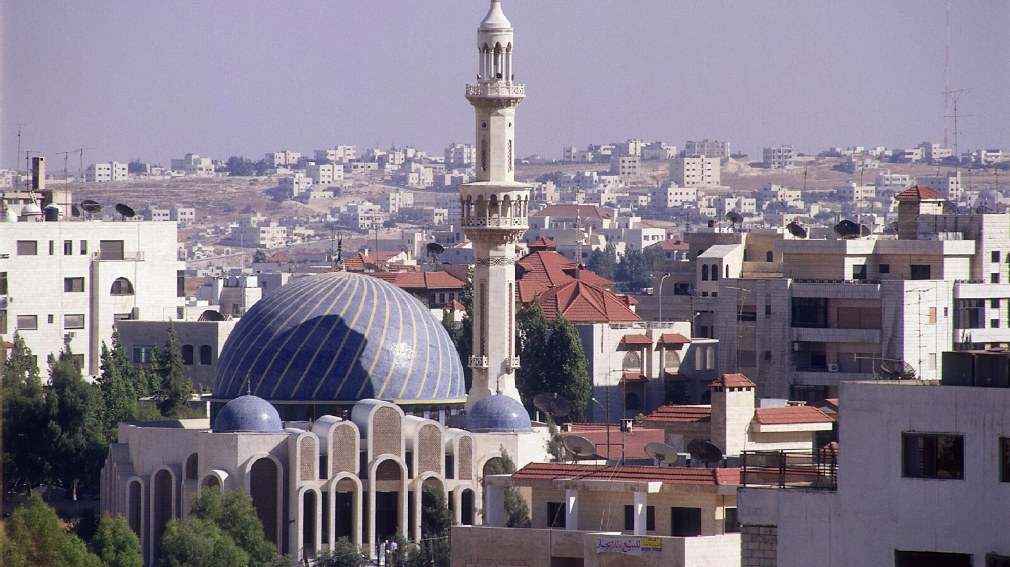 | April 25, 2018, Amman, Jordan  استقبلوا شهر رمضان المبارك في أجمل الأجواء في فندق فورسيزونز عمّان  https://publish.url/ar/amman/hotel-news/2018/ramadan-2.html
April 25, 2018, Amman, Jordan
Celebrate the Holy Month of Ramadan at Four Seasons Hotel Amman
https://publish.url/amman/hotel-news/2018/ramadan.html

PRESS CONTACTS

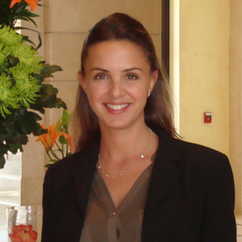 | Yasmin Sati  Director of Public Relations  Al Kindi Street, 5th Circle, Jabal Amman  Amman  Jordan  yasmin.sati@fourseasons.com  962 6 550 5555

