Celebrate Spring with a Spectacular Easter Brunch at Four Seasons Hotel One Dalton Street, Boston

March 23, 2023, Boston, U.S.A.

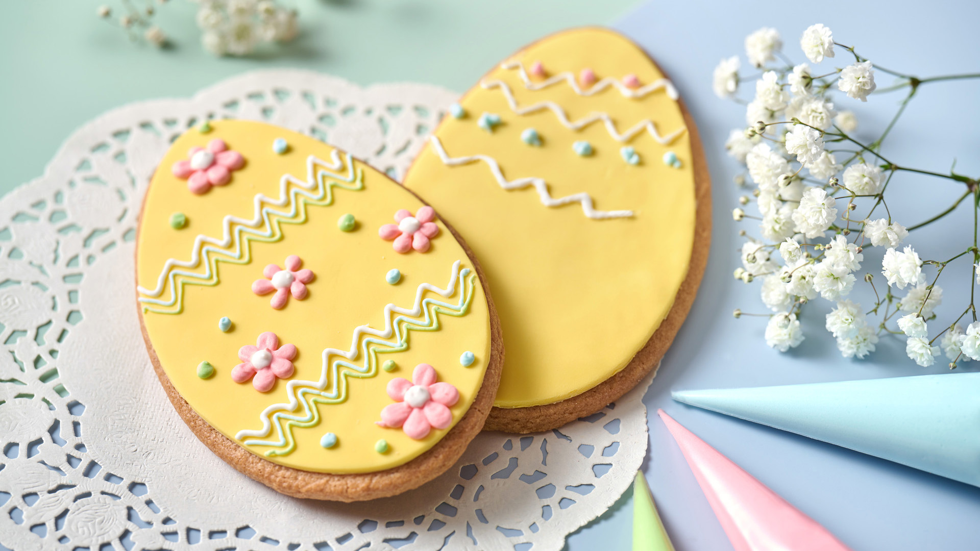
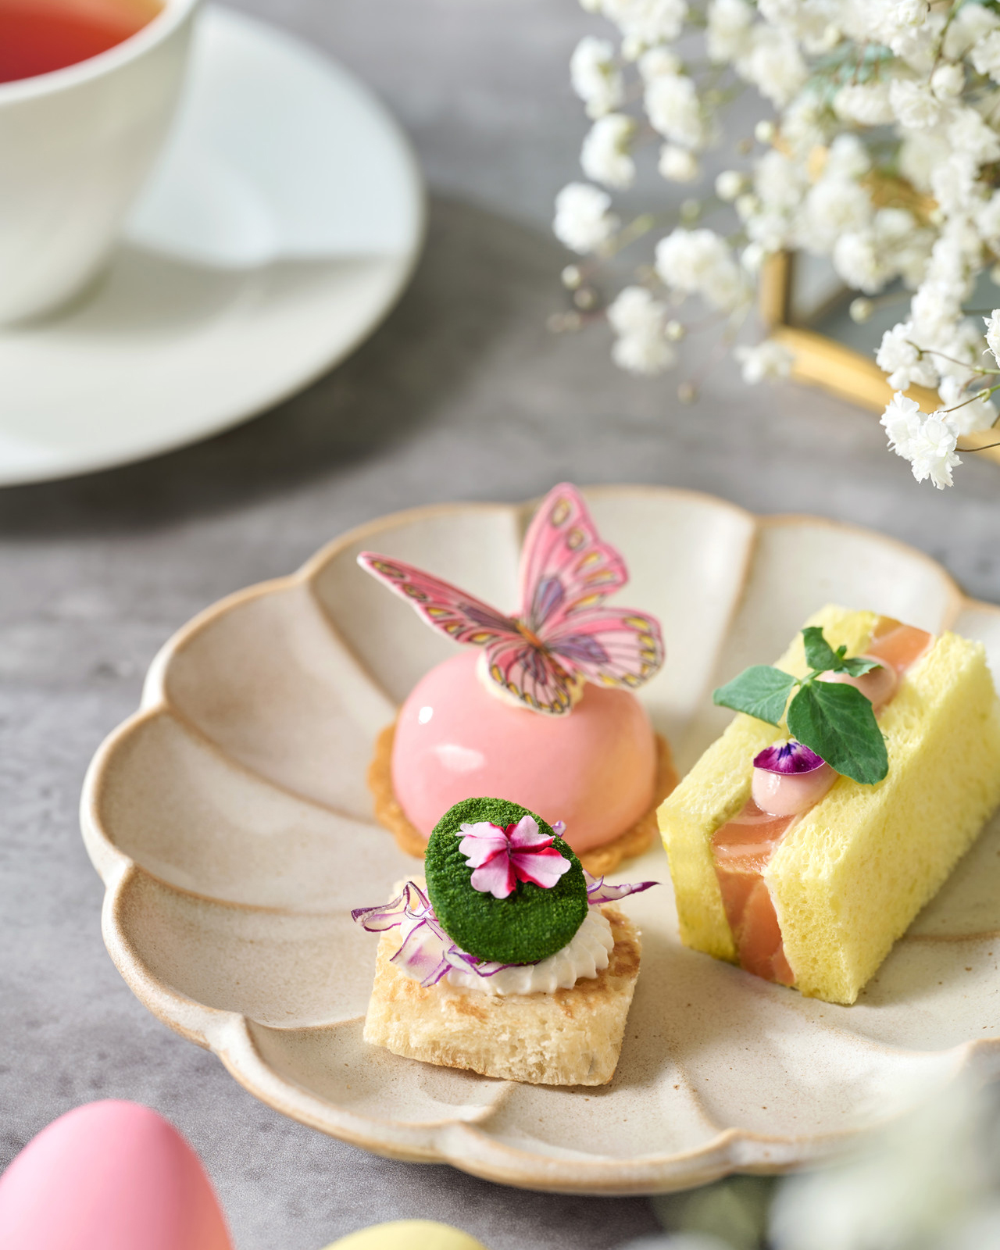 | 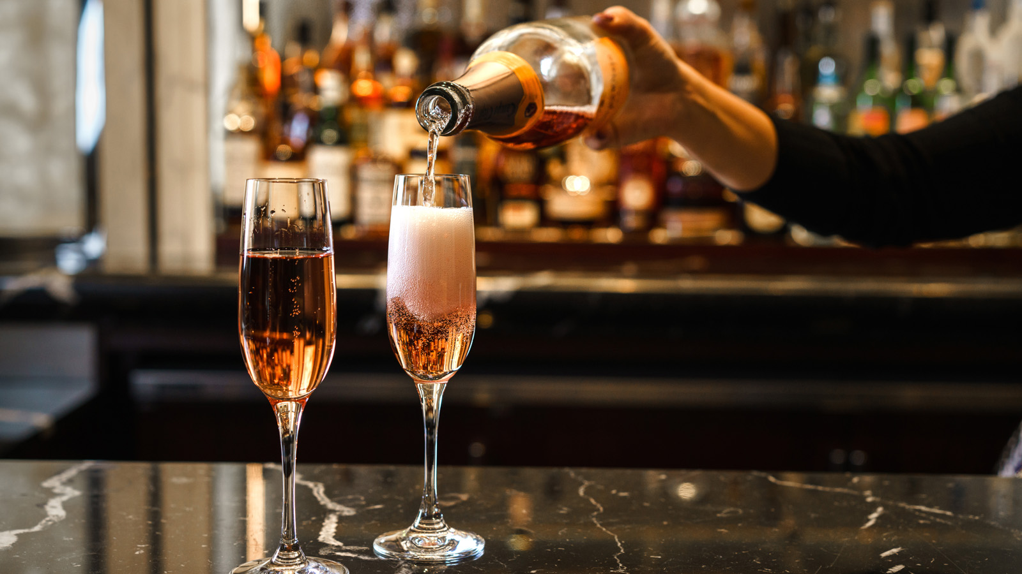 | 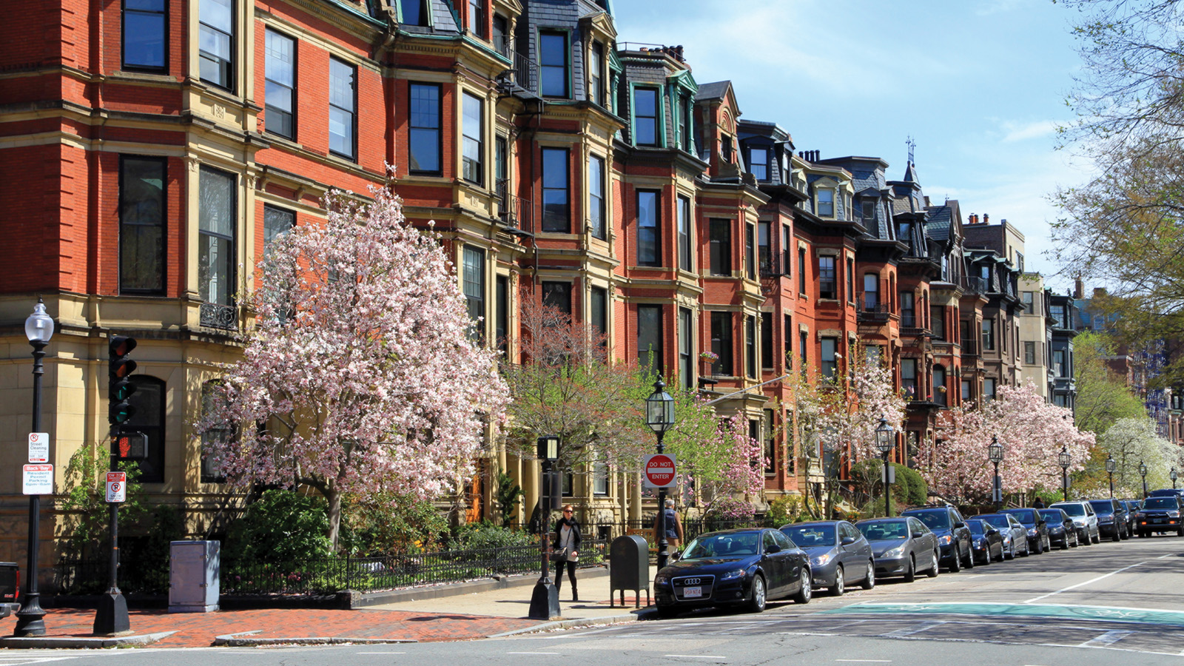
Celebrate the blooming springtime in Boston with a gourmet Easter brunch perfect for friends and family to enjoy. Allow Four Seasons Hotel One Dalton Street, Boston to serve as the perfect backdrop for Easter celebrations complete with a grand brunch experience, decadent raw bar, vibrant and whimsical dessert, ice cream station and more.

RELATED

February 15, 2023, Boston, U.S.A.
Four Seasons Hotel One Dalton Street, Boston Earns Ten Stars in Forbes Travel Guide 2023 Star Awards for the Second Consecutive Year
https://publish.url/onedalton/hotel-news/2023/forbes-five-star-hotel-and-spa.html

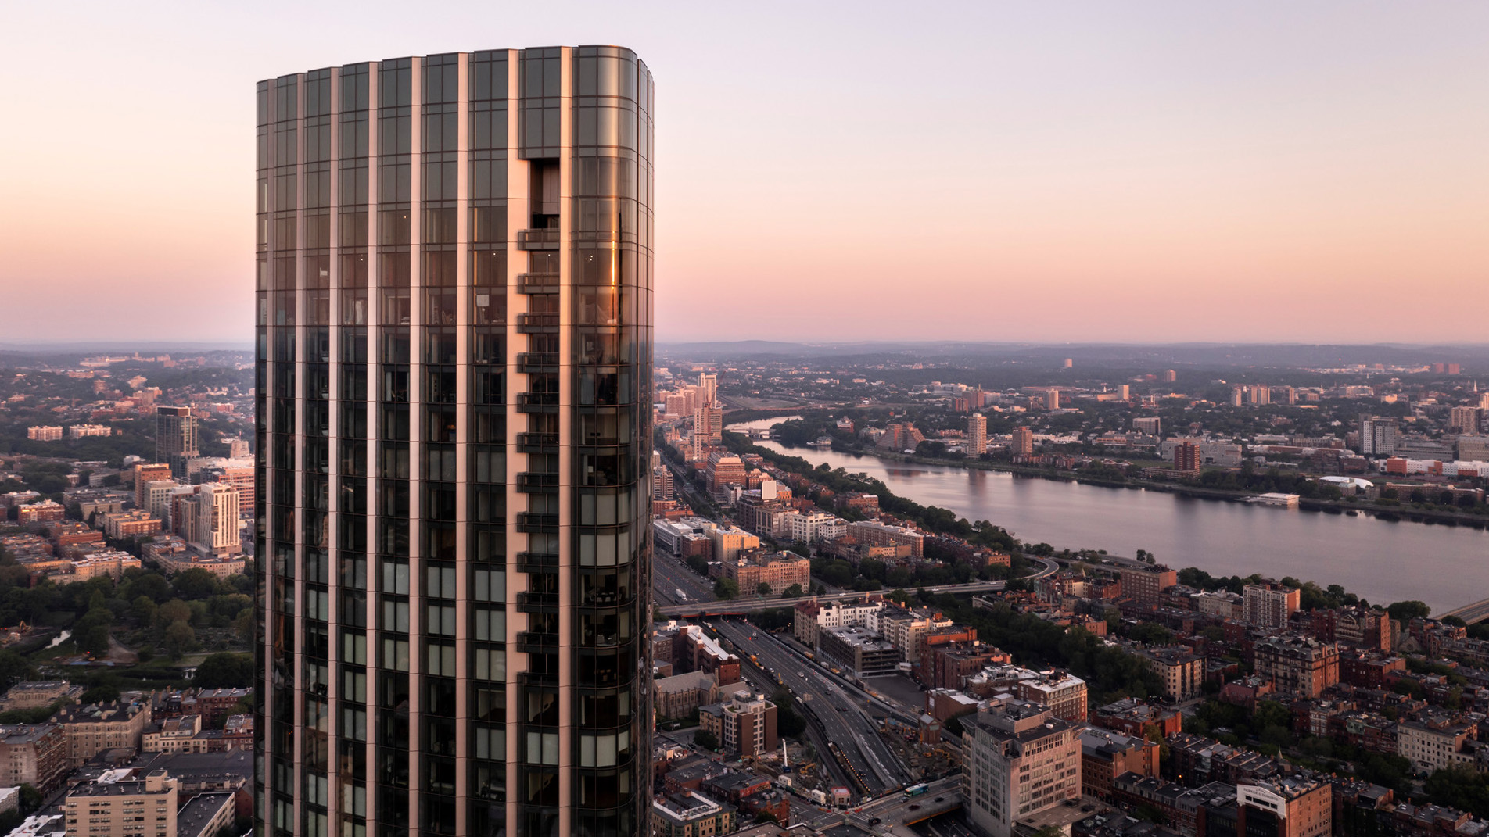 | February 8, 2023, Boston One Dalton, U.S.A.  Four Seasons Hotel One Dalton Street, Boston is the #1 Hotel in Boston, #1 in Massachusetts and #16 in the US According to U.S. News & World Report  https://publish.url/onedalton/hotel-news/2023/best-hotel-in-boston.html

PRESS CONTACTS

Vanessa Morin
Senior Director of Public Relations
27 Barclay Street
New York
USA
vanessa.morin@fourseasons.com

+1 646 880 1917

