Four Seasons Hotel Firenze Hosts Annual Open Day on December 17

The charity event hosted annually at
Four Seasons
Hotel Firenze will be dedicated to raising funds for the rebuilding of two schools devastated by the Livorno downpour last September
October 30, 2017, Florence, Italy

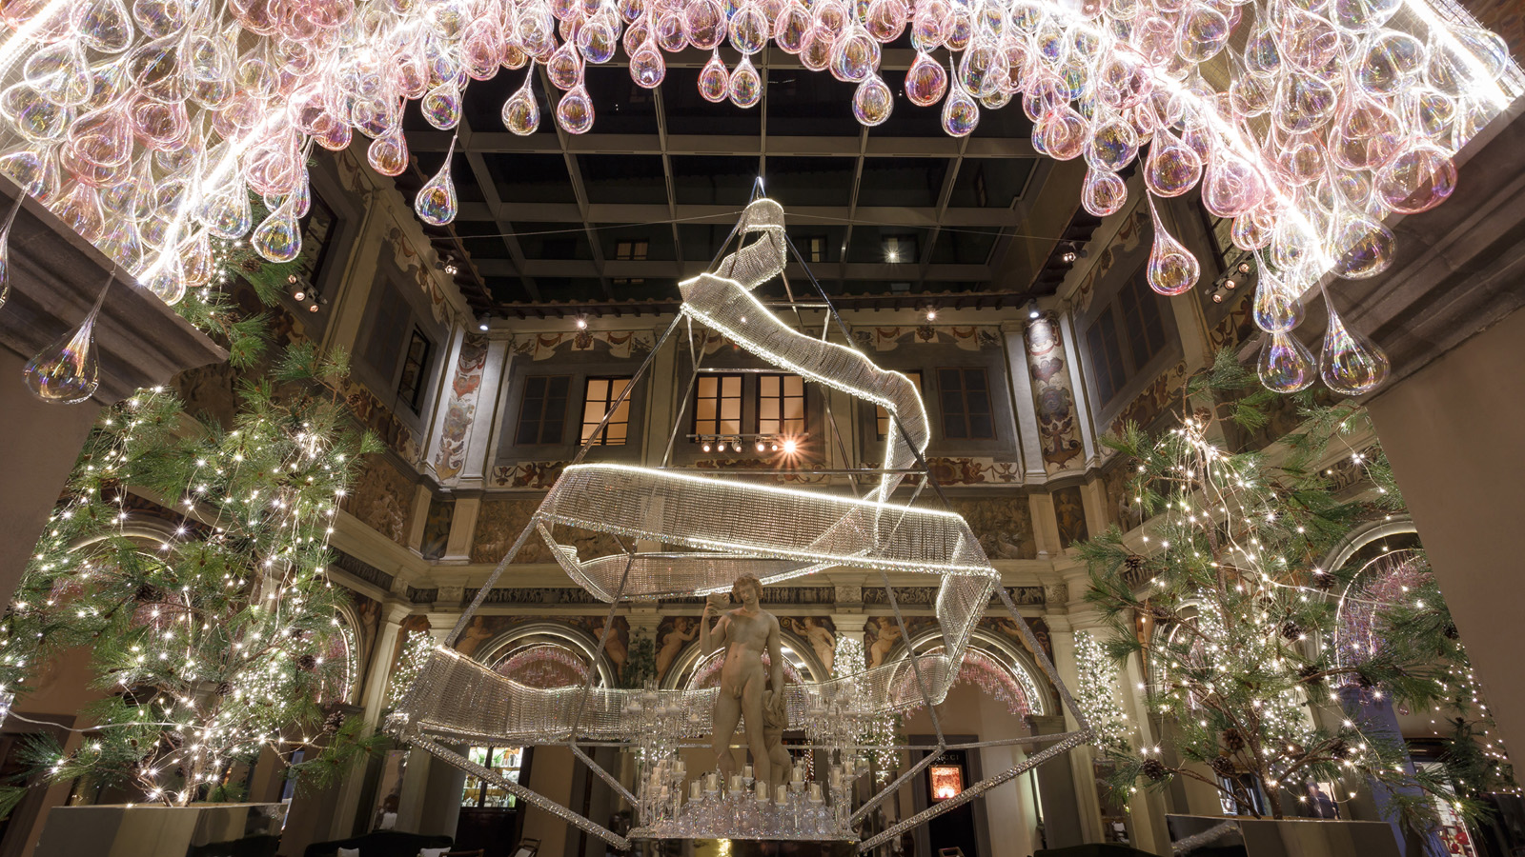 | 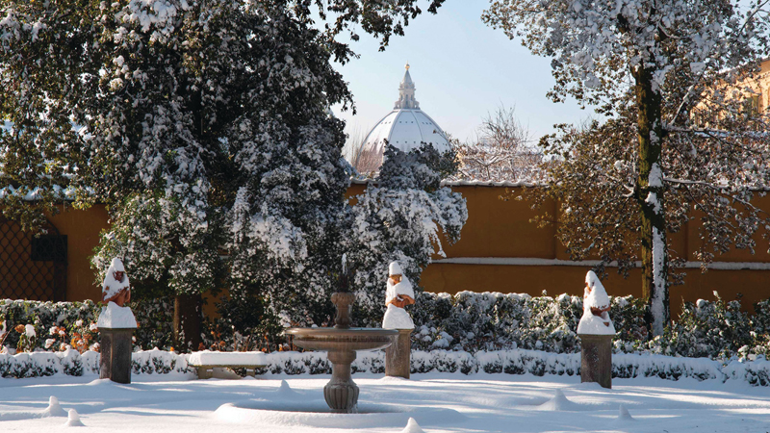
On Sunday, December 17, 2017,
Four Seasons
Hotel Firenze will host the 10th edition of its annual Open Day, one of the city's most eagerly-awaited Christmas events and a lovely get-together for family and friends for a great charity cause. The Hotel’s garden is the beautiful setting for the event with music, children's entertainment and the pleasure of sharing a special moment.
From 10:00 am to 4:00 pm, guests are free to browse and shop at the many Christmas market stalls set up in the garden, taste chestnuts and popcorn, or enjoy a cup of hot chocolate. Adults are treated to a spicy vin brul&eacute; or a good glass of wine, accompanied by the music of Radio Toscana, the event’s media partner. Entertainment for children and adults is provided by jugglers and magicians, Compagnia di Babbo Natale and Light Gospel Choir.
The “restaurants’ corner” in the garden will host representatives of many restaurants, such as Buca Lapi, Touch Florence, Four D'Acqua, Trattoria Mario, Trattoria Da Burde, and the Hotel’s Il Palagio, which will prepare specialties for attendees. This year, there will also be a pizza corner with the best Tuscan pizzerias, such as Lo Spela, Santarpia, Divina Pizza and Apogeo, and a corner dedicated to Livorno and its neighbourhood, with the Pirata del Polpo of Piombino and the restaurant Oscar.
Great for Christmas shopping, guests may buy products from a wide range of Christmas and holiday gifts on sale throughout the garden. Access to the event is granted by donating the symbolic sum of EUR 1 per adult, with all proceeds going to the rebuilding of two children's schools devastated by the Livorno downpour this past September.
Four Seasons
Hotel Firenze Open Day Details
- Date and time: Sunday, December 17, 2017 from 10:00 am to 4:00 pm
- Entrance from: Via Gino Capponi 54 - Borgo Pinti 97 - P. le Donatello 12
- Admission to the garden: EUR 1 (minimum charity donation)
- For information: (+39) 055.26261

RELATED

October 30, 2017, Florence, Italy
Open Day 2017: Four Seasons Hotel Firenze per i Bambini Colpiti dal Nubifragio di Livorno, Dicembre 17
https://publish.url/it/florence/hotel-news/2017/open-day-2.html

October 25, 2017, Florence, Italy
Four Seasons Hotel Firenze presenta il programma delle vacanze natalizie, il momento ideale per scoprire la magia di Firenze durante le festività
https://publish.url/it/florence/hotel-news/2017/festive-season-2.html

PRESS CONTACTS

Caroline Mennetrier
Director of PR and Marketing Communication
Borgo Pinti, 99
Firenze
Italy
caroline.mennetrier@fourseasons.com

+39 02 7708 1795

Martina Nesti
Public Relations and Marketing Communications Coordinator
Borgo Pinti, 99
Firenze
Italy
martina.nesti@fourseasons.com

+39 055 2626222

