Four Seasons Hotel Washington, DC Celebrates Love This Valentine’s Day

January 27, 2021, Washington, DC, U.S.A.

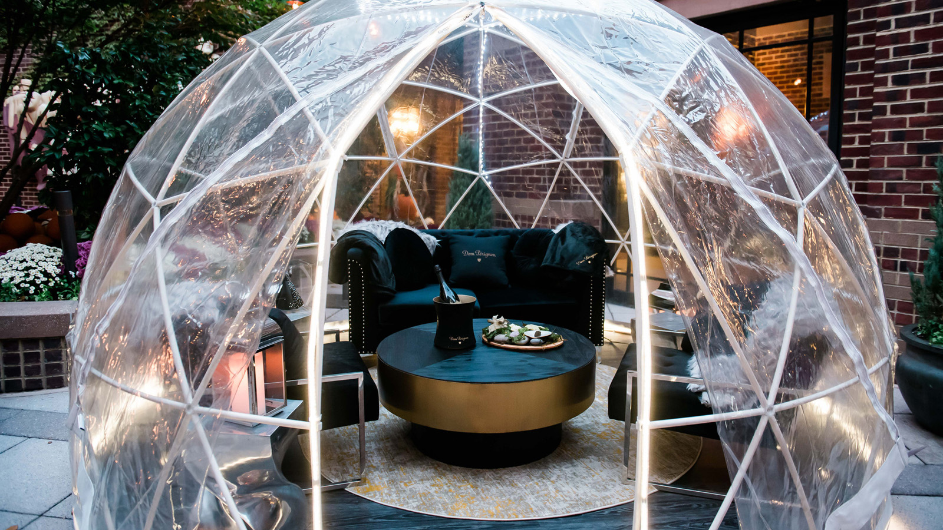
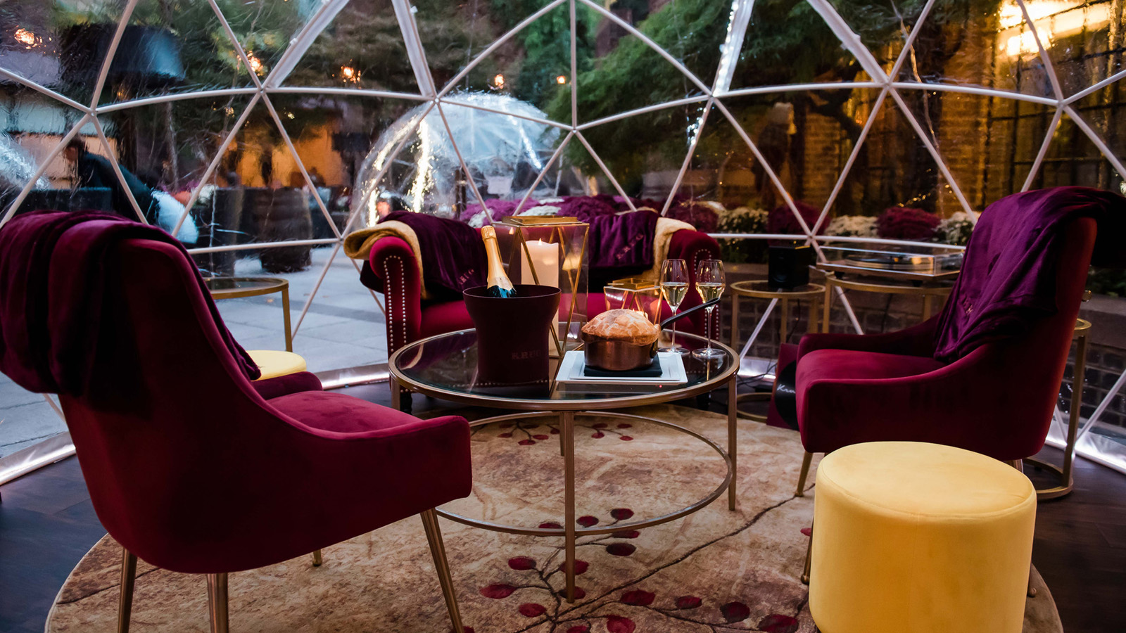 |  | 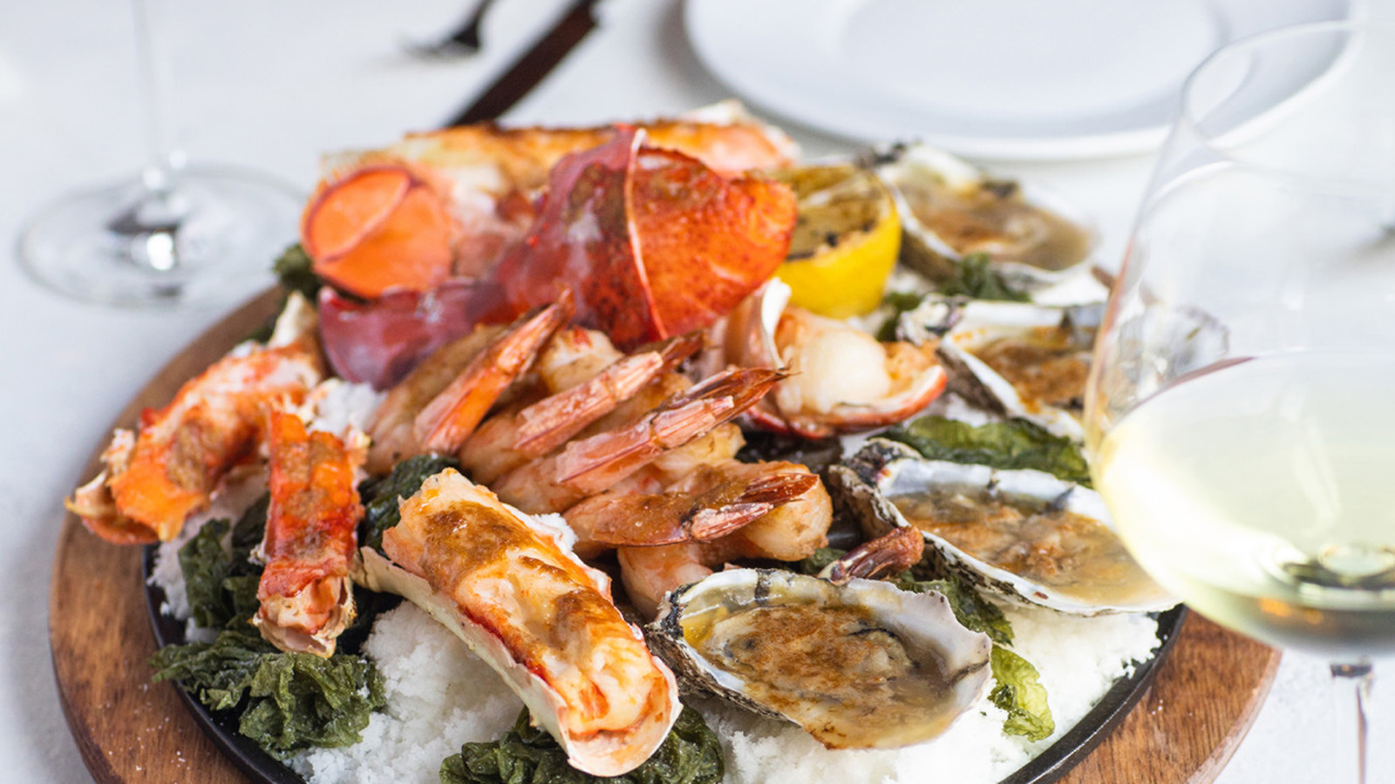
Four Seasons Hotel Washington, DC celebrates love this Valentine’s Day with romantic specials for staying in, going out or pampering oneself.
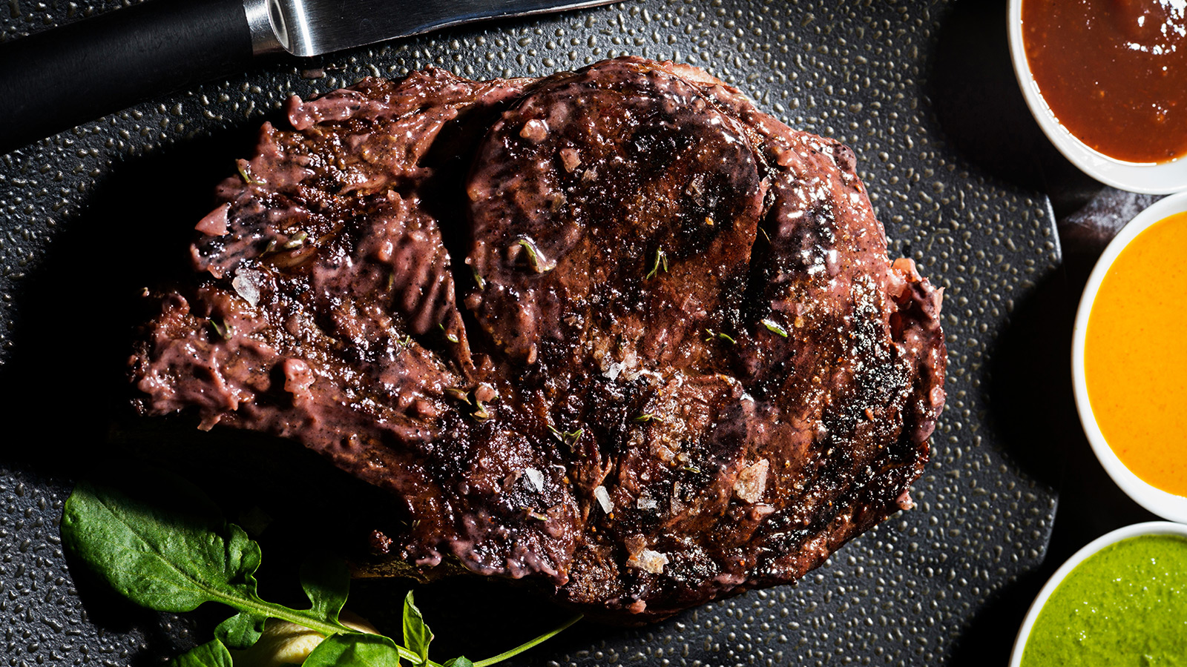 | 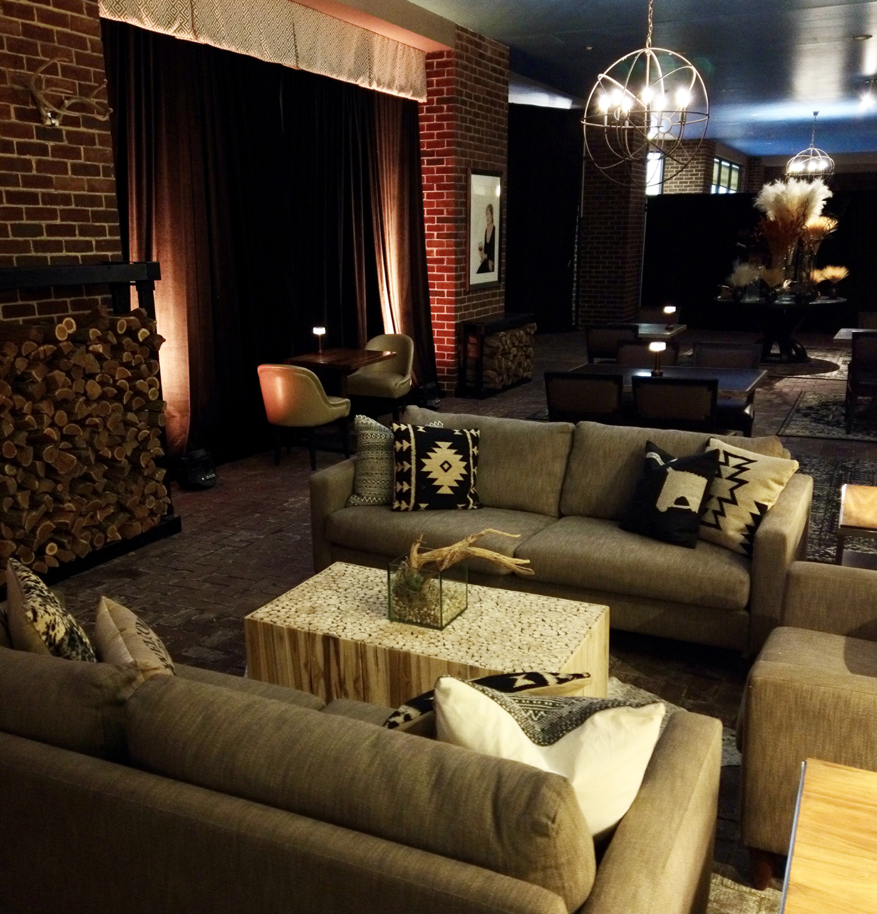
Valentines weekend heats up at BOURBON STEAK, whether staying in at home or dressing up to go out. Executive Chef Robert Curtis has prepared Valentine’s Day Specials to delight diners available from Friday, February 12 to Sunday, February 14, 2021.
Fire up the taste buds when dining in at BOURBON STEAK starting with lobster carpaccio accompanied by hearts of palm, Calabrian chile and fennel. A romantic special of grilled spring fluke served with radishes, mint salad and green garlic pistou offers a delicious combination of sultry and fresh, crisp flavours. The full BOURBON STEAK menu is available with dishes to please every palate. Lovers of seafood will delight in the miso-buttered shellfish platter featuring oysters, gulf shrimp, king crab and lobster, perfect for sharing. Red velvet mousse cake is a decadent end to the meal with cream cheese cremeux and vanilla ice cream. Reservations are available for indoor dining and outdoor dining in the heated, covered patio called The Ranch.
Through Valentine’s Day weekend and all through the month of February 2021, guests can choose to stay in their own little bubble within the luxurious Dom Pérignon, Krug, or Ruinart Champagne bubbles or Bourbon Ice bubble on the BOURBON STEAK terrace. Passionate patrons can clink glasses and feast to their heart’s content with a full selection of BOURBON STEAK’s delicious dishes matched with the incomparable elegance of fine spirits. Bubbles book up in advance and are available to rent for USD 500 with a USD 250 minimum food and beverage spend per person. Bubble guests who wish to continue their evening are welcome to reserve a luxurious room at the Hotel for a special rate of USD 350 per night over Valentine’s Day weekend.
If a cosy night at home is desired, Chef Curtis has prepared a BOURBON STEAK Classics Menu for two available for contact-less pick up. Indulge in BOURBON STEAK favourites – the classic wedge salad, a bone-in New York strip steak to share, truffle mac & cheese, whipped potatoes and the most decadent of desserts, the Bourbon chocolate bar. Accompanied by a half bottle of Thibaut-Jannison Virginia sparkling wine, guests can enjoy the best of BOURBON STEAK in their own home. Pick up menu is USD 250 and available for reservation on Tock.
For guests who wish to treat themselves to some indulgent pampering, The Spa at Four Seasons Hotel Washington, DC is offering a Cocoa Rose enhancement to any body treatment for USD 35. Revel in luxury with a hand, foot or back exfoliating sugar scrub while sipping a pomegranate champagne cocktail and macarons made by Pastry Chef Yudith Bustos.
The safety and security of guests and employees remains top priority and, as such, Four Seasons Hotel Washington, DC has embarked on an enhanced Four Seasons global health and safety program, Lead With Care, to provide ongoing, real-time guidance on the evolving COVID-19 situation. Grounded in health care expertise and enabled by access to leading technologies and tools, Lead With Care sets out clear procedures that educate and empower employees to take care of guests and each other. Through the Lead With Care program, Four Seasons Hotel Washington, DC focuses on enhancing cleanliness, guest comfort and safety and employee training. All employees and guests are required to submit to a temperature check upon arrival on property. Heightened cleanliness measures are in place and all guests and employees must wear a mask at all times, except while seated at BOURBON STEAK.
Plan a winter getaway to Four Seasons Hotel Washington, DC and call +1 202 342 0444 to benefit from a Stay Longer – Third Night Free offer.

RELATED

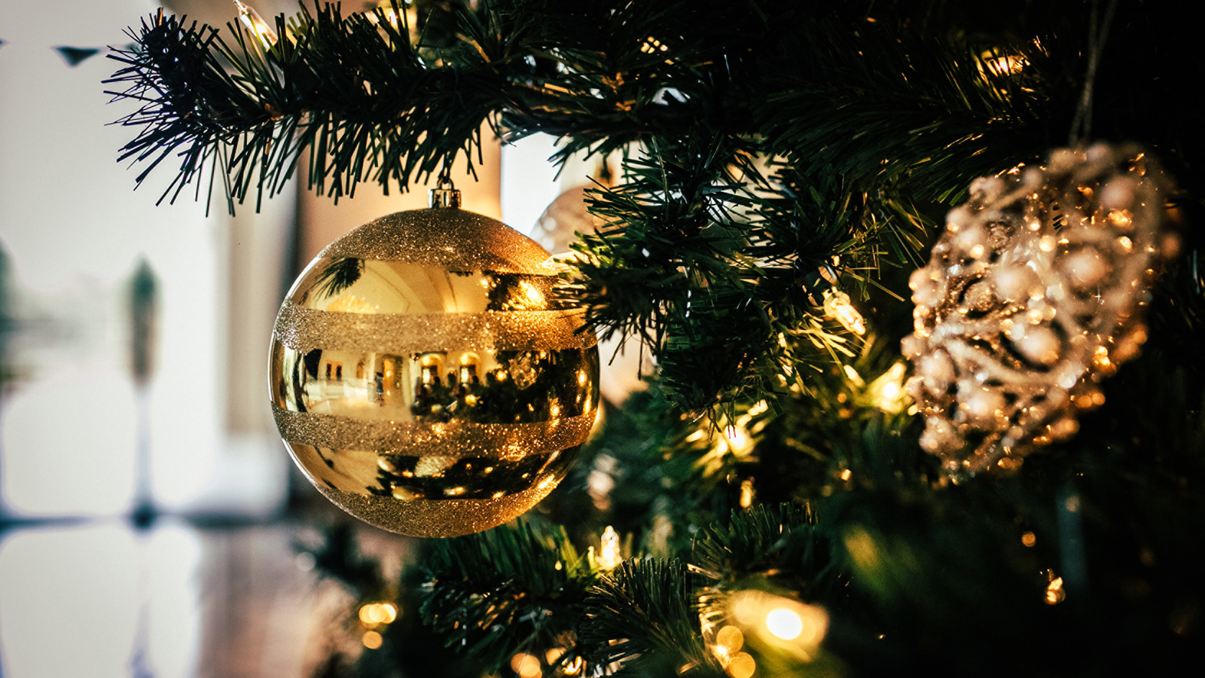 | December 4, 2020, Toronto, Canada  Discover the Holidays Along the US North East Coast with Four Seasons Hotels  https://publish.url/news-releases/2020/urban-festive-getaways.html
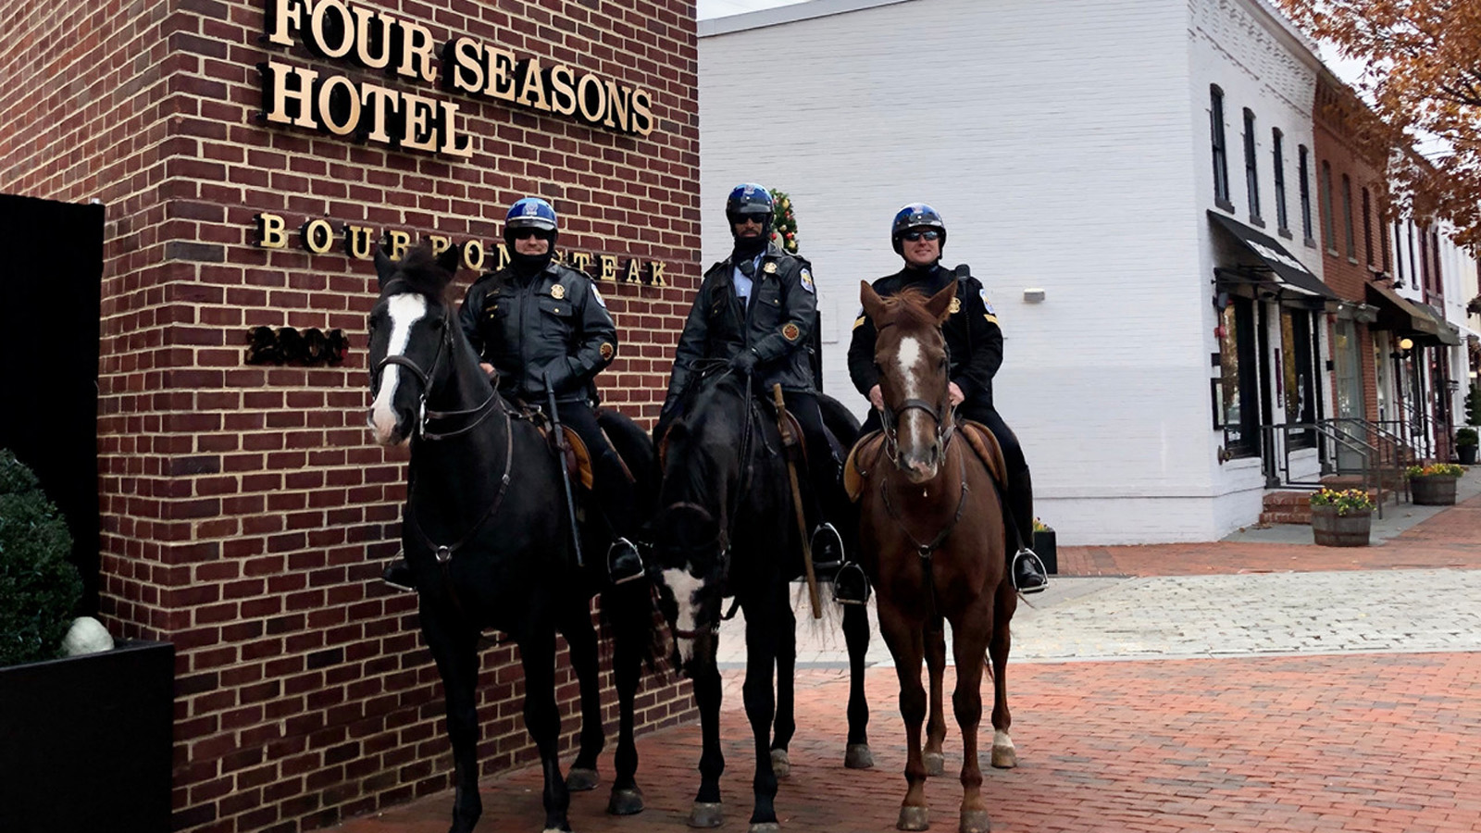 | November 10, 2020, Washington, DC, U.S.A.  Four Seasons Hotel Washington, DC Salutes Washington’s Public Service Heroes During Annual “Thanksgiving on the Mayflower”  https://publish.url/washington/hotel-news/2020/thanksgiving-on-the-mayflower.html

PRESS CONTACTS

Anina Belle Giannini
Director of Public Relations
2800 Pennsylvania Avenue N.W.
Washington
U.S.A.
aninabelle.giannini@fourseasons.com

+1 202 944 2074

