Four Seasons Resort Bali at Jimbaran Bay Launches Night Spa Exclusively for Imperial Villa Guests

Ocean-edge treatment provides ultimate inspiration for sweet dreams
March 26, 2019, Bali at Jimbaran Bay, Indonesia

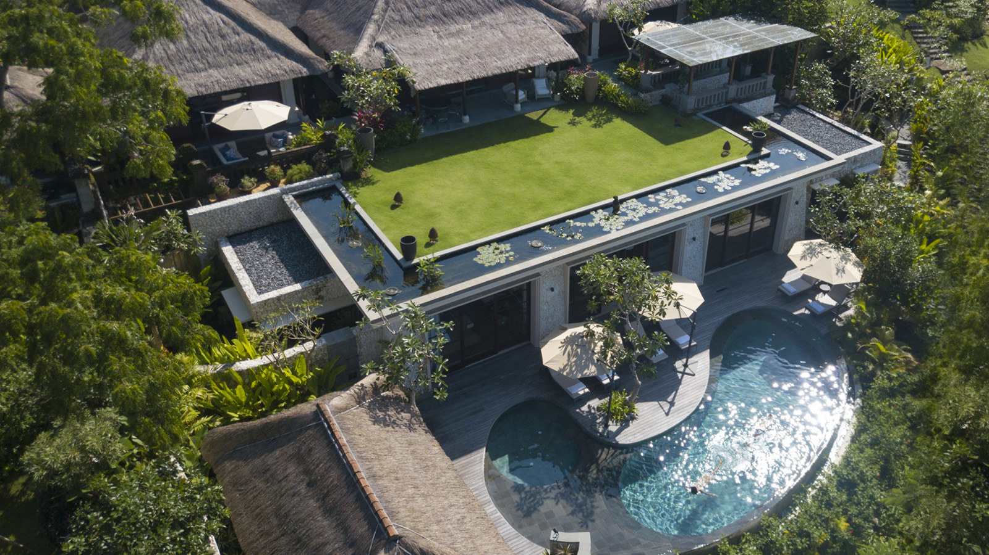 | 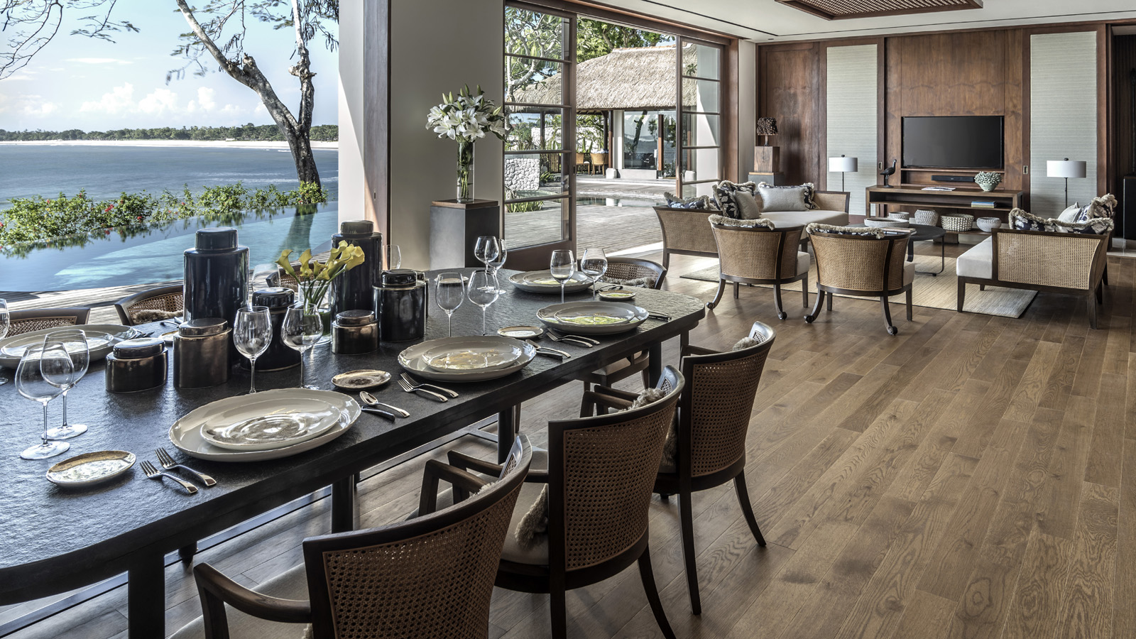
Just when you thought Bali’s most exclusive coastal villa could not be any more indulgent, guests of the Imperial Villa at Four Seasons Resort Bali Jimbaran Bay are now able to be soothed to sleep under the stars, with a new in-villa Night Spa ritual.
Sekar Malam, or “flowers of the night” in Indonesian, is a 2.5 hour treatment only available for couples staying at the three-bedroom Imperial Villa. Set in the privacy of the two-storey villa’s ocean-front garden, the treatment has been designed to unite couples emotionally, cleanse energy spiritually, and relax physically to ensure the most restful night’s sleep.
Starting at 9:00 pm, it is a sensuous and aromatic experience that showcases the unrivalled location of the Imperial Villa and unsurpassed expertise of the Healing Village Spa’s therapists. “Few places offer both the connection with nature and absolute privacy necessary for couples to surrender their senses to a dreamy night spa ritual,” says Luisa Anderson, Regional Spa Director for Four Seasons Resorts Asia-Pacific. “The Imperial Villa is a unique-in-the-world venue for our therapists to share the ancient wisdom of Balinese therapies.”
As Bali settles to sleep, couples are invited to slow their thoughts and listen to the waves on the shore, breathe in the heady scent of frangipanis, and feel the soft sea breeze and healing touch of the spa therapists. A smoothing salt scrub and full body clay wrap are followed by a rose and tuberose flower bath, and restorative Balinese massage. The new range of Sekar Malam spa products are made in Bali using natural ingredients specifically to avoid stimulation and to support intimacy; the wondrous aromas of Balinese temple flowers cananga, cempaka, jasmine and tuberose are perfectly balanced with Indonesian sandalwood.
The next morning, couples awaken to a sense of renewal and the sparkling blue views of the Imperial Villa by day. In-villa breakfast is served by their private chef in the dining room – or perhaps on a floating tray in the swimming pool. Guests also enjoy access to a private yoga instructor and personal trainer at the in-villa gym, and 24-hour butler to attend to every whim. For those eager to explore, the three-mile (five kilometre) beach beckons, and sunset cocktails and live music create a buzz at Sundara beach-club. Meanwhile, traditional fishing boats glide by on their overnight journey, returning each morning with their fresh catch ready to be cooked over a coconut husk barbecue.
From its unique location, the Imperial Villa offers guests both an opportunity to escape and explore. And now, a dreamy Night Spa ritual under a star-lit sky.

RELATED

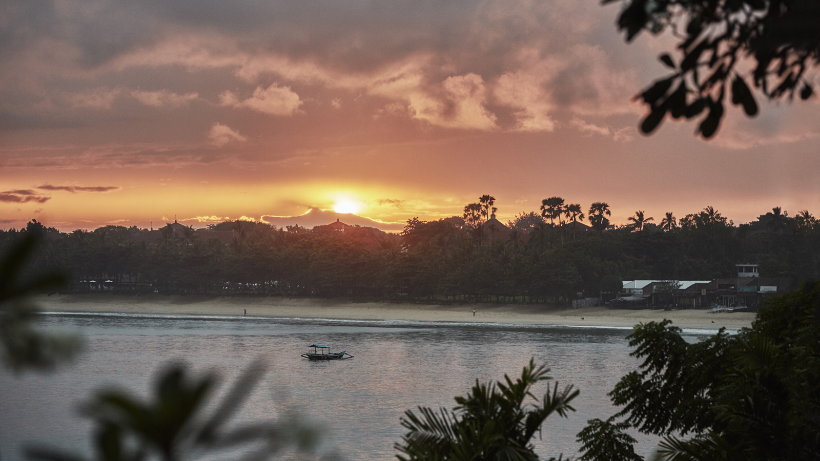 | February 25, 2019, Bali, Indonesia  Four Seasons Resorts Bali: Why Bali’s Annual “Silent Day” Needs to Be on Everyone’s Bucket List  https://publish.url/jimbaranbay/hotel-news/2018/nyepi-silent-day.html
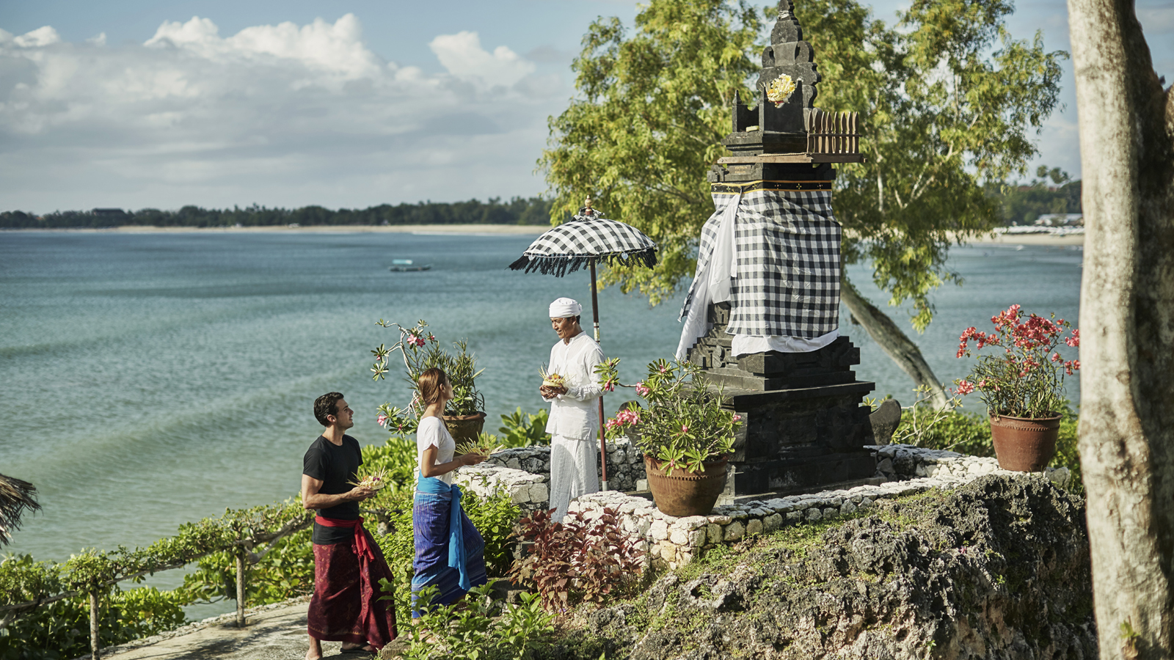 | December 4, 2018, Bali, Indonesia  Dazzling Events and Deep Healing: Keeping the New Year in Balance at Four Seasons Resorts Bali  https://publish.url/jimbaranbay/hotel-news/2018/festive-season.html

PRESS CONTACTS

Marian Carroll
Director of Public Relations

Jimbaran
Indonesia
marian.carroll@fourseasons.com

+62 (361) 701010

