Four Seasons Hotel New Orleans Designated as the Only AAA Five Diamond Hotel in Louisiana

August 16, 2022, New Orleans, U.S.A.

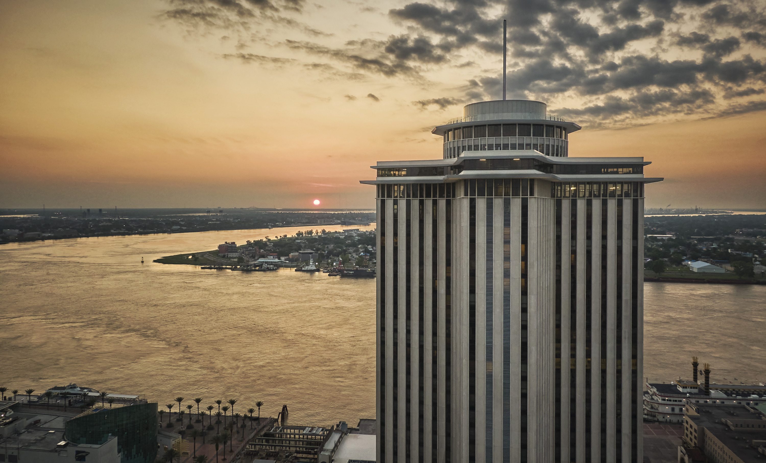
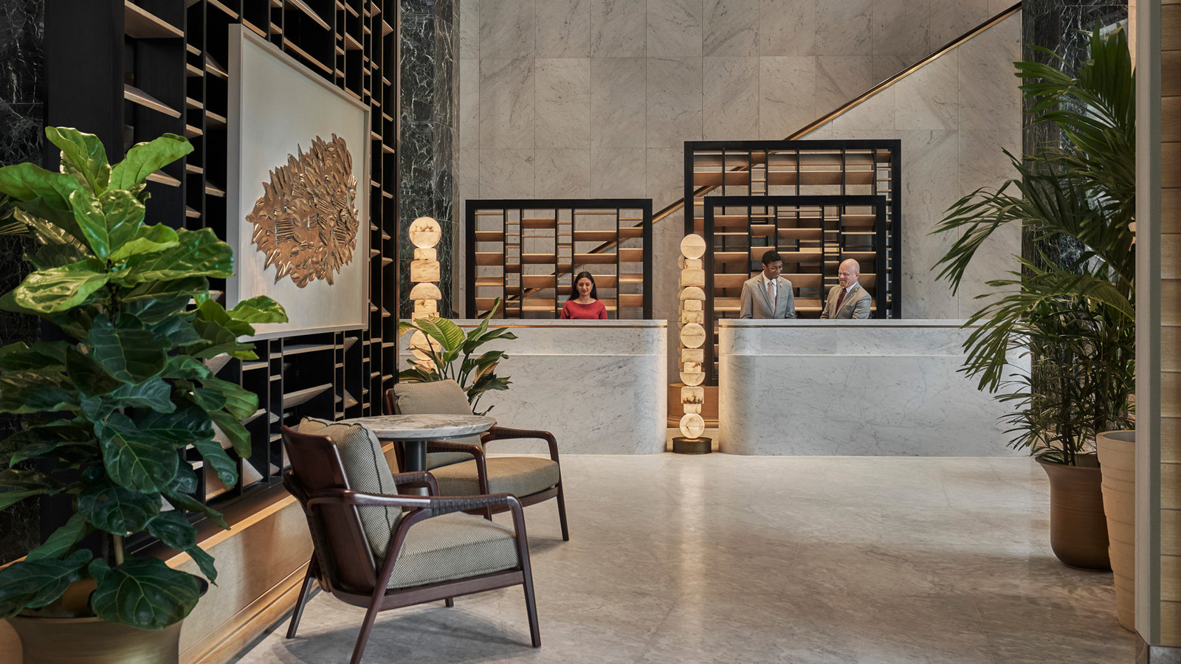 | 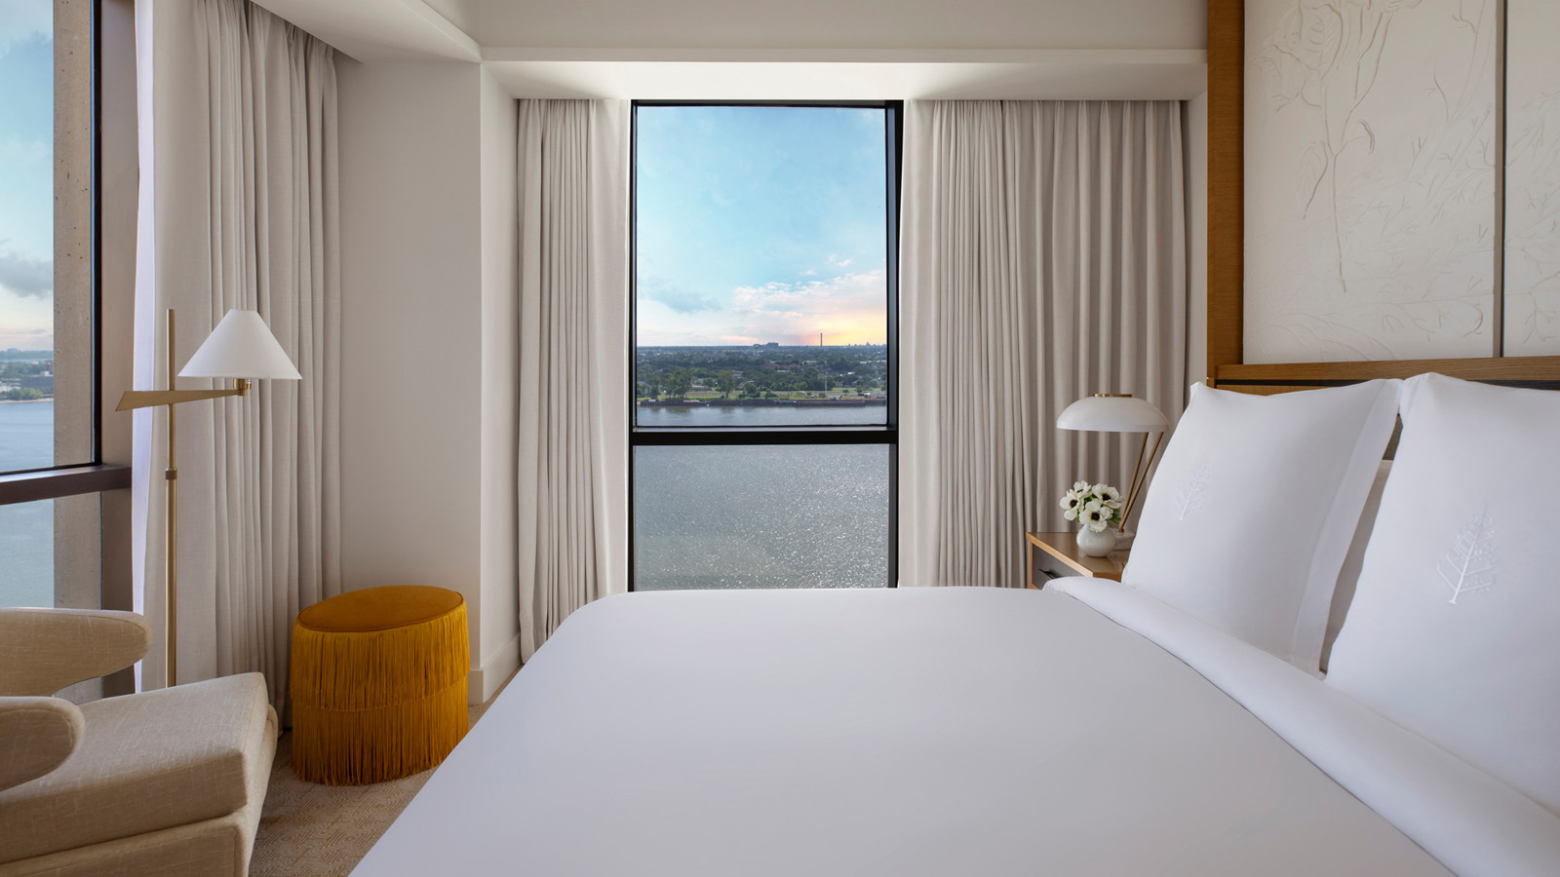 | 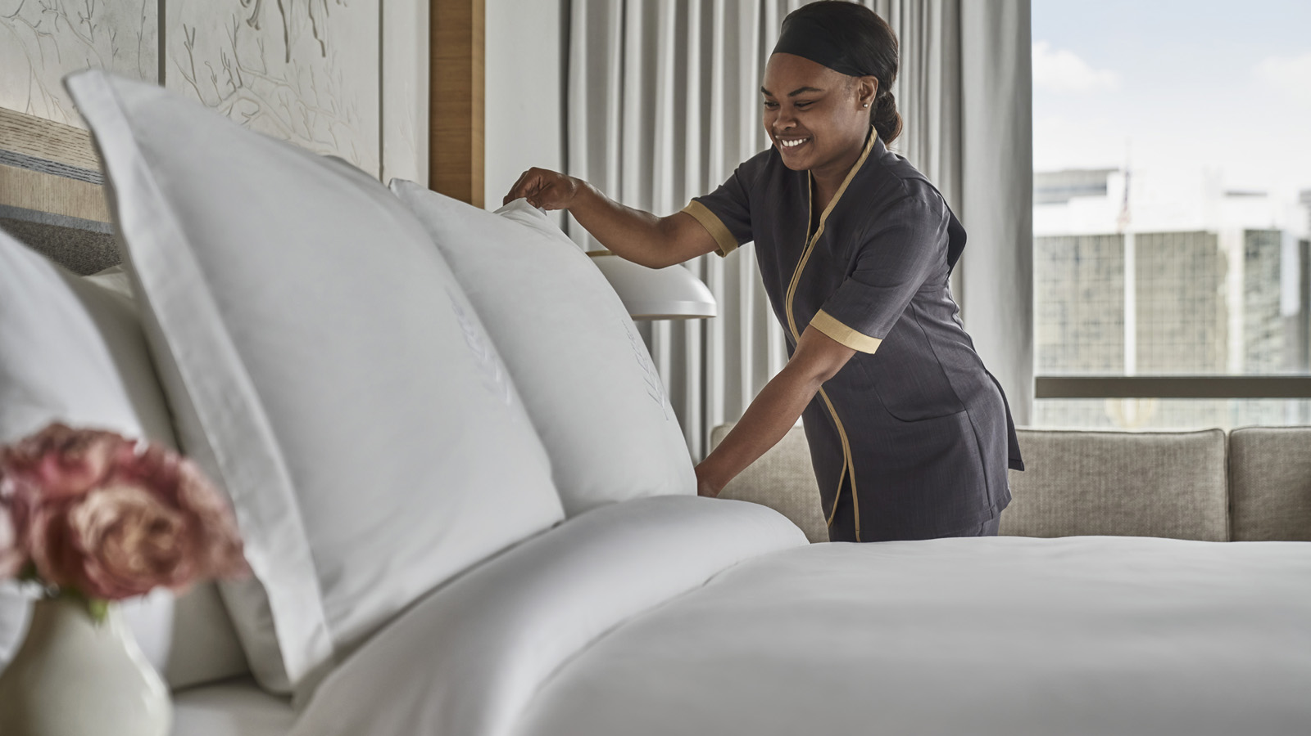
Four Seasons Hotel New Orleans announces that it has been accredited with a AAA Five Diamond hotel designation, the only Hotel in Louisiana bestowed with the award. This is the first time Four Seasons Hotel New Orleans has attained this prestigious honour and is one of just three in North America and the Caribbean added to the 2022 list.
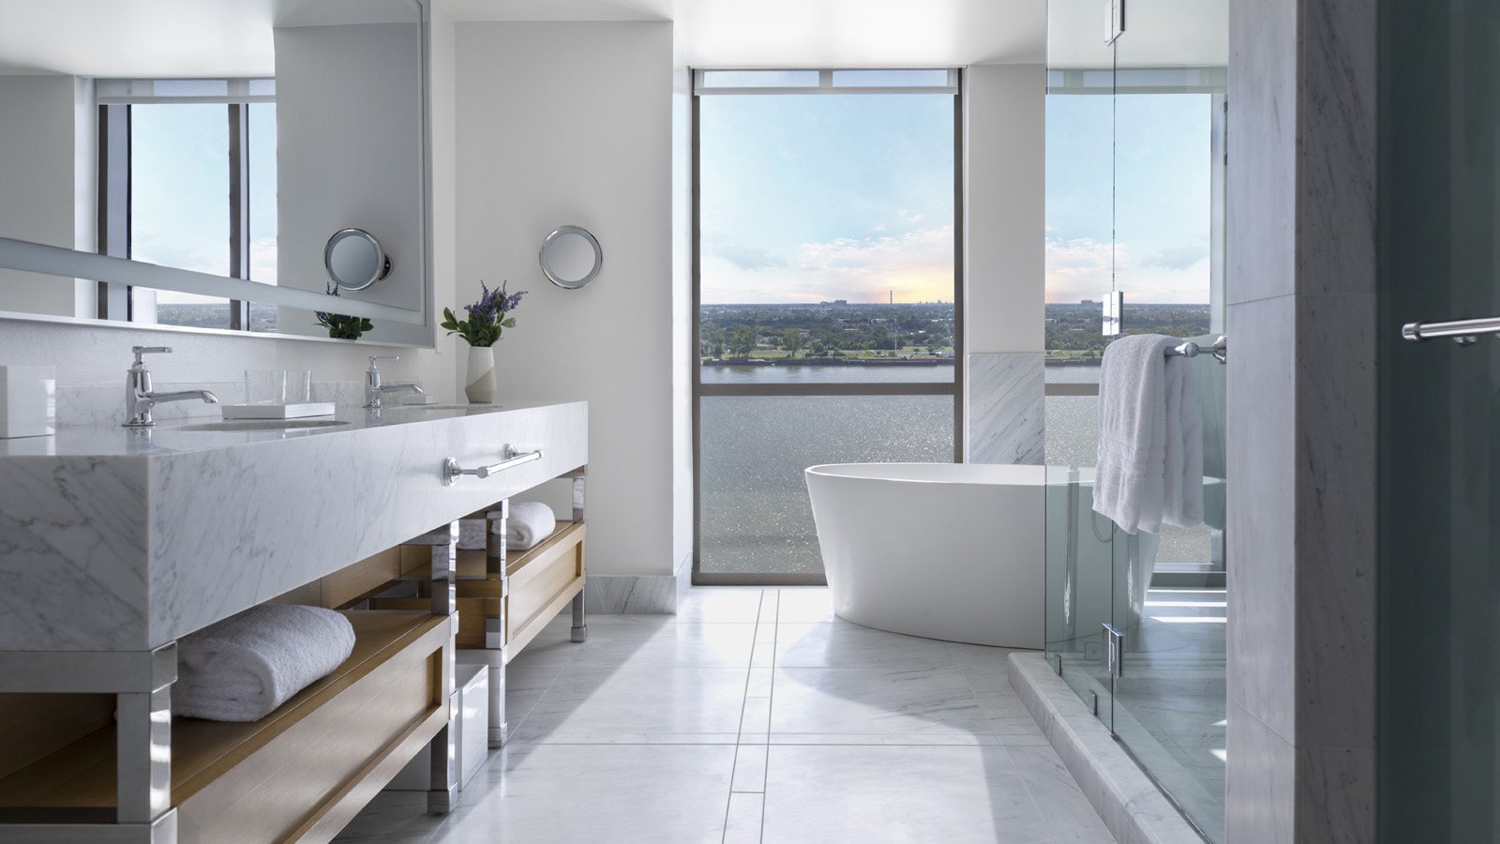 | 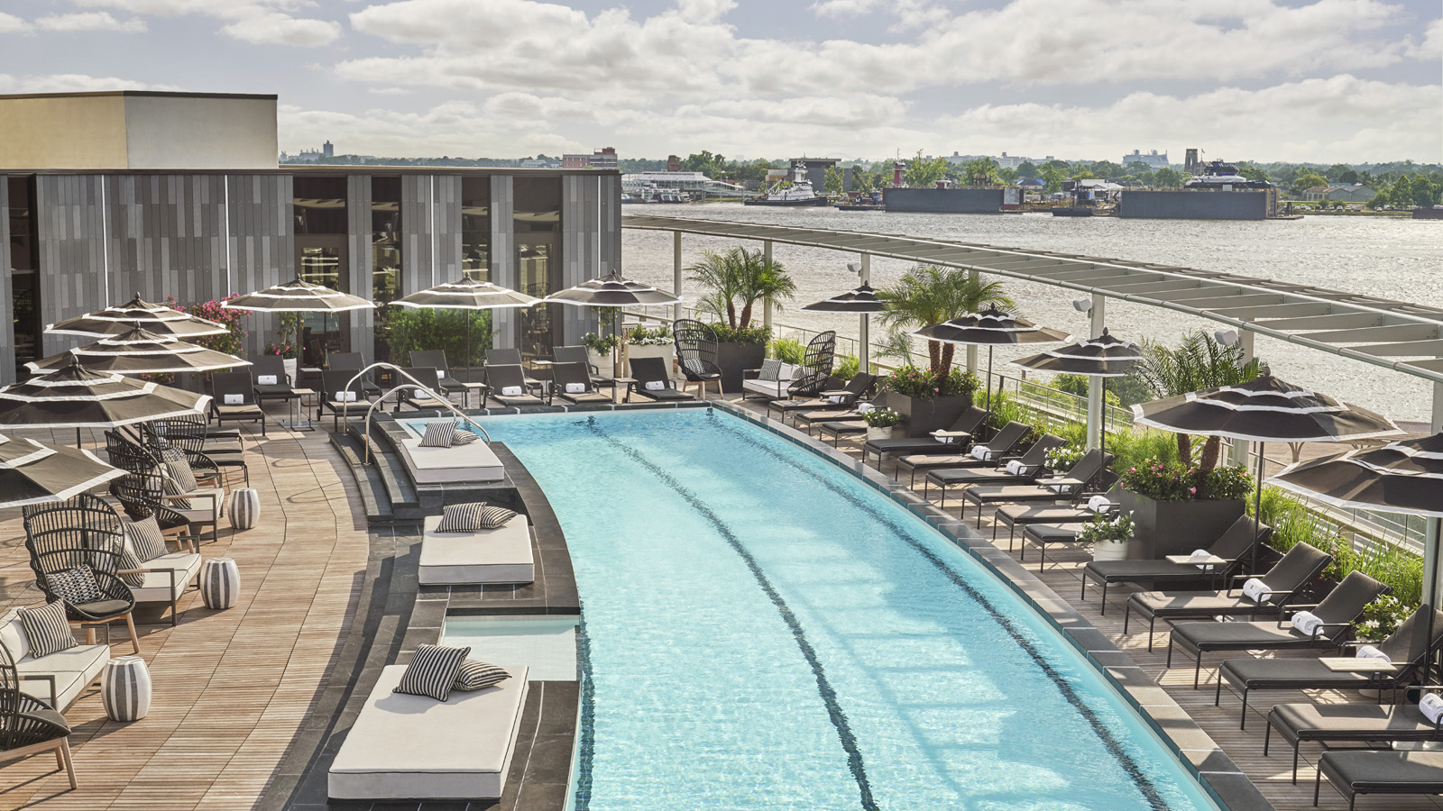
“Guests have one more reason to celebrate with us here in New Orleans,” says Mali Carow, General Manager of Four Seasons Hotel New Orleans. “We are honoured to have received the coveted AAA Five Diamond designation in our opening year, raising the bar for luxury accommodations in the state. This award is a testament to our Hotel’s stunning design and commitment to provide exceptional hospitality.”
This designation is reserved for the top one percent of the nearly 25,000 AAA Diamond lodgings and represents the highest level of world-class luxury, amenities, and indulgence for a once-in-a-lifetime experience. To earn the coveted AAA Five Diamond designation, hotels must pass an unannounced, anonymous inspection for overall quality, condition, and cleanliness.
Recognized globally for its luxury design, Four Seasons Hotel New Orleans offers 341 rooms and suites with views of the Mississippi River and cityscape. The Hotel is home to the glamorous Chandelier Bar and two of the city’s hottest new restaurants led by James Beard Award-winning chefs Alon Shaya and Donald Link. On the lobby-level, Miss River pays tribute to New Orleans grand dining, showcasing Chef Shaya’s spirited take on beloved local dishes. On the fifth floor with panoramic views of the Mississippi River, Chemin à la Mer offers a curated menu of Louisiana fare expertly executed with French technique. Coupled with the largest Hotel swimming pool in the city to offer a genuine urban resort experience, The Spa offers rejuvenating treatments utilizing coveted French skincare line Biologique Recherche as well as a variety of body treatments to have guests looking and feeling their best.
Guests interested in experiencing Louisiana’s only AAA Five Diamond Hotel can take advantage of the Third Night Free offer at Four Seasons Hotel New Orleans, valid now through September 30, 2022. For reservations, book online or call 504 434 5100.

RELATED

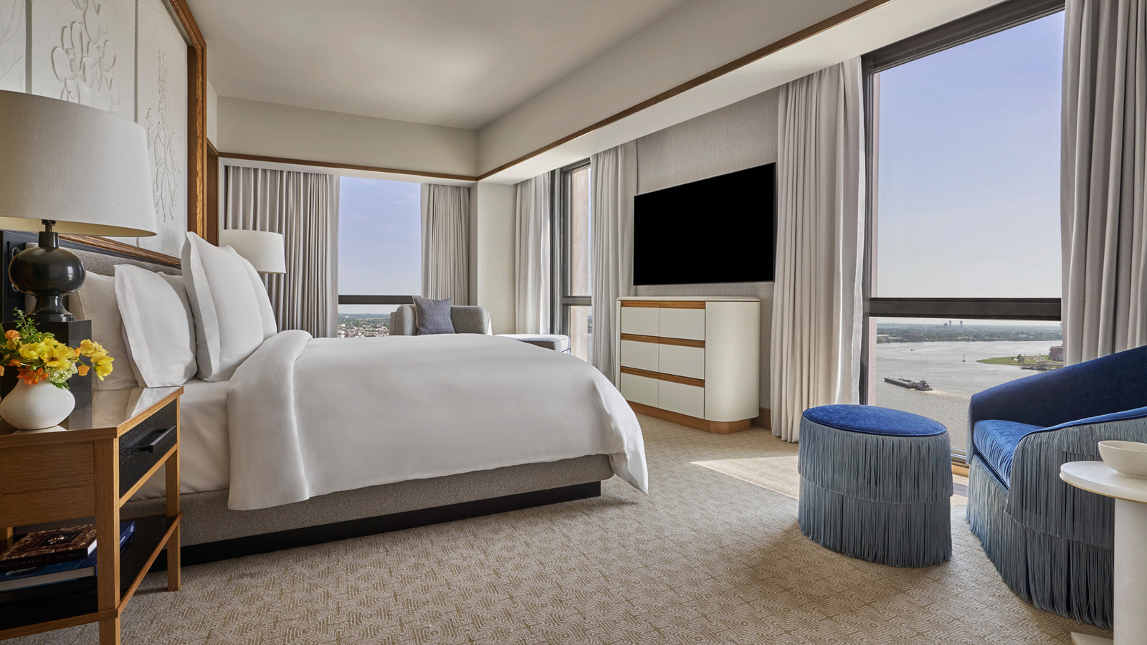 | August 4, 2022, New Orleans, U.S.A.  Classic Luxury Meets Modern Design at Award-Winning Four Seasons Hotel New Orleans  https://publish.url/neworleans/hotel-news/2022/design-awards.html
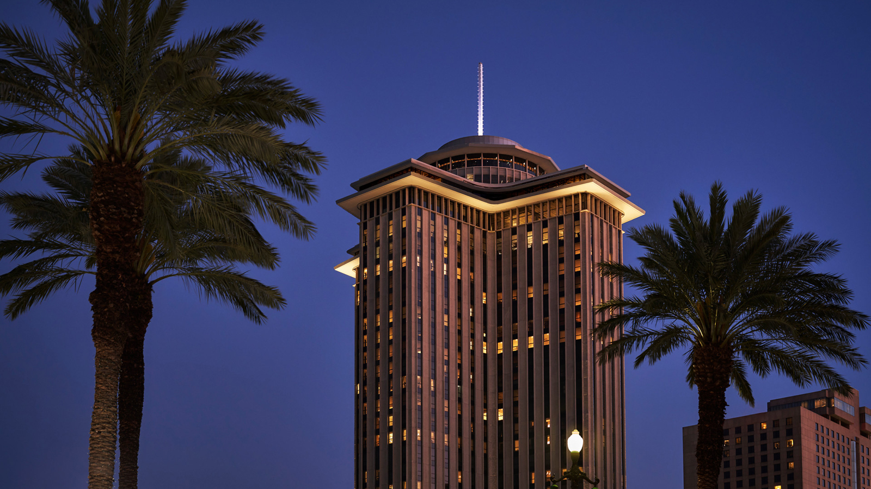 | July 26, 2022, New Orleans, U.S.A.  Four Seasons Hotel New Orleans Celebrates One-Year Anniversary with Impressive Achievements and Awards  https://publish.url/neworleans/hotel-news/2022/one-year-anniversary.html

PRESS CONTACTS

Vicki Bristol
Director of Public Relations and Communications
2 Canal Street
New Orleans
USA
vicki.bristol@fourseasons.com

+1 504 434 7012

