The Spa at Four Seasons Hotel New York Downtown Celebrates Father’s Day

Father’s Day celebrations include a Men’s Urban Retreat, bespoke leather goods and appearance by New York artist Corvy
June 13, 2018, New York, U.S.A.

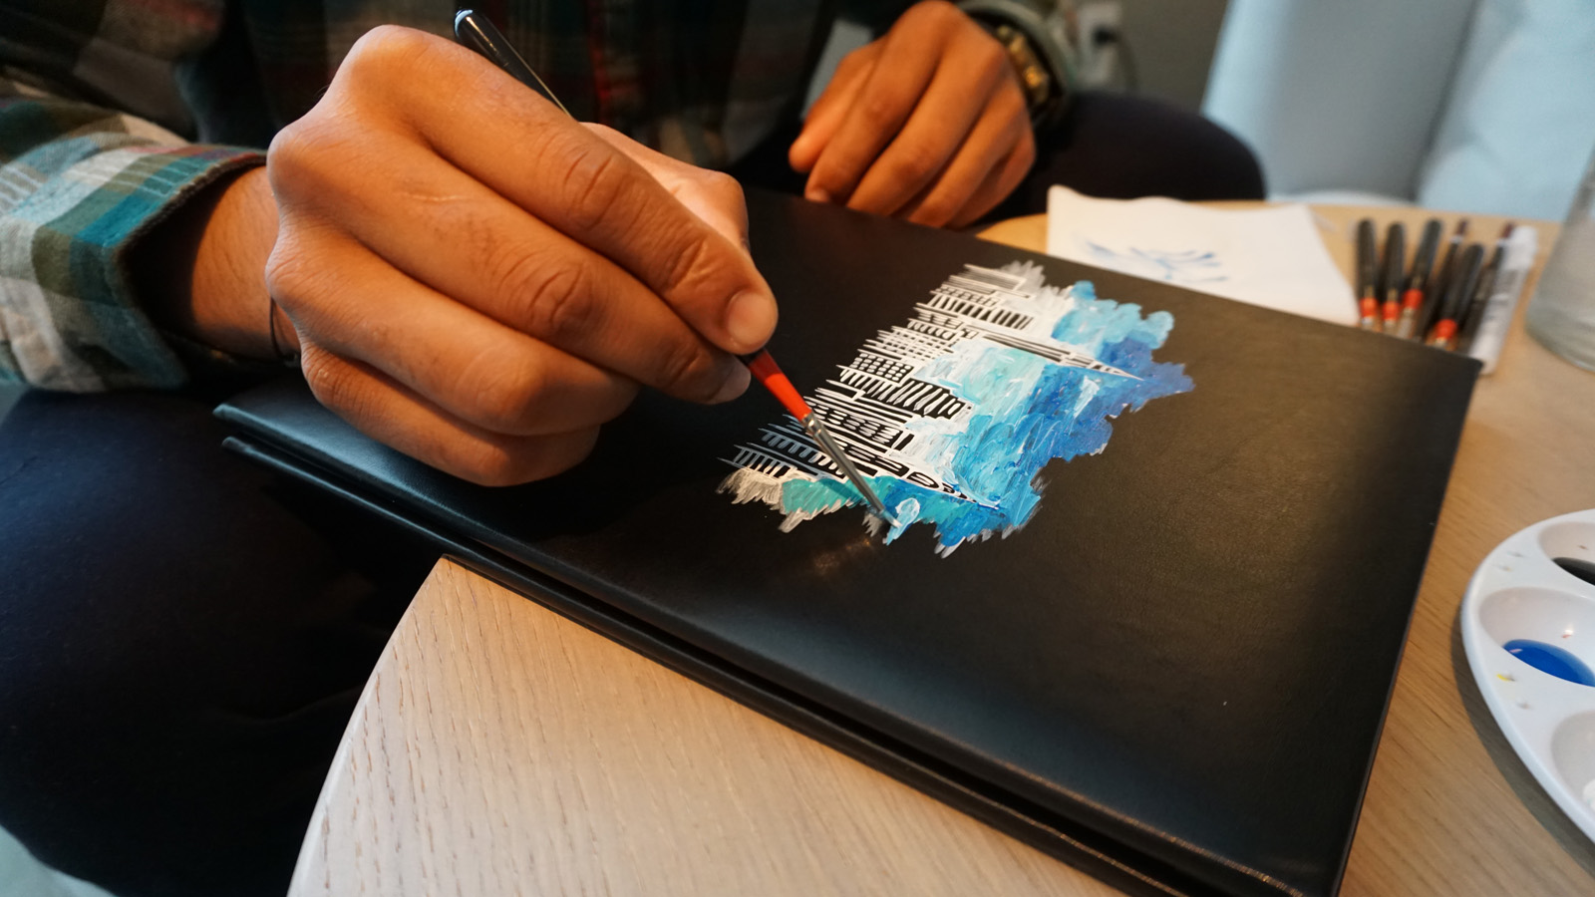
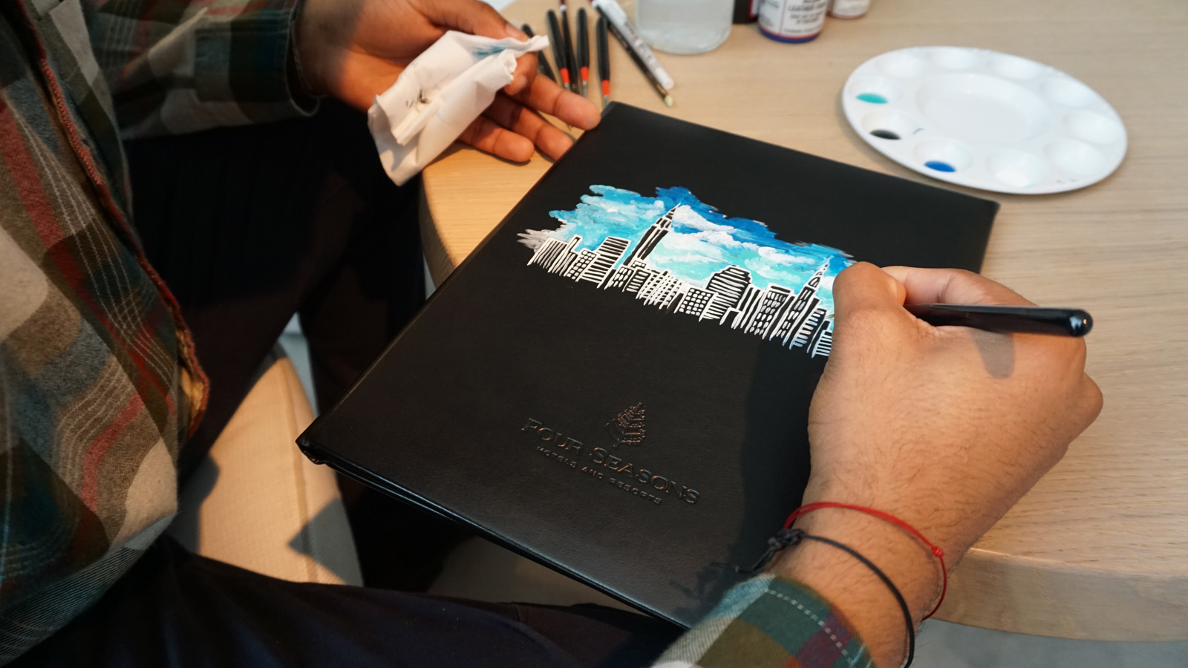 | 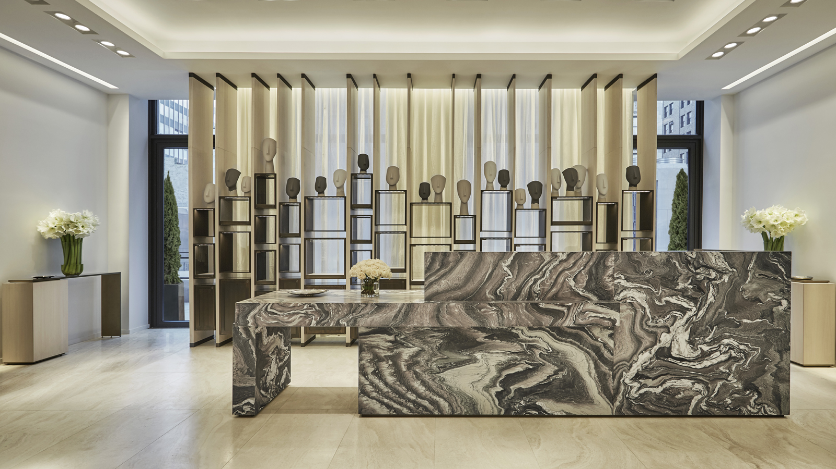 | 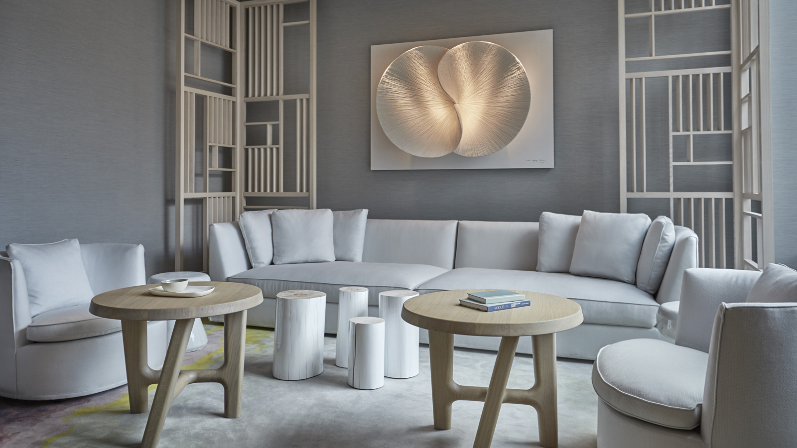
The Spa at
Four Seasons
Hotel New York Downtown celebrates Father’s Day this Sunday, June 17, 2018 with the latest in health, wellness and style.
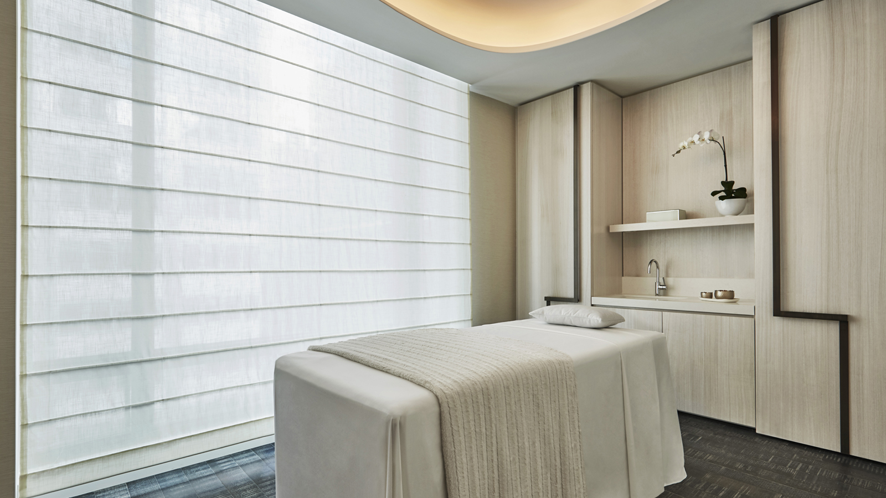
For a limited time only from June 16 to 30, The Spa will be offering an exclusive Men’s Urban Retreat, which includes:
- 50 minute Therapeutic Deep Tissue Massage
- Hungarian Moor Mud Back Treatment
- 50 minute Omorovicza Gentleman’s Facial
- Men’s Hot Stone Pedicure
- Complimentary gift from Omorovicza
- Complete with detoxifying wellness elixir
The Men’s Urban Retreat is USD 524 for three hours and is by private appointment only. Reservations are essential. Call The Spa directly for appointments on 646 880 1999.
In celebration of the discerning gentleman and just in time for Father’s Day,
Four Seasons
Hotel New York Downtown has partnered with The Bespoke Company, a custom leather goods retailer, to design a limited-edition range of bespoke branded items. Based in Paris, The Bespoke Company offers unique tailored bags, luggage and accessories using only the finest materials sourced by teams in Italy.
Always looking for the perfect partner utilising the latest style trends in fashion and design,
Four Seasons
Hotel New York Downtown offers the following exclusive bespoke products, discreetly embossed with the Hotel logo, just in time for Father’s Day:
- Bespoke leather duffel bag – USD 550
- Bespoke leather passport holder – USD 125
- Bespoke leather notebook – USD 142
For gentlemen who would like an extra special touch, New York based artist Corvy will be hand-painting leather goods in both The Spa and Hotel lobby throughout Father’s Day weekend. Originally from Honduras and inspired by the world around him, Corvy is a renowned New York artist with the ability to paint any individual guest requests. Full name or initials are complimentary with the purchase of a limited-edition leather piece. Hand painting on any other items or for custom pieces including portraits on leather goods can be arranged with prices starting at USD 125 per piece. Call The Spa directly on 646 880 1990 to make an appointment or for any additional information.

RELATED

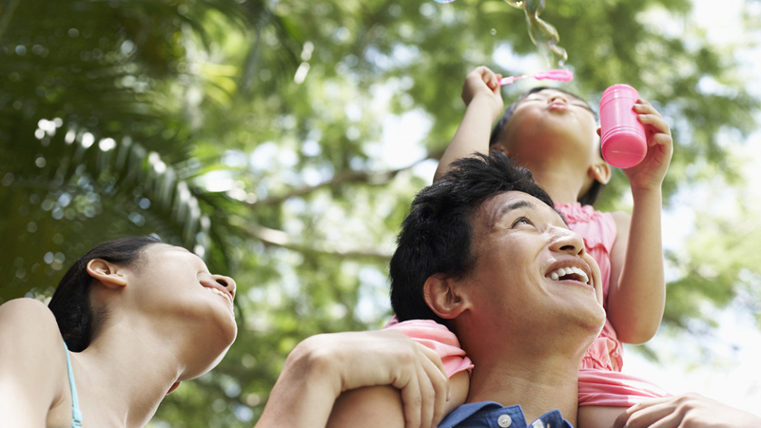 | June 1, 2018, Toronto, Canada  Four Seasons Offers New Family Escape Packages in Three Timeless Northeastern American Cities  https://publish.url/news-releases/2018/family-escape-boston-newyork-washington.html
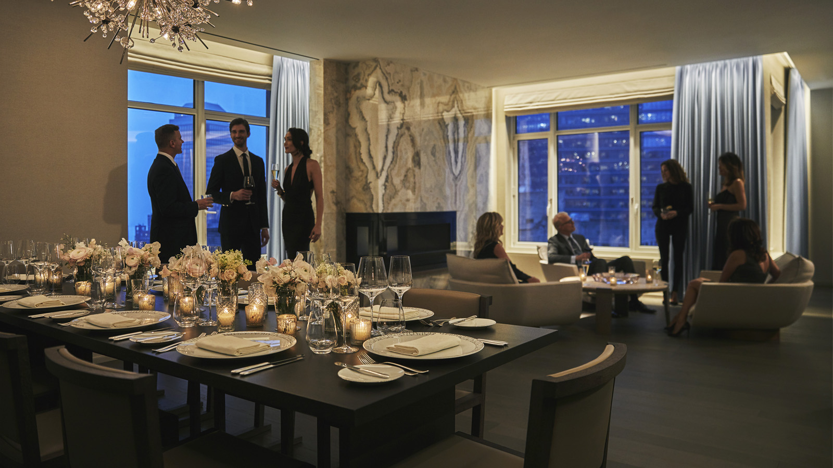 | May 18, 2018, New York, U.S.A.  Four Seasons Hotel New York Downtown Launches “Live Like A Royal” Experience  https://publish.url/newyorkdowntown/hotel-news/2018/live-like-a-royal-experience.html

PRESS CONTACTS

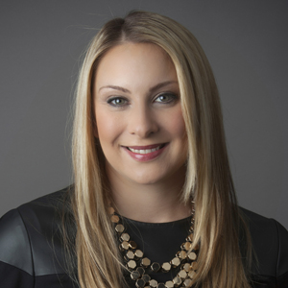 | Kristi Blake  Director of Public Relations and Communications  27 Barclay Street  New York  U.S.A.  kristi.blake@fourseasons.com  +1 (646) 880-1917

