All-Day Gourmet: MAISON MARUNOUCHI at Four Seasons Hotel Tokyo at Marunouchi Introduces a Curation of Flavours

From breakfast to nightcap – and everything in between
June 1, 2021, Tokyo, Japan

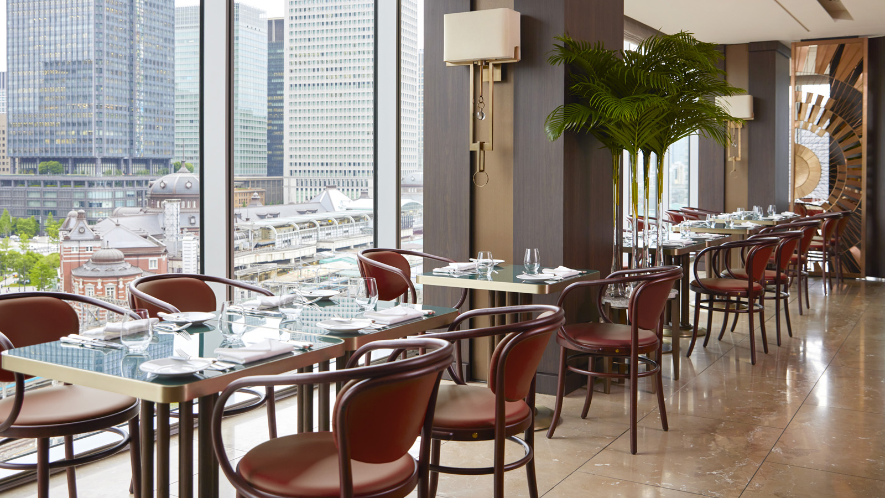
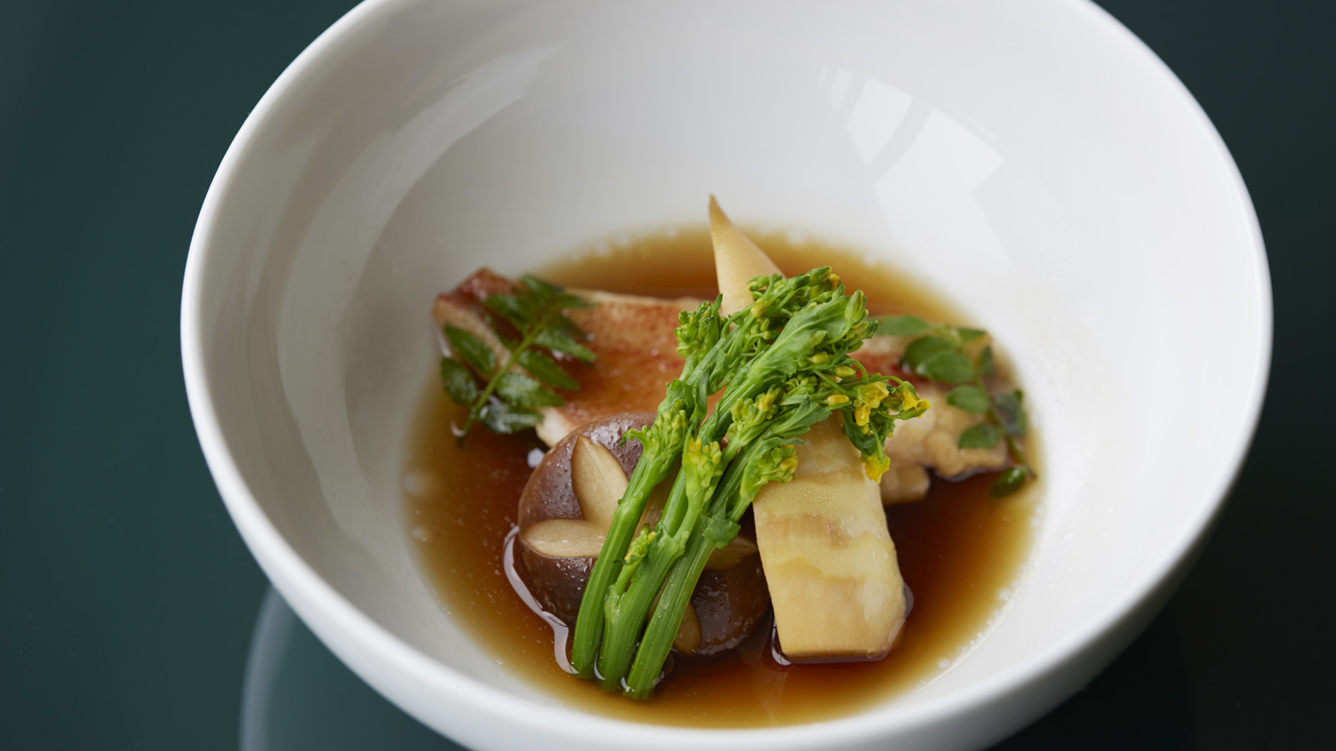 | 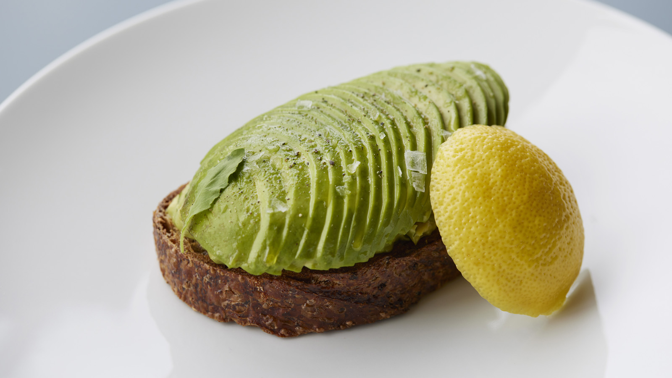 | 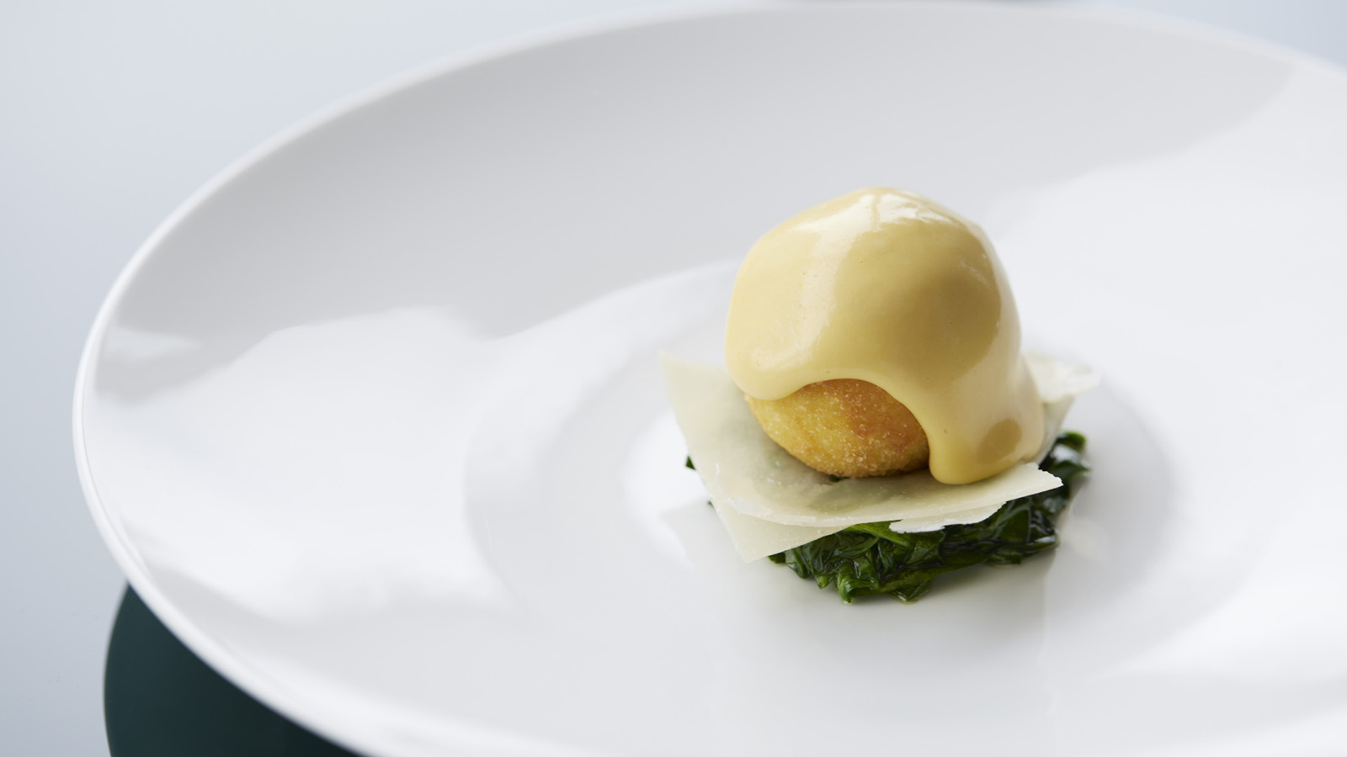
One of 2021's most anticipated openings, MAISON MARUNOUCHI at Four Seasons Hotel Tokyo at Marunouchi opens the door to extraordinary all-day gastronomy. Warm, inviting and sociable, the French bistro has quickly become a mainstay for the city’s residents – from Marunouchi’s moguls to Ginza’s fashionistas.
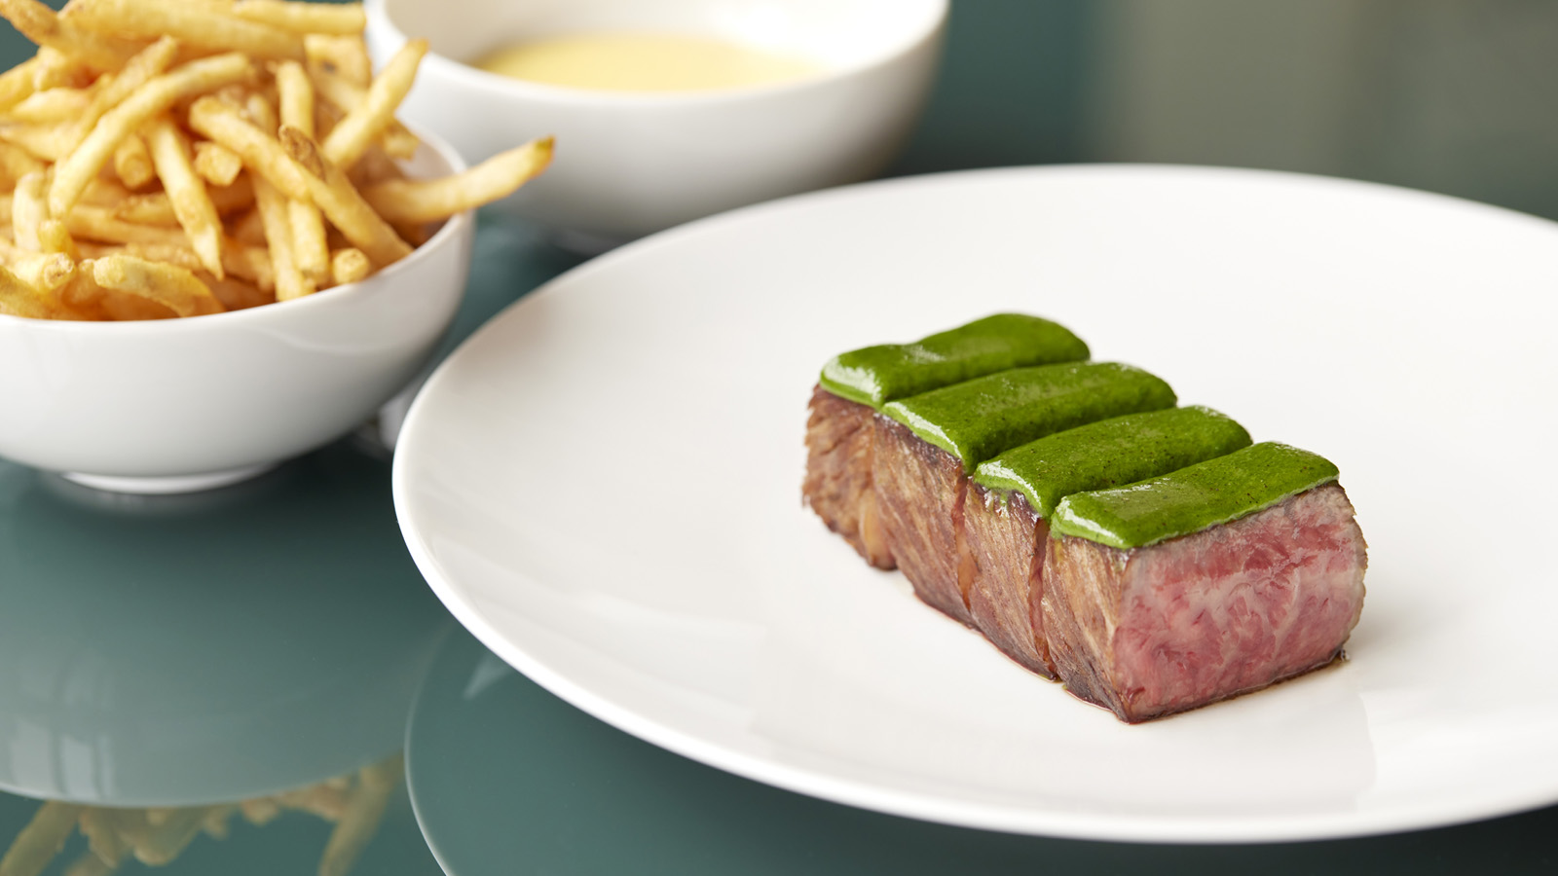 | 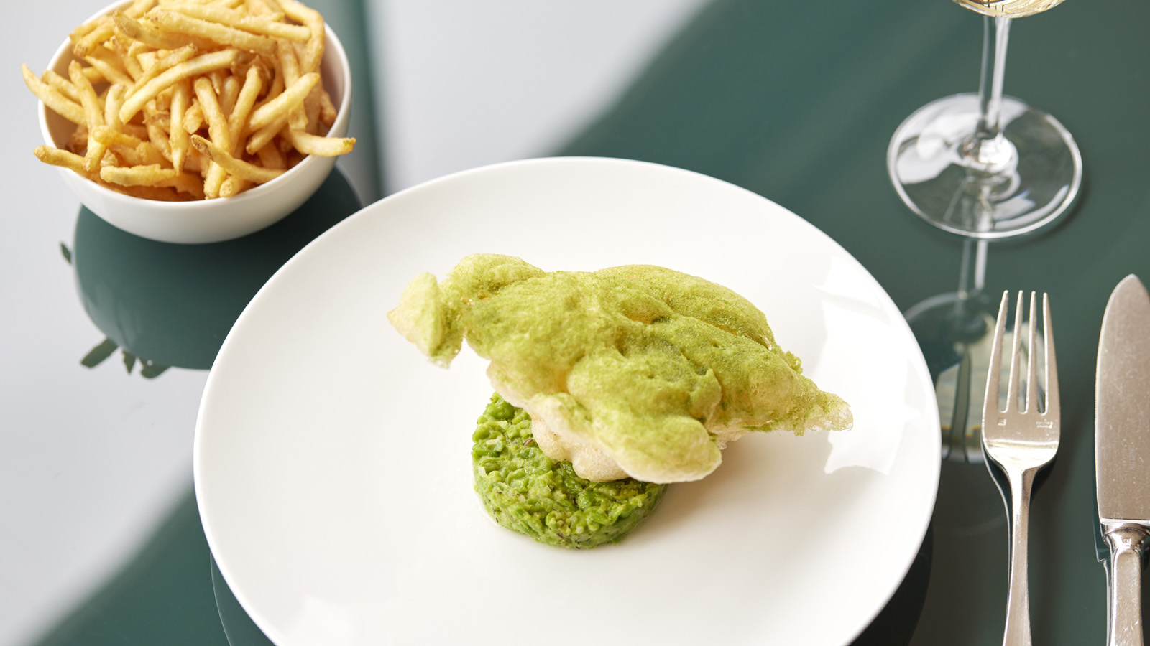 | 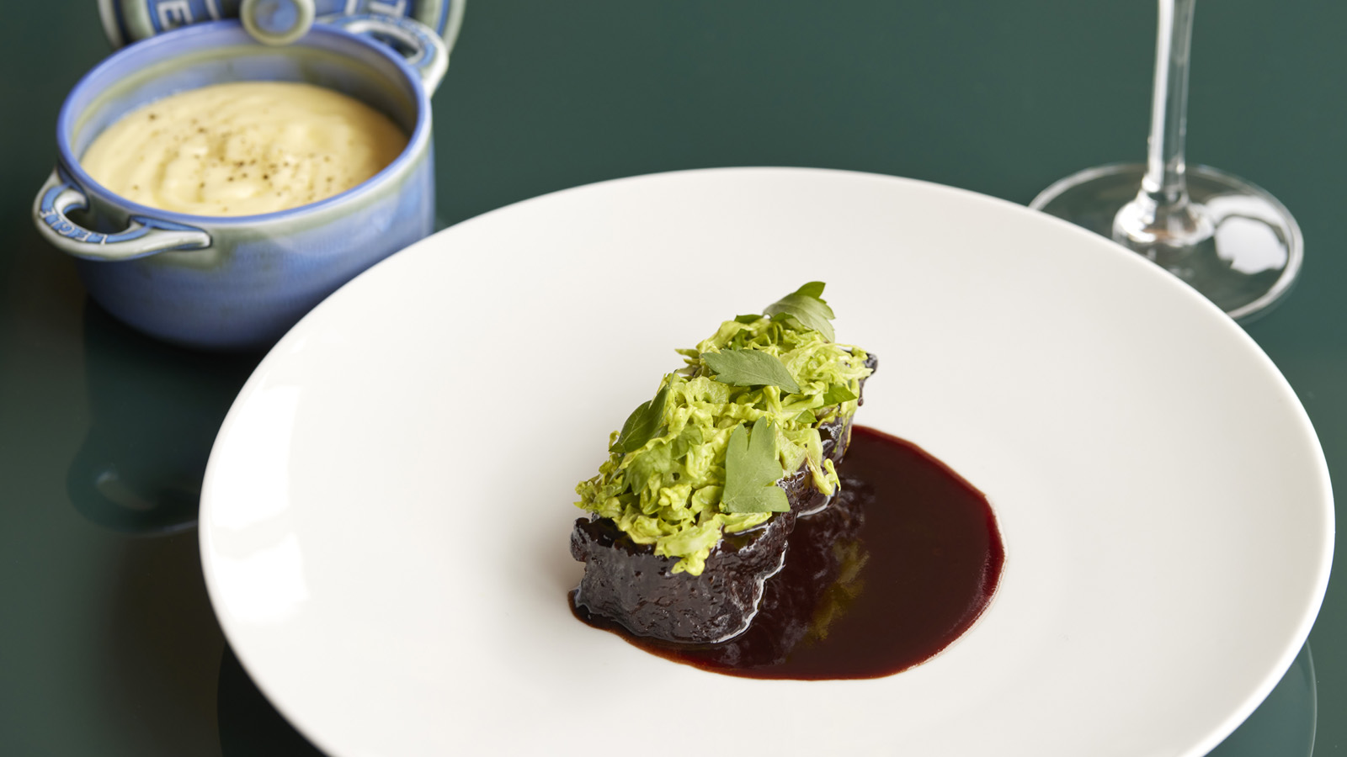
The culinary team serves up fresh interpretations of bistro classics, guided by Michelin-starred Chef Daniel Calvert, who led Belon in Hong Kong to the #4 spot among Asia’s 50 Best Restaurants. Desserts are helmed by Pastry Chef Elwyn Boyles, who honed his confectionary craft in award-winning kitchens across London, New York and California. The iconic bar, overseen by Head Bartender Koichi Urata, offers classic cocktails, a selection of Japanese gins and whiskies, and mocktails infused with homemade syrups and native ingredients.
Envisioned by famed designer André Fu, MAISON MARUNOUCHI gazes out at stunning views of gliding Shinkansen bullet trains and the elite Marunouchi district. This exciting venue pulses with energy and vitality, making it the perfect spot for everything from power lunches to celebrations with friends. In-house guests as well as local residents can discover an engaging program of dining experiences.
Breakfast. Explore a selection of thoughtfully-elevated breakfast favourites. The Marunouchi Breakfast features specialties including the kinki-nitsuke cooked in a sweet and savoury dashi broth and served with shiitake mushrooms. The avocado toast is composed of an entire avocado on SÉZANNE sourdough, brightened by yuzu pepper and Thai basil. The egg hollandaise is made with organic eggs from Yamanashi, battered, crisped and served on a bed of comté cheese and baby leaf spinach. The Continental Breakfast boasts handpicked ingredients such as Hokkaido yogurt, lending its creamy freshness to the bircher muesli and the Earl Grey tea soaked prunes.
- Continental Breakfast: JPY 3,200++ (JPY 4,048)*
- Marunouchi Breakfast: JPY 5,000++ (JPY 6,325)*
Menu du Jour. Meet in the heart of downtown Tokyo for a gourmet lunch. The menu of the day includes one starter, one main course and one dessert, along with Vaner bread and tea or coffee. The dishes are set to change weekly, so there is always something new for regular guests to discover.
- Available Monday to Friday
- JPY 5,000++ (JPY 6,325)*
Menu Premium. Elevate Friday afternoon with lunch at Marunouchi’s newest social hub. The exclusive set menu features house specialties such as jambon-eurre, steak frites with béarnise sauce, and crème caramel, along with Vaner bread and tea or coffee.
- Available only on Friday
- JPY 12,000 (JPY 15,180)*
A La Carte Lunch and Dinner. The a la carte menu for lunch and dinner features bistro-style plates, crafted with finesse. Sample the perfectly-crisp monkfish “fish & chips” with peas, or the wagyu beef cheeks braised in bourguignon sauce. The tandoori-spiced frog’s legs are accompanied by curried lentils and coriander cream, while the silken chicken liver parfait is cooked with riesling and served with apricot gelée.
Afternoon Tea. Experience teatime traditions in an imaginative new format. Daniel and Elwyn came together to create a wondrous repertoire of sweets and savouries that unfold through the afternoon. In a departure from convention, the six savouries arrive first – fresh, hot, and plated with precision. Next up, four desserts that showcase a beautiful balance of flavours, starring seasonal Japanese peaches and fine teas. The culinary treats are complemented by premium Ronnefeldt brews and artisanal coffees.
- Weekdays: 2:30-5:00 pm (last order at 4:30 pm) 6,000++ (JPY 7,590)*
- Weekends: 2:30-5:00 pm (last order at 4:30 pm) 6,500++ (JPY 8,223)*
Marunouchi Fried Chicken. Celebrate the weekend with MAISON MARUNOUCHI’s version of an all-time classic. Start with Cobb salad, then move on to the main event – fried chicken accompanied by braised kale, mashed potatoes, corn bread and house pickles. Elwyn’s lemon meringue pie brings the meal to a perfect sweet finish.
- Available on Saturday and Sunday
- JPY 6,500++ (JPY 8,223)*
In-Room Dining. Staycations at Four Seasons Hotel Tokyo at Marunouchi are set to get even better, with specialties from MAISON MARUNOUCHI now available for In-Room Dining. Book a delightful escape with the Family Getaway package: enjoy 15 percent savings on room rate and daily breakfast for two adults and two children, served in the room.
- From JPY 44,200++ (JPY 55,913)*
To reserve a table, click here. To book a staycation, click here.

*All prices show net price listed first, followed by the gross price including 10 percent tax and 15 percent service charge.

RELATED

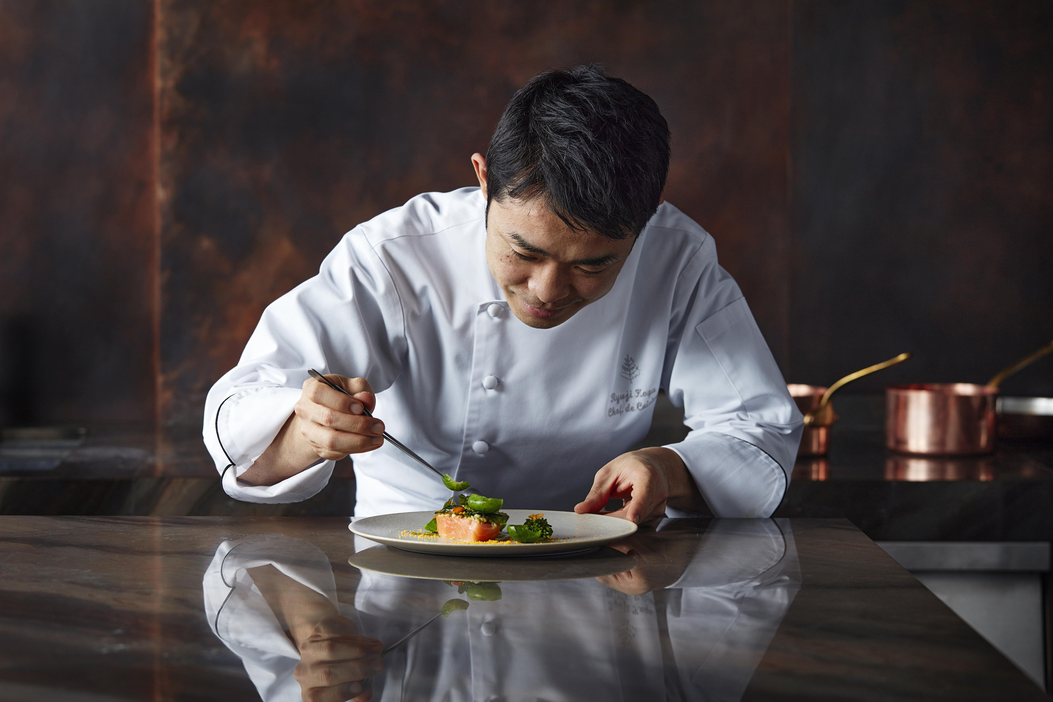 | August 20, 2021, Kyoto, Japan  歴史ある京野菜農家・樋口農園の野菜など、旬の食材を堪能する秋限定のコース料理をスタート  https://publish.url/jp/kyoto/hotel-news/2021/autumn-menu.html
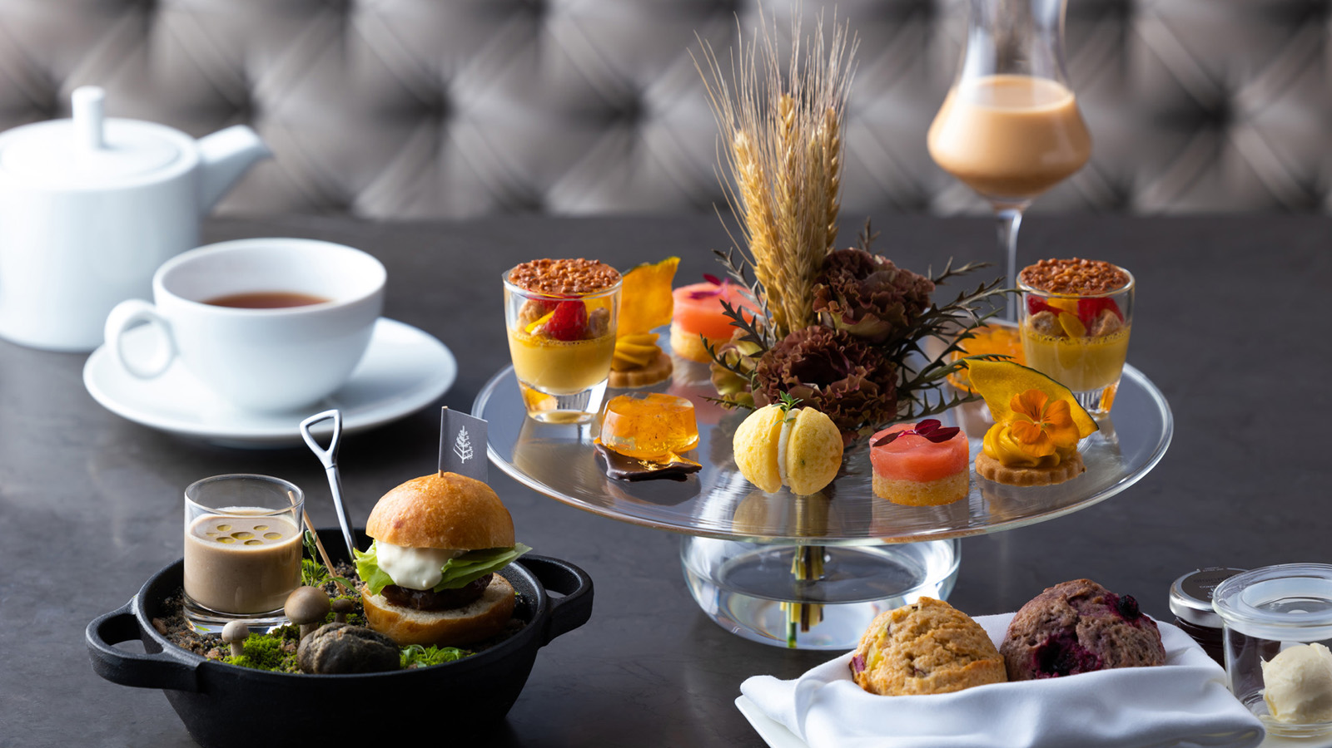 | August 20, 2021, Kyoto, Japan  “秋の収穫祭”をテーマにした「オータム・ハーベスト・アフタヌーンティー」が2021年9月13日よりスタート  https://publish.url/jp/kyoto/hotel-news/2021/autumn-harvest-afternoon-tea.html

PRESS CONTACTS

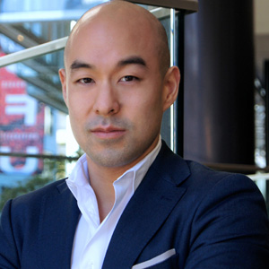 | Shingo Kido  Director of Public Relations and Communications  Pacific Century Place Marunouchi, 1-11-1 Marunouchi  Tokyo  Japan  shingo.kido@fourseasons.com  81 (3) 5222-7222

