Regional Vice President Yvette Thomas-Henry Appointed General Manager of Four Seasons Resort Nevis

Caribbean native returns home, bringing decades of diverse hospitality experience to the role
January 7, 2020, Nevis, West Indies

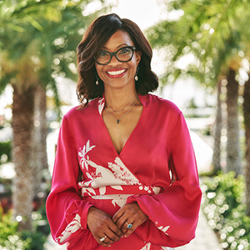
Four Seasons Resort Nevis, the award-winning Resort consistently ranked by travellers and travel experts as one of the top resorts in the Caribbean, has named Four Seasons Hotels and Resorts Regional Vice President Yvette Thomas-Henry as its newest General Manager, effective January 2, 2020. Born in St. Thomas, USVI and raised in St. Croix, Thomas-Henry is returning home to the region, becoming the first Caribbean native to serve in the top position in Nevis or any other Four Seasons property in the Caribbean. In addition to her role in Nevis overseeing a property that recently completed a multi-year, multi-million dollar enhancement project, Thomas-Henry is also responsible for the operational oversight of several properties, including two Caribbean resorts.
“Coming back to the region after many years working and living in the United States, I can personally identify with the Resort’s positioning as a modern embodiment of the spirit and soul of the Caribbean,” says Thomas-Henry. “I am excited and honoured to have the opportunity to lead such an incredible team in such a great moment in its history.”
Prior to joining Four Seasons Resort Nevis, Thomas-Henry most recently served as General Manager of Four Seasons Hotel Atlanta since 2015, during which time she received a promotion to Regional Vice President of Four Seasons Hotels and Resorts in 2018. As a part of the Four Seasons family since 2007, Thomas-Henry has also held leadership positions at Four Seasons Hotel New York and Four Seasons Hotel Washington, DC, as well as hospitality experience with Loews Hotels, The Plaza Hotel, The Waldorf-Astoria NYC and The Ritz Carlton Boston.
Encouraged by her mother – who was born and raised on Nevis’ sister island of St. Kitts, where Thomas-Henry also attended primary school – she always strived to be the best at whatever she did. After earning her Bachelor of Arts from Pace University, Thomas-Henry went on to receive a Master of Science from Audrey Cohen College in New York. Throughout her career, Thomas-Henry has developed a sharp eye for detail, a dedication to giving back to the community and a focus on women in leadership. During her tenure in Atlanta, the Hotel has continued to thrive as the only AAA Five-Diamond and Forbes Five-Star hotel in the city – an accolade it has held since opening in 1997.
Thomas-Henry’s appointment comes on the heels of the launch of an updated look for Four Seasons Resort Nevis, which over the past two years has seen a multi-phase unveiling of re-envisioned guest rooms and suites and Great House lobby; the opening of delicious new dining outlets On the Dune, EsQuilina and crowned monkey RUM BAR; a beautiful new space for the Kids for All Seasons kids club; a stunning new pier to welcome guests upon arrival and the perfect spot to catch a Caribbean sunset; and a new signature infinity edge pool at the centre of the Resort.
For reservations, book online, call (869) 469 6238 or contact your travel professional (chain code FS).

RELATED

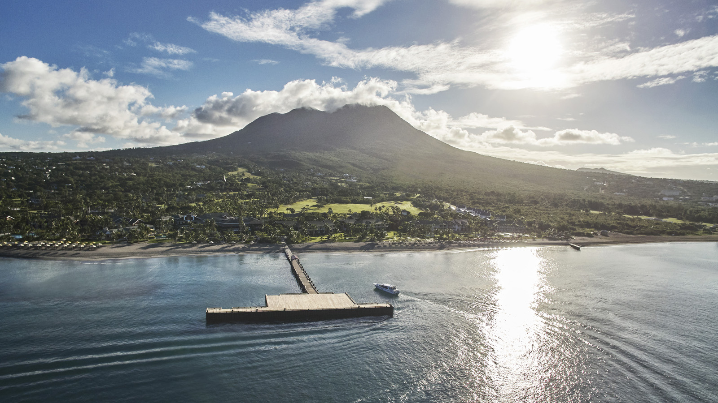 | March 10, 2020, Nevis, West Indies  Four Seasons Resort Nevis Announces Exclusive Caribbean Residents’ Rate for 2020  https://publish.url/nevis/hotel-news/2020/caribbean-residents-rate.html
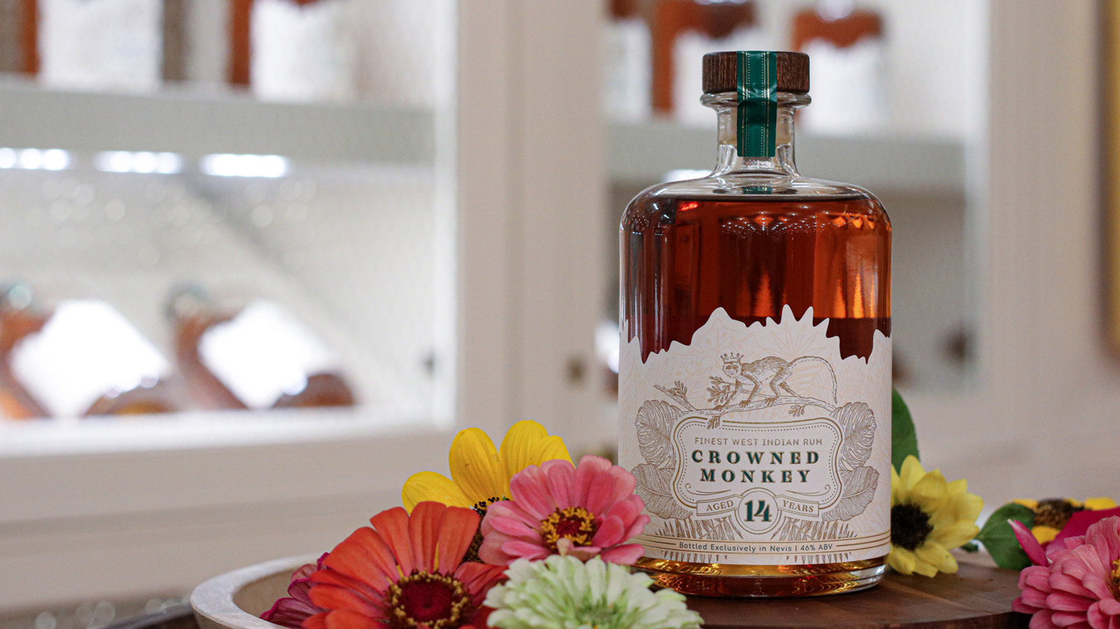 | February 14, 2020, Nevis, West Indies  Four Seasons Resort Nevis Celebrates 29th Anniversary with Unveiling of Exclusive New Crowned Monkey Rum  https://publish.url/nevis/hotel-news/2020/exclusive-crowned-monkey-rum.html

PRESS CONTACTS

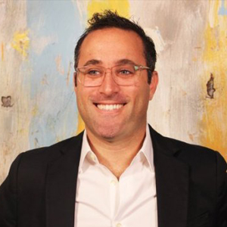 | Mitchell Nover  Director of Public Relations and Communication  3350 SW 148th Avenue, Suite 204  Miramar  U.S.A.  mitchell.nover@fourseasons.com  +1 (786) 655-8509
Gillian Stoney
Digital Marketing Communications Manager

Four Seasons Resort Nevis
Nevis, West Indies, Caribbean
gillian.stoney@fourseasons.com

+1 (786) 655-8507

