Helios at Four Seasons Astir Palace Hotel Athens Features Sun-Kissed Flavours from the Americas

Helios ties in the spectacularly rich and varied cuisine of Latin America with a view that spills beyond its olive-lined pools to the Saronic Gulf
June 24, 2019, Athens, Greece

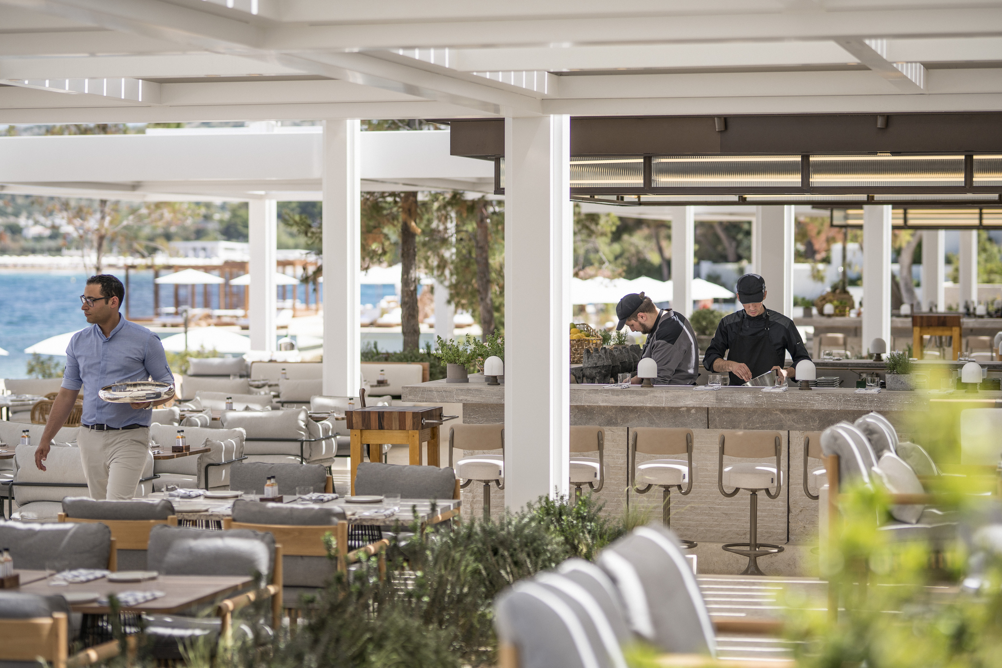
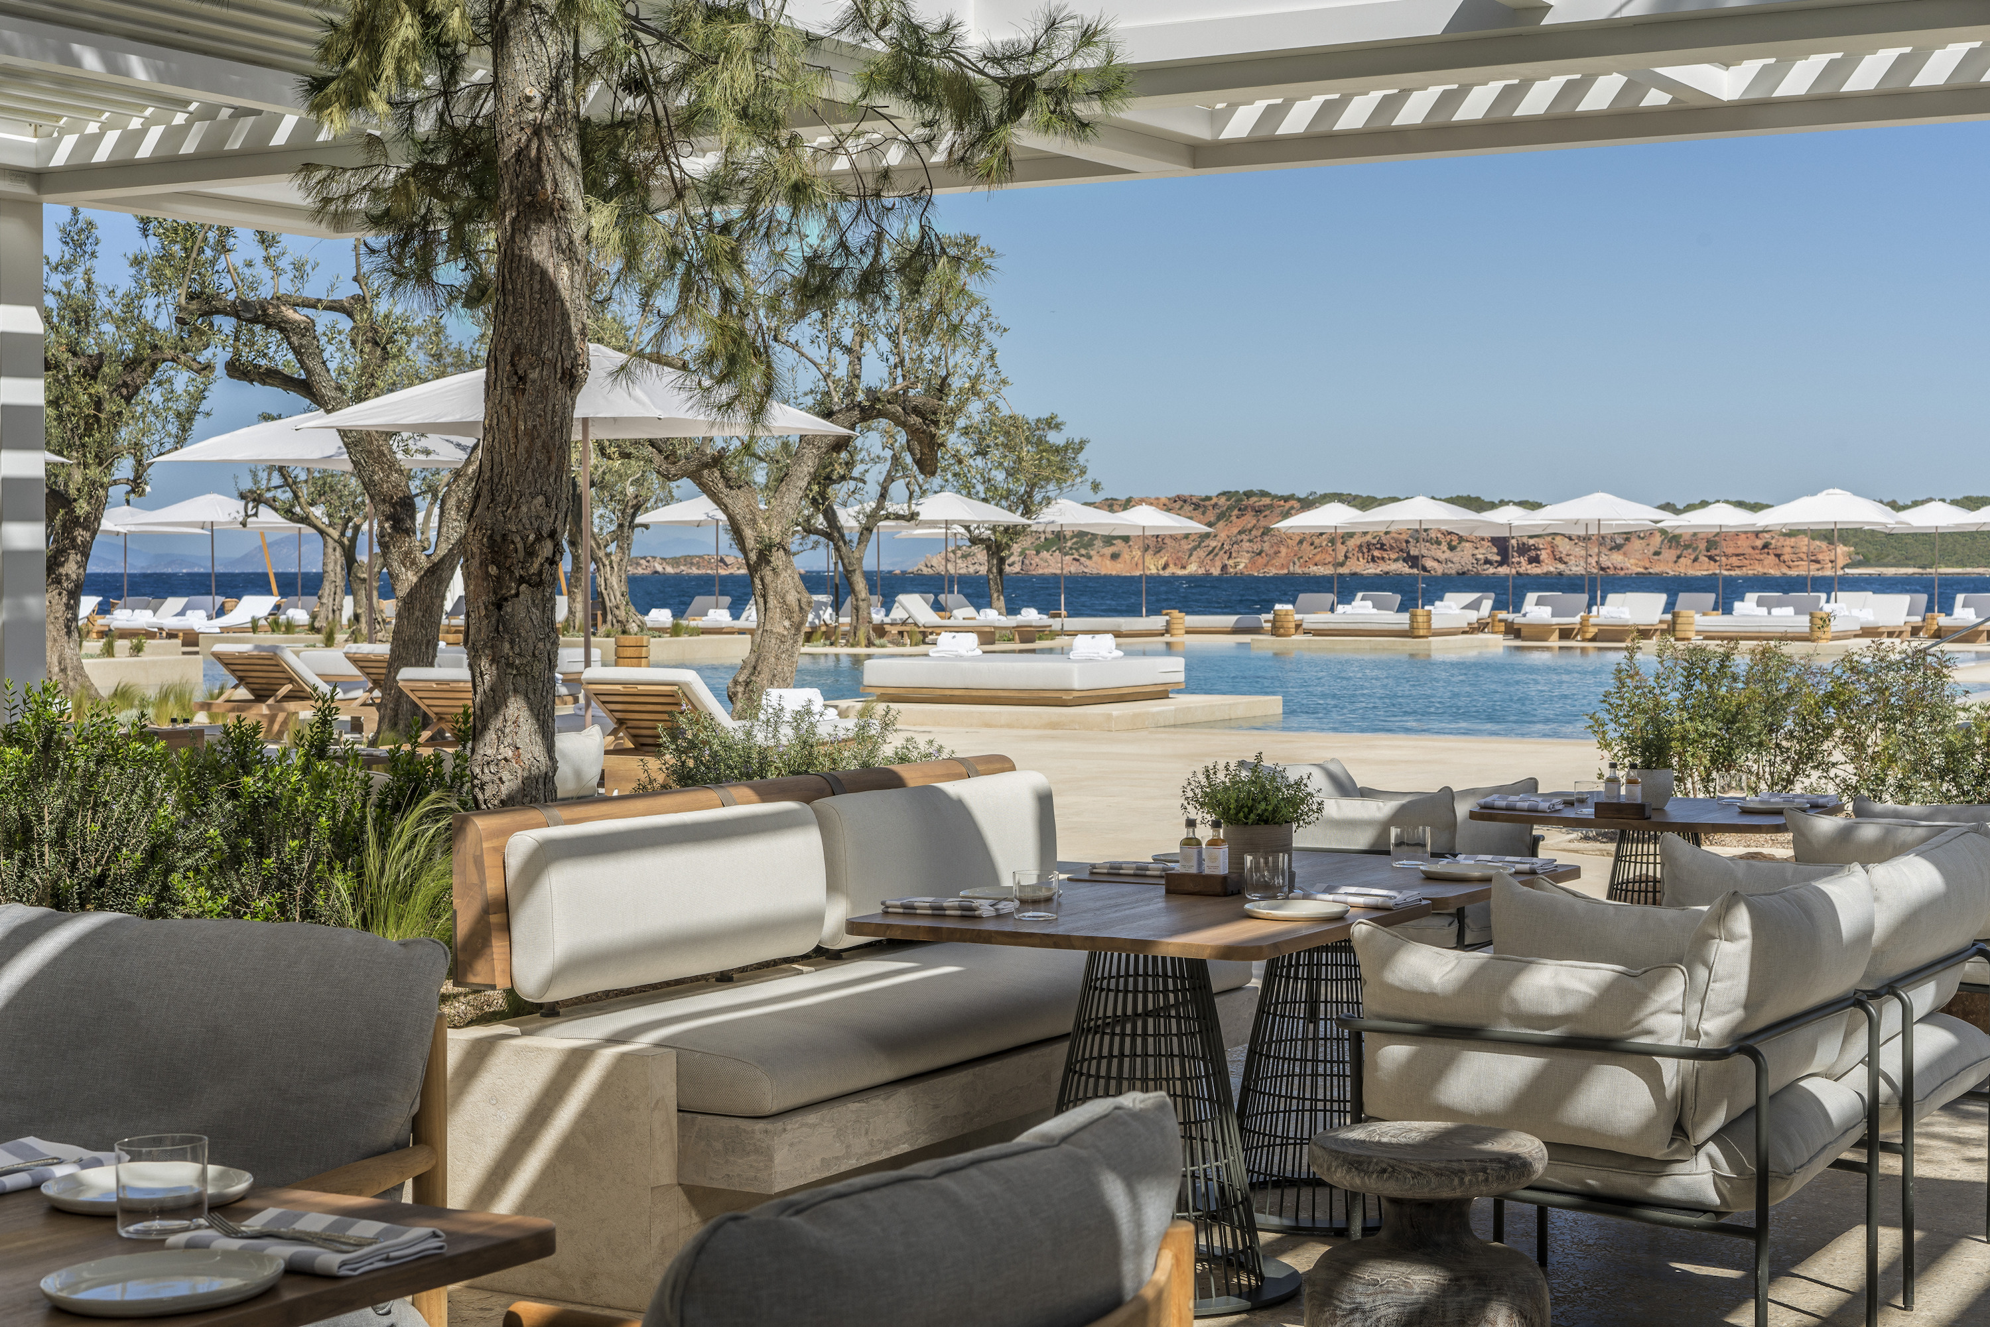 | 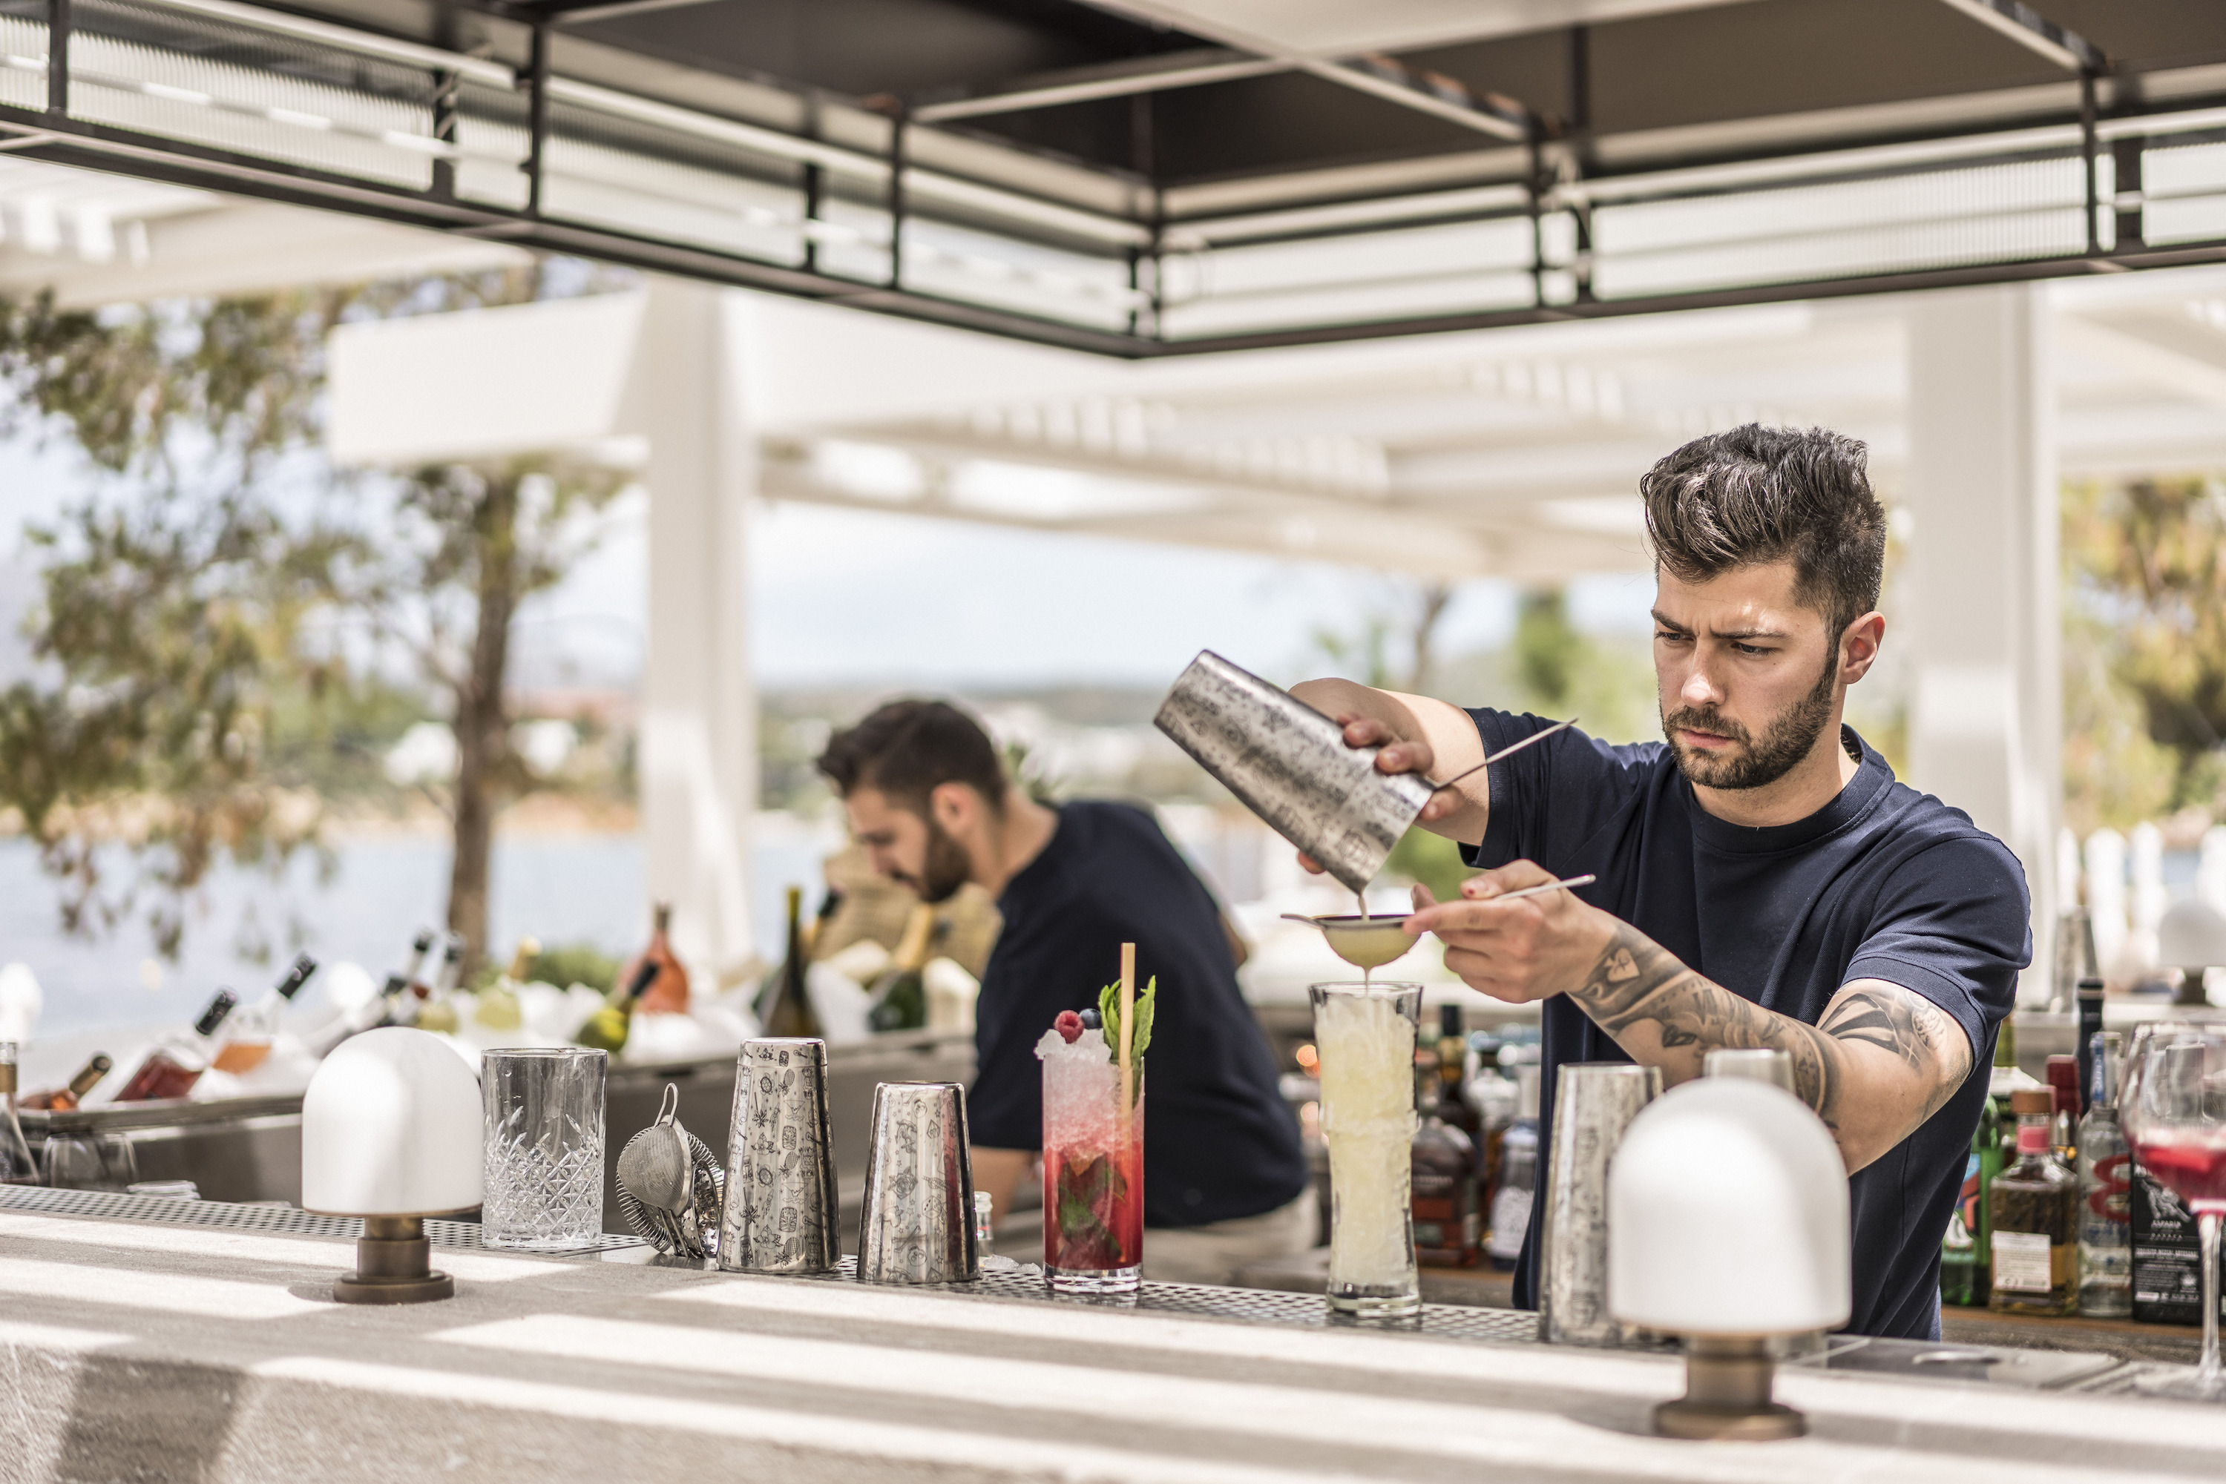
When a cuisine is inspired by an interesting geography - from the Andean peaks to the Amazonian rainforest and the Atlantic and Pacific oceans, providing chefs with an unrivalled natural pantry - expect a full-throttle Latin fiesta on the plate.
A melting pot of Ibero-American accents, Helios impossibly but oh-so brilliantly marries sweet chunks of plantains and mango with raw fish marinated in lime juice, onions, coriander and jalapeno.
The guacamole here is rich, creamy, fresh, tangy and really hits the spot – guests often order seconds, in which case Helios recommends that they claim to be in the know by pronouncing it the Spanish way as "wakamole."
The Restaurant Manager here, George Kamaras, who earned his stripes at Gordon Ramsay’s temple of fine dining Savoy Grill, suggests Amazonian staples, dripping with unexpected layers of flavour, such as the Nikkei tiradito – sea bass with truffle ponzu, elevated with the berry-like smoky flavour of Peruvian chilli, aji panca. Revel in the subtle freshness of ceviche, tinged with just the right doses of piquancy and zest or try the crispy pork bao, served with yucca and plantain for an explosive burst of flavours.
The bar at Helios celebrates a continent that takes its cocktails seriously. When it comes to Latin-inspired concoctions, bartenders can really flex their mixology chops. In between slinging rums, tequilas, cachacas, piscos and coconut brandys to experimenting with exotic flavours of agave and hibiscus, the drinks here are a playful, bold take on classics. The bar team highly recommends Purple Rain with rum, hibiscus and cinnamon and the Smoky Margarita, a twist on the classic version with tequila, mezcal and agave.
Desserts are every adult’s childish fantasy come true – crunchy churros with the creamy, goodness of dulce de leche.
Designed by K-Studio, with deep, white sofas to recline into by the pool, it is easy to understand Helios’ inspiring appeal.
Helios at Four Seasons Astir Palace Hotel Athens: tel: 210. 890.1000

RELATED

June 12, 2019, Athens, Greece
Taverna 37: Introducing a Rustic Seafront Dining Experience at Four Seasons Astir Palace Hotel Athens
https://publish.url/athens/hotel-news/2019/taverna-37.html

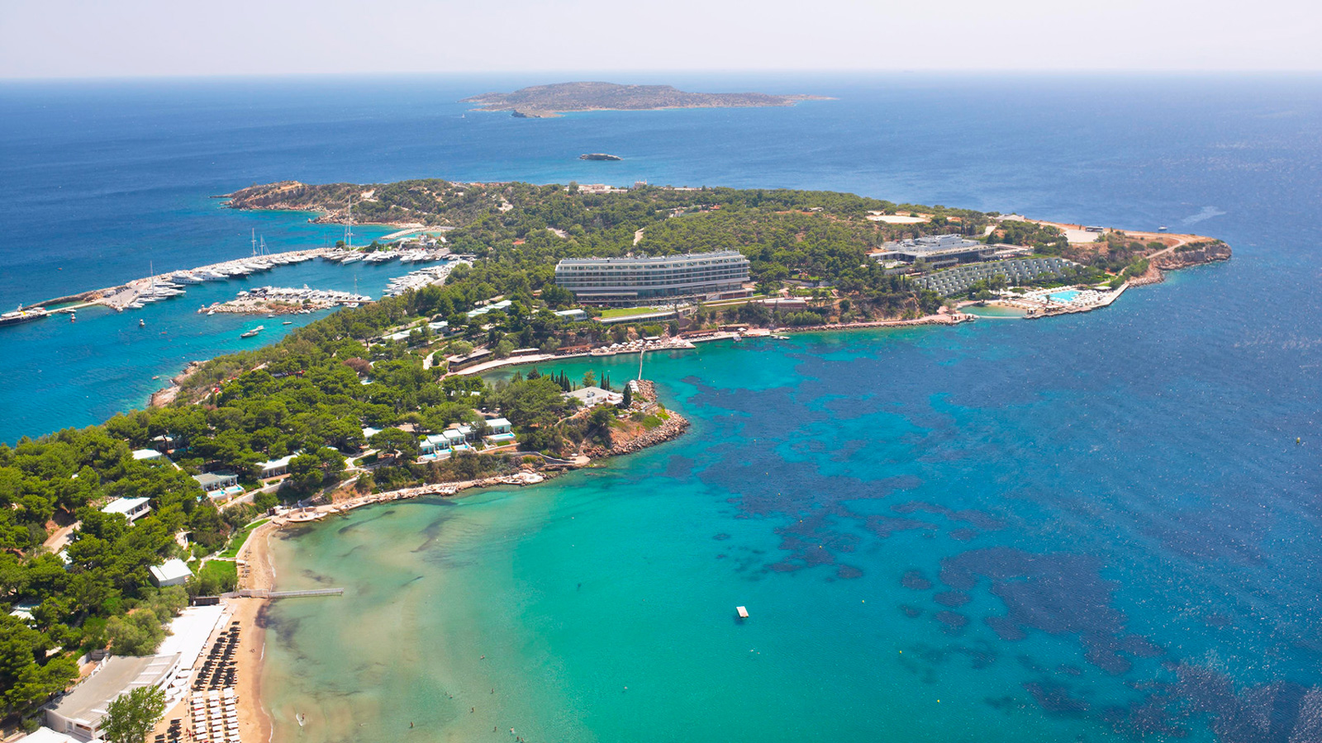 | March 29, 2019, Athens, Greece  Four Seasons Astir Palace Hotel Athens é inaugurado e define novo conceito de luxo na Riviera Ateniense  https://publish.url/br/athens/hotel-news/2019/now-open-4.html

PRESS CONTACTS

Elia Kentrota
Director of Public Relations
40 Apollonos Street
Vouliagmeni, Athens
Greece
elia.kentrota@fourseasons.com

+30 210 8901077

