Four Seasons Hotel George V, Paris Reopens its Celebrated Marble Courtyard on May 21

To celebrate the reopening of outdoor dining and the arrival of summer, the elegant interior courtyard of George V will offer sunny Mediterranean dishes prepared by Chef Simone Zanoni
May 10, 2021, Paris, France

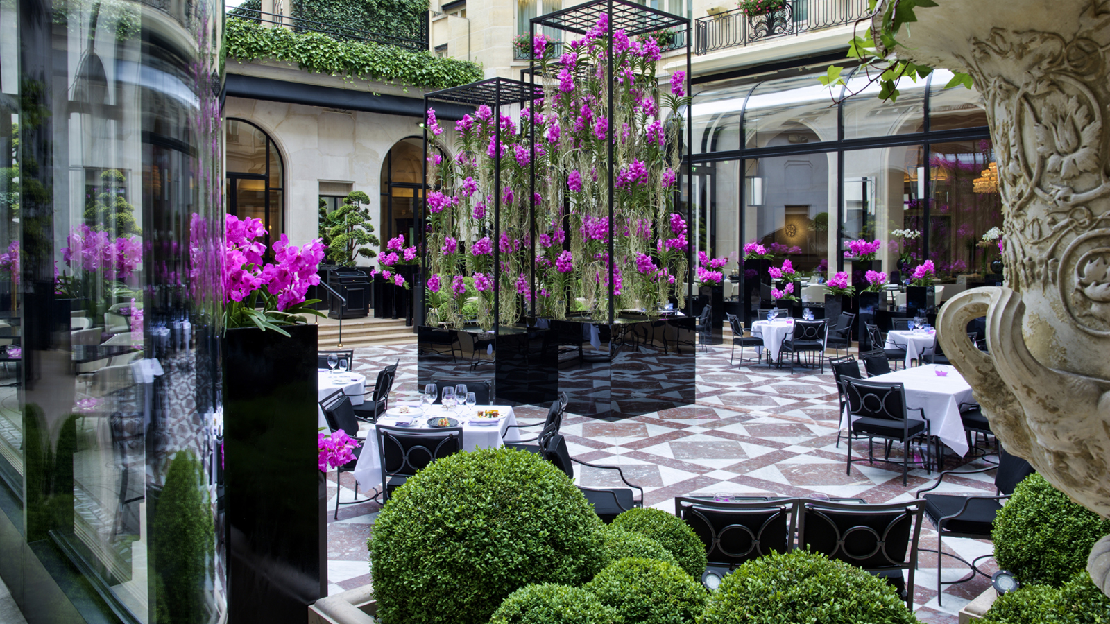
The Marble Courtyard of Four Seasons Hotel George V, Paris will reopen on May 21, 2021 with a seasonal summer menu crafted by Chef Simone Zanoni. Flooded with natural light, the Courtyard provides the perfect setting to enjoy a convivial Mediterranean meal with friends and family.
Jean-Claude Wietzel, Regional Vice President and General Manager of Four Seasons Hotel George V, Paris explains: “We look forward to once again welcoming guests to our Marble Courtyard. It’s the perfect spot to enjoy a pleasant, laid back bite with family and loved ones, with outstanding service provided by our experienced and attentive team of talents. We are all thoroughly looking forward to having guests back and providing them with a memorable experience in complete safety and in strict compliance with sanitary protocols.”
Located a stone’s throw away from the Champs Elysées, the Marble Courtyard is a quiet and sophisticated haven of peace where guests can enjoy an authentic gastronomic experience with summery dishes prepared by Chef Simone Zanoni.
A selection of summer starters featuring Italian cold cuts and cheeses are the perfect way to begin the meal. The menu includes the likes of tomato, strawberry and red pepper gazpacho; creamy burrata; saffron arancini with tuna tartare; and the Chef’s much loved vitello tonnato. A selection of light and refreshing salads are perfect to enjoy during the warmer months, including baby spinach and prawn salad, and a surprisingly zesty Amalfi caesar salad. As a main, guests will be able to choose from a variety of pasta dishes, such as tomato tagliolini with burrata; exquisite ravioli del plin stuffed with guinea fowl and parmesan; and braised veal tortelli with a drizzle of veal jus. The menu features summery mains to suit all tastes, including aubergine parmigiana, mixed fish grill, and woodfired black angus beef.
Sweet tooths will love Chef Michael Bartocetti’s frosted lemonade with vanilla-flavoured strawberries. His raspberry sorbet with fromage frais crème brulée is also not to be missed. Among the other delectable sweet treats on offer are dulce de leche chocolate cream, and tiramisu with artisanal mascarpone.
These gourmet delights can be enjoyed with zesty, refreshing cocktails. Expert mixologists shake up classics with a creative twist, including Spritz, Negronis, Bellinis and Moscow Mules.
The Marble Courtyard at Four Seasons Hotel George V, Paris is open from Friday, May21, 2021 from 12:30 to 9:00 pm.
For reservations, call +33 149527209 or e-mail le.george@fourseasons.com

RELATED

May 10, 2021, Paris, France
Le Four Seasons Hotel George V, Paris rouvrira les portes de sa célèbre Cour de Marbre dès le 21 mai prochain
https://publish.url/fr/paris/hotel-news/2021/marble-courtyard-reopening-2.html

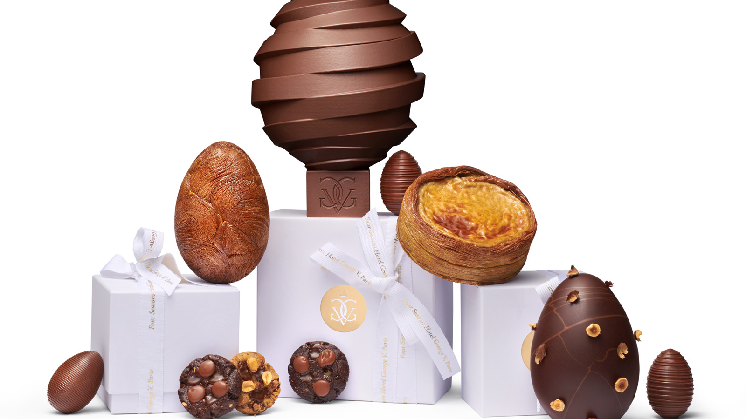 | March 19, 2021, Paris, France  “1,2,3... Chocolat!”: Le Four Seasons Hotel George V, Paris dévoile sa collection de Pâques autour d’un Pop Up espiègle et gourmand  https://publish.url/fr/paris/hotel-news/2021/easter-2.html

PRESS CONTACTS

Samuelle Dorol
Public Relations and Communications Manager
31, avenue George V
Paris
France
samuelle.dorol@fourseasons.com

+33 1 49 52 71 69

Nathalie Vimar
Director of Public Relations and Communication
31 avenue George V
Paris
France
nathalie.vimar@fourseasons.com

+33 1 49 52 71 69

