Four Seasons Resort Rancho Encantado Santa Fe Introduces Experiential Honeymoon Getaway Package

The Resort invites couples to celebrate their “I Dos” with an undeniably romantic, personalised escape in New Mexico’s “Land of Enchantment”
April 6, 2021, Santa Fe, U.S.A.

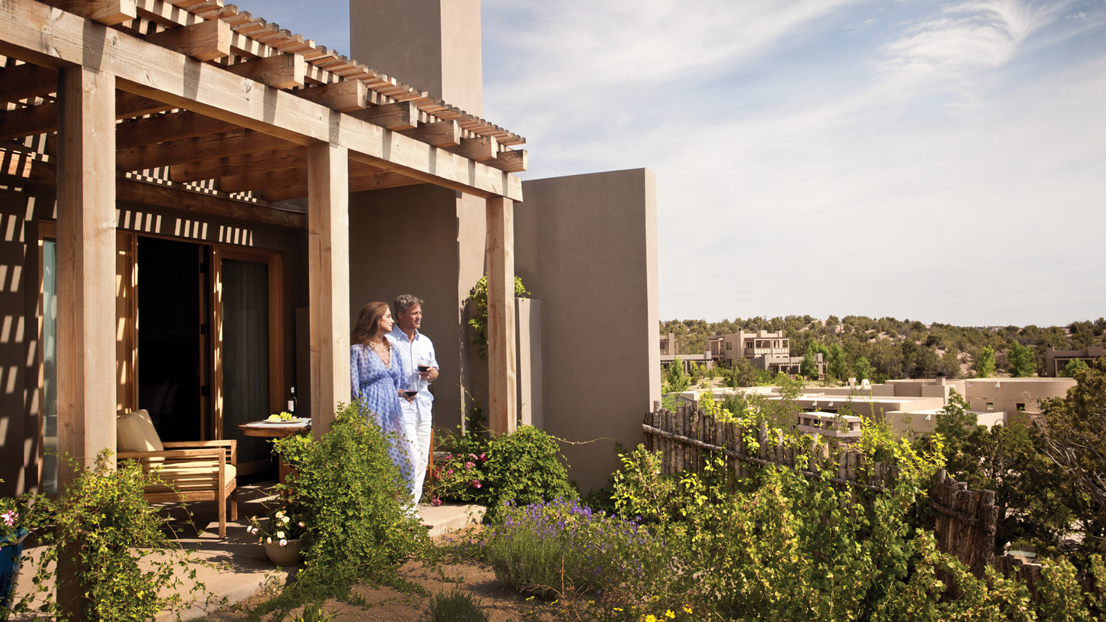
 | 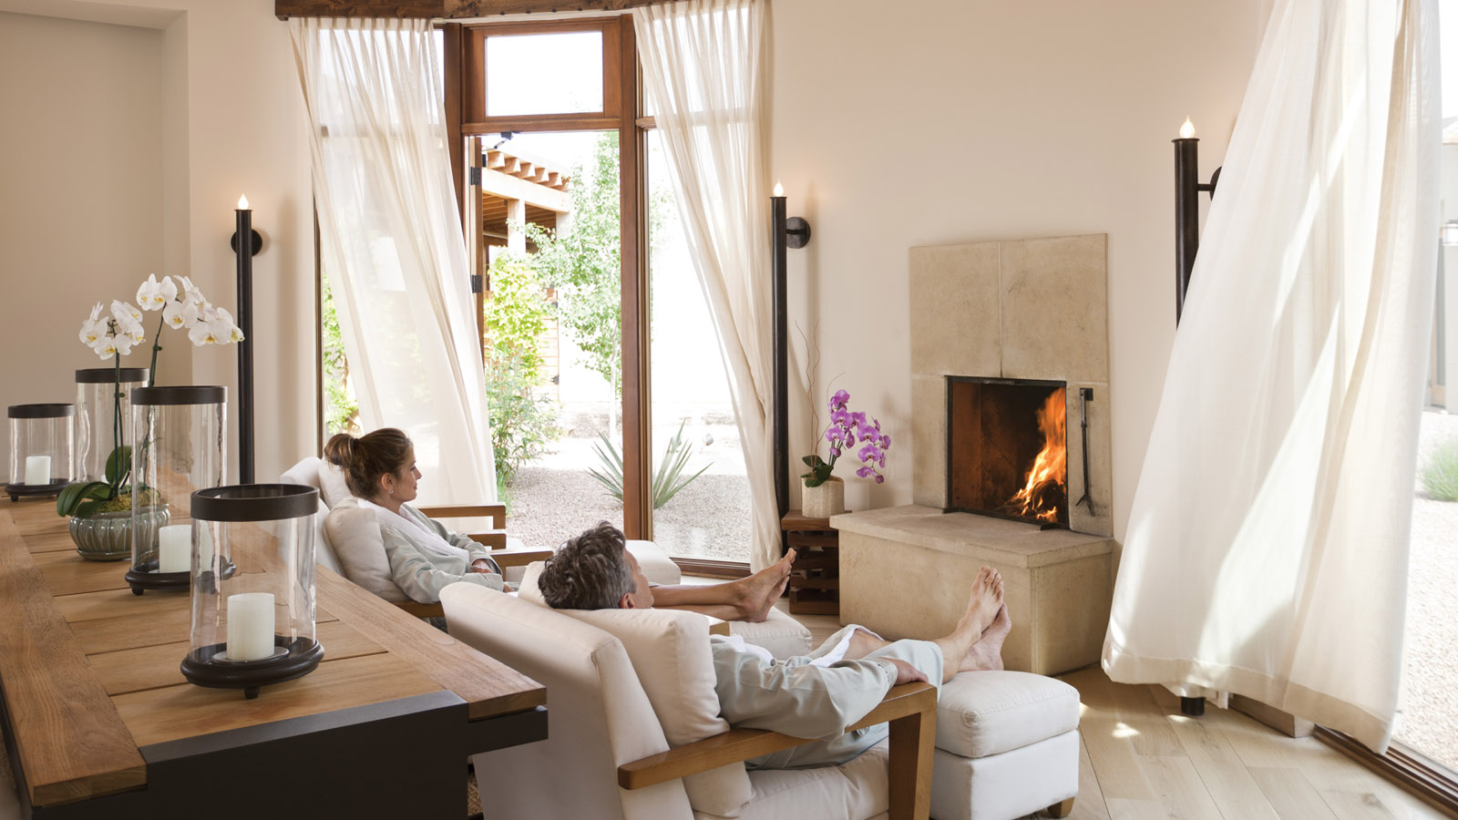 | 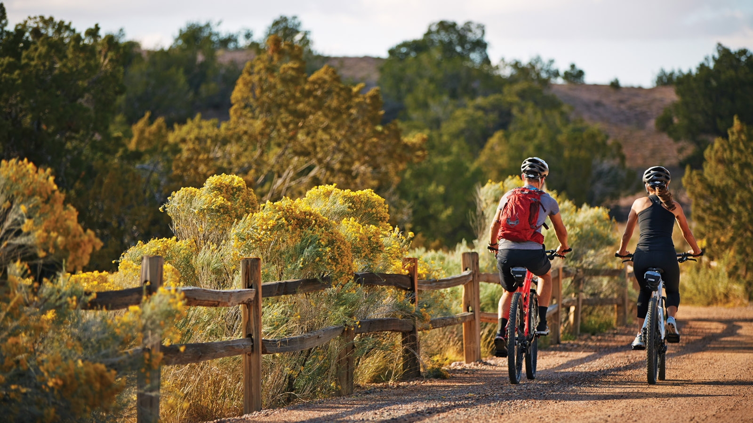
A boutique, luxury retreat situated amidst 57 sprawling acres (23 hectares) in the foothills of the Sangre de Cristo mountains outside Santa Fe, Four Seasons Resort Rancho Encantado features 65 casitas; a 10,000 square foot (930 square metre) indoor/outdoor Spa; on-site Adventure Center; inventive dining at Terra; and original outdoor, culture, culinary and wellness experiences. The Resort’s intimate setting surrounded by nature, coupled with a spacious layout, uninterrupted views and private casitas make for an ideal honeymoon destination in a distinct high desert-mountain locale.
 | 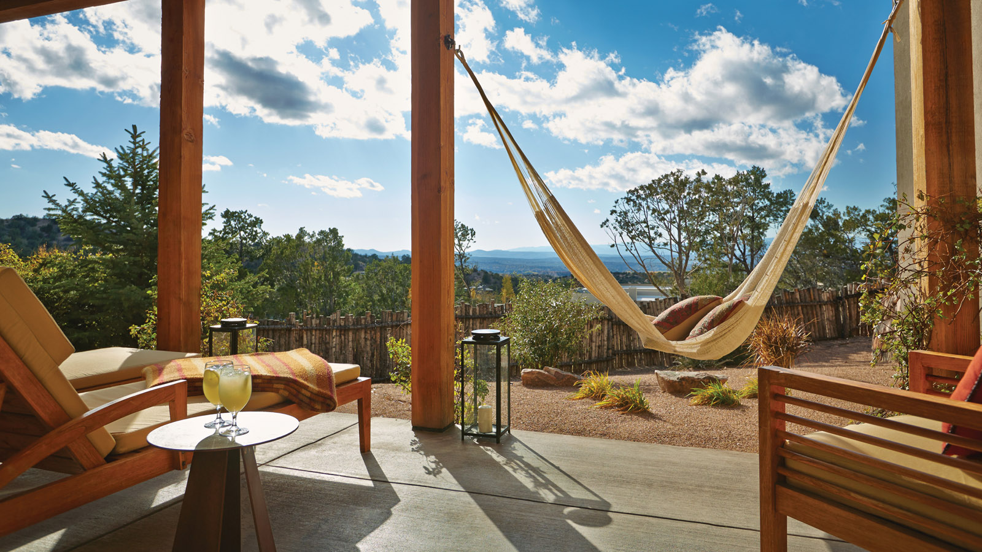 | 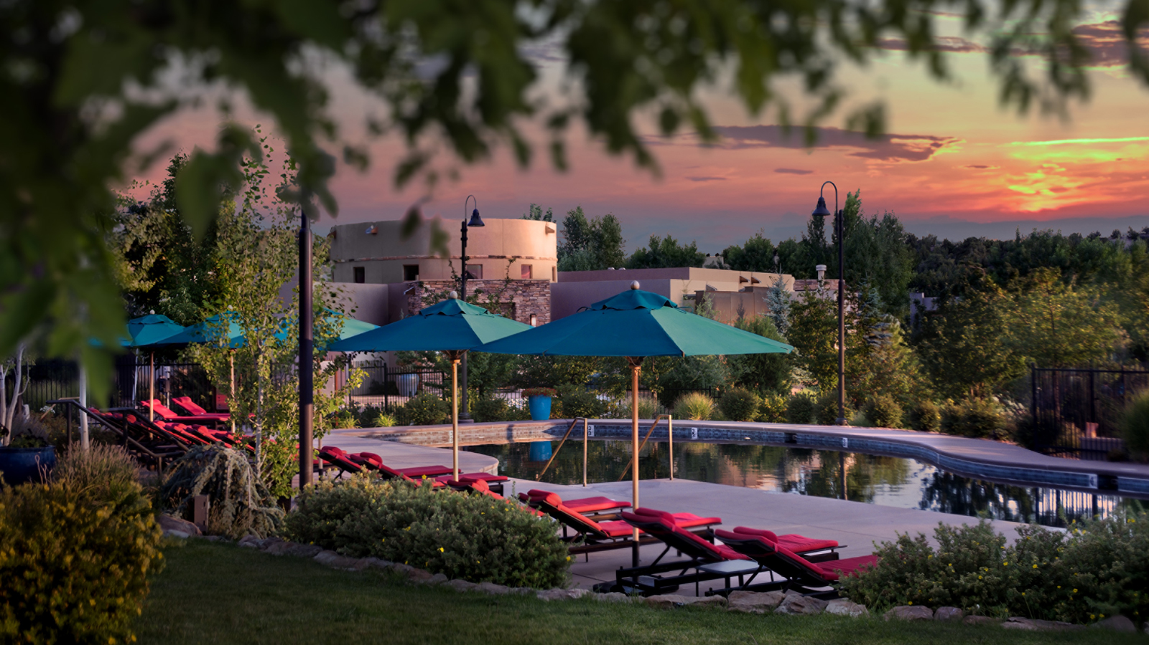
With the new honeymoon package, guests can relax in their spacious casita - complete with wood-burning fireplaces, private patio and spa-inspired bathroom with deep soaking tub - and enjoy a variety of exclusive "newlywed perks" including a bottle of champagne, USD 200 Resort credit, sunset drinks at Terra Bar, and custom amenities.
Plus, couples can enhance their honeymoon with a series of curated, private experiences to choose from to fully customise their vacation. From creative culinary and cocktail learning activities and “choose your own” private-guided outdoor adventures, local cultural excursions, and unique spa and wellness offerings, the options are endless for guests to “Honeymoon Your Way" at Four Seasons Santa Fe.
Honeymoon Package Inclusions
- Bottle of Beau Joie champagne upon arrival
- USD 200 resort credit towards a Spa or Adventure experience
- Two drinks at Terra Bar’s outdoor fire pit
- Late check out at 2:00 pm
Plus a special “Honeymooner’s Choice” amenity - choose from one of the following in-casita amenities:
- David’s Chocolate Heart + Bottle of Gruet - Hollow chocolate heart halve filled with macaroons, chocolate truffles and marshmallows, paired with a bottle of Gruet wine
- New Mexican Tapas with Sangria - Chef’s selection of tapas using local ingredients, served with a refreshing house-made sangria
- Chocolate Fondue with Fruit - accompanied by two glasses of Champagne brut
- Spanish Cheese and Charcuterie Board with Bottle of Iconoclast - D.O. Spanish cheeses and charcuterie selection with wine, specially made for Four Seasons
- Macaroons and Mimosas Flight - Assortment of Santa Fe macaroons (pinon/cajeta/chile), paired with prickly pear, orange-lavender and guava Mimosas

RELATED

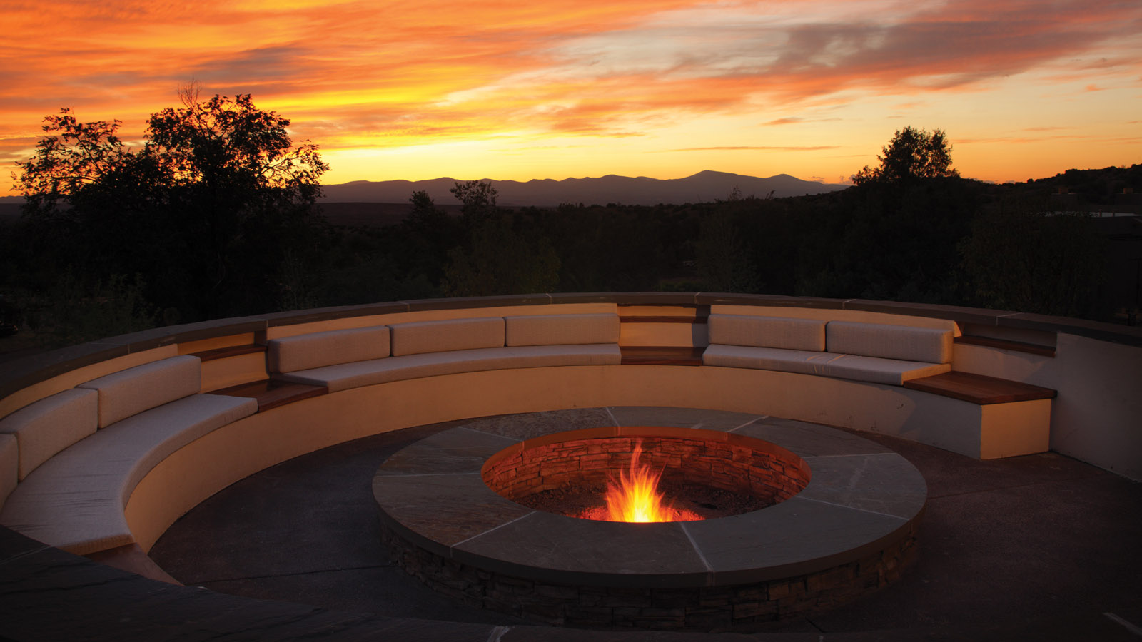 | January 27, 2021, Santa Fe, U.S.A.  From Four Seasons Resort Rancho Encantado Santa Fe, With Love  https://publish.url/santafe/hotel-news/2021/valentines-day.html
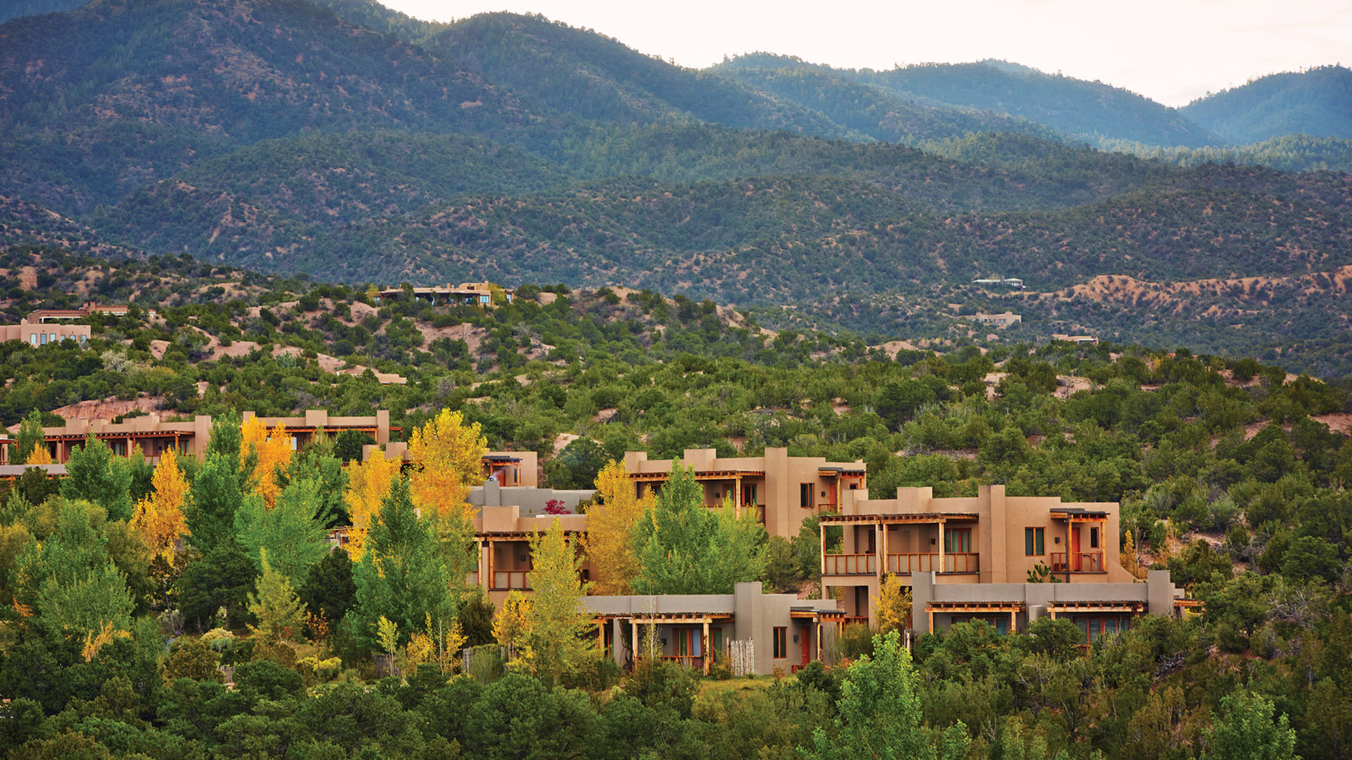 | September 10, 2020, Santa Fe, U.S.A.  Four Seasons Resort Rancho Encantado Santa Fe Launches New “Back-to-School” Program Offering a Bespoke Remote Learning Vacation Experience  https://publish.url/santafe/hotel-news/2020/schoolcations.html

PRESS CONTACTS

Michelle Duncan
Director of Public Relations
198 State Road 592
Santa Fe
USA
michelle.duncan@fourseasons.com

+1 646 229 2797

