From Adventure to Relaxation, From Wellness to Reconnection, Choose Your Pura Vida at Four Seasons Resort Costa Rica at Peninsula Papagayo as the Resort Reopens on November 12, 2020

September 9, 2020, Costa Rica

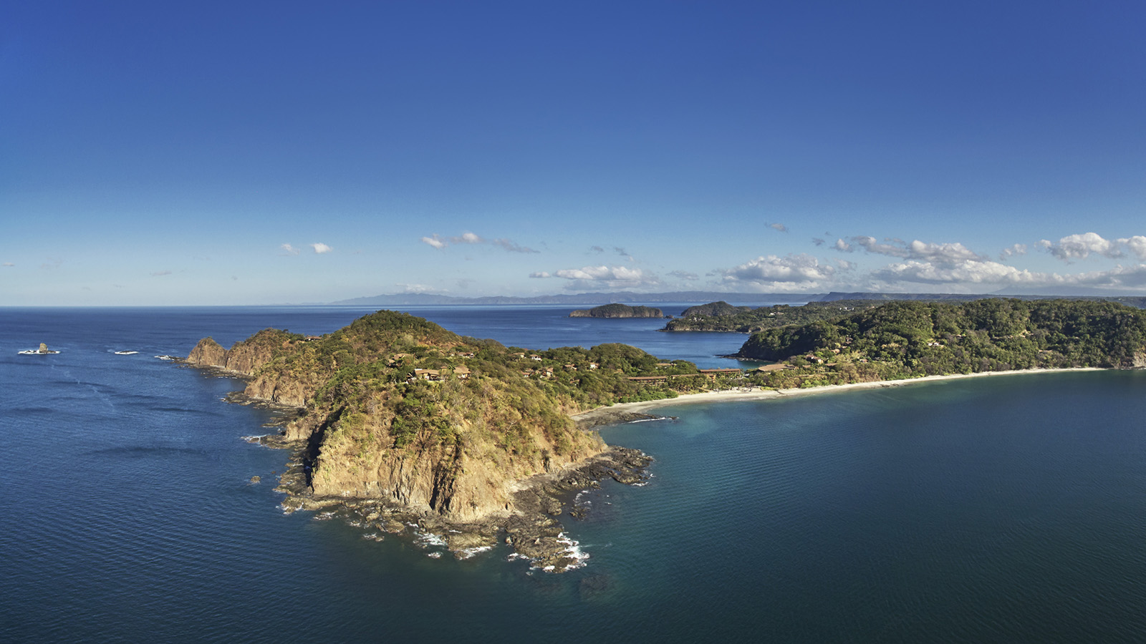
 | 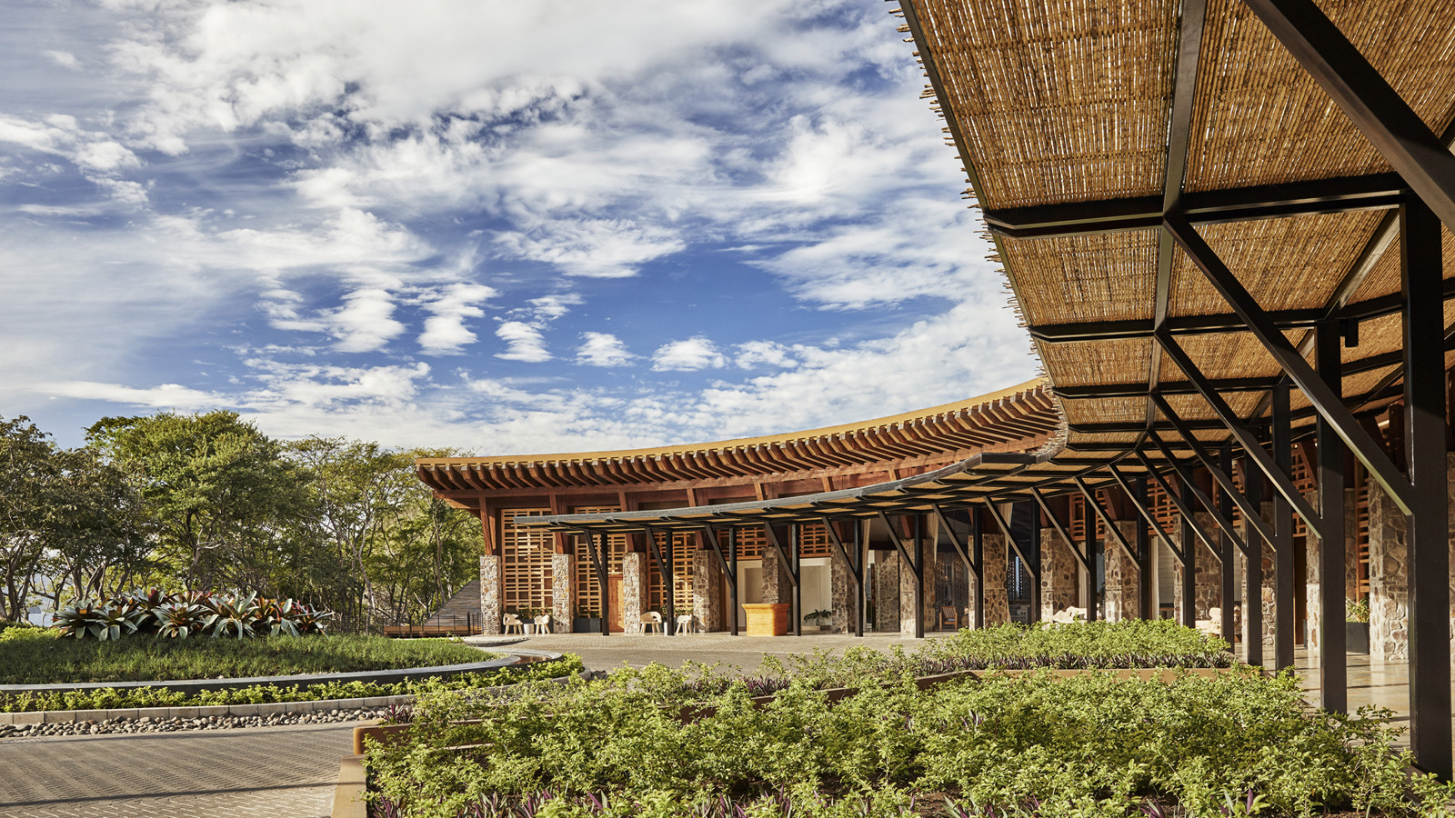 | 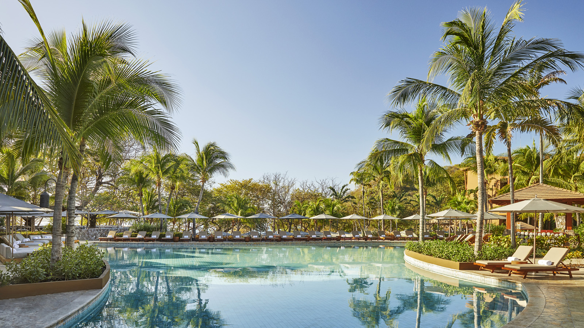
Four Seasons Resort Costa Rica at Peninsula Papagayo has announced the Resort will reopen on November 12, 2020 in time for the Thanksgiving and festive holidays. The recently-renovated Resort is established as the go-to private paradise that boasts the most extraordinary landscapes and biological corridors on the planet: a dreamlike 1,400-acre canvas of towering bluff tops, dry tropical forest, and miles of uncrowded beaches - all teeming with rare and magical wildlife. It’s heaven on earth for surfers, divers, hikers, bikers, nature lovers, and anyone who feels happiest in the outdoors.
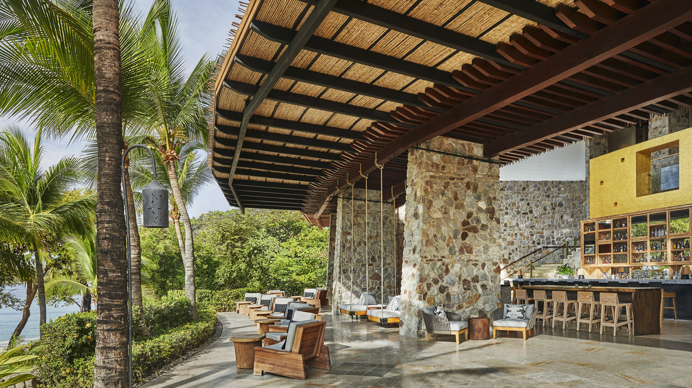 | 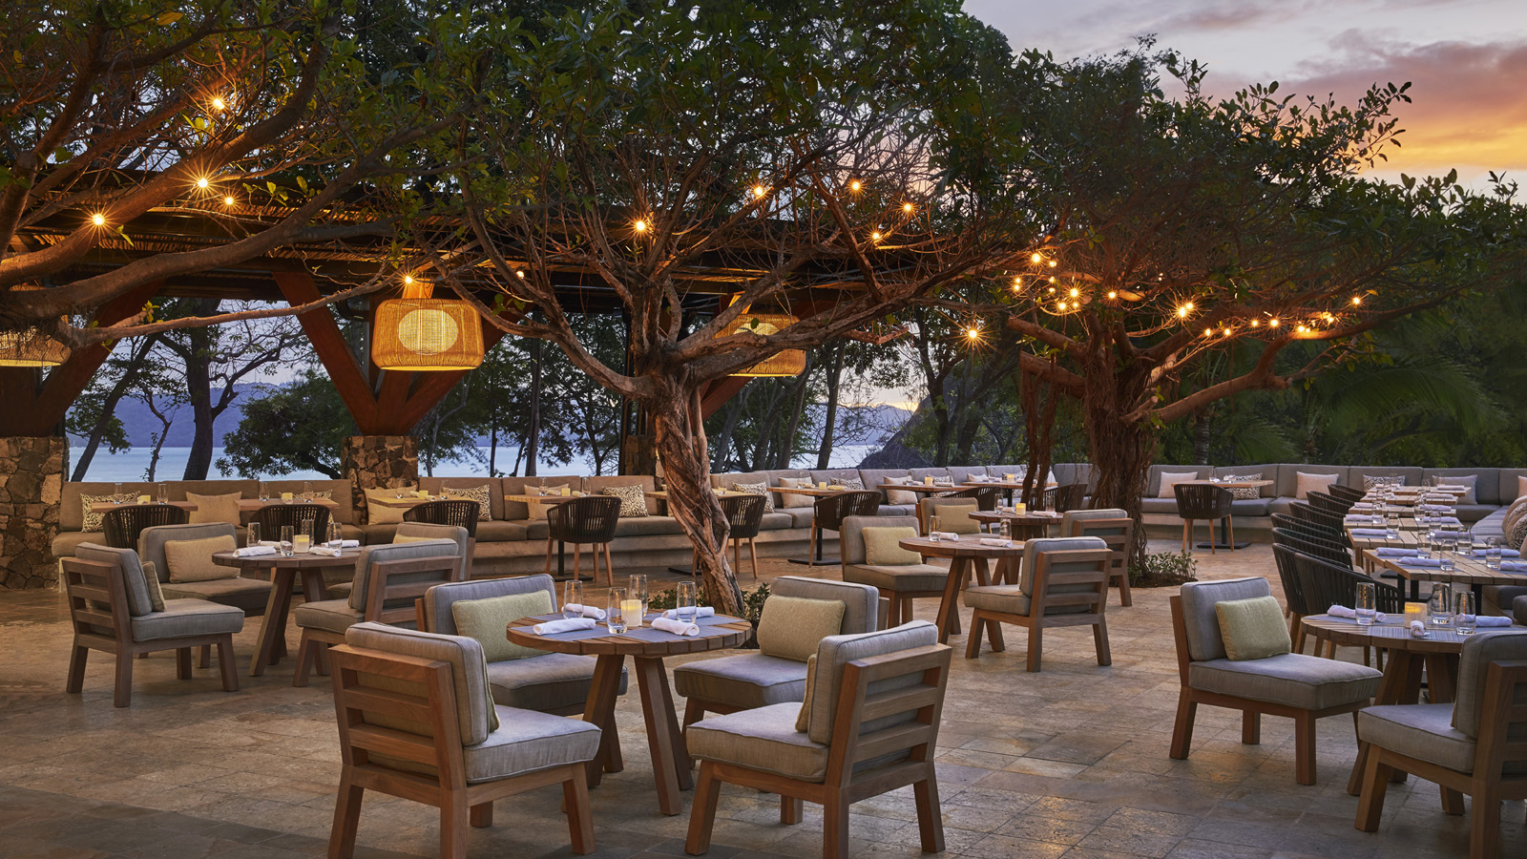
As it welcomes guests back to pura vida, Four Seasons introduces its Lead With Care program and its enhanced health and safety measures. Grounded in healthcare expertise and enabled by access to leading technologies and tools, the Lead With Care program is focused on delivering the utmost care, confidence and comfort to all Four Seasons guests, residents and employees.
“While the Four Seasons experience may look different the new atmosphere is grounded by the Four Seasons service and guest experience that you have come to trust and expect,” says Michael Mestraud, General Manager at Four Seasons Resort Costa Rica. “Perfectly located, the Resort sits at nature’s doorstep and offers expansive and uncrowded spaces. We have created an environment where guests and residents can return to enjoy what they love while feeling safe and cared for.”
Whether guests are a couple or a family, they can expect a Four Seasons experience they have come to rely on: unique and engaging activities, world-class restaurants, an expansive spa, Arnold Palmer golf course and a tennis centre. Two pristine beaches, four pools, private cabanas and water sports invite total relaxation and passion for adventure. On this getaway, guests can enjoy the Resort’s notable amenities and all that Peninsula Papagayo has to offer.
- Dining: The five culinary venues have a fresh approach that focus on locally-sourced organic foods. Highlights include four restaurants, a bar, an all-new beach bar and library lounge serving artisanal rum and spirits.
- Kids: Be part of the extended KFAS Learning Program, and enroll in the Tree Top School where younger guests can learn remotely, have full support of a study buddy, experience the nature, wildlife and local culture and challenge themselves with the after-school sports and activities offered.
- Wellness: Rejuvenate with morning meditation, sound healing and breathing workshops, four types of yoga, HIIT, sculpt barre classes and more. Led by Wellness Ambassador Beto Pena, the Ayurveda consultation will identify one's primal nature and will recommend methods of achieving balance and harmony.
- Experiences: A collection of guest activities and experiences rooted in a deep connection to self and nature, including exhilarating manta ray and dolphin expeditions, mountain biking along the Peninsula’s new trail system, surfing trips and yoga practice.
Plus guests can get first access to the latest addition to the award-winning Four Seasons Resort Costa Rica at Peninsula Papagayo: the Prieta Bay residences are an exclusive residential enclave overlooking a dramatic and picturesque coastline. As part of Four Seasons Private Retreats collection, the Residences at Prieta Bay is a limited collection of custom eco-luxury three-four- and five-bedroom villas and estate homes that sit on 17 acres of prime oceanfront in a private and gated enclave adjacent to Four Seasons Resort Costa Rica at Peninsula Papagayo.
As part of the new health and safety protocols all guests, residents and employees will adhere to a temperature check before entering the hotel. Employees will be wearing personal protective equipment and all guests are asked to wear a face mask when in public spaces inside the hotel. The Four Seasons Mobile App provides a convenient and contactless way for individuals to customise their stay. With Four Seasons service at their fingertips, they have the ability to make and manage reservations, request luggage pickup, airport transfers, room service, housekeeping requests, and more.
More information on Four Seasons Lead With Care program can be found here.
Four Seasons Costa Rica at Peninsula Papagayo reservations can be made online or by 1 800 781 5700.

RELATED

January 21, 2020, Costa Rica
Peninsula Papagayo Hosts Second Annual Invitational Member-Guest Charity Golf Tournament at Four Seasons Resort Costa Rica with Global Ambassador and World Golf Hall of Famer Ernie Els
https://publish.url/costarica/hotel-news/2020/invitational-member-guest-charity-golf-tournament.html

November 12, 2019, Toronto, Canada
Four Seasons apresenta a Costa Rica em programa que revoluciona o relacionamento da marca com influenciadores
https://publish.url/news-releases/2019/envoy-by-four-seasons-hari-and-deepti-2.html

PRESS CONTACTS

Danielle Finnegan
Director of Public Relations
Peninsula Papagayo
Guanacaste
Costa Rica
danielle.finnegan@fourseasons.com

+1 (786) 655-9898

