Four Seasons Continues to Expand Global Portfolio of Hotels, Resorts and Residences

2018 includes new market debuts, the company’s first standalone residential project, and a new executive appointment to oversee growing residential portfolio
January 22, 2018, Toronto, Canada

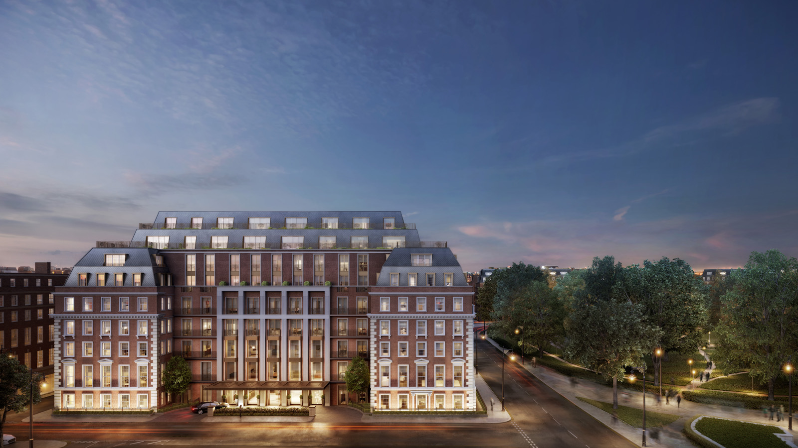
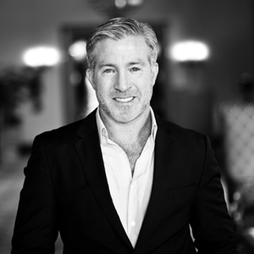 | 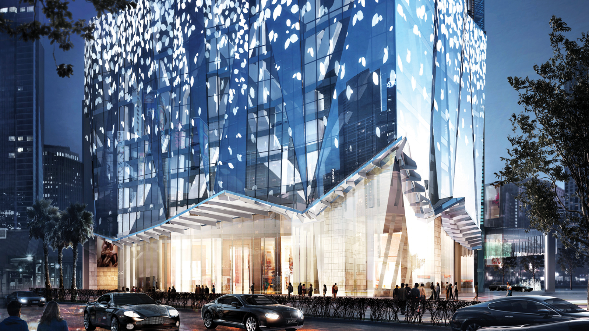 | 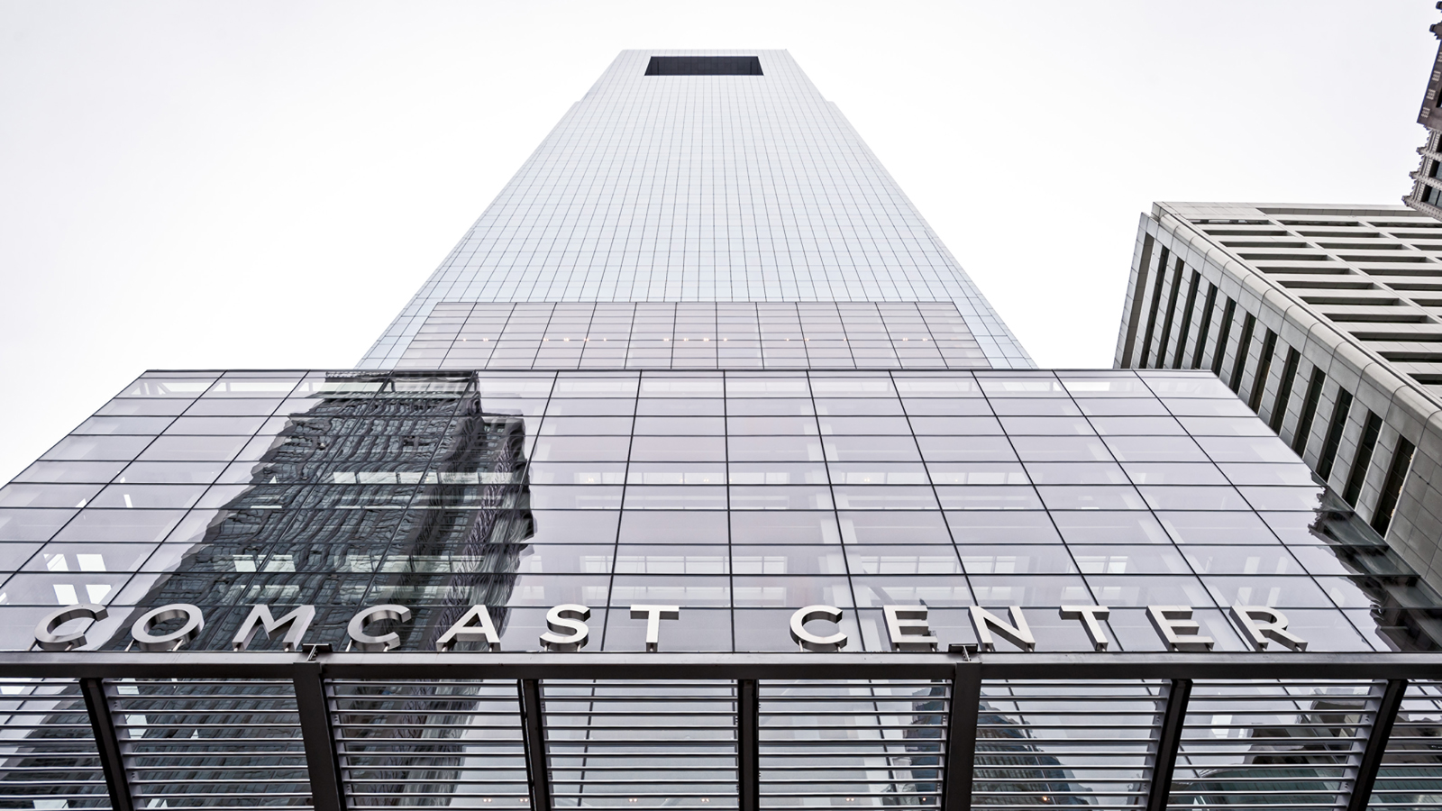
Following a year of highly successful openings including new builds, the rebirth of two historic landmarks and the conversion of one of the world’s finest resorts,
Four Seasons
Hotels and Resorts, the world’s leading luxury hospitality company, enters 2018 with a remarkable list of openings planned, including the company’s first standalone residential project.
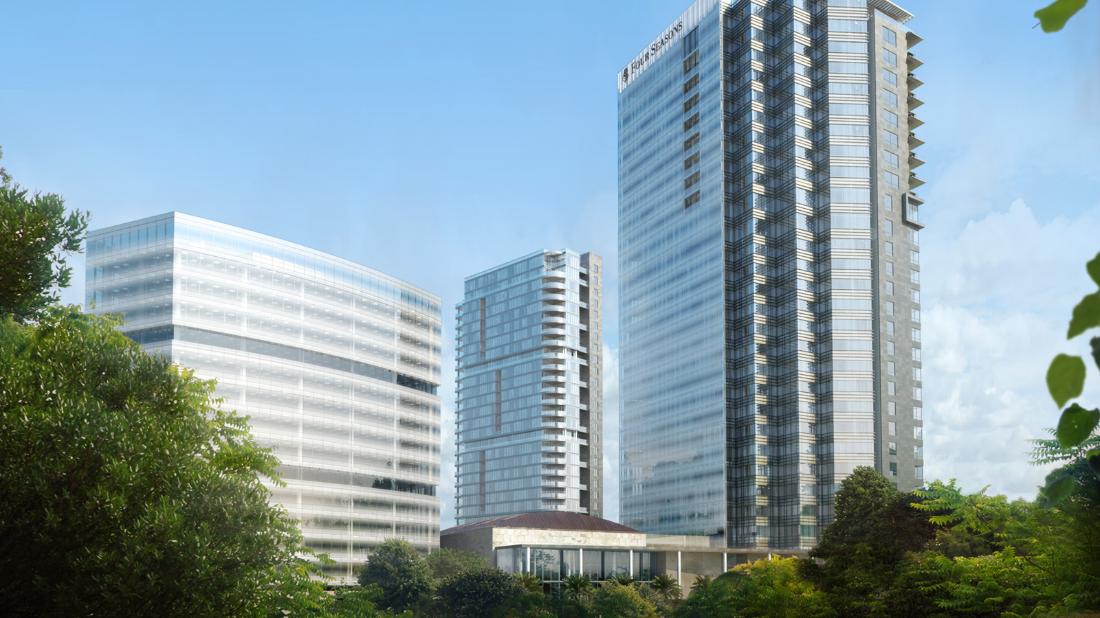 | 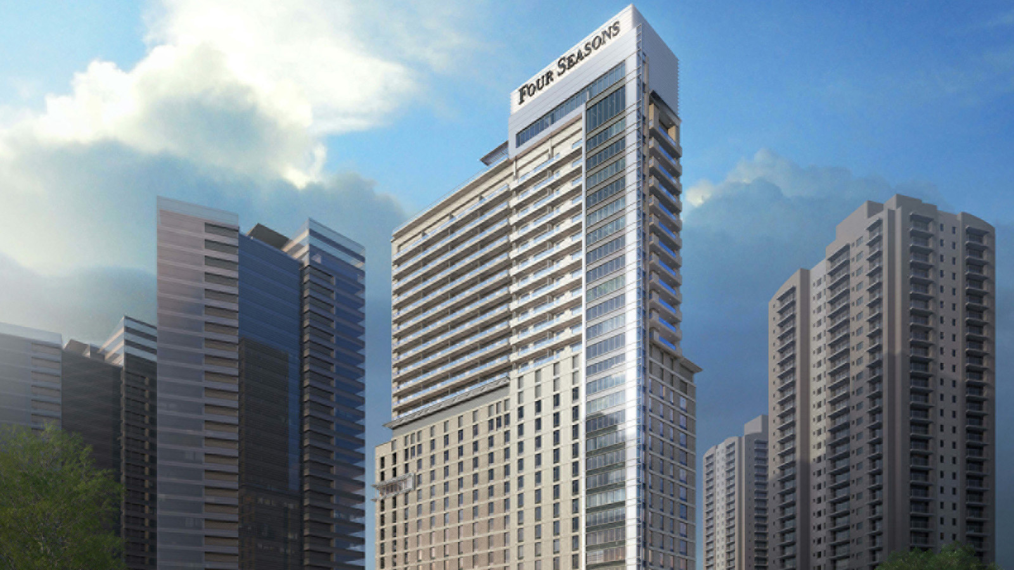 | 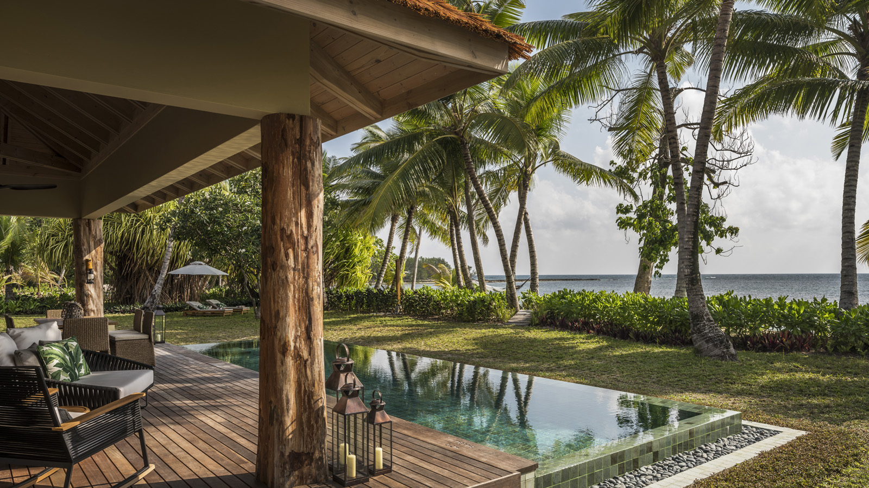
“Our singular focus is on luxury lifestyle, encompassing
Four Seasons
hotels and resorts, and increasingly,
Four Seasons
Private Residences,” says J. Allen Smith, President and CEO,
Four Seasons
Hotels and Resorts. “For decades,
Four Seasons
has been synonymous with the highest standards of quality and service for luxury travellers, many of whom have now chosen to ultimately live at
Four Seasons
. We are now committing even greater resources to this priority.”
Strategic Priority:
Four Seasons
Residential
To support the company’s growing residential business, Paul White has been appointed to President, Residential at
Four Seasons
Hotels and Resorts. Reporting to the President of Portfolio Management and Owner Relations, Michael A. Crawford, this newly created global role is focused exclusively on the company’s existing residential properties and the more than 30 projects currently in advanced stages of development, including working with owner partners to develop, design and market residential projects.
“Paul and his team oversee what we project will be USD 10 billion in
Four Seasons
residential sales over the next five years,” says Crawford. “
Four Seasons
is distinct in the market as we also manage our residential properties, thus ensuring world-class service for our homeowners. We are also the only brand with a dedicated residential team, a team that under Paul’s leadership will continue to evolve our offerings and provide owners with a luxury lifestyle experience that can only be found through
Four Seasons
.”
Since entering the luxury real estate business in 1985, the company’s portfolio of
Four Seasons
Private Residences, as well as its villa and residence rentals program, has grown to include 38 properties in 17 countries, and is set to double in the next five years. Twenty Grosvenor Square, a
Four Seasons
Residence in London, opening this year, will be the first standalone
Four Seasons
residential property, while approximately 80 percent of current hotel and resort development projects include a residential component.
Building on Success: 2017 Growth Highlights
Four Seasons
opened seven hotels and resorts last year, including a second location in London at Ten Trinity Square, which realised the meticulous restoration of a historic landmark. Additional expansion took place in China, where the company opened its ninth location in this key market, this time in the port city of Tianjin.
In Surfside, Florida, architect Richard Meier’s and designer Joseph Dirand’s vision for reviving the historic Surf Club came to life as a
Four Seasons
hotel and residences, while the company’s first hotel in Kuwait is a modern marvel of architecture, art and design. The first
Four Seasons
in Tunisia also opened on a prime beachfront location just minutes from both urban attractions and major archaeological sites.
Late in the year, just one month after announcing plans to convert, Paradise Island’s legendary Ocean Club in the Bahamas debuted as a
Four Seasons
experience. In another
Four Seasons
first, the company expanded its mountain portfolio to Europe in collaboration with the Rothschild family with an all-new hotel in Megève.
In 2017, the company also announced plans to open
Four Seasons
hotels, resorts and residences in Korea at Jeju Island; the Chinese port city of Dalian; a second location in Saudi Arabia at Makkah; and a second property in Vietnam in the heart of Hanoi.
Looking Ahead at 2018
In addition to Twenty Grosvenor Square, a
Four Seasons
Residence, there are several anticipated hotel and resort openings in 2018, with most featuring Private Residences, including a new hotel next to the Petronas Towers in Kuala Lumpur.
The company will open its second hotel in India along with Private Residences in Bengaluru, one of India’s fastest growing cities, as well as its second resort in Seychelles on the secluded Desroches Island.
Four Seasons
will return to Philadelphia with a new hotel in what will be the city’s tallest building. In partnership with Comcast, the hotel will introduce a new level of enhanced technology for luxury travellers.
Four Seasons
will also debut in Brazil with a new hotel and residences in São Paulo; and in Greece with the conversion of a longstanding favourite on the Athenian Riviera, the Astir Palace.

RELATED

January 19, 2018, Toronto, Canada
Four Seasons Hotels and Resorts and Embassy Group to Introduce New Luxury Hotel and Private Residences in Bengaluru, India
https://publish.url/news-releases/2018/new-four-seasons-in-bengaluru.html

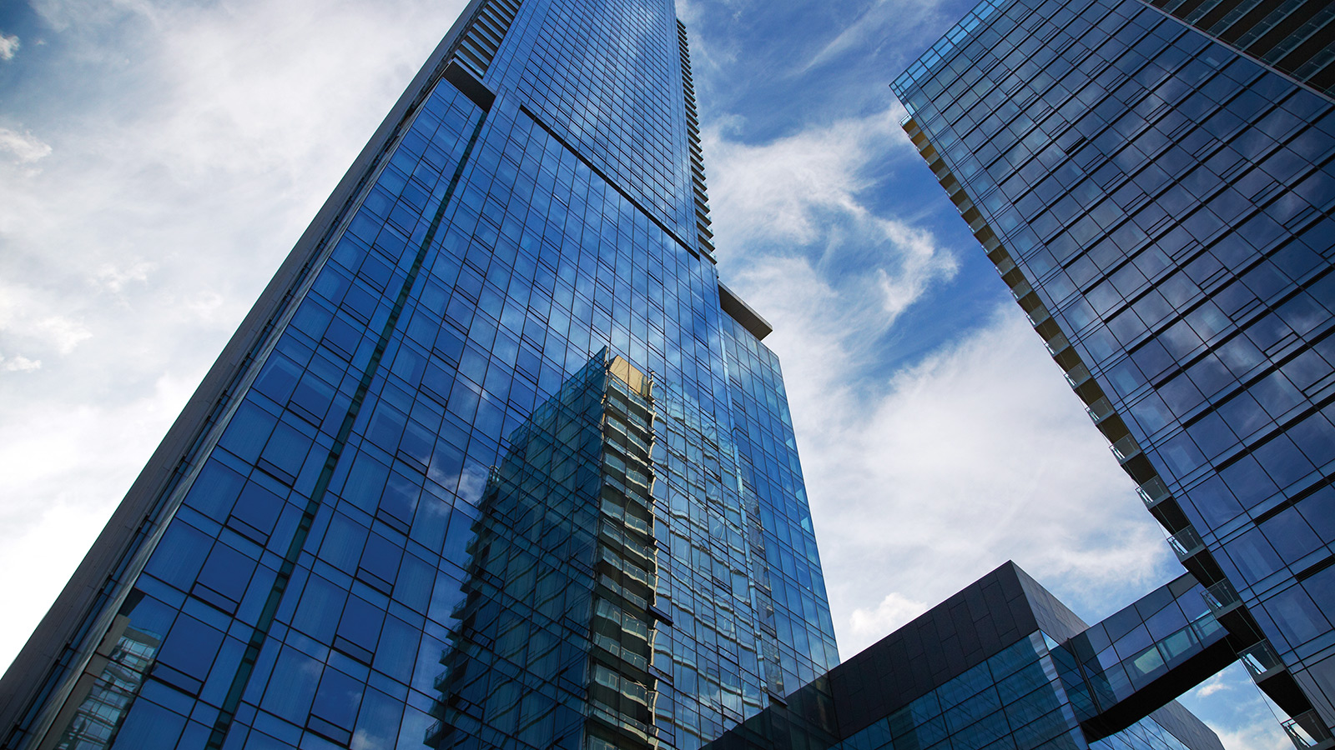 | January 1, 2018, Toronto, Canada  History Behind Four Seasons - Four Seasons Hotels and Resorts  https://publish.url/news-releases/the-story-of-four-seasons.html

PRESS CONTACTS

Sarah Tuite
Director, Corporate Communications and Public Relations
1165 Leslie Street
Toronto
Canada
prsm@fourseasons.com

+1 (416) 441-4440

