Bar Margot Launches $5 Lunchtime Menu Through Summer at Four Seasons Hotel Atlanta

Lunchtime tacos and burgers now available for dine-in or take-out
August 12, 2020, Atlanta, U.S.A

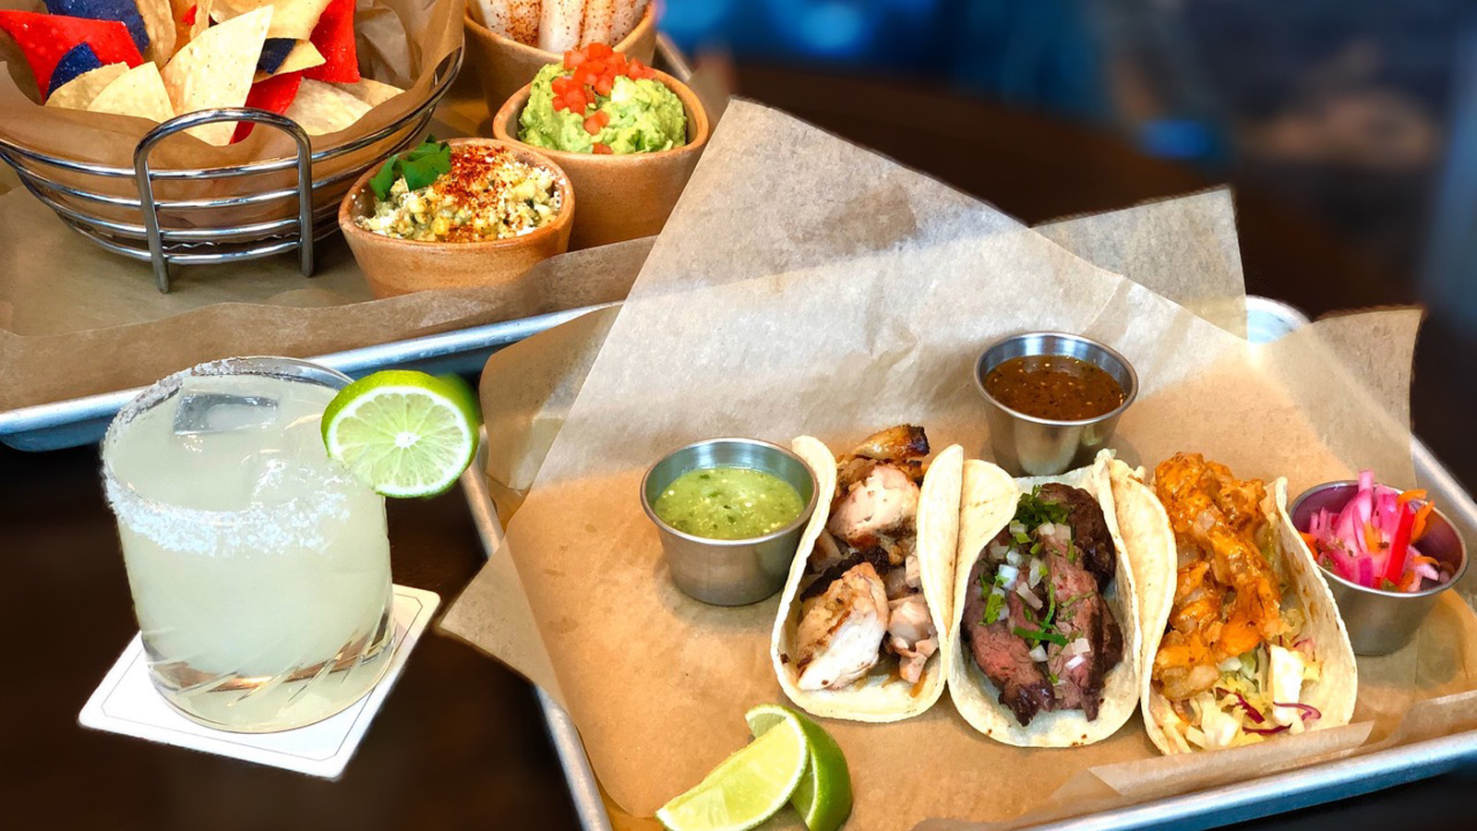
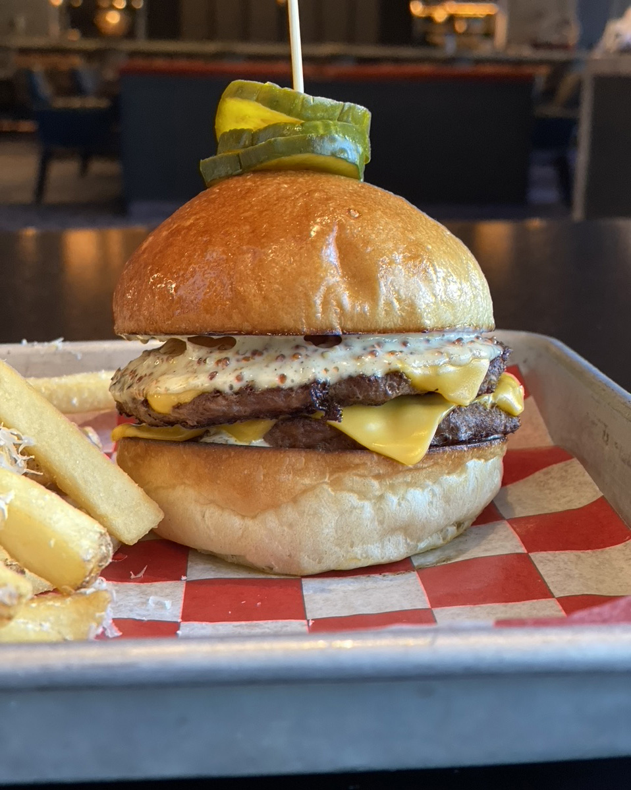 | 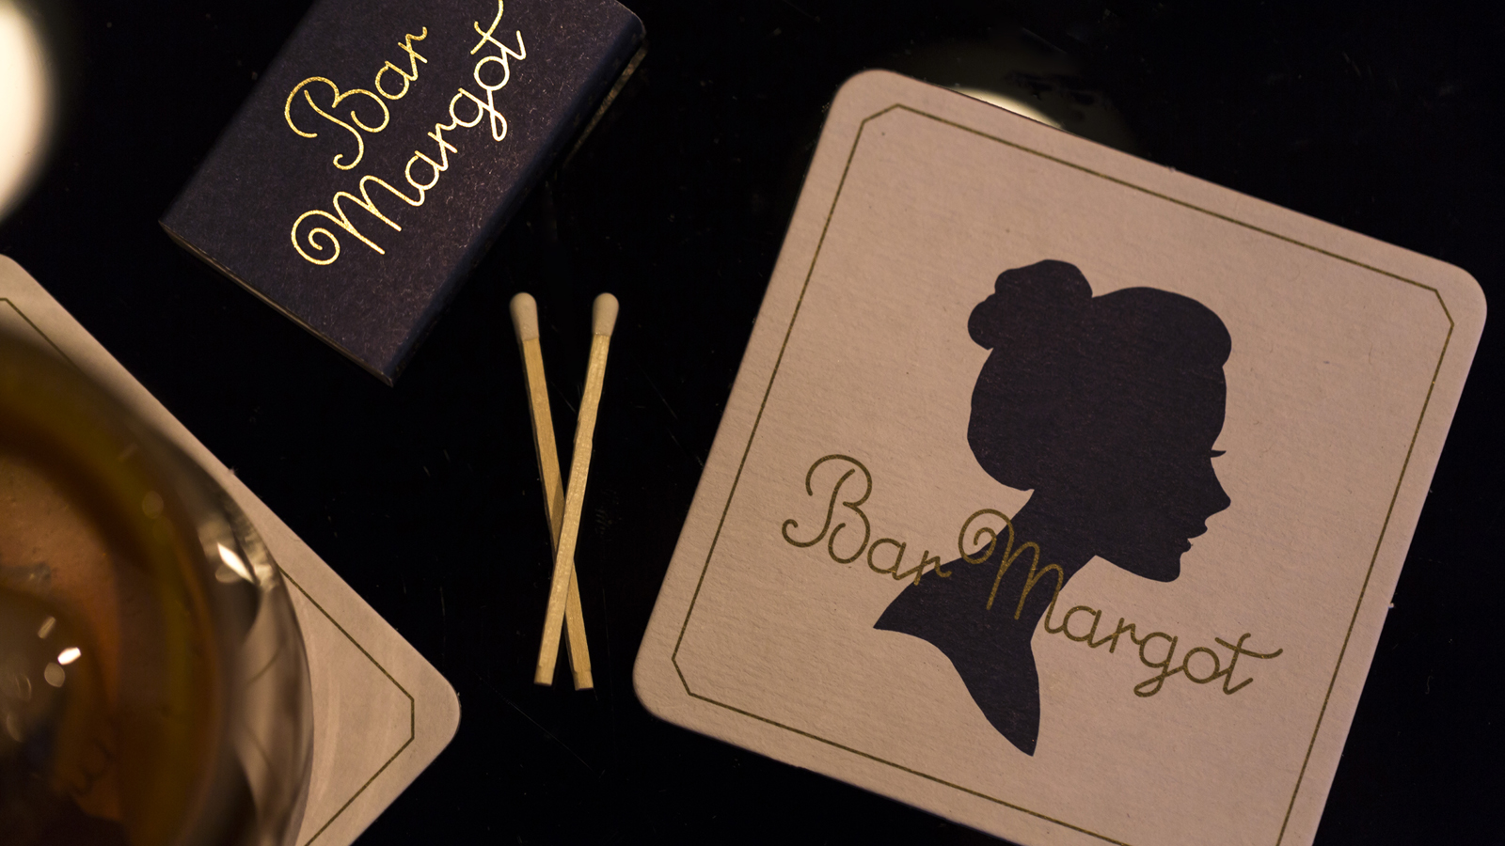 | 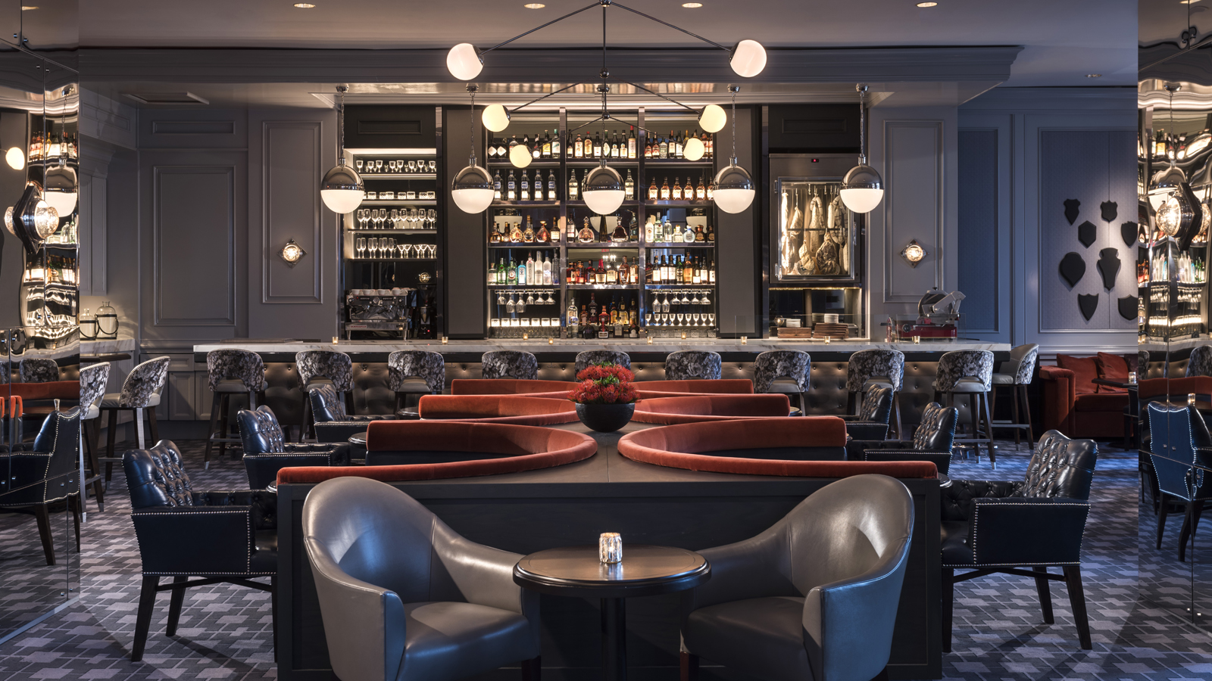
Some of Bar Margot’s favourites are on the summertime menu for a USD 5 steal. Escape the Atlanta heat for a seat inside Bar Margot and some of Executive Chef Edgar Kano’s hot weather favourites, especially for those who need a pick me up or a simple escape from their work-from-home assignment.
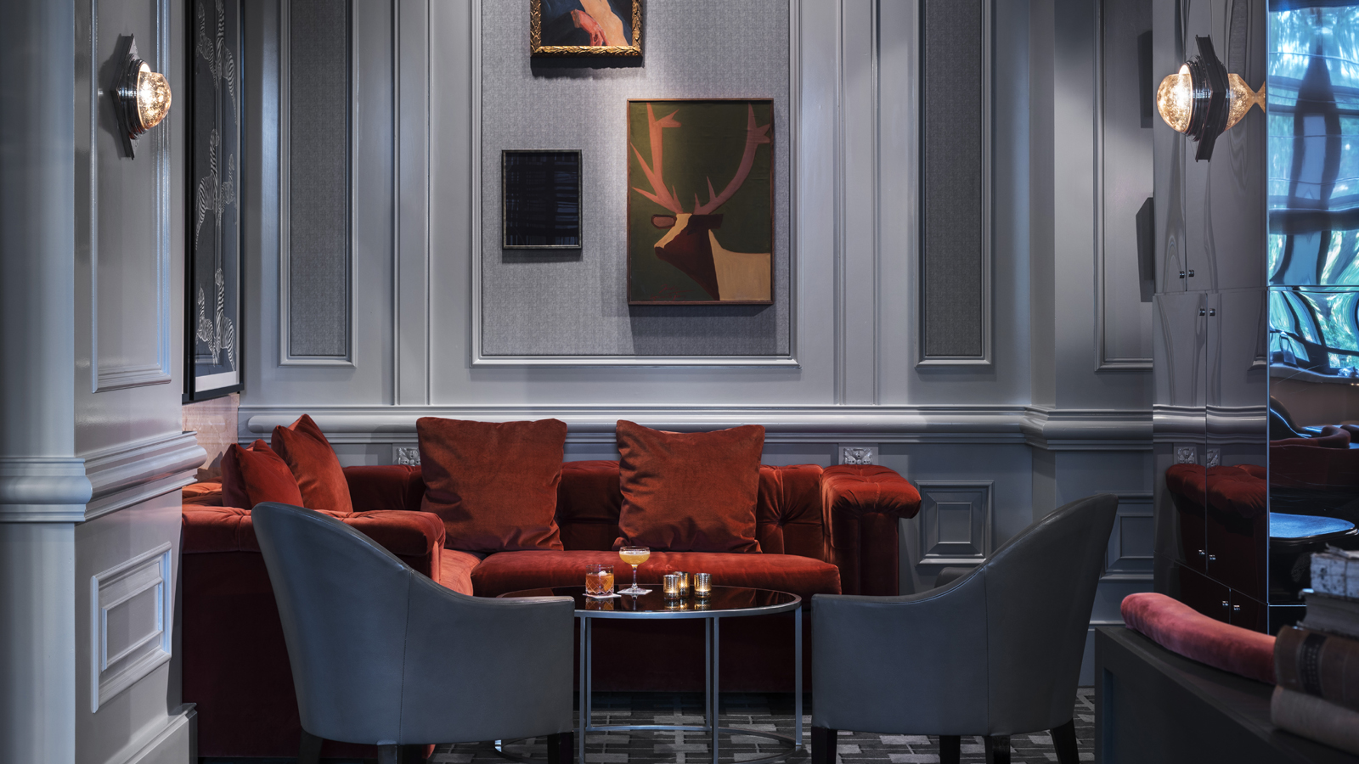 | 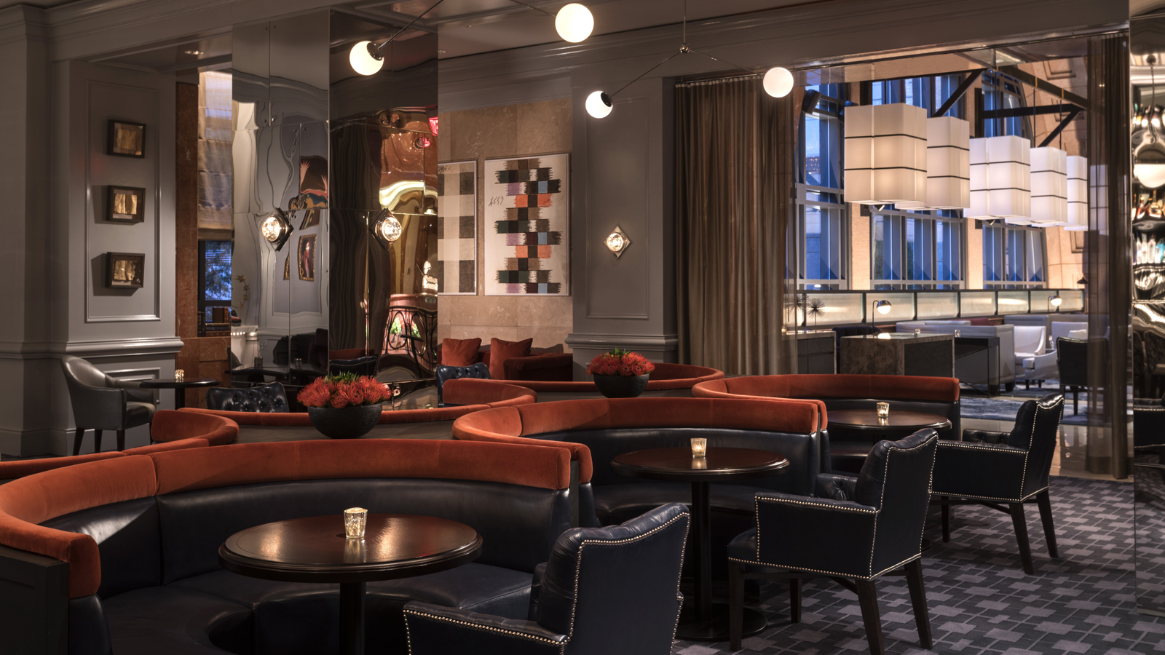 | 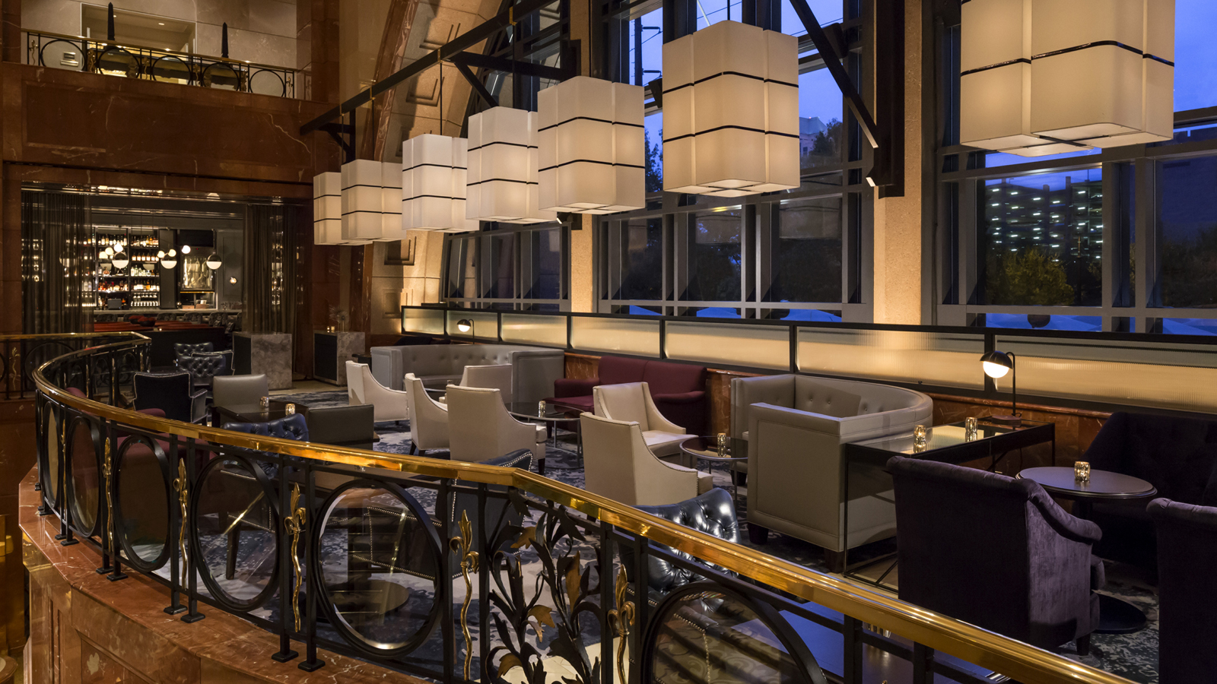
On Tuesdays from 11:00 am to 2:00 pm, Kano takes us home to his native Mexico with his Taco Tuesday special, which includes the option of a Baja shrimp, chicken or beef taco served with a side of serrano tomatillo salsa and chipotle aioli sauce.
If Tuesday felt more like a Monday and one was too busy to slip over to Bar Margot, then hump day is calling. Formerly known as the USD 5 Burger that took Atlanta lunch-goers by storm last year, The Midtowner Burger is a double-patty-stacked burger topped with American cheese, red onion, house-made mayonnaise and topped with pickles - all for just USD 5. Burger lovers will be tempted every Wednesday from 11:00 am to 2:00 pm, especially with the upgrade options of truffled-parmesan fries, sautéed mushrooms, a fried egg and crisp jalapeño peppers.
“Nothing about summer 2020 is normal, so we might as well use this time to really enjoy life, family, friends and the things that we eat,” says Kano. “My team and I are so excited to be back together and these summertime offers are the perfect reason to come see us!”
Both USD 5 specials run through Wednesday, September 9, 2020. Both offers are available for dine-in or takeout. Bar Margot is located inside Four Seasons Hotel Atlanta.

RELATED

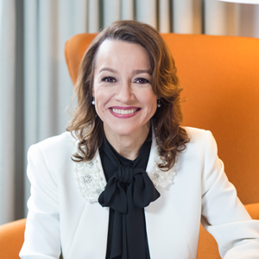 | July 8, 2020, Atlanta, U.S.A  Four Seasons Hotel Atlanta Welcomes New General Manager Nancy Chacon  https://publish.url/atlanta/hotel-news/2020/new-gm-nancy-chacon.html
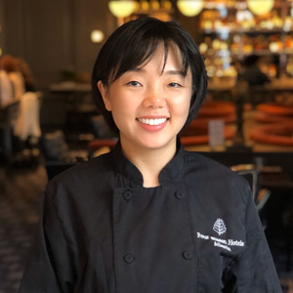 | December 17, 2019, Atlanta, U.S.A  Four Seasons Hotel Atlanta Welcomes Pastry Chef Erica Lee  https://publish.url/atlanta/hotel-news/2019/new-executive-pastry-chef-erica-lee.html

PRESS CONTACTS

Emilie Plouchart
Director of Public Relations
75 Fourteenth Street NE
Atlanta
USA
emilie.plouchart@fourseasons.com

+1 818 424 1006

