Celebrate This Valentine’s Day the Four Seasons Way at Four Seasons Astir Palace Hotel Athens

January 30, 2020, Athens, Greece

Love is in the air at Four Seasons Astir Palace Hotel Athens, as the Hotel embraces the art of romance and prepares to host a Valentine’s Day celebration like no other. Guests can treat their significant others to exquisite dining or a romantic getaway with an overnight stay at the most iconic hideaway of the Athenian Riviera.
Mercato sparks the romance with a fabulous four-course dinner carefully crafted by Chef Bertrand Valegeas, served throughout the weekend from Friday, February 14 until Sunday, February 16, 2020.
A glass of Taittinger Rosé Champagne introduces patrons to the romantic dining experience before the first course of red carabineros shrimps with marinated foie gras and passion fruit coulis arrives to the table. Savour the second course, the signature homemade lobster ravioli with black winter truffle and lime zest. Then, the third course is a choice between US prime beef fillet with chanterelle mushrooms, pomme Maxim’s, caramelised onions and guanciale, or roasted fillet of sole with oscietra caviar beurre blanc, basil and beetroot gnocchi. The exquisite night ends on a sweet note with a dessert created for this special occasion: a red berries heart with lime cream, vanilla and tonka bean ice cream, and then guests can take with them an assorted chocolates box as a souvenir of the time they spent in Four Seasons in Athens. The dinner is priced at EUR 75 per person.
The romantics will wish to celebrate love all weekend long with an overnight stay. The Hotel’s Valentine's Weekend Package offers the special room rate of EUR 250 per night for stays between February 13 and 16, 2020 along with themed in-room amenities, a bottle of sparkling wine, a celebration cake and late checkout. Impressing a loved one has never been easier with the help of the concierge team, who can help create the most memorable touches: stage a guest room with red roses, champagne for two, a path of rose petals, chocolate truffles and more.
To book the Valentine’s Weekend Package, call +30 210 890 1000 or email reservations.athens@fourseasons.com.

RELATED

November 14, 2019, Athens, Greece
It’s the Most Wonderful Time of Year on the Athens Riviera at Four Seasons Astir Place Hotel
https://publish.url/athens/hotel-news/2019/festive-season.html

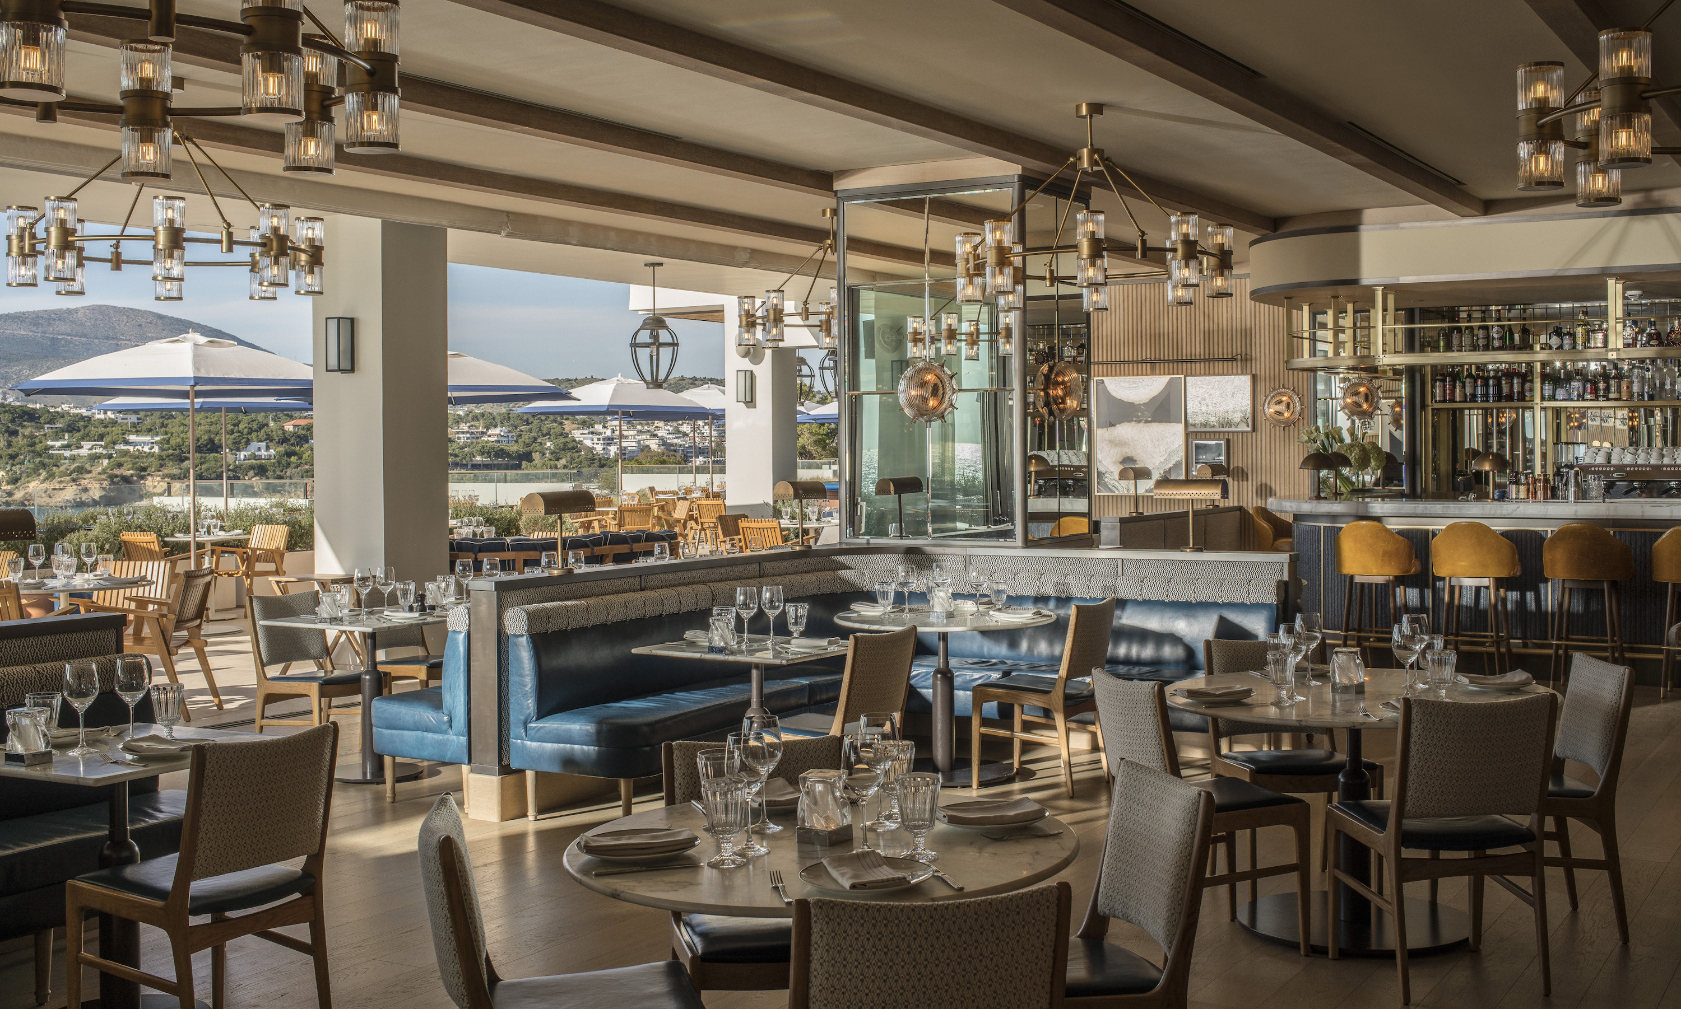 | October 18, 2019, Athens, Greece  SUNDAY BRUNCH ΣΤΟ MERCATO: Η AΠΟΛΥΤΗ ΕΜΠΕΙΡΙΑ ΓΕΥΣΤΙΚΗΣ ΑΠΟΛΑΥΣΗΣ ΣΤΟ FOUR SEASONS ASTIR PALACE HOTEL ATHENS  https://publish.url/el/athens/hotel-news/2019/sunday-brunch-at-mercato-2.html

PRESS CONTACTS

Elia Kentrota
Director of Public Relations
40 Apollonos Street
Vouliagmeni, Athens
Greece
elia.kentrota@fourseasons.com

+30 210 8901077

