The Wedding Club at Four Seasons Hotel Beirut, an Exclusive Year-Round Journey for Newlyweds-to-Be

Unforgettable experiences and benefits for the privileged few
September 5, 2019, Beirut, Lebanon

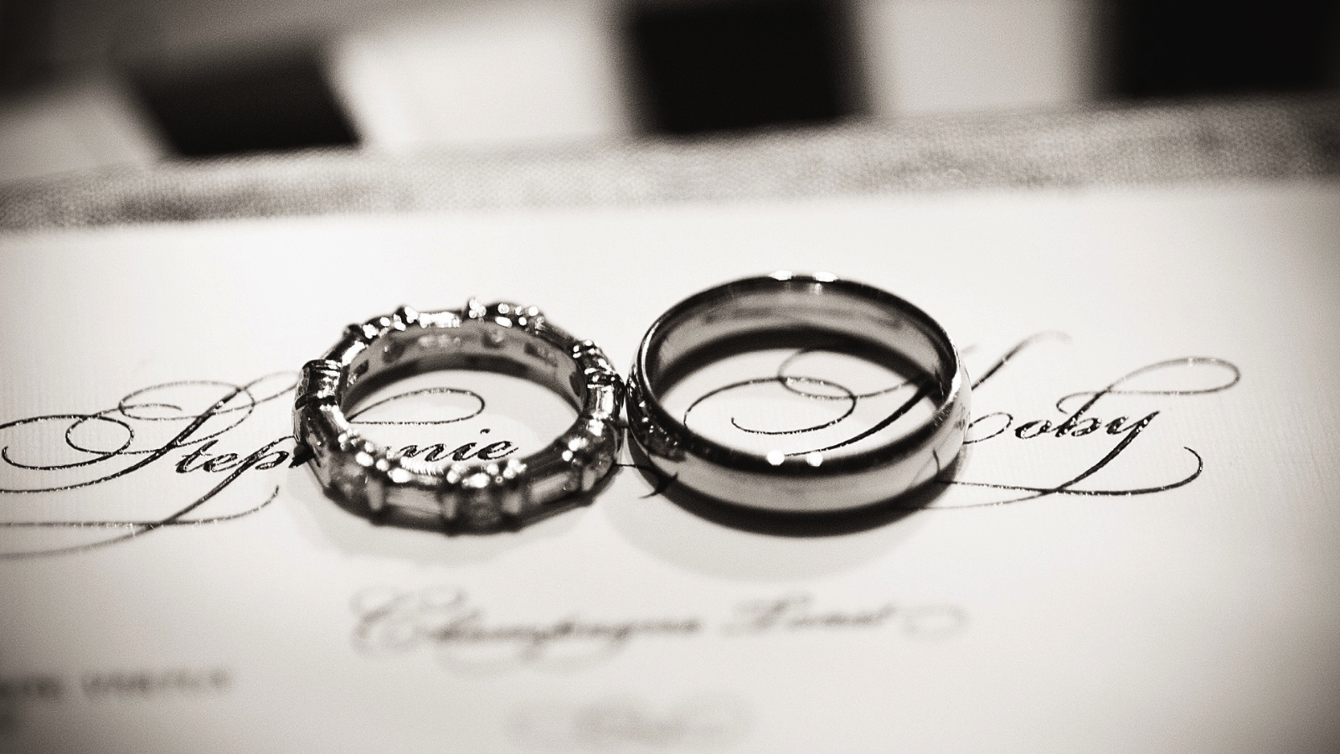
Couples can start their wedding journey earlier and extend their celebrations until their first anniversary as Four Seasons Hotel Beirut gets ready to pamper them long after they have solemnly said “I do” to the love of their life.
Enter a VIP exclusive golden circle by joining the Wedding Club, a new privileged club intended for couples who wish to have their wedding at Four Seasons Hotel Beirut. Pre-wedding specials start with a customised meal for the bride and groom, along with two additional guests, prepared by the Hotel’s talented Banquet Chef Marc Jebran and his team, who will make sure all culinary wishes fall nothing shorter than exceptional. Couples can then head to The Spa’s private suite and enjoy relaxing treatments by the hands of professional therapists, to prepare them for the big day.
On the wedding day, bridal pampering goes to dizzying new heights in a Bridal Suite dedicated for an all-day-use, offering the bride the tranquility needed as she makes her preparations. The Hotel’s team of experts will offer suggestions and personalise every detail to ensure that this special day will be unforgettable.
Special menus can be drawn together from a broad range of culinary choices; even personalised signature mocktails can be created – and named after the bride and groom!
Couples will then enjoy spending their first night together as newlyweds in a Honeymoon Suite overlooking vibrant and sleepless Beirut in personalised his and hers bathrobes with embroidered initials. Gifts will still be pouring on the following morning with a limousine drop off service at the airport. And it does not end here.
The team at Four Seasons Hotel Beirut will mark their calendar to be among the first to wish the couple a happy first wedding anniversary. As soon as they reach this first milestone, a complimentary stay in a sea view suite, including breakfast in bed for two and a couples’ massage with 50 percentconcession will be offered by the Hotel.
Couples can now embark on their happily ever after with the exclusive Wedding Club at Four Seasons Hotel Beirut, who will vow to have and to hold them, every step of the way.

RELATED

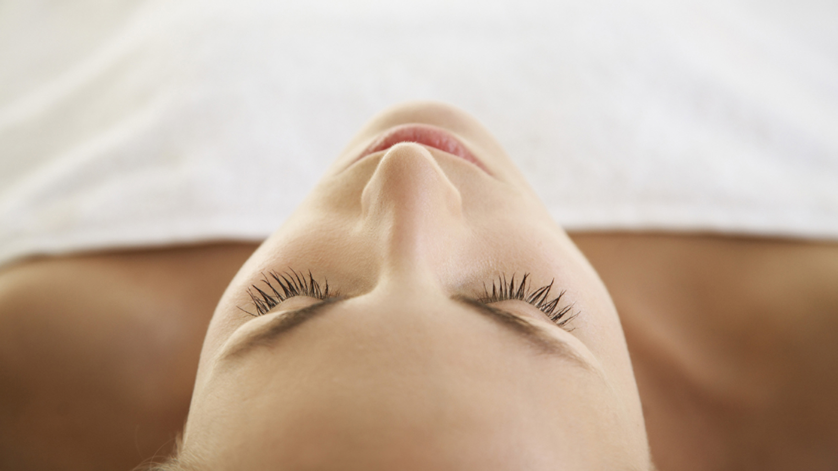 | August 13, 2019, Beirut, Lebanon  Revitalise Your Inner Self with Energy Healer Tim Stoneman at Four Seasons Hotel Beirut  https://publish.url/beirut/hotel-news/2019/visiting-energy-healer-at-the-spa.html
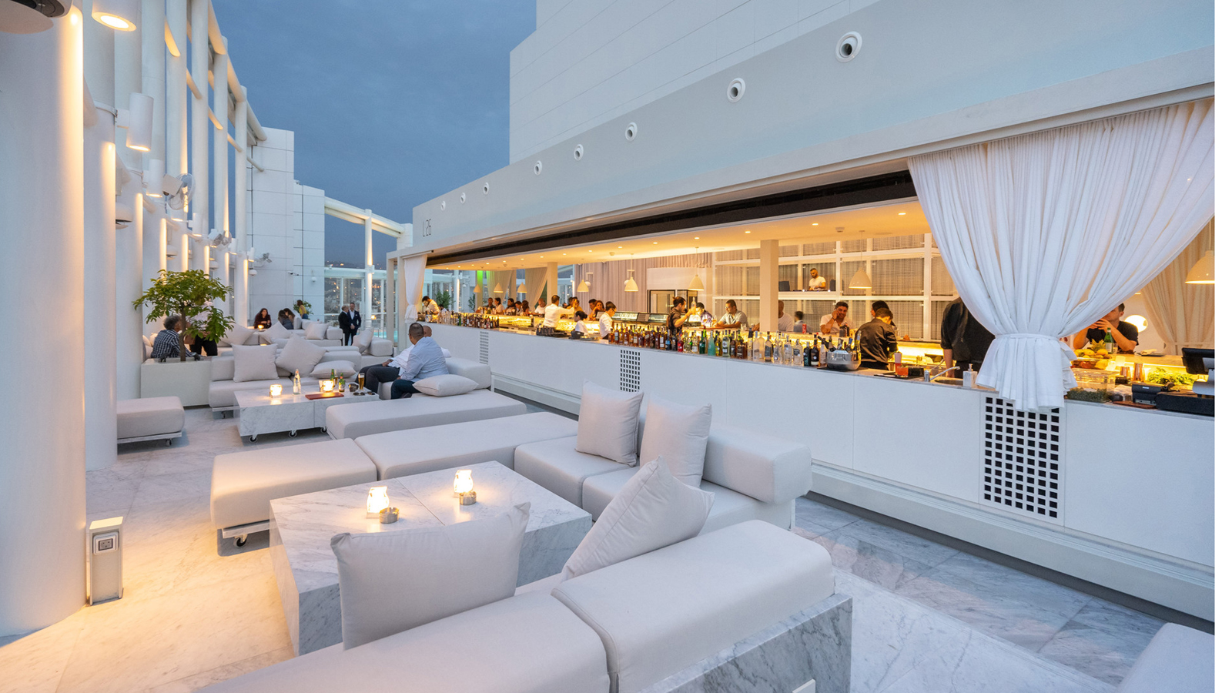 | June 20, 2019, Beirut, Lebanon  افتتاح أعلى روفتوب في بيروت بتصميم جديد لبرنارد خوري  https://publish.url/ar/beirut/hotel-news/2019/level-26-rooftop-pool-lounge-bar-2.html

PRESS CONTACTS

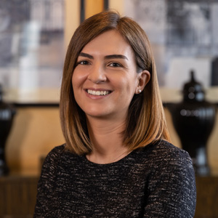 | Nada Atieh  Director of Public Relations & Communications  1418 Avenue Professor Wafic Sinno  Beirut  Lebanon  nada.atieh@fourseasons.com  +961 70 008829
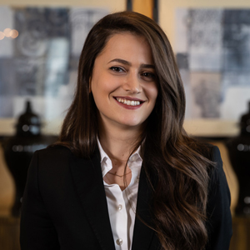 | Christina Jeokjian  Public Relations Coordinator  1418 Avenue Professor Wafic Sinno  Beirut  Lebanon  christina.jeokjian@fourseasons.com  +961 1 761000

