Festive Dining on the Menu Through the Season at Castanyoles Restaurant at Four Seasons Hotel Casa Medina Bogota

December 7, 2021, Bogota (Casa Medina), Colombia

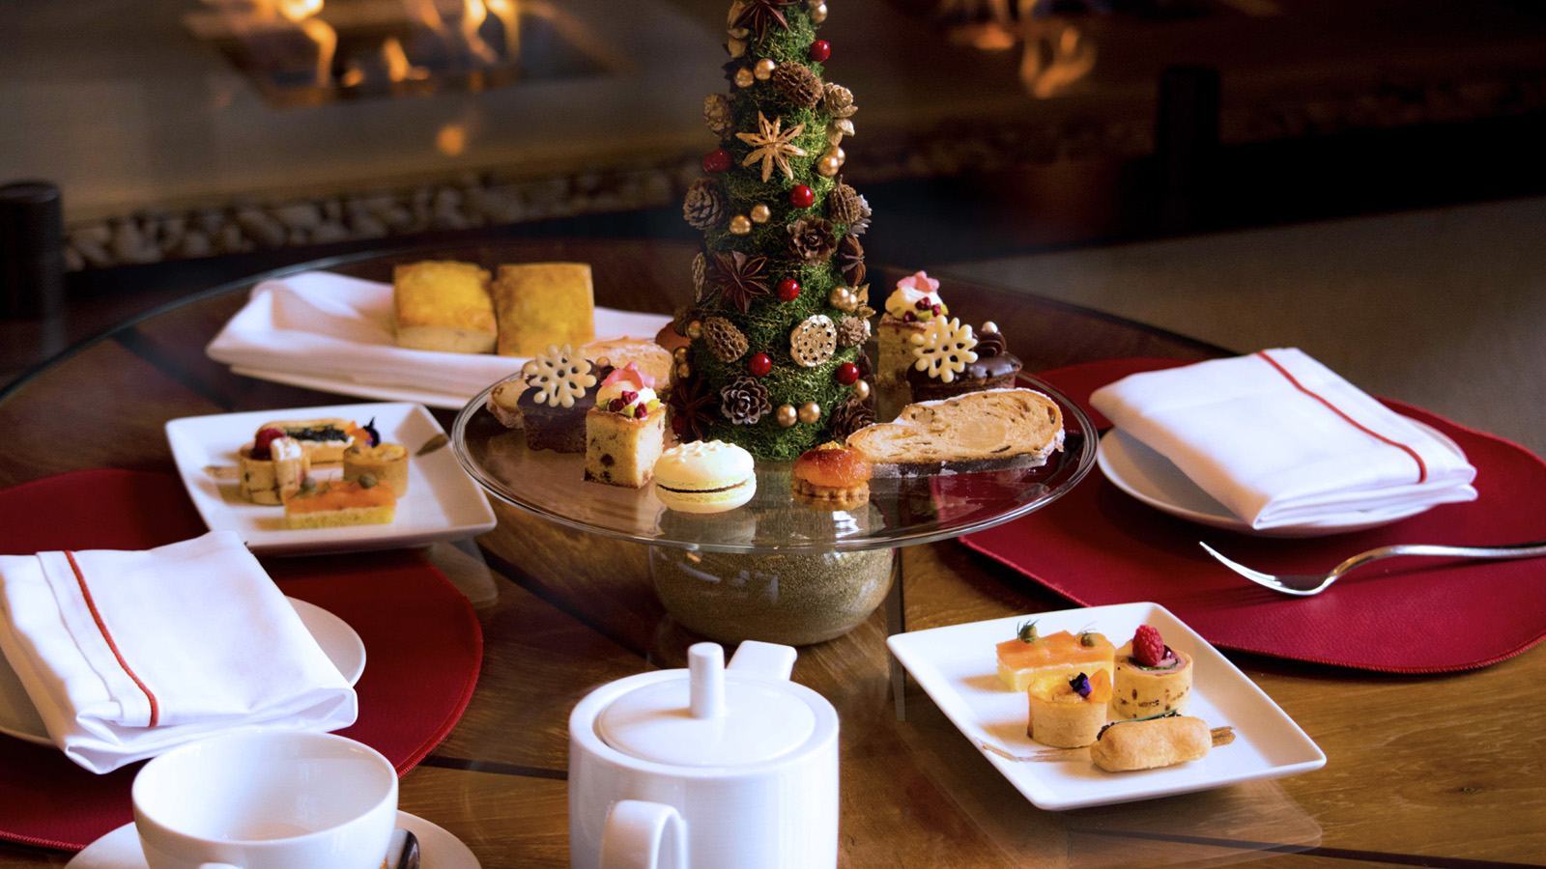
How best to finish a big, delicious Thanksgiving feast? Get back in the kitchen and start preparing for Christmas and New Year’s Eve. That’s just what the culinary team is doing at Four Seasons Hotel Casa Medina Bogota as its signature dining experience Castanyoles Restaurant readies to mark the heart of the festive season and invites guests and locals to book a table, celebrate, and enjoy.
There is much to savour at Castanyoles, whatever the occasion or time of year. Located off the lobby with seating indoors surrounded by warm interiors, in a courtyard with a stone fireplace, and on an atrium beneath a retractable roof, the restaurant focuses on Spanish cuisine, serving traditional dishes as well as a Colombian tasting menu created with the best ingredients from local famers and Pacific fisheries.
With its recent Thanksgiving service now an appetising memory, Castanyoles is pulling out all the stops to offer something festive and delicious for every age and appetite – omnivorous and vegetarian alike.
Available on December 24, 2021, the Castanyoles Christmas menu will be a four-course affair, with choice of starters including roasted and smoked pumpkin soup with micro greens, and white wine soup with king grilled prawns. Second course will serve offerings such as smoked octopus and beetroot hummus, while the third course – aka, the main event – will offer beef wellington, lamb chops with pistachio and herbs crust, and white fish in veloute and caviar sauce, as well as grilled cauliflower with herbs and mushrooms.
And for dessert? Take a pick of black forest cake, mille-feuille with vanilla curd, or salted chocolate tart, each paired perfectly with flavourful ice cream. Either way – yum! Christmas menu priced at COP 210 per person.
Come New Year’s Eve, Castanyoles will be ready to party like the capital city around it. The evening’s four-course menu will offer starters including grilled prawns, octopus salad, and smoked Portobello, followed by a second course choice of rice socarrat inked with calamari tint, salmon tartare, or falafel with cucumber compress. For the main course, choose from beef tenderloin with red wine sauce, poached white fish, turkey brick in its jus, and aubergine filled with escalivada.
Finish off 2021 in lip-smacking style with a dessert course featuring chocolate piononno cake, a chocolate sphere filled with cherries cream and crunchy nuts, and an apple strudel. New Year’s Eve menu priced at COP 260 per person.
Kids Stuff and To Go
Castanyoles is also featuring a special Kids Menu through the month of December 2021 designed to appeal to youthful appetites. This selections include skewer of loin with tasty BBQ sauce, mac and cheese topped with crispy bacon, everyone’s favourite fish and chips, and more. There are also three dessert options, one of which, irresistible hot brownie with ice cream and strawberry sauce, is likely to be the hottest ticket. Kids menu priced at COP 105 per person.
Don't’ feel like venturing out for the holidays? Castanyoles will happily bring the celebration to one's home with its Festive Season Menu To Go. Designed for parties of eight, options include choice of multiple vegetable-driven sides, desserts, and main courses, with whole roasted turkey or porchetta (pork roulade) as the stars of the show. Festive to-go menu priced at COP 780 for eight people; available for pick up. Order on a week in advance.
To reserve a stay at Four Seasons Hotel Casa Medina Bogota, festive dining at Castanyoles, or both, see your travel professional, contact +57 6013257900, or book online.

RELATED

December 6, 2021, Bogota, Colombia
Los Spas en Four Seasons Hotels Bogotá están de vuelta e inspirados en la naturaleza
https://publish.url/es/bogota/hotel-news/2021/spa-reopenings-2.html

December 6, 2021, Bogota, Colombia
The Spas at Four Seasons Hotels Bogota are Back in Business, Ready to Welcome Guests and Locals with New Treatment Menus and Nature-Inspired Tranquillity
https://publish.url/bogota/hotel-news/2021/spa-reopenings.html

PRESS CONTACTS

Paula Gamboa
Director of Marketing
Cra 7 No. 69A-22
Bogotá DC
Colombia
paula.gamboa@fourseasons.com

+57 1 325 7912

