Can’t Help Falling in Love with the Vegas-Style Pop Up Chapel at Four Seasons Hotel St. Louis This Valentine’s Day

Award-winning Elvis tribute artist to perform weddings and vow renewals for limited three-night engagement; Hotel package includes an “overnight honeymoon”
January 4, 2023, St. Louis, U.S.A.

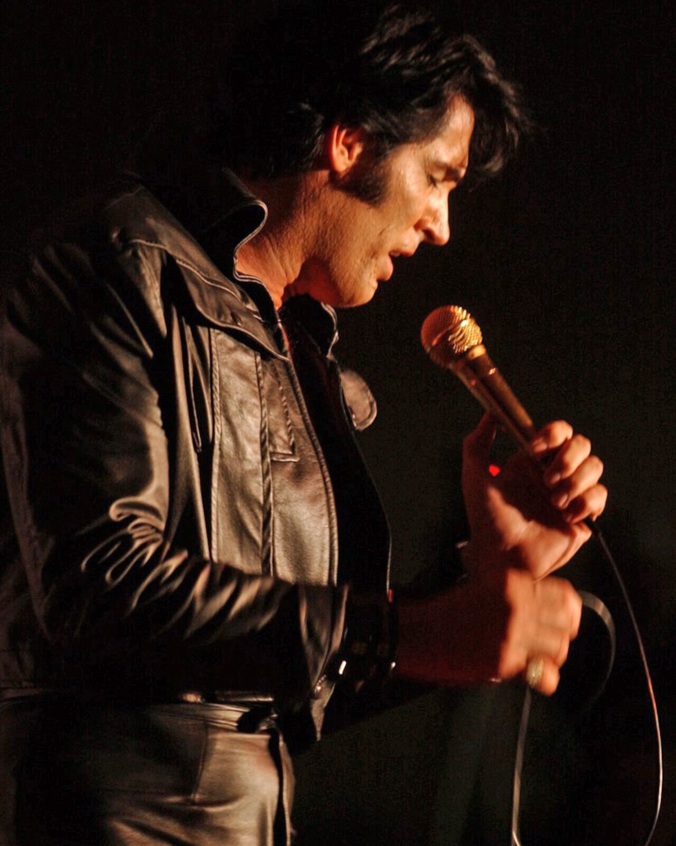
Calling all couples, newlyweds, friends, lovers, and Elvis fanatics! What happens in St. Louis, stays in St. Louis. And, this Valentine’s Day what’s happening is a pop up Vegas-style chapel at Four Seasons Hotel St. Louis. The Hotel has created its own “Little White Chapel” in the iconic style of the original located in Las Vegas. Elvis tribute artist Terry Phillips of Close To Elvis will be on hand to wed couples, renew vows, or hold commitment ceremonies, where he will perform the immortal Elvis song, “Can’t Help Falling In Love” and other classics from The King that couples request.
An ordained minister legally qualified to perform marriages, Terry will officiate all types of weddings and commitment ceremonies at the bedecked pop-up chapel on the evenings of February 10, 11, and 14, 2023. Clad in a classic Vegas-era Elvis jumpsuit, Terry will serenade couples who book one of the 30-minute appointments with a live processional and recessional Elvis song of their choice.
Setting the stage for romance, the chapel itself will be abundantly adorned with florals and replicate the original with décor flourishes including a scalloped marquee and ornamental design elements creating the look and feel of its Las Vegas inspiration. Each ceremony package also includes up to ten digital photos taken by Lawrence Bryant of LB Photography to capture the moment and seating for up to ten guests. The price for each ceremony is USD 500.
For those who want to include a romantic mini break or overnight honeymoon, a package is available that features a one-night stay in one of the Hotel’s newly renovated guest rooms. The Hotel package includes accommodations for one night, an early check-in so guests can dress for the chapel, a welcome amenity, and the full ceremony program. The price of the room package starts at USD 850 plus tax.
Just across from the Hotel’s Little White Chapel pop-up is Cinder House restaurant, where couples can make a dinner reservation to celebrate following the ceremony, with stunning views of the Gateway Arch and twinkling city lights. They can even share a mini wedding cake for dessert, if ordered in advance. For Valentine’s dinner, Chef de Cuisine Peter Slay is serving a romantic and luxurious three-course prix fixe menu with a spicy chocolate mousse for a sweet and sexy finish. The full Cinder House a la carte menu is also available.
Details and booking:
- Chapel Availability: Ceremonies are available for booking every 30 minutes on Friday, February 10 and Saturday, February 11 from 6:00 to 10:00 pm; and, Tuesday, February 14, 2023 from 6:00 to 9:00 pm
- Package: Included in the ceremony package is use of the decorated pop-up chapel for a ceremony with Elvis tribute artist as officiant; digital wedding photography; up to two live Elvis songs of couple’s choice; seating for up to ten guests. (Personal floral bouquet/boutonniere not included)
- Weddings: Couples wishing to wed at the chapel must secure a Missouri state marriage license in advance and present it at the ceremony.
- Booking: Email elvis.stlouis@fourseasons.com

RELATED

December 7, 2022, St. Louis, U.S.A.
Ring in the New Year in Style at Four Seasons Hotel St. Louis
https://publish.url/stlouis/hotel-news/2022/new-years.html

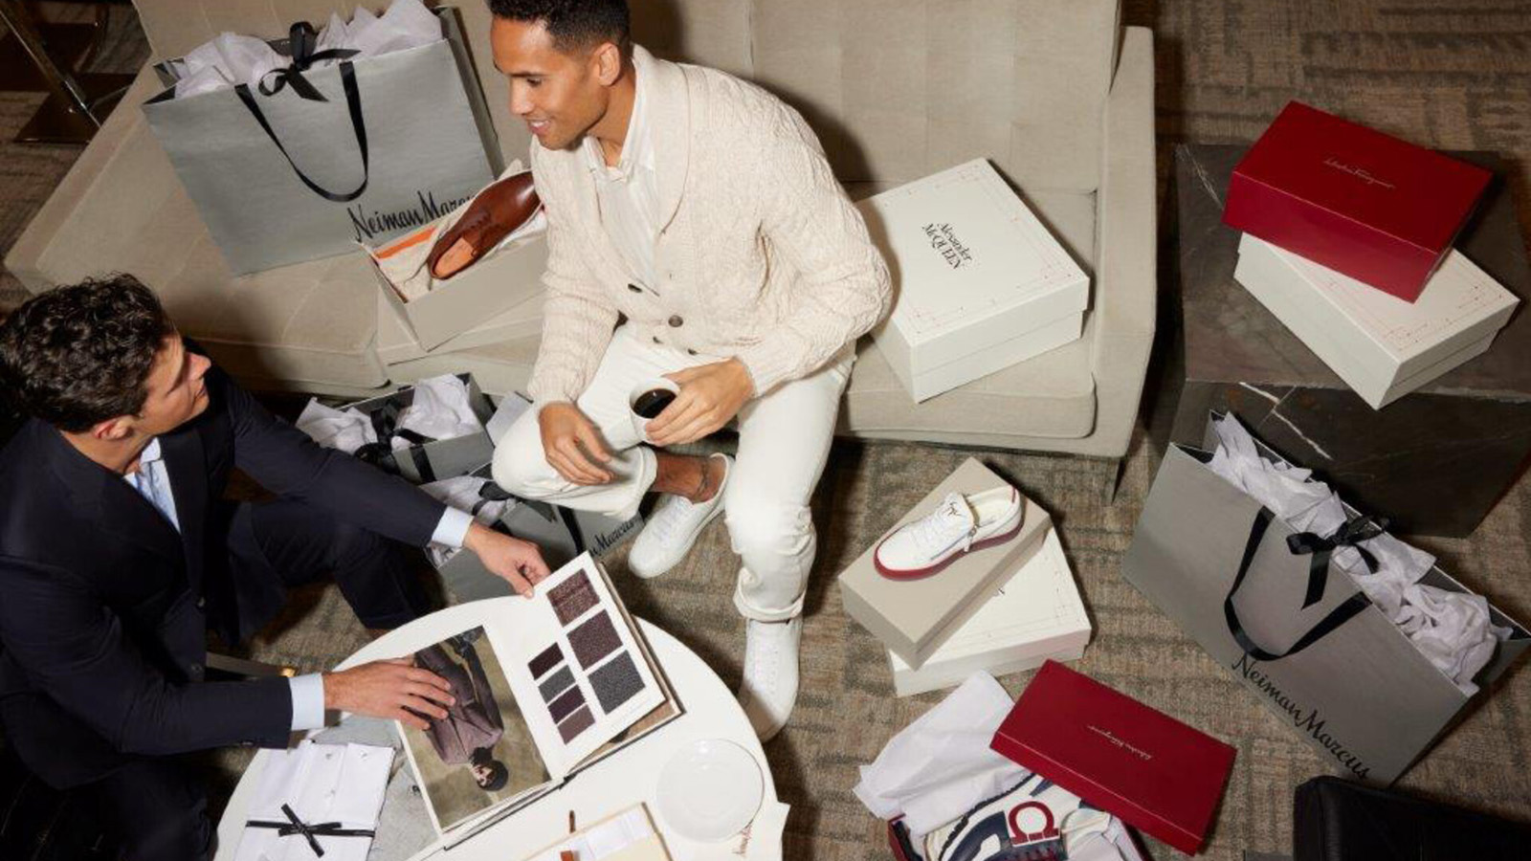 | November 23, 2022, St. Louis, U.S.A.  Four Seasons Hotel St. Louis Partners with Neiman Marcus for Ultimate Holiday Shopping Experience  https://publish.url/stlouis/hotel-news/2022/neiman-marcus-holiday-shopping.html

PRESS CONTACTS

Teresa Delaney
Director of Public Relations
999 North 2nd Street
St Louis
USA
teresa.delaney@fourseasons.com

+1 314 881 2025

