A Sweet Valentine at Four Seasons Hotel Milano

Shopping, spa, gastronomy and romance await at Four Seasons Hotel Milano, where guests will indulge in warm relaxation and chocolate treats in the heart of Milan’s fashion district
January 12, 2018, Milan, Italy

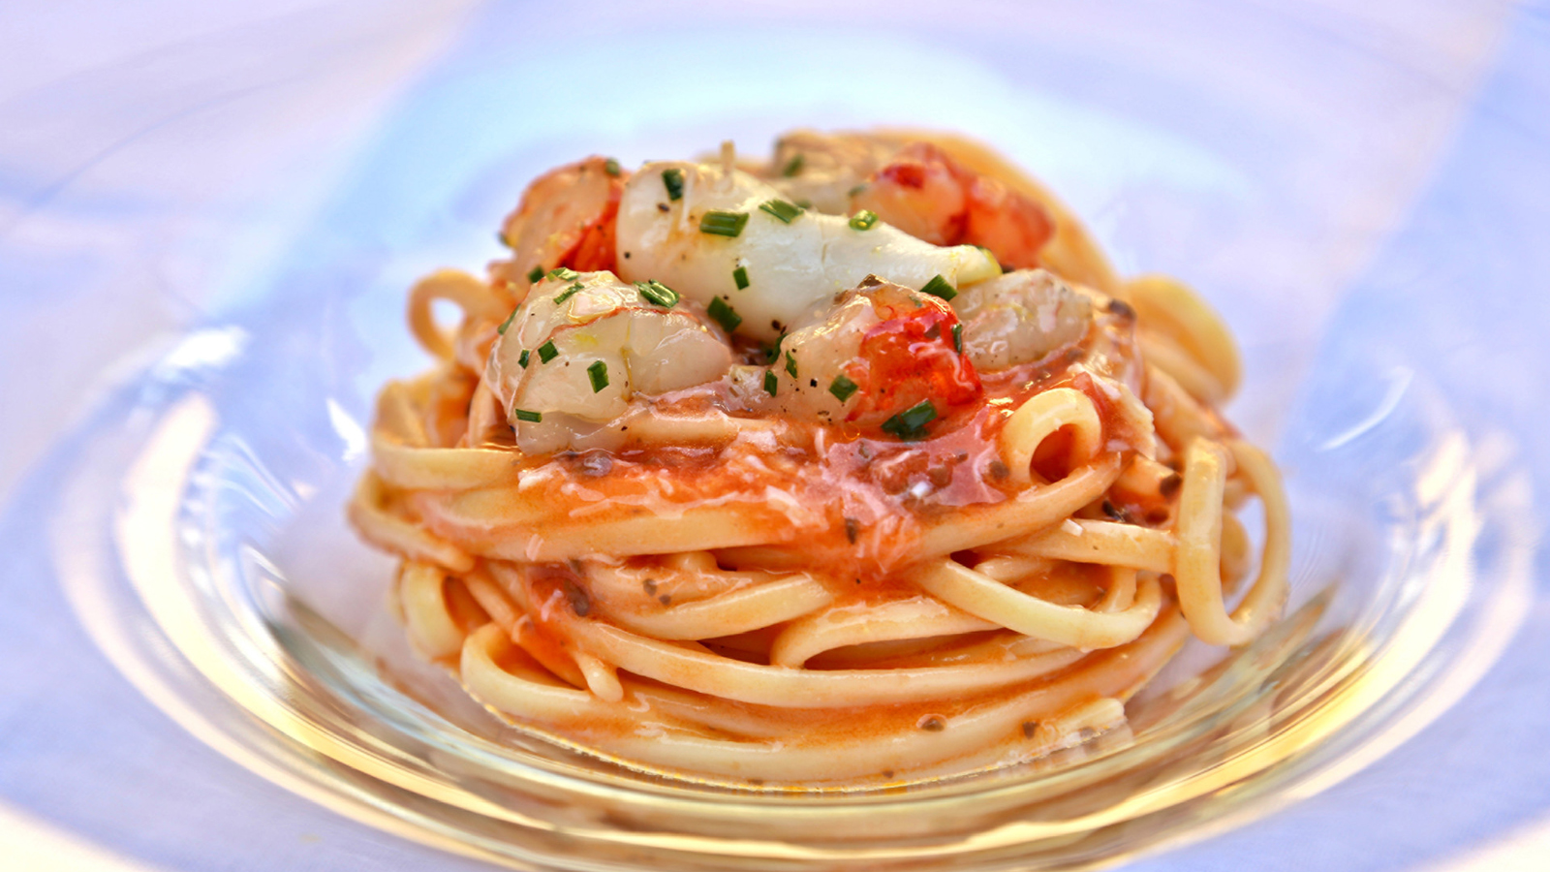
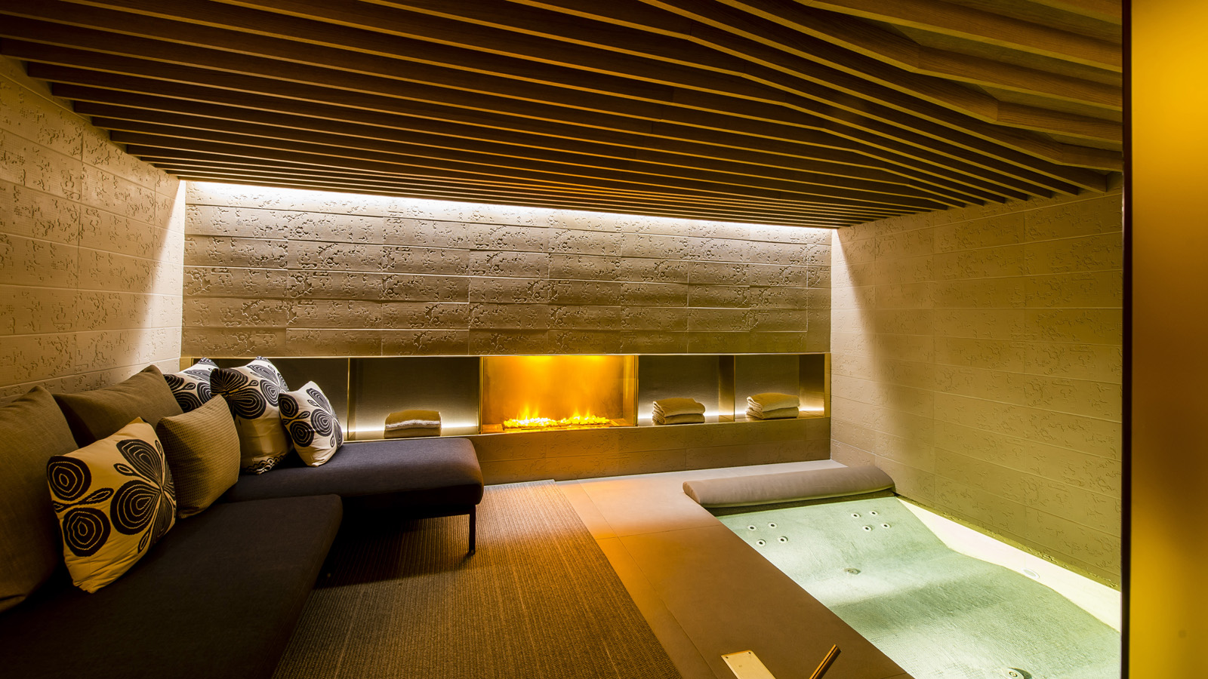 | 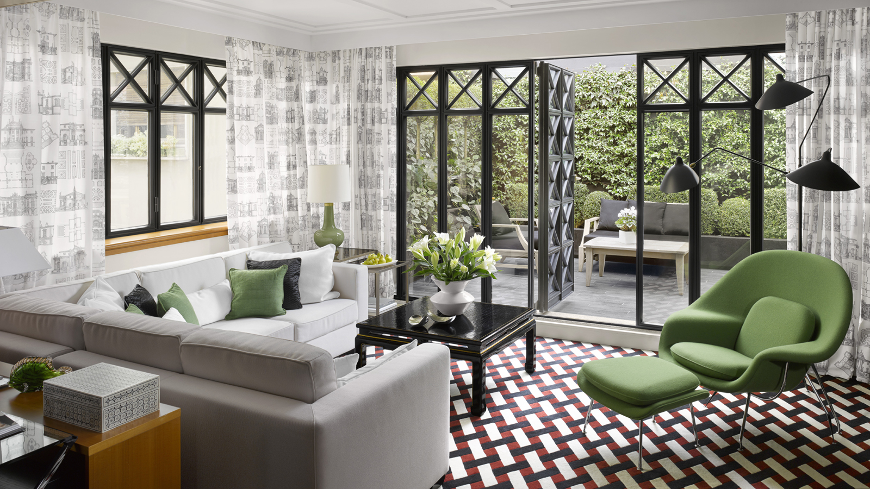 | 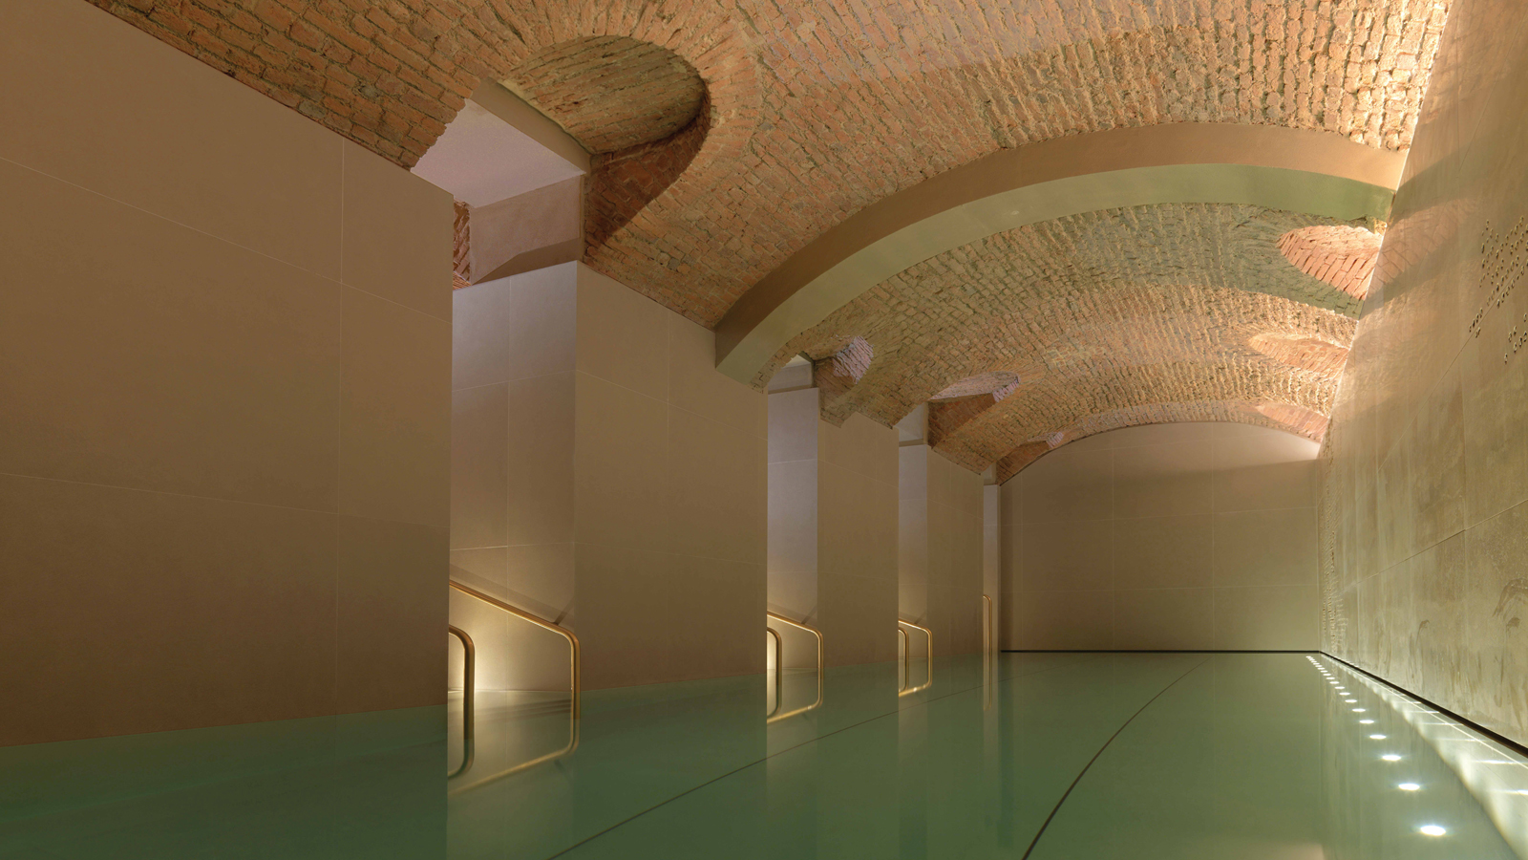
On the occasion of Valentine’s Day,
Four Seasons
Hotel Milano presents “Sweet Valentine,” an experience for couples to enjoy romantic time together at the Spa, dinner at La Veranda Restaurant, and a chocolate tasting in the Hotel’s Chocolate Room.
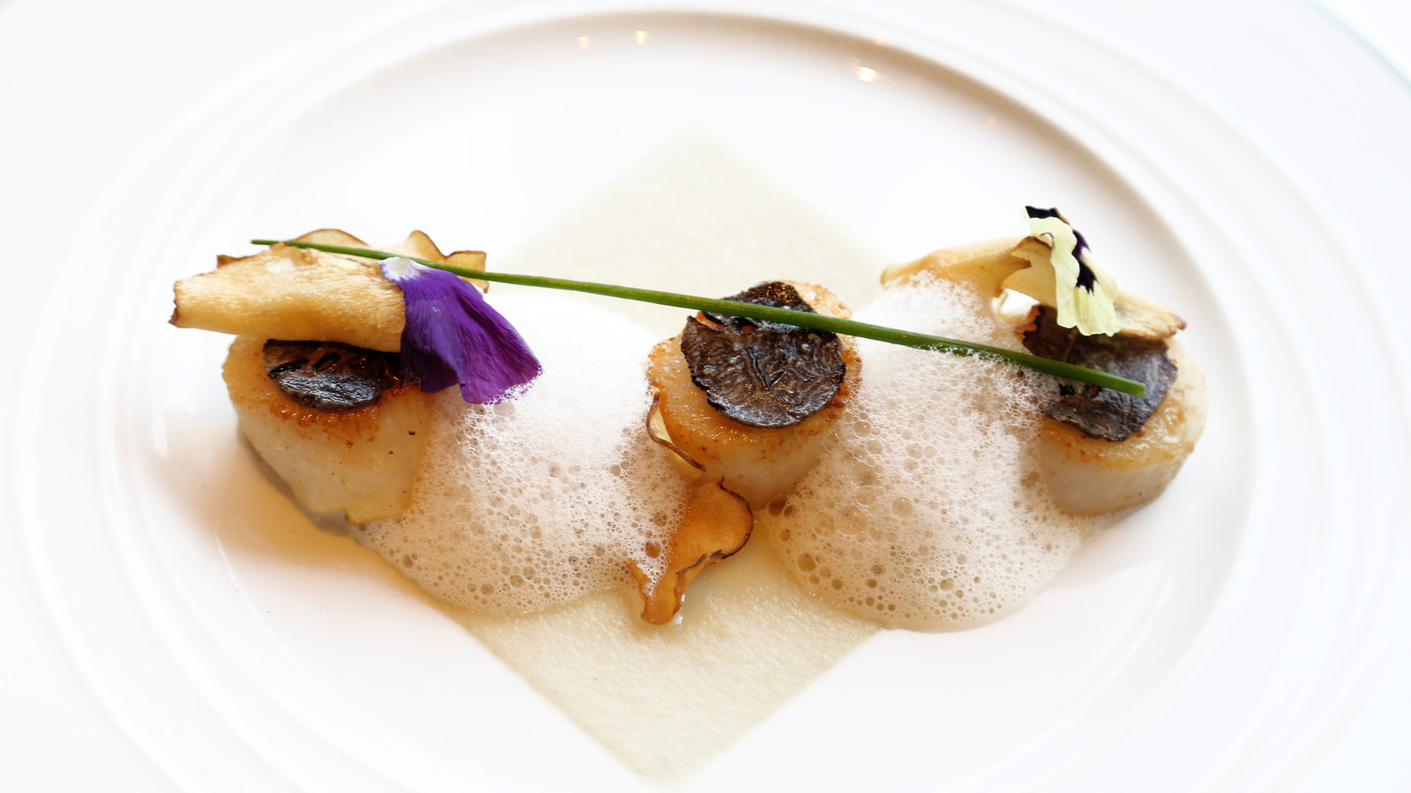 | 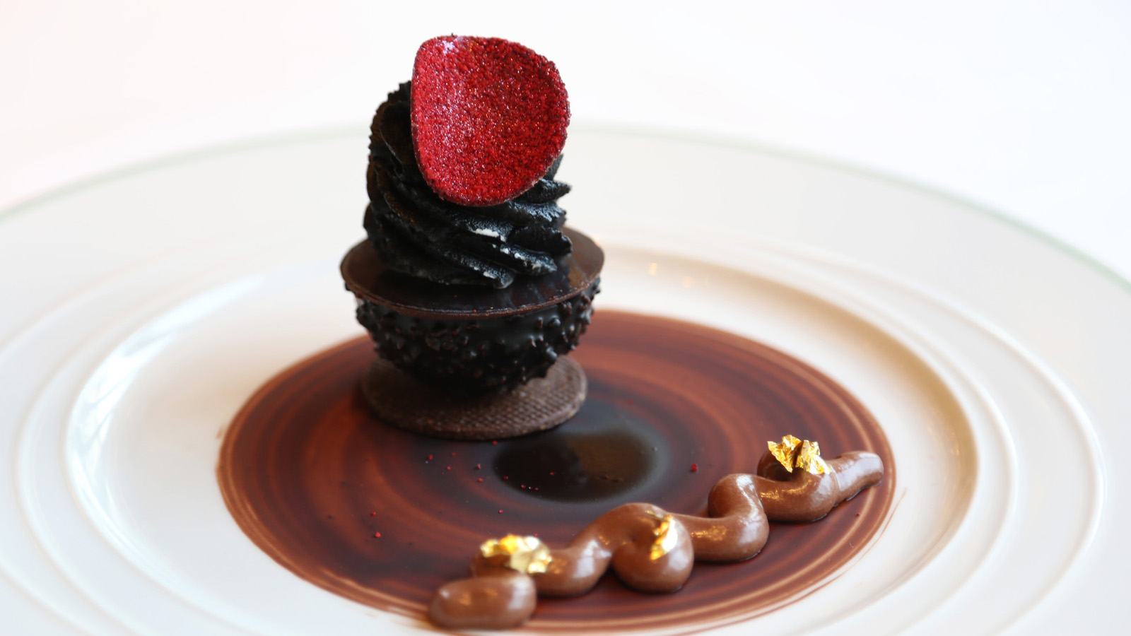
Located in the heart of the city’s fashion district,
Four Seasons
Hotel Milano makes the perfect destination for those looking for an intimate break combining Italy’s rich culinary heritage, great shopping and relaxing time. The Hotel’s Spa, designed by Patricia Urquiola in a converted 15th century cellar, naturally invites guests to slow down and enjoy relaxing time with loved ones. An indoor swimming pool with vaulted ceiling, and a large selection of massages and beauty treatments featuring Swiss Perfection and Sodashi products provide all the ingredients to retrieve serenity and peace of mind. During their stay, guests will experience the Hotel’s Spa Suite comprising a whirlpool, steam bath and a relaxation area, and enjoy a 60 minute treatment of their choice, side by side.
The lovebirds will also get a taste of the finest Italian cuisine, including traditional dishes reinterpreted into the most sophisticated creations. Resident Chef Marco Veneruso has created a special Valentine’s Day menu at La Veranda featuring risotto with champagne and caviar shards, roasted scallops with Jerusalem artichoke cream and black truffle, and chocolate crémeux with passion fruit and Tahitian vanilla, to enjoy in the warm atmosphere of Veranda restaurant overlooking the Hotel’s inner garden.
To complete this romantic experience, guests will enjoy a privileged access into the Hotel’s Chocolate Room, entirely covered by chocolate recreating the decor of a tropical forest. In this inspiring atmosphere filled with chocolate aromas, they will indulge into a chocolate tasting combined with a glass of champagne.
Sweet Valentine experience includes:
- Spa Suite Experience including a 60 minute treatment for two
- Valentine’s menu at La Veranda restaurant (available on February 14, 2018) or a la carte menu
- Access to the Chocolate Room for a chocolate tasting paired with a glass of champagne
Rates from EUR 1,800 plus tax for two in a Deluxe room, from February 14 to 21, 2018, based on availability. Reservations at Roberto.frau@fourseasons.com or +39 027708167.

RELATED

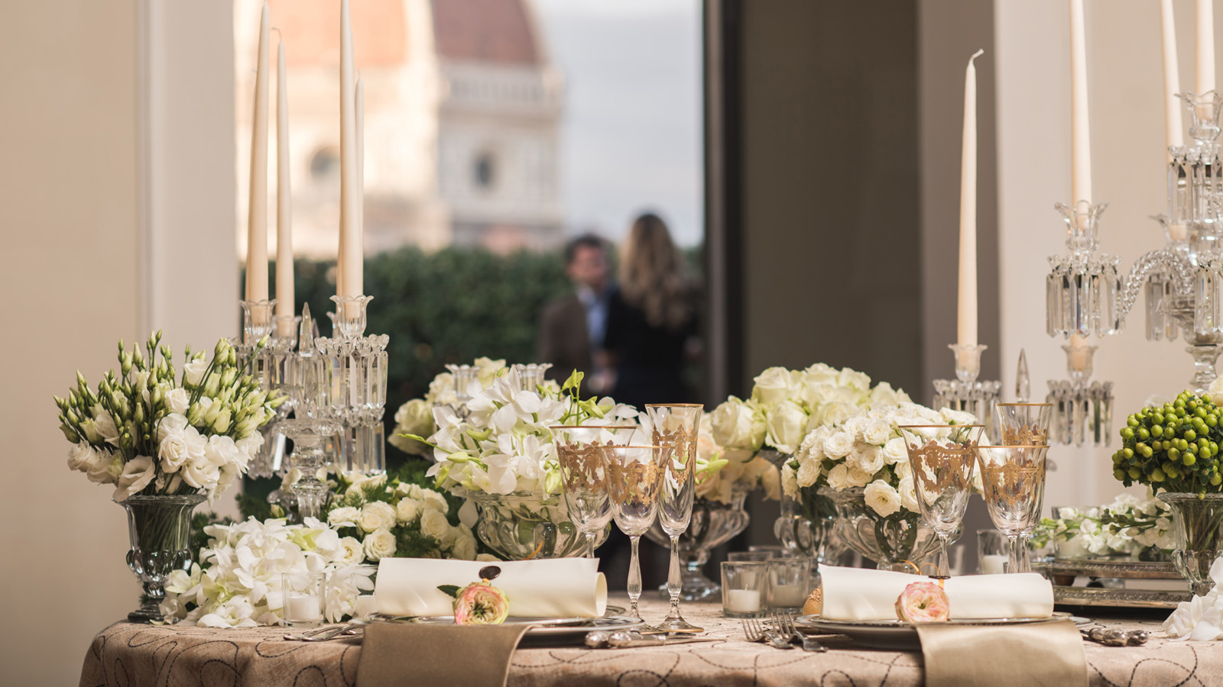 | January 17, 2018, Dubai, U.A.E.  In the Mood for Love with Four Seasons Across Europe This Valentine’s Day  https://publish.url/news-releases/2018/emea-valentines-day-2.html
January 12, 2018, Milan, Italy
“Sweet Valentine” a Four Seasons Hotel Milano
https://publish.url/it/milan/hotel-news/2018/valentines-day-2.html

PRESS CONTACTS

Anita Ruozzi
Public Relations and Marketing Communication Coordinator
Via Gesu, 6/8
Milano
Italy
anita.ruozzi@fourseasons.com

+39 02 7708 1123

Caroline Mennetrier
Director of PR and Marketing Communication
Via Gesù 6/8
Milano
Italy
caroline.mennetrier@fourseasons.com

+39 02 7708 1795

