Experience the Ultimate Spring and Summer Getaway with a Fourth Night Free at Four Seasons Resort Orlando

Enjoy even more fun in the sun at the Resort’s own water park and adult pool
April 4, 2023, Orlando at Walt Disney World Resort, U.S.A.

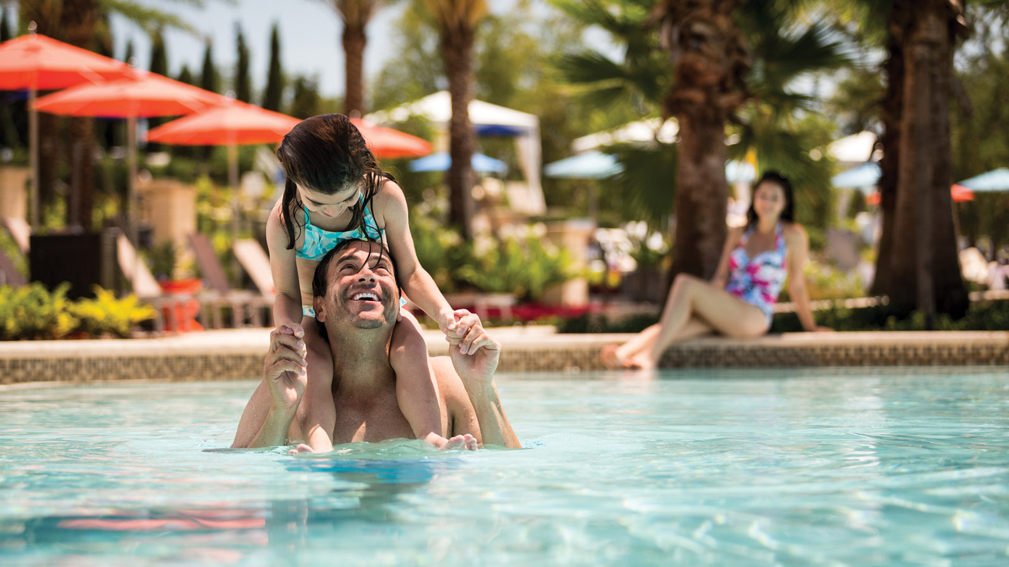 | 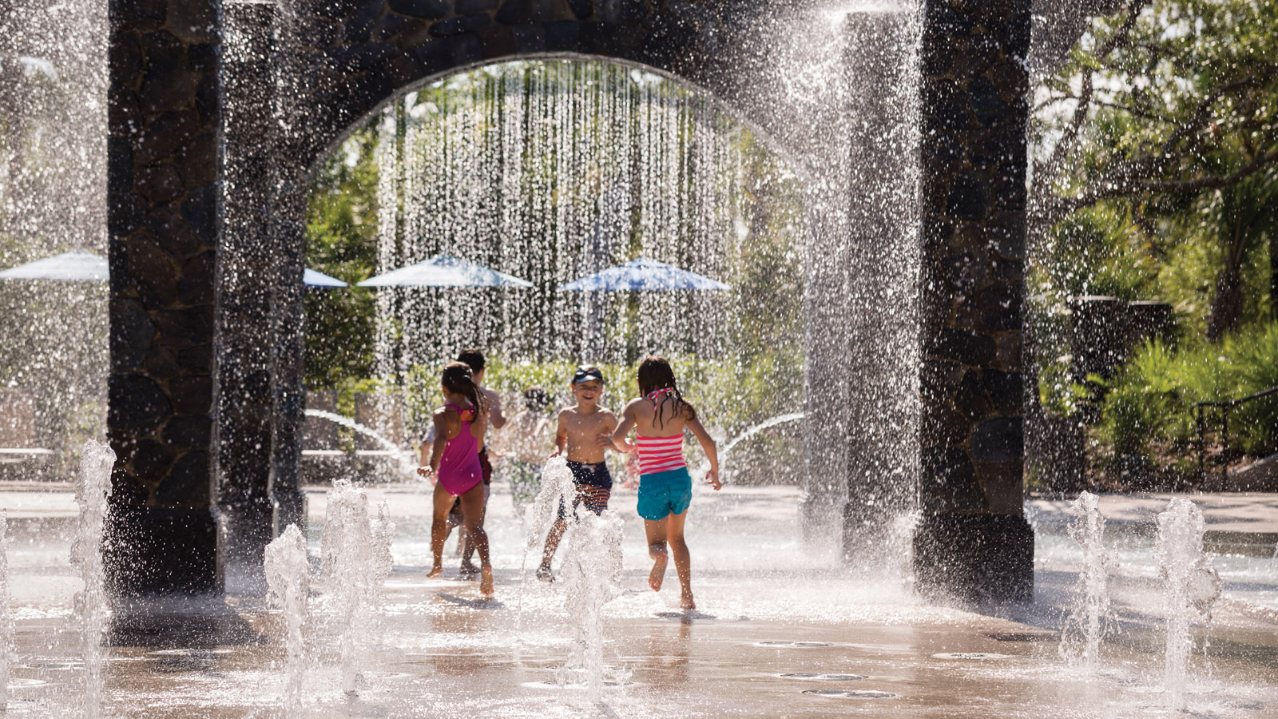 | 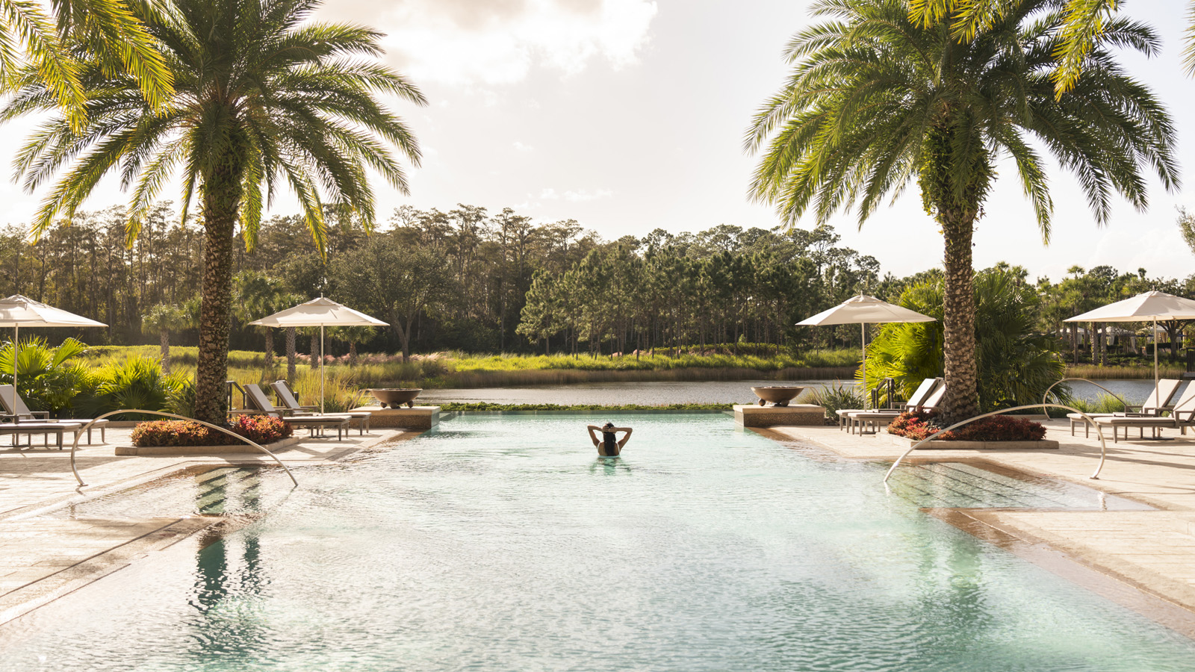
Now more than ever, travellers are seeking meaningful vacation experiences that allow them to escape and cherish quality time connecting with family and friends. At Four Seasons Resort Orlando at Walt Disney World Resort, recognized as the #1 resort and #1 hotel in Walt Disney World according to U.S. News & World Report, holding a top ranking for nine consecutive years, amenities and activities for all ages abound. Nestled within 26 sprawling acres (10.5 hectares) of lush Florida woodlands and tranquil lakeside scenery, the Resort boasts an expansive private water park, a complimentary kids club, the only adult pool within Walt Disney World Resort, and a recently rated Michelin star restaurant, Capa Steakhouse. Guests are invited to enjoy even more fun with a complimentary fourth night, providing added value and a perfect reason to experience all the award-winning destination resort has to offer.
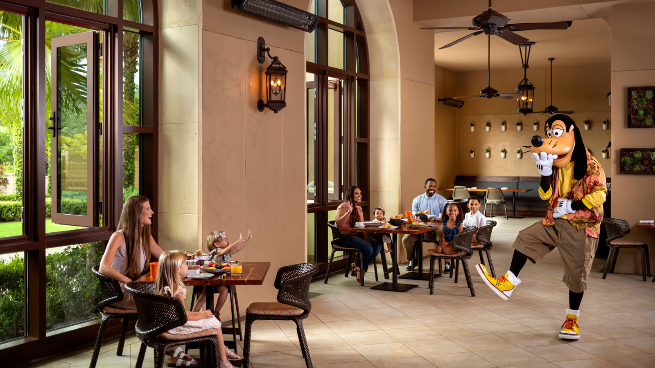 | 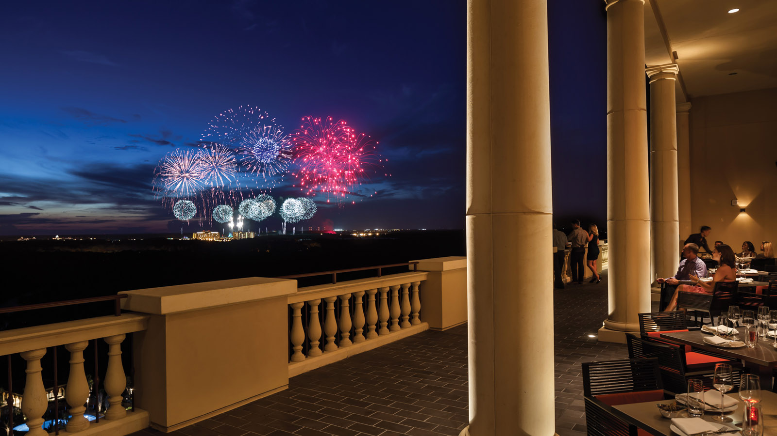
Stay Longer-Fourth Night Free Package
The Stay Longer- Fourth Night Free package offers a complimentary fourth night with every three paid nights, April 20 through September 30, 2023. Numerous added values are included within the rate, such as the complimentary daily Kids For All Seasons kids camp; kids five and younger dine free at Resort restaurants; complimentary transportation to the Walt Disney World Resort theme parks; and complimentary access to the on-site five-acre (two hectare) waterpark, state-of-the-art fitness centre, 18-hole putting course, and Spa relaxation areas. Whether seeking more quality time with those who matter most, extra time lounging poolside, or an extra day of fun at Disney Parks, the fourth night free enables guests to celebrate a rejuvenating escape at a destination that truly has it all.
On-Property Recreation
Guests of all ages will have a blast at Explorer Island, the Resort’s five-acre (two hectare) water park featuring a winding lazy river with cascading waterfalls, a gradually sloping zero entry family pool, an interactive splash zone, two exhilarating water slides and more. Tucked away behind a secluded bend of the lazy river is The Hideout, a teen haven complete with the latest gaming systems such as virtual reality, multi-player PAC-MAN interactive video table games and more. Sand volleyball and basketball courts are also available, in addition to table tennis, billiards, and foosball found at the Ruinous Mansion - home to Kids For All Seasons, the Resort’s complimentary kids camp available daily for children ages 4 to 12.
While kids are entertained at Kids For All Seasons, offering indoor and outdoor activities including twice daily supervised swimming, parents can unwind at the 18-treatment room spa or retreat to the sanctuary of the Oasis adult pool, for ages 21 and up, featuring private cabanas and poolside cocktail service.
Three Har-Tru tennis courts and a variety of clinics offer even more active recreation, as well as an expansive fitness centre overlooking the lake and gardens, featuring Peloton bikes, on-demand digital classes, and complimentary live fitness classes ranging from yoga to boot camp. Private instruction is also available, including personal Pilates reformer sessions guided by the Resort’s talented fitness instructors.
Golfers will love the 18-hole championship golf course at Four Seasons Golf and Sports Club Orlando. Whether seeking challenging play fit for professionals or family fun on the Par 3 six-hole short course, guests are sure to enjoy an incomparable golf experience within the picturesque setting of the Tom Fazio-designed course, a certified Audubon Sanctuary featuring varying elevations, abundant wildlife and protected wetlands.
Summer Activities for All Ages
There is truly nothing better than a summer vacation at Four Seasons Resort Orlando, with myriad complimentary activities offering something for everyone to enjoy. In addition to traditional poolside entertainment such as air brush tattoos, hair wraps, and balloon artistry, Kids For All Seasons offers daily activations including family game nights and teen takeovers at The Hideout, glow golf tournaments, dive-in movies at the family pool and much more. While the kids splash and play, moms and dad will enjoy shopping signature trunk shows with designer appearances at Wardrobe boutique. In the evenings, the entertainment continues with live music on select nights at The Lobby Bar and at Capa.
In addition, other fee-based activities will be offered, such as Explorer Island Takeover on Saturday nights, where parents can drop off kids for a few hours, to enjoy a romantic dinner.
The Most Magical Place on Earth
Guests of the Resort who wish to experience the excitement of the Walt Disney World Resort Theme Parks enjoy many on-site conveniences, including a twice weekly character breakfast at Ravello and access to the Resort’s lobby level Disney Planning Center. Staffed by a Disney Cast Member, the Disney Planning Center team offers complimentary assistance with all Disney needs, including assisting guests with purchasing Park tickets conveniently on site, making Disney Park Pass and Disney dining reservations, and much more. Guests can venture to the nearby Disney Parks with complimentary transportation in a luxury motor coach and enjoy even more time to experience the magic with 30 minutes Early Park Entry to any Theme Park of choice daily.
Click here or call 1 800 267 3046 for reservations.

RELATED

April 3, 2023, Orlando at Walt Disney World Resort, U.S.A.
Four Seasons Resort Orlando Appoints Adrien Harel as Resort Manager
https://publish.url/orlando/hotel-news/2023/new-resort-manager-adrien-harel.html

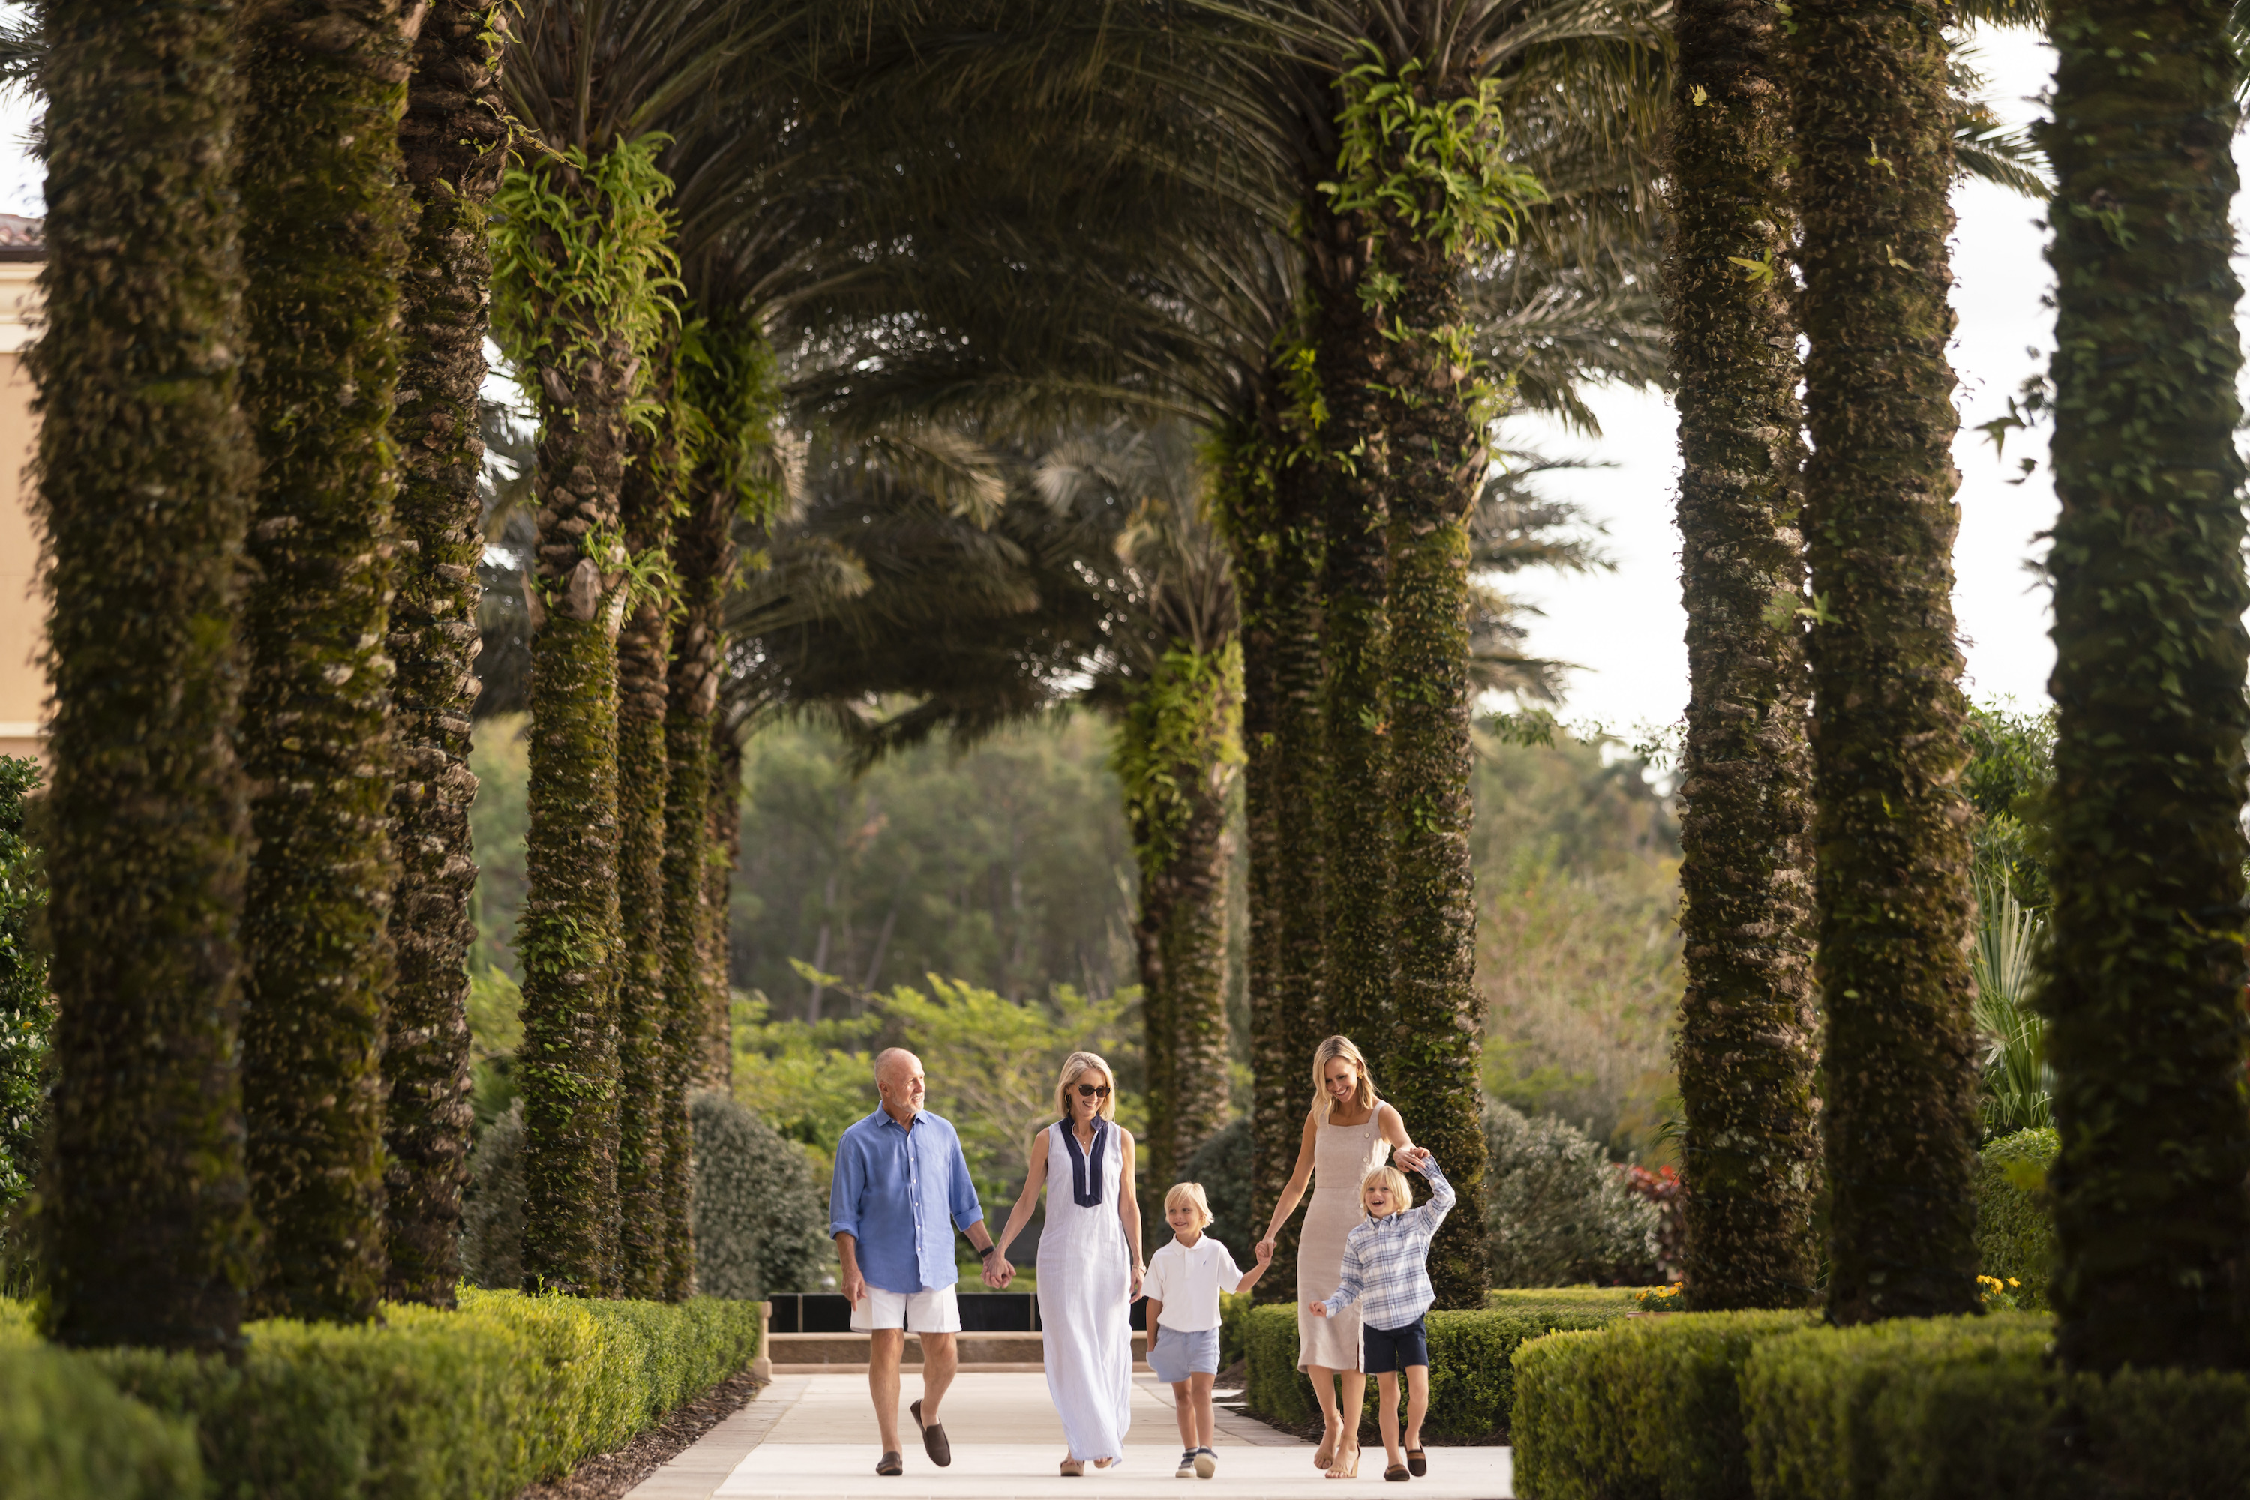 | March 27, 2023, Orlando at Walt Disney World Resort, U.S.A.  Easter Celebrations at Four Seasons Resort Orlando  https://publish.url/orlando/hotel-news/2023/easter.html

PRESS CONTACTS

Dana Berry
Director of Public Relations
10100 Dream Tree Boulevard
Orlando
USA
dana.berry@fourseasons.com

1 407 313 7777

Nicole Abinajem
Public Relations Manager
10100 Dream Tree Boulevard
Orlando
USA
nicole.abinajem@fourseasons.com

1 407 313 6742

