Get Immersed in the Holiday Spirit at Four Seasons Resort Rancho Encantado Santa Fe with Culture, Culinary and Wellness

The luxurious retreat kicks off the seasons with a lineup of holiday offerings and festive favourites in the Land of Enchantment
November 18, 2022, Santa Fe, U.S.A.

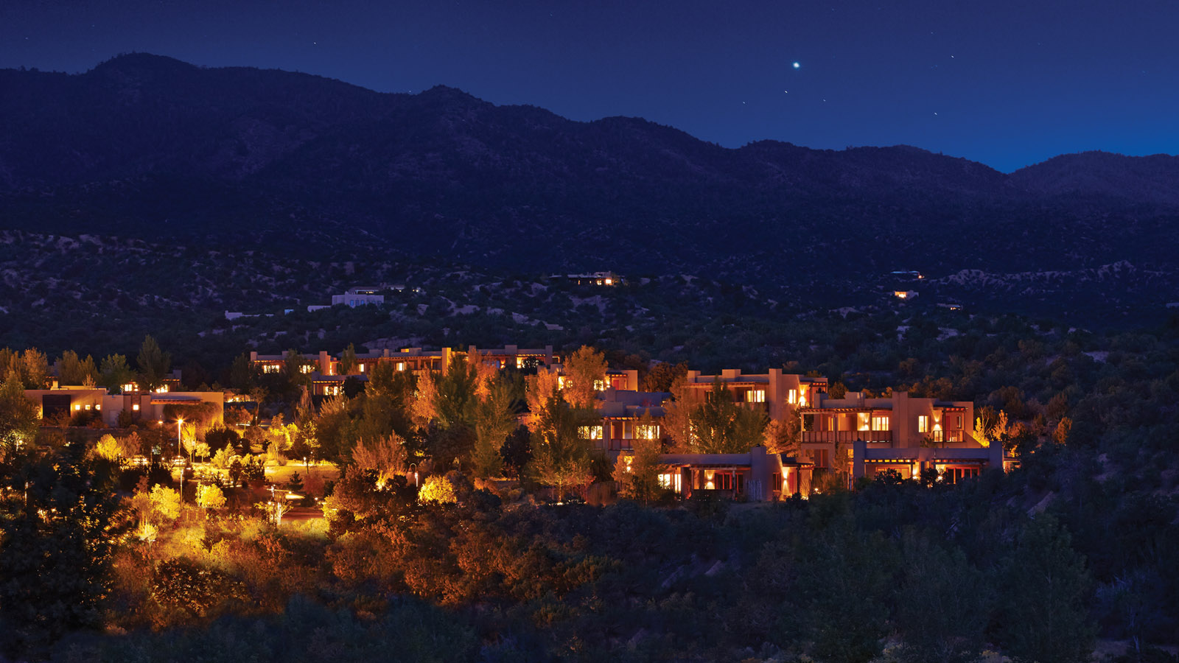
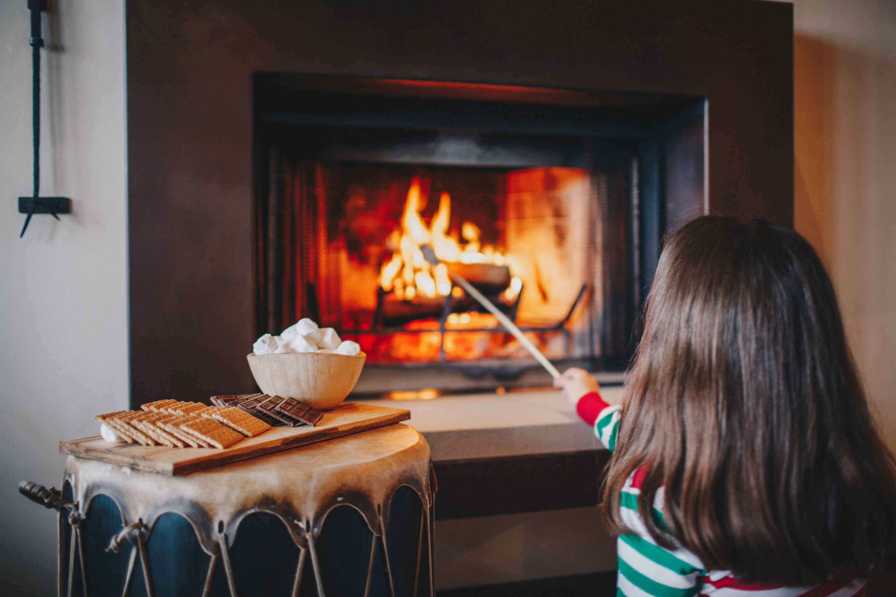 | 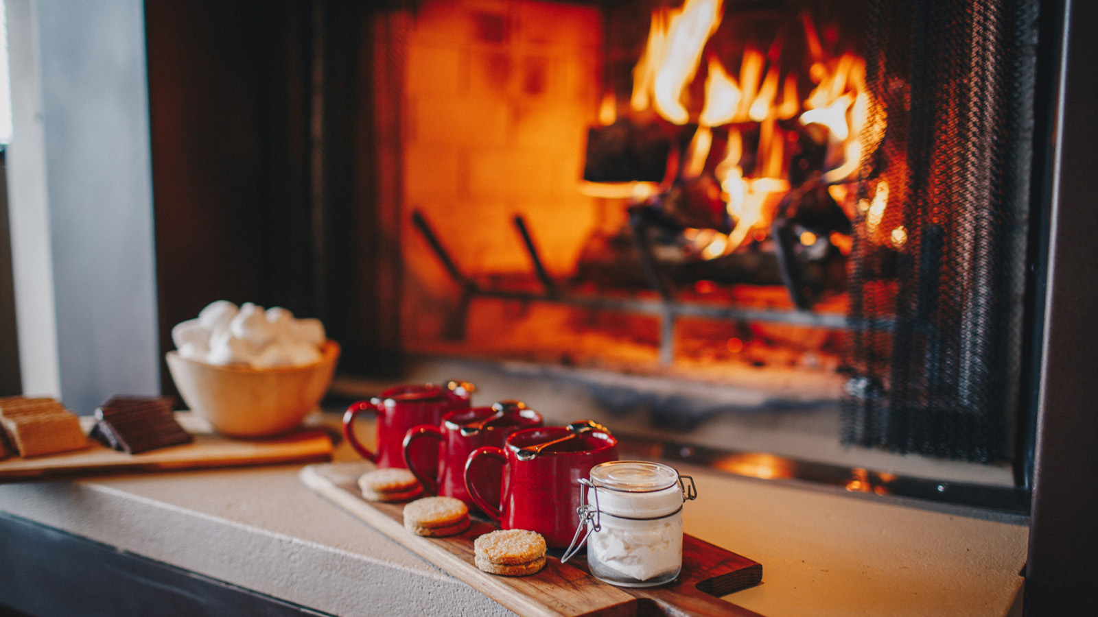 | 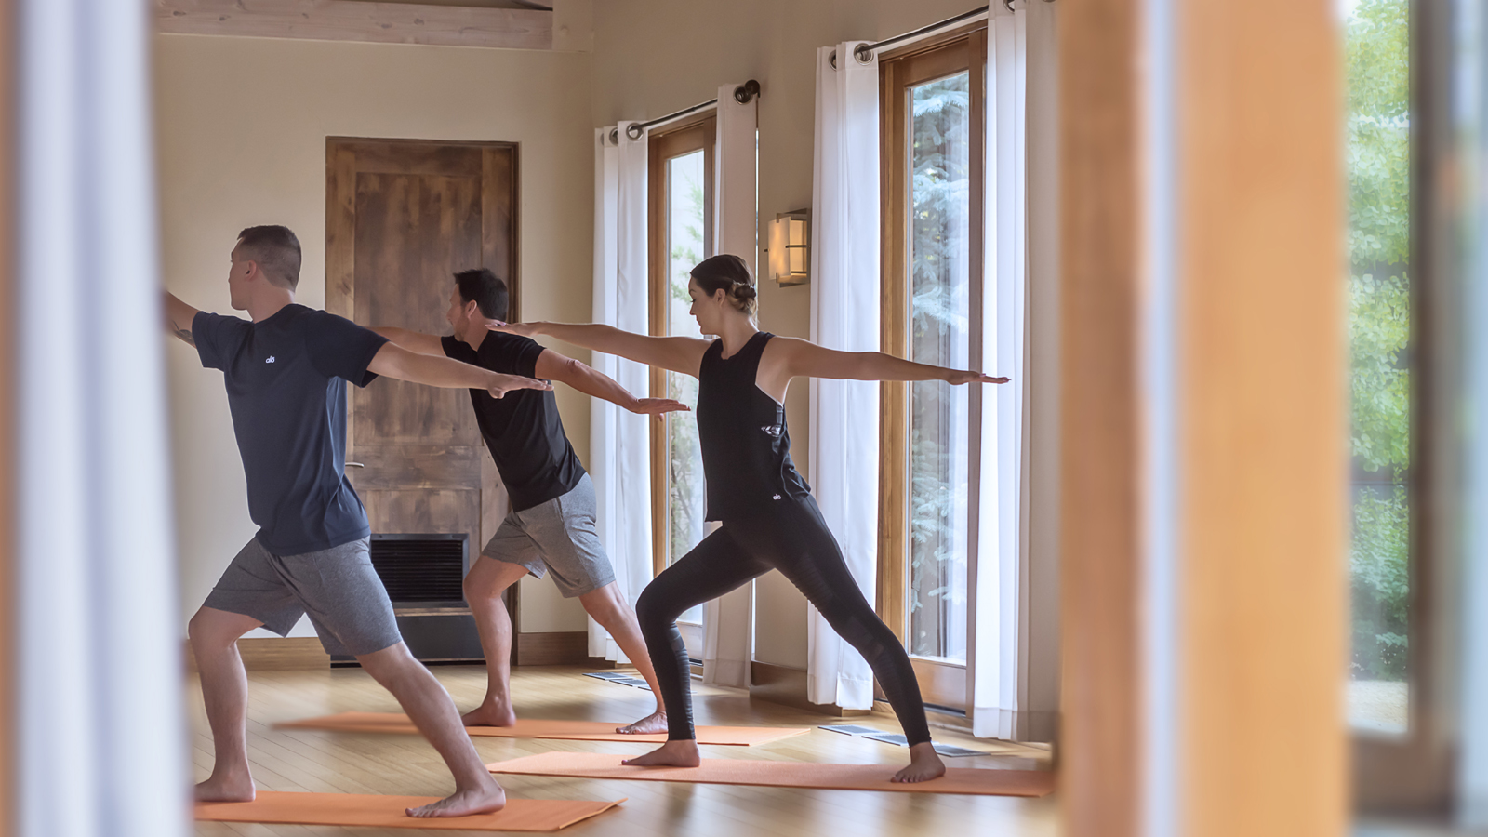
With its festive and robust holiday offerings, Four Seasons Resort Rancho Encantado Santa Fe, nestled in the foothills of the Sangre de Cristo Mountains, offers a one-of-a-kind holiday getaway rich in adventure, culture, culinary and wellness experiences, making for the ideal destination for a high-desert mountain retreat this season.
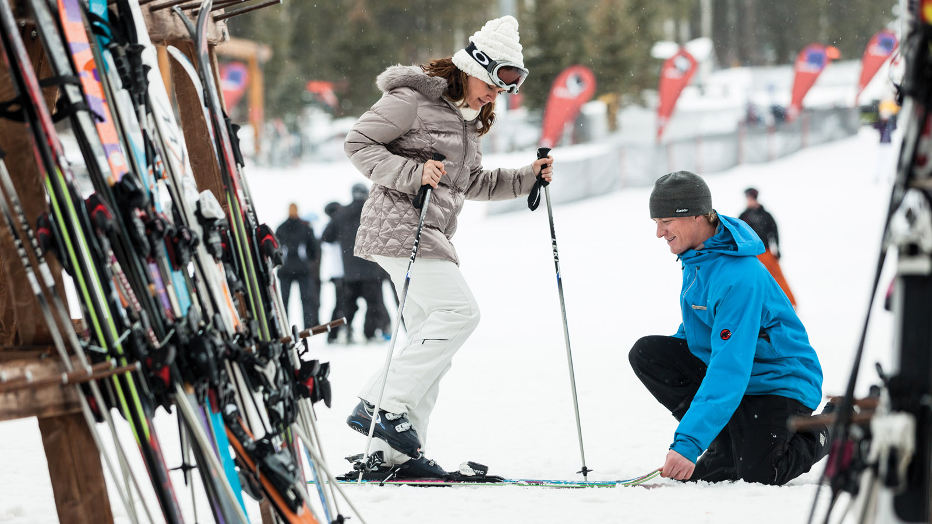
This year, guests can get in the spirit with the Resort’s curated series of festive offerings and original seasonal activities. Highlights include:
Holiday Dining
Chef de Cuisine Alejandro Di Bello at Terra, the signature restaurant at Four Seasons Resort Rancho Encantado Santa Fe, is offering a variety of special dining options and holiday menus, including:
- Thanksgiving To-Go (USD 230): Enjoy a Four Seasons family-style meal with winter squash soup, artisanal mix green salad, whole slow herb roasted turkey and pumpkin pie for 6-8 guests. Orders are accepted up to one week in advance.
- Have a holly jolly time with loved ones and indulge in a Christmas Eve Dinner at Terra featuring Roasted Cauliflower and Pear Soup (USD 12) with garlic rock shrimp, black trumpet mushrooms and chili oil to start; 12 ounce Herb Crusted Prime Rib (USD 49) served with garlic green beans with shaved almonds, Asadero cheese mashed potatoes, Harissa-Honey glazed baby carrots and rosemary jus for the entrée; and Vanilla and Chocolate bûche de Noël (USD 12) with eggnog anglaise and cranberry-hibiscus sorbet for dessert
- On Christmas Day, gather around the table at Terra with those who matter most for an unforgettable Christmas Day Dinner. Standouts from the prix fixe menu include New Mexico Bison Tartare with pickled Fresno chiles, fresh avocado, apples, arugula, crispy capers and toasted brioche points; Radicchio and Frisee Salad with endives, shaved heirloom carrots, candied walnuts, goat cheese and champagne vinaigrette; Root Vegetable Lasagna with Manchego cheese, winter squash mole and an herb salad; and Winter Berry Cobbler served with Honey-Jack ice cream. Guests can enjoy the prix fixe menu for USD 105+ per adult and USD 53+ per child ages 6-12.
- Guests can also ring in the new year at Terra with a multi-course New Year’s Eve Dinner, complete with party favours, including live music a glass of champagne for 21+ guests and sparkling apple cider for non-alcohol drinkers and children. Standouts from the menu include Blue Corn and Lobster Bisque with crispy tortilla strips, chile oil and citrus crème fraiche; Grilled New Mexico Wagyu Ribeye with butternut squash and sweet potato, black truffles and winter petite salad; and Gianduja Chocolate Opera Cake with carajillo sphere and blackcurrant sauce. Guests can enjoy the prix fixe menu for USD 185+ per adult and USD 93+ per child ages 6-12.
Festive Culinary Learning Experiences
Terra is offering a series of holiday-inspired experiences for curious foodies and cocktail enthusiasts to try their hand in the kitchen or behind the bar this holiday season.
- Complimentary Mixology and Culinary Classes: Learn to make festive libations and eats with the Resort’s complimentary mixology and cooking classes available throughout November and December 2022.
Holiday Cheer and Festivities
Evoke good cheer with a series of special, festive-infused offerings, activities, décor and events, including:
- 10th Annual Tree Lighting Ceremony: To kick off the holiday season, Four Seasons Resort Rancho Encantado is unveiling its holiday tree on Friday, December 2, 2022 from 6:00 to 8:00 pm and welcoming guests and the community with a lighting ceremony, live music, festive treats and beverages, including assorted holiday cookies, apple cider and spiced hot chocolate. Plus, a Gingerbread Village Silent Auction will be held during the event, with all proceeds going to the New Mexico Wildlife Center.
- Cooking Decorating, S’mores and More: Get creative while enjoying sweet treats with holiday cookie decorating kits or cozy up around Terra’s outdoor firepit with nightly complimentary s’mores kits and hot cider service.
- Holiday Sip & Shop: From Thursday, December 1 to Sunday, December 4, 2022, stop by The Trading Post and shop the boutique’s curated holiday collection, enjoy festive bubbles and bites and complimentary gift wrapping. Also, receive a USD 25 spa gift card for every USD 100 Four Seasons Gift Card purchase.
Holiday Spa and Wellness
‘Tis the season to relax, unwind and practice self-care with an escape to the Resort’s full-service spa for a personalised wellness journey rooted in rejuvenating the mind, body and spirit. Highlights of The Spa’s new seasonally inspired treatments and wellness offerings include:
- Winter Fresh Facial (USD 250): This season, revive the skin with a cooling mint mask and refreshing diamond powder-infused serum that will leave the skin toned and illuminated. After the facial, guests can unwind fireside with a glass of peppermint tea and truffles.
- Peppermint Polish (USD 225): Rejuvenate the skin with a pure cane sugar polish followed by a hydrating application of peppermint essential oil-infused whipped body butter to leave the skin hydrated and glowing. After the body treatment, unwind fireside with peppermint tea and truffles.
- Peppermint Manicure and Pedicure (USD 150): Smooth the hands and feet with a pure cane sugar peppermint scrub and cooling, tension-melting massage using a whipped peppermint body butter, followed by nail maintenance and the perfect polish – while unwinding with a cozy glass of peppermint tea and truffles.
- Winter Warming Ritual (USD 325): Soak in the warming scents of the season and smooth the skin with a warm piñon pine body polish infused with the essence of wintergreen and lavender, followed by a warming body wrap infused with hydrating lavender body butter. Conclude the ritual with a Tibetan Bowl Sound Bath Meditation and refreshing wintergreen misting. After the treatment, enjoy a cup of tea nestled by the fire in the Warming Room, which allows guests to relax before and after treatments in an inviting space with complimentary beverages.
Find Zen with a series of yoga and meditation classes intended to ignite gratitude, calm and holiday cheer within:
- Complimentary Yoga: Take time for wellness at Movement Studio with Gratitude Yoga, available Wednesday, November 23 to Saturday, November 26, 2022 except for Thanksgiving Day, and Yuletide Yoga, available Thursday, December 22 to Monday, December 26, 2022 except for Christmas Day.
- Sound Bath Meditation and Clarifying Yoga: Stimulate the senses with a refreshing Tata Harper clarifying mask applied at the beginning of class, followed by a mindful meditation and gentle flow paired with intentional music, available Monday, January 2, 2023.
Seasonal Adventures and Cultural Experiences
Immerse in the local culture and explore the region’s widely diverse, high desert and mountain terrain with the onsite Adventure Center, offering a variety of customized outdoor adventures and excursions led by local, expert private guides.
Outdoor enthusiast can stay active over the holidays with complimentary daily morning hikes along the Resort’s Camino Encantado Trail, snowshoeing treks, e-bike mountain tours, hitting the slopes at nearby Ski Santa Fe with the Resort’s ski package or combine adventure with culture and uncover New Mexico’s rich history with a variety of unique excursions.
To learn more about Four Seasons Resort Rancho Encantado Santa Fe or to book a reservation, visit click here.

RELATED

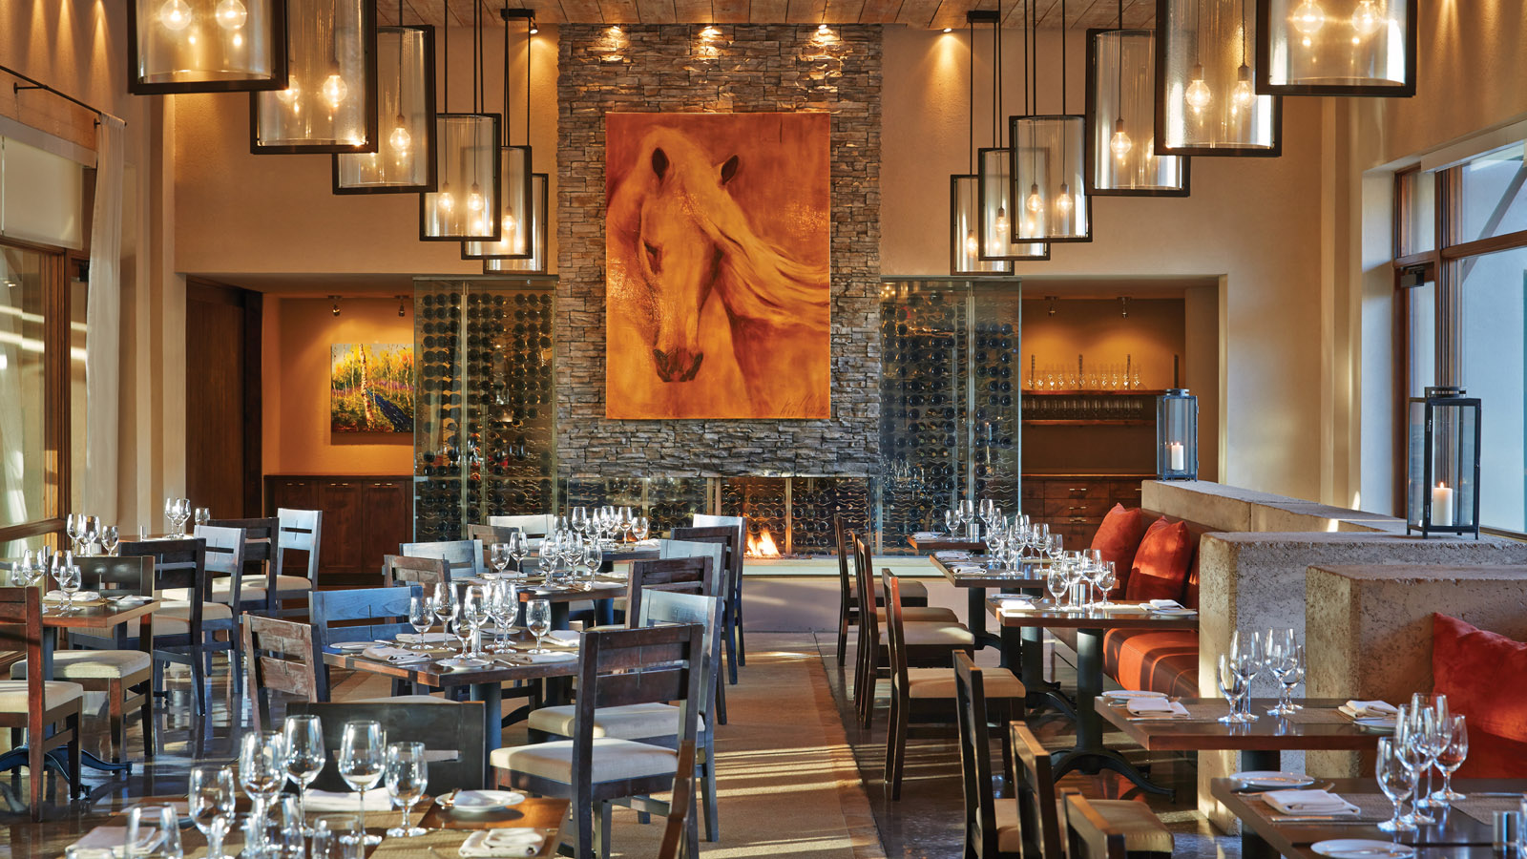 | October 19, 2022, Santa Fe, U.S.A.  Terra at Four Seasons Resort Rancho Encantado Santa Fe Captures Autumnal Spirit with New Menu  https://publish.url/santafe/hotel-news/2022/new-fall-menu-at-terra.html
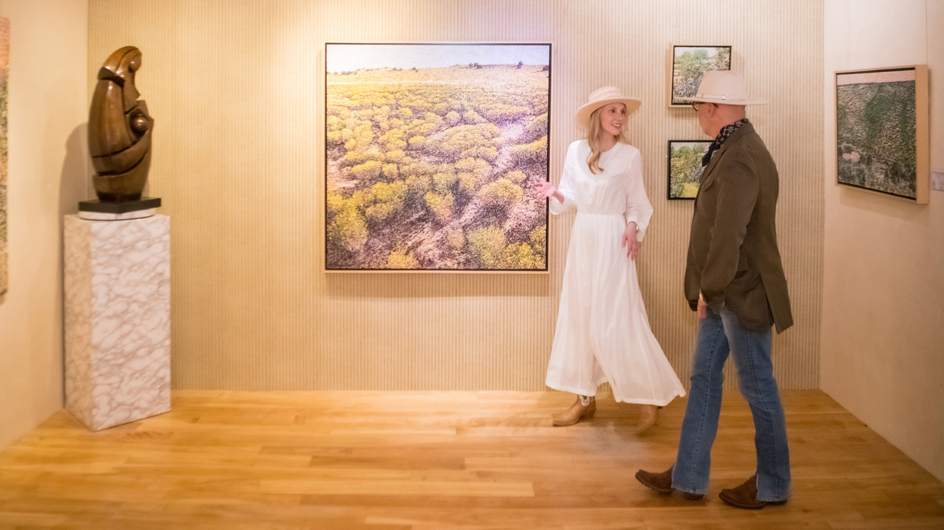 | September 19, 2022, Santa Fe, U.S.A.  Country’s First Art Concierge Program Now Available at Four Seasons Resort Rancho Encantado Santa Fe  https://publish.url/santafe/hotel-news/2022/art-concierge-program.html

PRESS CONTACTS

Jan Bracamonte
President of J. Lauren PR & Marketing
21 E. 6th Street, #415
Tempe
USA
fourseasonssf@jlaurenpr.com

+1 480 540 3842

