Enjoy a Private Island Paradise with Family and Friends at Four Seasons Resort Bora Bora and Get 50% Off a Second Overwater Bungalow Suite

Bora Bora and Room to Relax package is ideal for multi-generational travellers, extended family and travel friends
June 30, 2021, Bora Bora, French Polynesia

 | 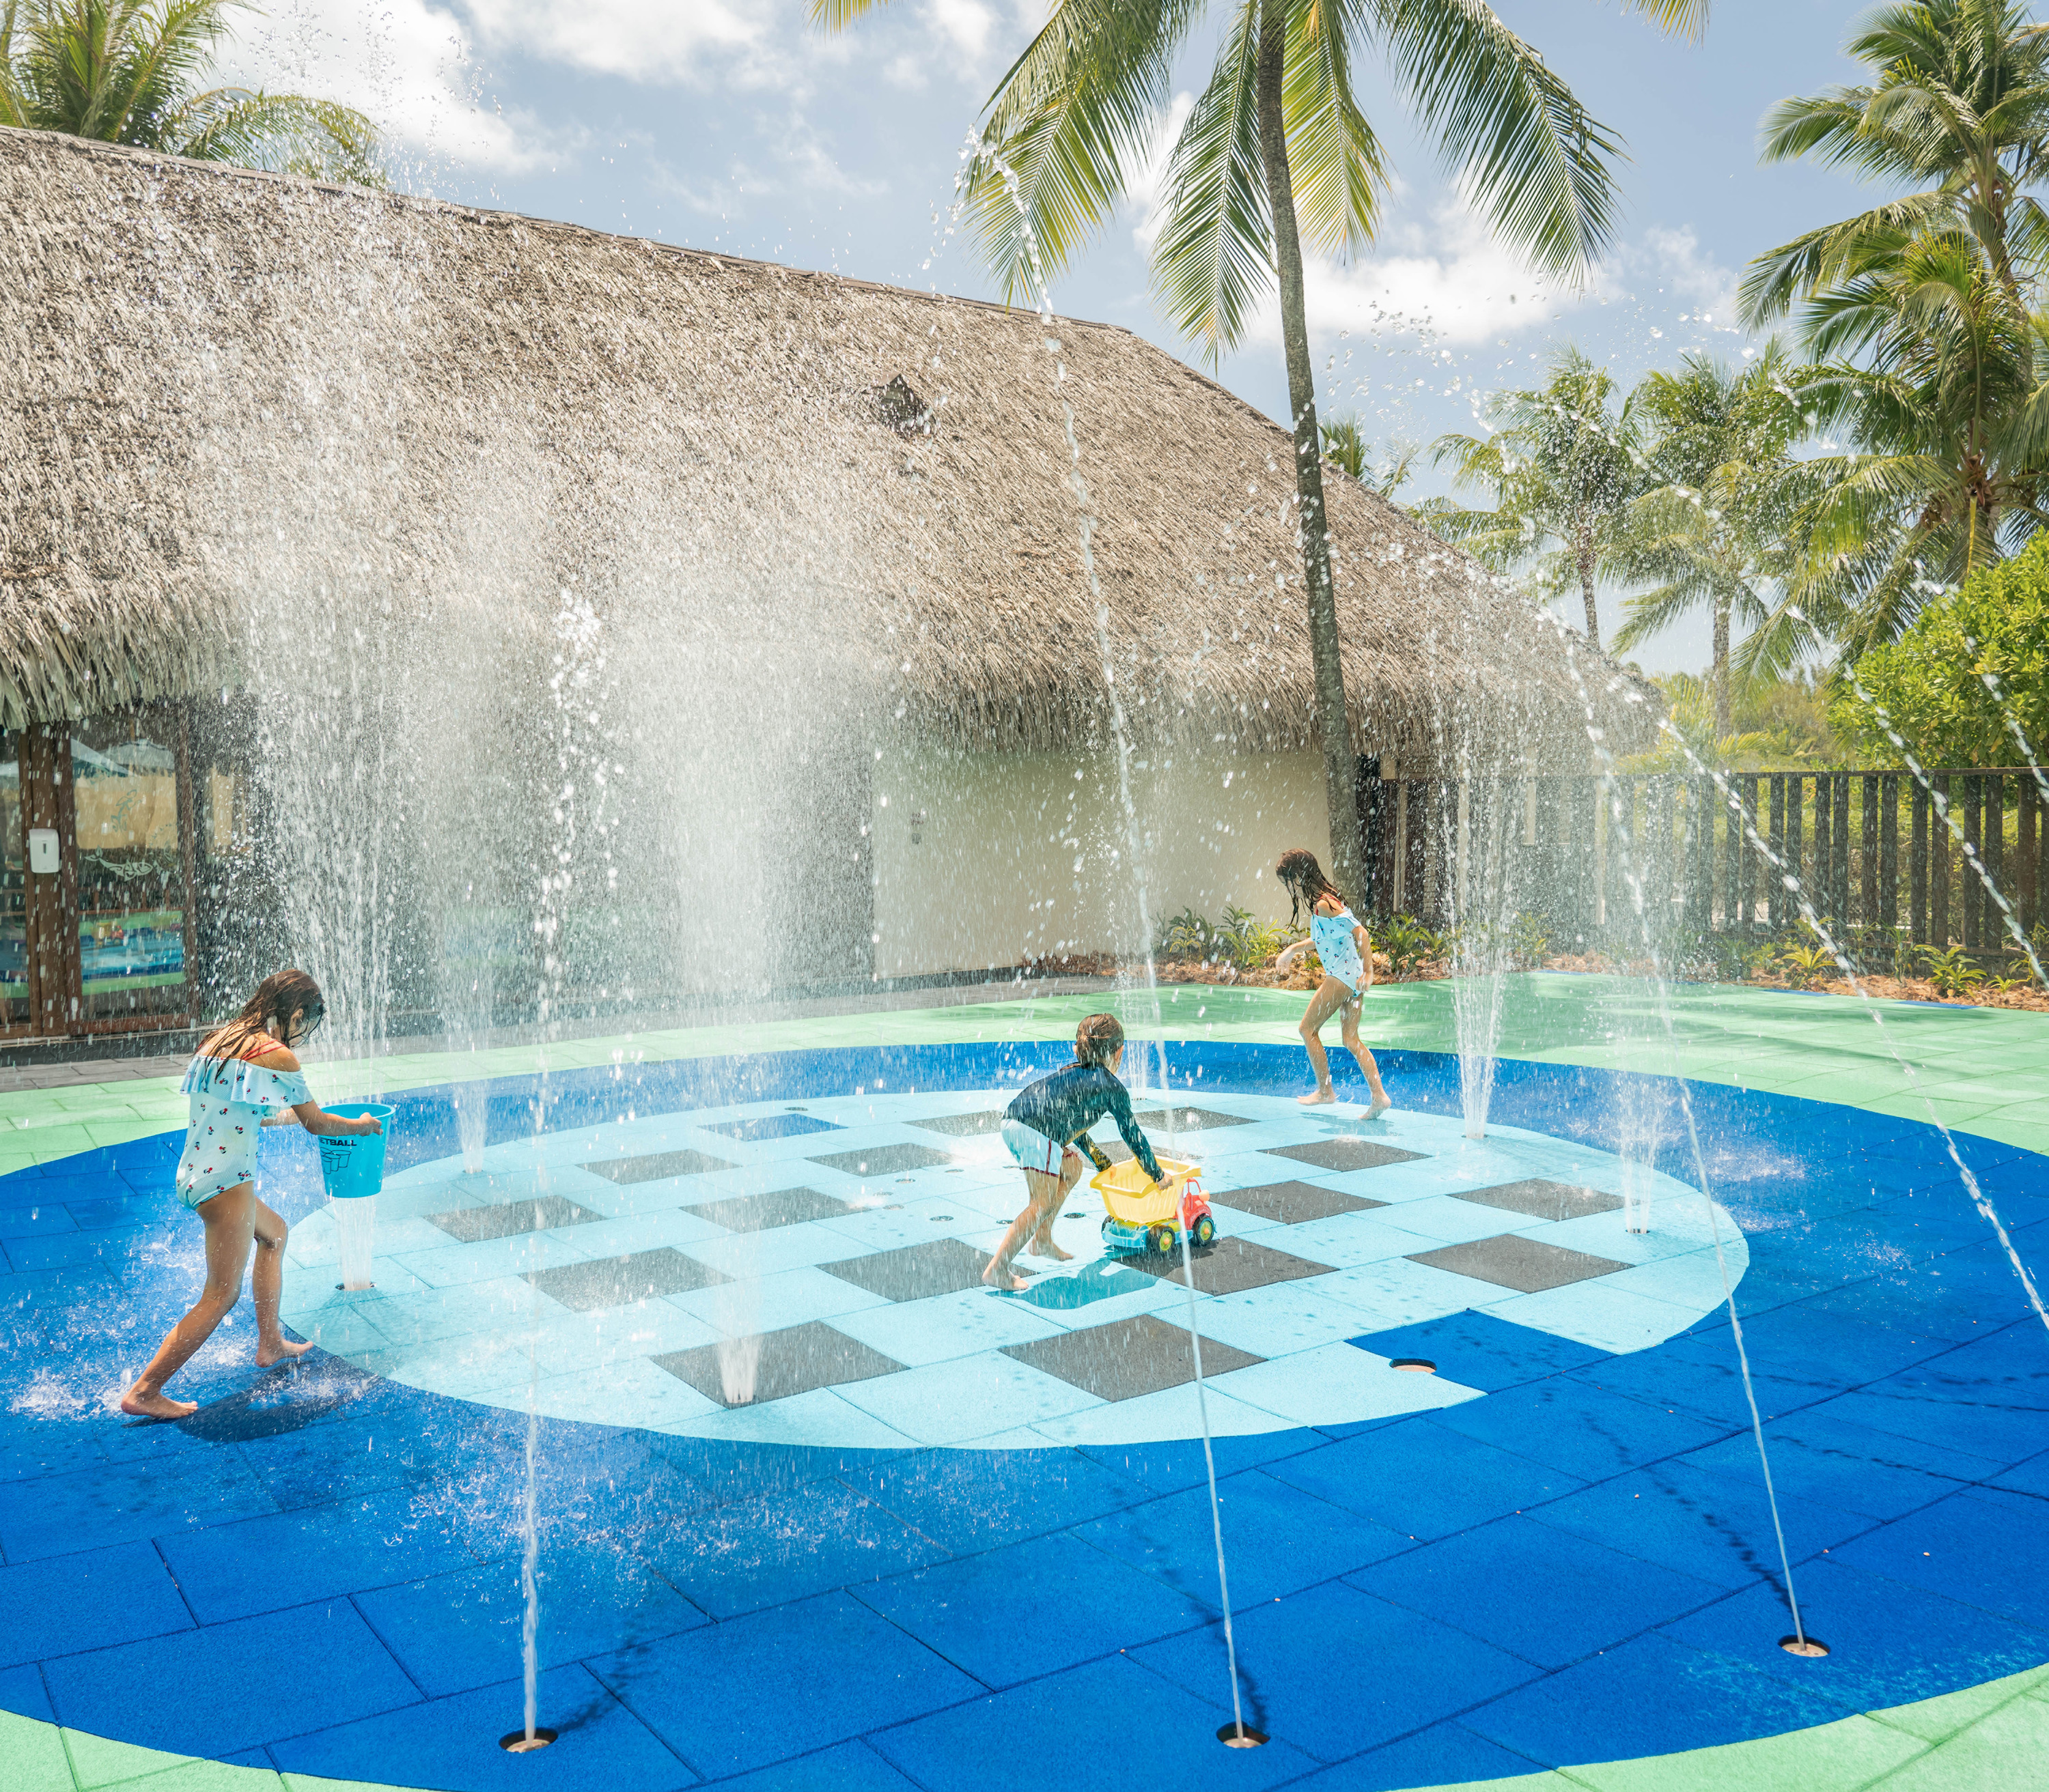 | 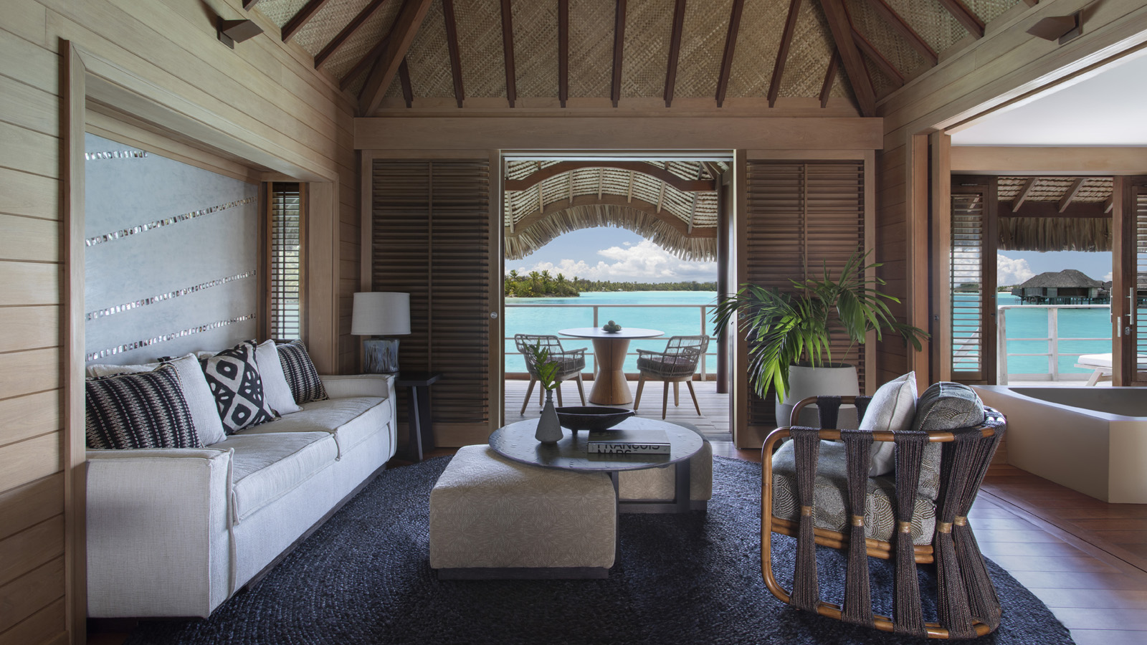
The recently-refreshed Four Seasons Resort Bora Bora, named “Best For an Epic Stay” in the world by AFAR, shares its Room to Relax package, offering 50 percent off a second overwater bungalow suite.
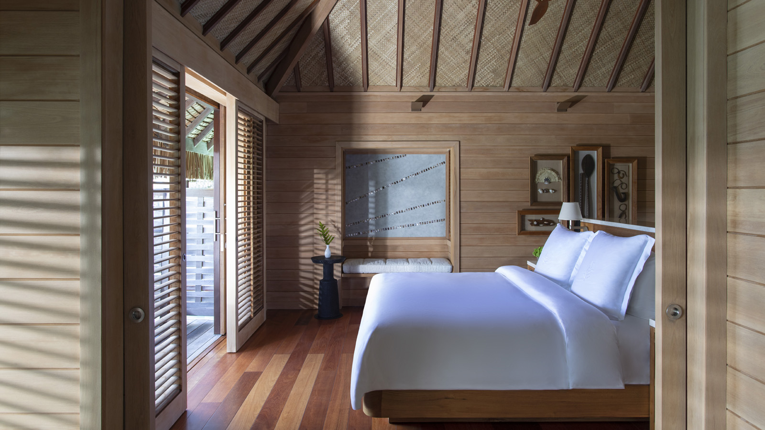 | 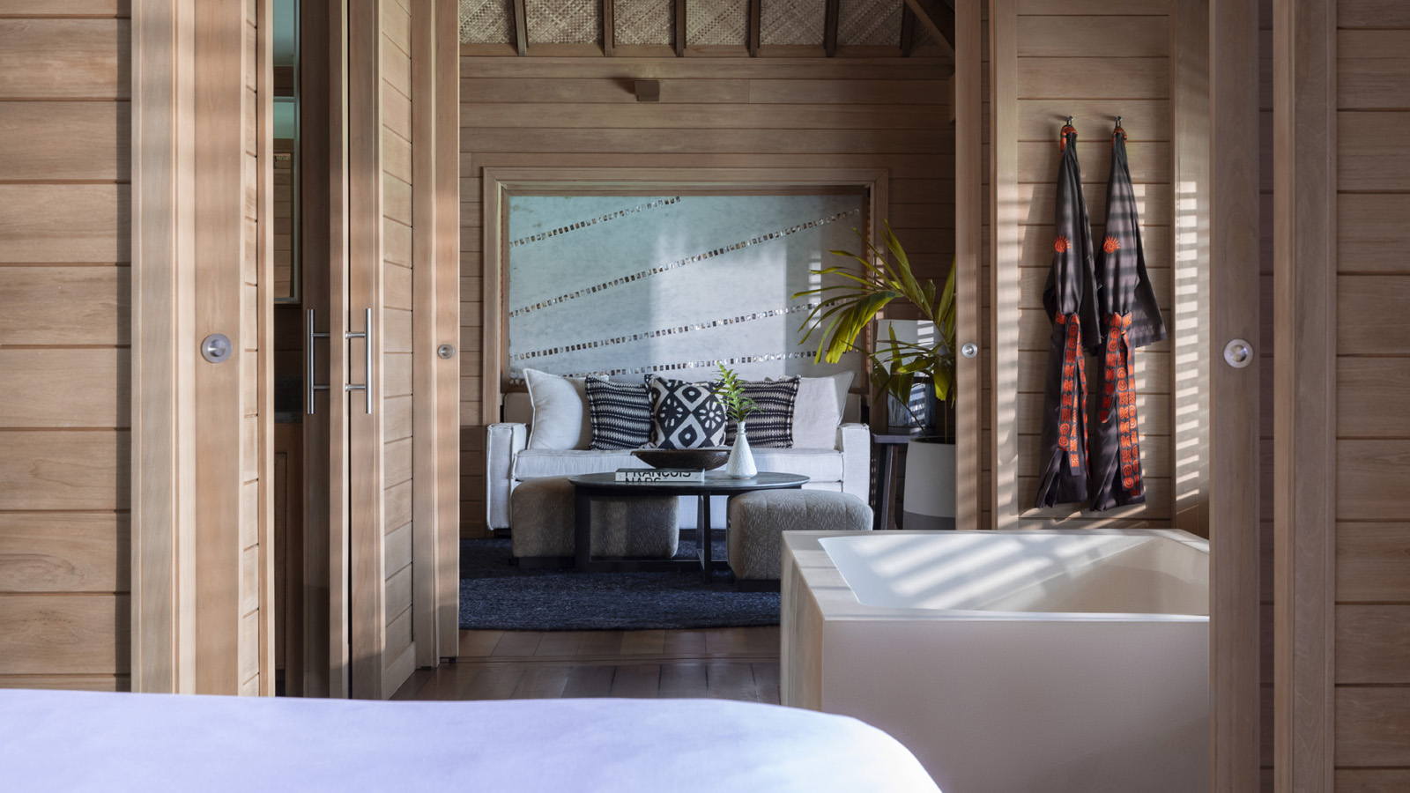 | 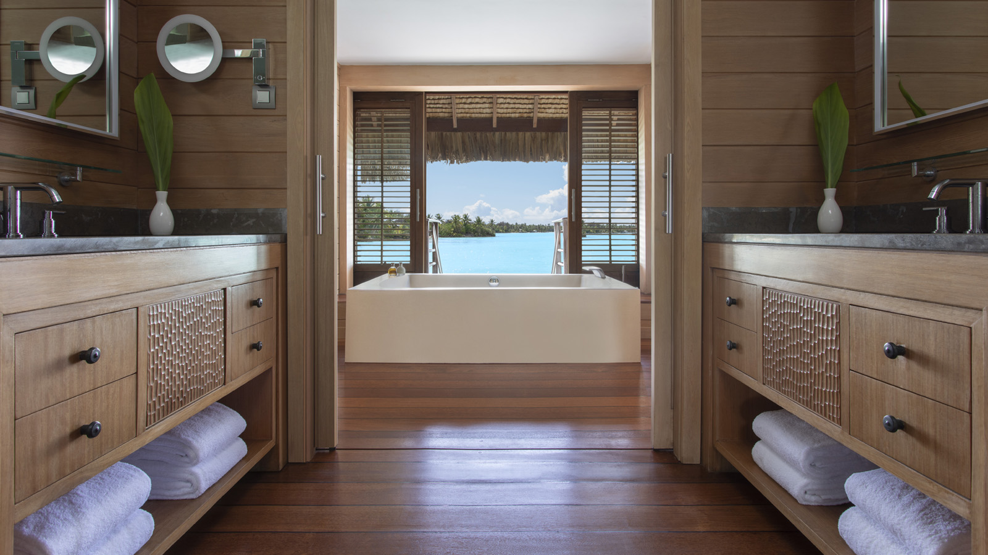
Guests booking the Room to Relax Package receive 50 percent off a second overwater bungalow suite with the purchase of one overwater bungalow suite for three nights or longer. Also included are meals for children ages five and under; 50 percent savings on meals for children ages 6-12; access to the Kids For All Seasons program for children ages 5-12; breakfast for adults, airport boat transfers, and wireless internet access. Additionally, the Resort’s partnership with WiseOceans provides an abundance of underwater adventure, discovery and learning for guests of all ages.
"With guests safely travelling again, we have seen a lot of families and close friends choosing to visit paradise together,” says Diego Stembert, General Manager of Four Seasons Resort Bora Bora. “Our Room to Relax package caters to these guests, and provides great value, while also ensuring a memorable multi-generational experience for all.”
Designed for privacy and space, the recently-enhanced private island resort is located on a private motu (islet), accessible only by boat or helicopter. This unique private island setting is a natural barrier to crowds, as foot traffic and outside guests are not a concern. The 108 one and two-bedroom overwater bungalow suites and seven two and three-bedroom beachfront villa estates are all freestanding accommodations, with true indoor-outdoor living space, ideal for those looking for space and privacy, while each of the Resort’s restaurants and bars offer open-air dining. The 22-hectare (54 acre) Resort offers guests ample space to spread out and enjoy their own slice of island paradise, surrounded by Bora Bora’s famous turquoise lagoon and majestic Mount Otemanu, while an array of recreational pursuits on and under the water provide exceptional opportunities to make memories.
Grounded in health care expertise and enabled by access to leading technologies and tools, the Lead With Care program is focused on providing care, confidence and comfort to all Four Seasons guests, employees and residents within the new COVID-19 environment. In addition, Four Seasons continues to invest in its award-winning App and Chat that further allows guests to control how they engage with others – limiting face-to-face interactions while maintaining the highest levels of personal service. Features include the ability to make and manage reservations, request luggage pickup, airport transfers, room service, restaurant and spa reservations, and much more. Wait-free check-in and check-out is also offered, while Four Seasons Chat integration offers instant translation of 100+ languages giving guests the flexibility for contactless engagement throughout their stay.
For reservations, book online, call 888 521 6648 or contact your travel professional (chain code FS).

RELATED

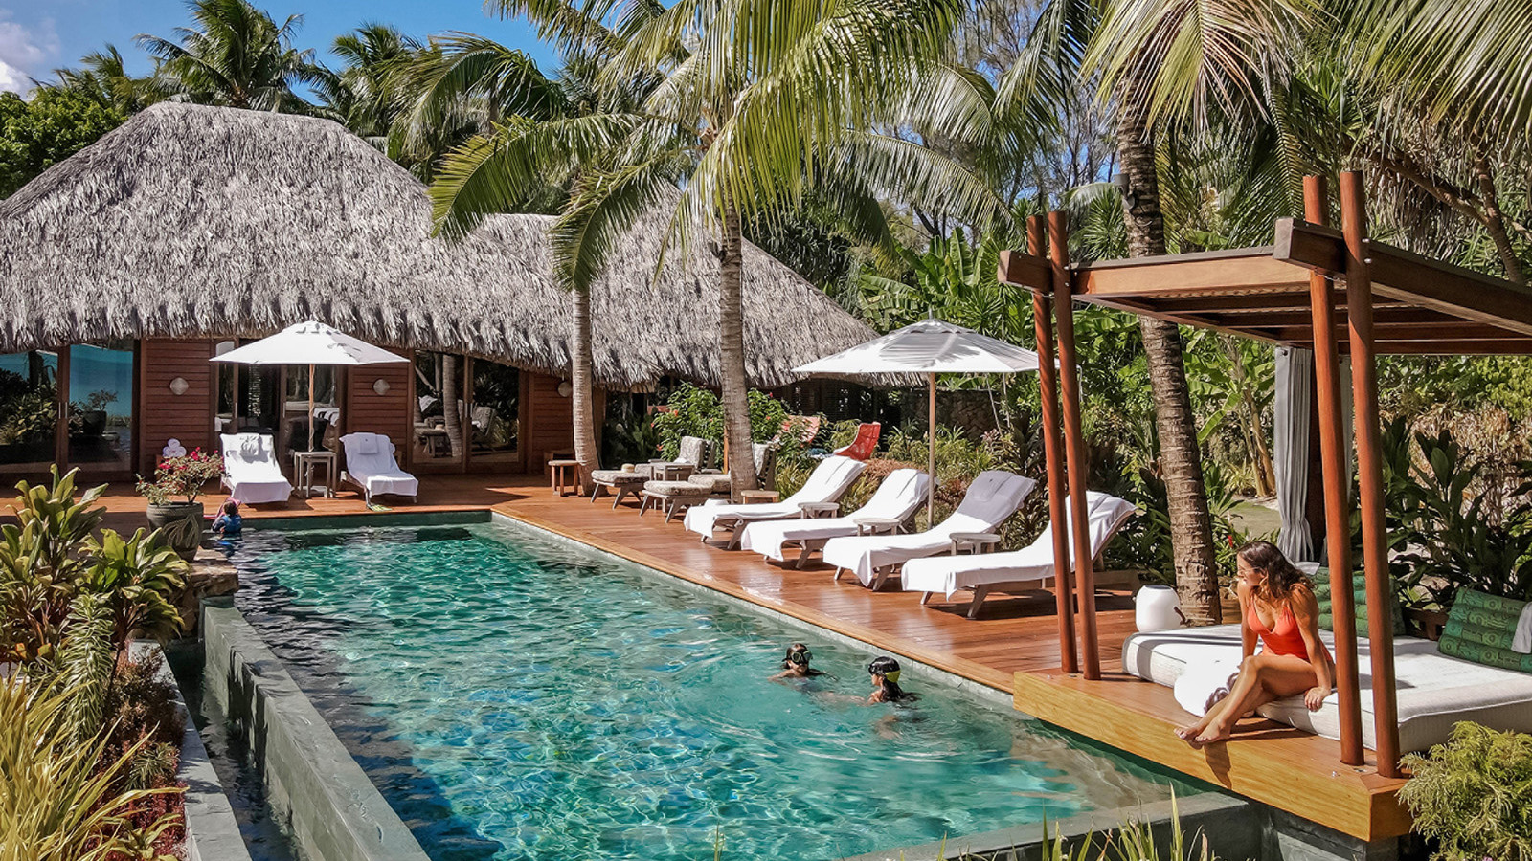 | January 12, 2021, Bora Bora, French Polynesia  Four Seasons Resort Bora Bora Introduces Extended Stay Program  https://publish.url/borabora/hotel-news/2021/extended-stay-program.html
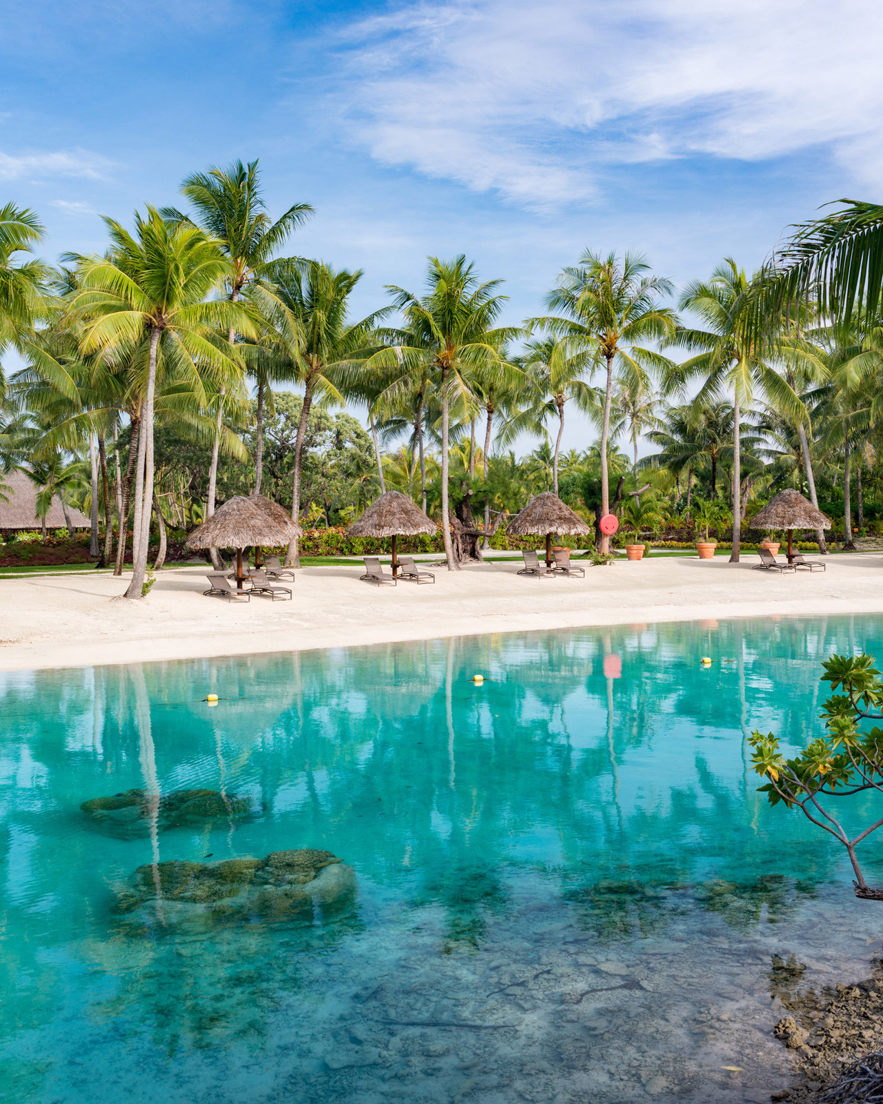 | December 17, 2020, Bora Bora, French Polynesia  Four Seasons Resort Bora Bora Announces Partnership with WiseOceans  https://publish.url/borabora/hotel-news/2020/wiseoceans-partnership.html

PRESS CONTACTS

Brad Packer
Director of Public Relations
350 South Beverly Drive, Suite 100
Beverly Hills
USA
brad.packer@fourseasons.com

+1 310 712 1493

