Four Seasons Resort and Residences Whistler Announces New Winter Pop-Up Restaurant G.O.A.

The unique culinary experience is inspired by Executive Chef Sajish Kumar Das’s hometown in India
December 8, 2022, Whistler, Canada

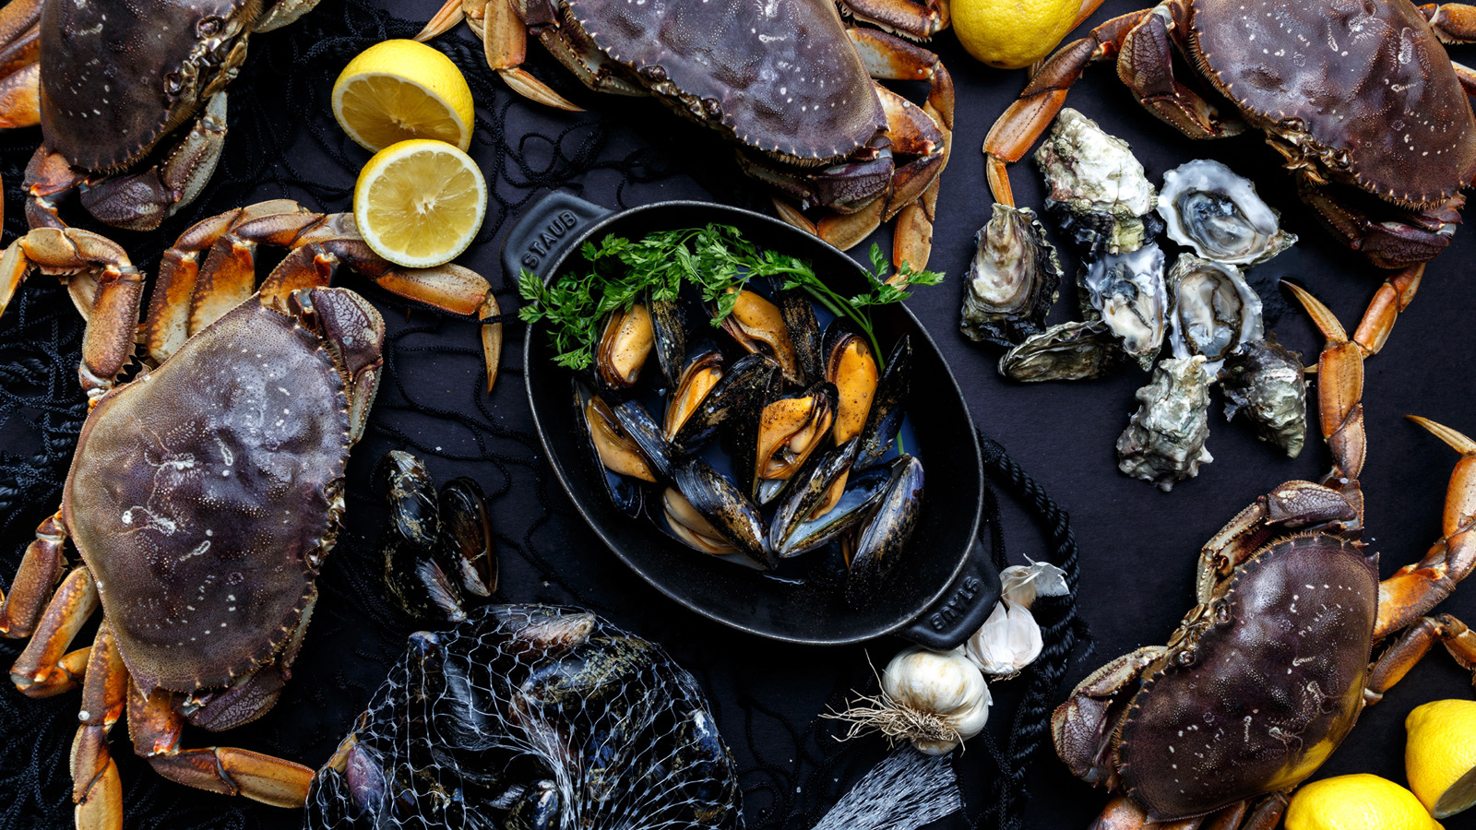
An extraordinary dining experience unlike anything Whistler has ever seen is being unveiled at Four Seasons Resort and Residences Whistler this month. G.O.A. is a new winter pop-up restaurant onsite at the luxury mountain property that takes inspiration from Executive Chef Sajish Kumar Das's hometown. Goa is small state on the west coast of India, a former Portuguese colony that is known for its spectacular beaches, sun-soaked climate - and delicious and diverse cuisine.
G.O.A. runs from December 9, 2022 to January 8, 2023.
Bringing a taste of the bold and diverse flavours of that tropical piece of Indian paradise to Whistler is a dream come true for Kumar Das. It was in the family kitchen in Goa where the internationally recognized chef first developed an appreciation for food, cooking, and the culinary traditions of his culture. To turn his passion into a profession, Kumar Das acquired a diploma from Goa’s Institute of Hotel Management and went on to work at five-star properties in India, the United Arab Emirates, Oman, Qatar, and Canada prior to joining Four Seasons Whistler. Kumar Das brings more than 20 years of expertise to the mountain resort, dedicated to delivering an unforgettable dining experience to each and every guest.
“We’re so excited for festive season,” Kumar Das says. “The team has worked very hard in coming up with different exciting activations that turn our Resort into a true winter wonderland. The newest and most exciting experience this season is the new winter pop-up restaurant, G.O.A. By using different techniques, ingredients and spices from the western coast of India and BC's freshest produce, we look forward to introducing this coast to coast culinary experience to our guests.”
Among the options for starters on G.O.A.’s thoughtfully designed menu is Oven Roasted King Prawns with squid-ink rice crisp, shaved garlic, and sweet and sour balchao spice, a pickle-like blend of ingredients.
Soup From the Sea is a nourishing dish of clams, mussels, and prawns in a fragrant tomato seafood broth with rasam essence (a spice made with toor dal, pepper, coriander, jeera, red chilies, and hing). Seared Octopus is served with onion-tomato masal, turmeric scented potato, and fried chilies; crispy pork belly, brined in dark rum, has a cafreal emulsion - a deeply flavourful green spice paste - with garlic chili aioli and microgreens. Other appetizing selections to start the Goan experience include Fried Soft Shell Crab (mint raita, paratha bread, and coconut) and Tandoori Carrot Tikka (pumpkin dal purée, micro greens, and tamarind reduction).
There are more Portuguese-Indian flavours to discover in G.O.A.’s main courses. Seared Lamb Rack, for instance, is served with traditional vindaloo sauce and cilantro oil, while Veal Shank is enhanced with semi-dried masala, curry leaf and dried chili.
Kumar Das has created a lavish Lobster Curry with coconut curry and tender poached okra and an indulgent Duck Dosa, featuring duck curry masala with fried egg and cilantro. King Porcini Mushrooms Korma come with a silken cashew gravy and morel dust. Seafood lovers will get a taste of the coast with sable fish, done as a Tawa Fry with Indian spices, mussels and clams molee, with coconut; then there’s a decadent Creamy Seafood Rice starring fresh BC seafood with spiced pork crumble and saffron.
All of the mains are served with a choice of bread, white rice, or paratha (unleavened layered flatbread).
Goan-inspired cocktails are also part of this exquisite menu. Specifically crafted for G.O.A., selections include The Goan Twist, a premium-rum based drink with clarified tamarind mix, lime, and chaat masala; and Mumbai Affair, with Bombay Sapphire gin, lychee, lime, and rose water. Wine pairings are another option.

RELATED

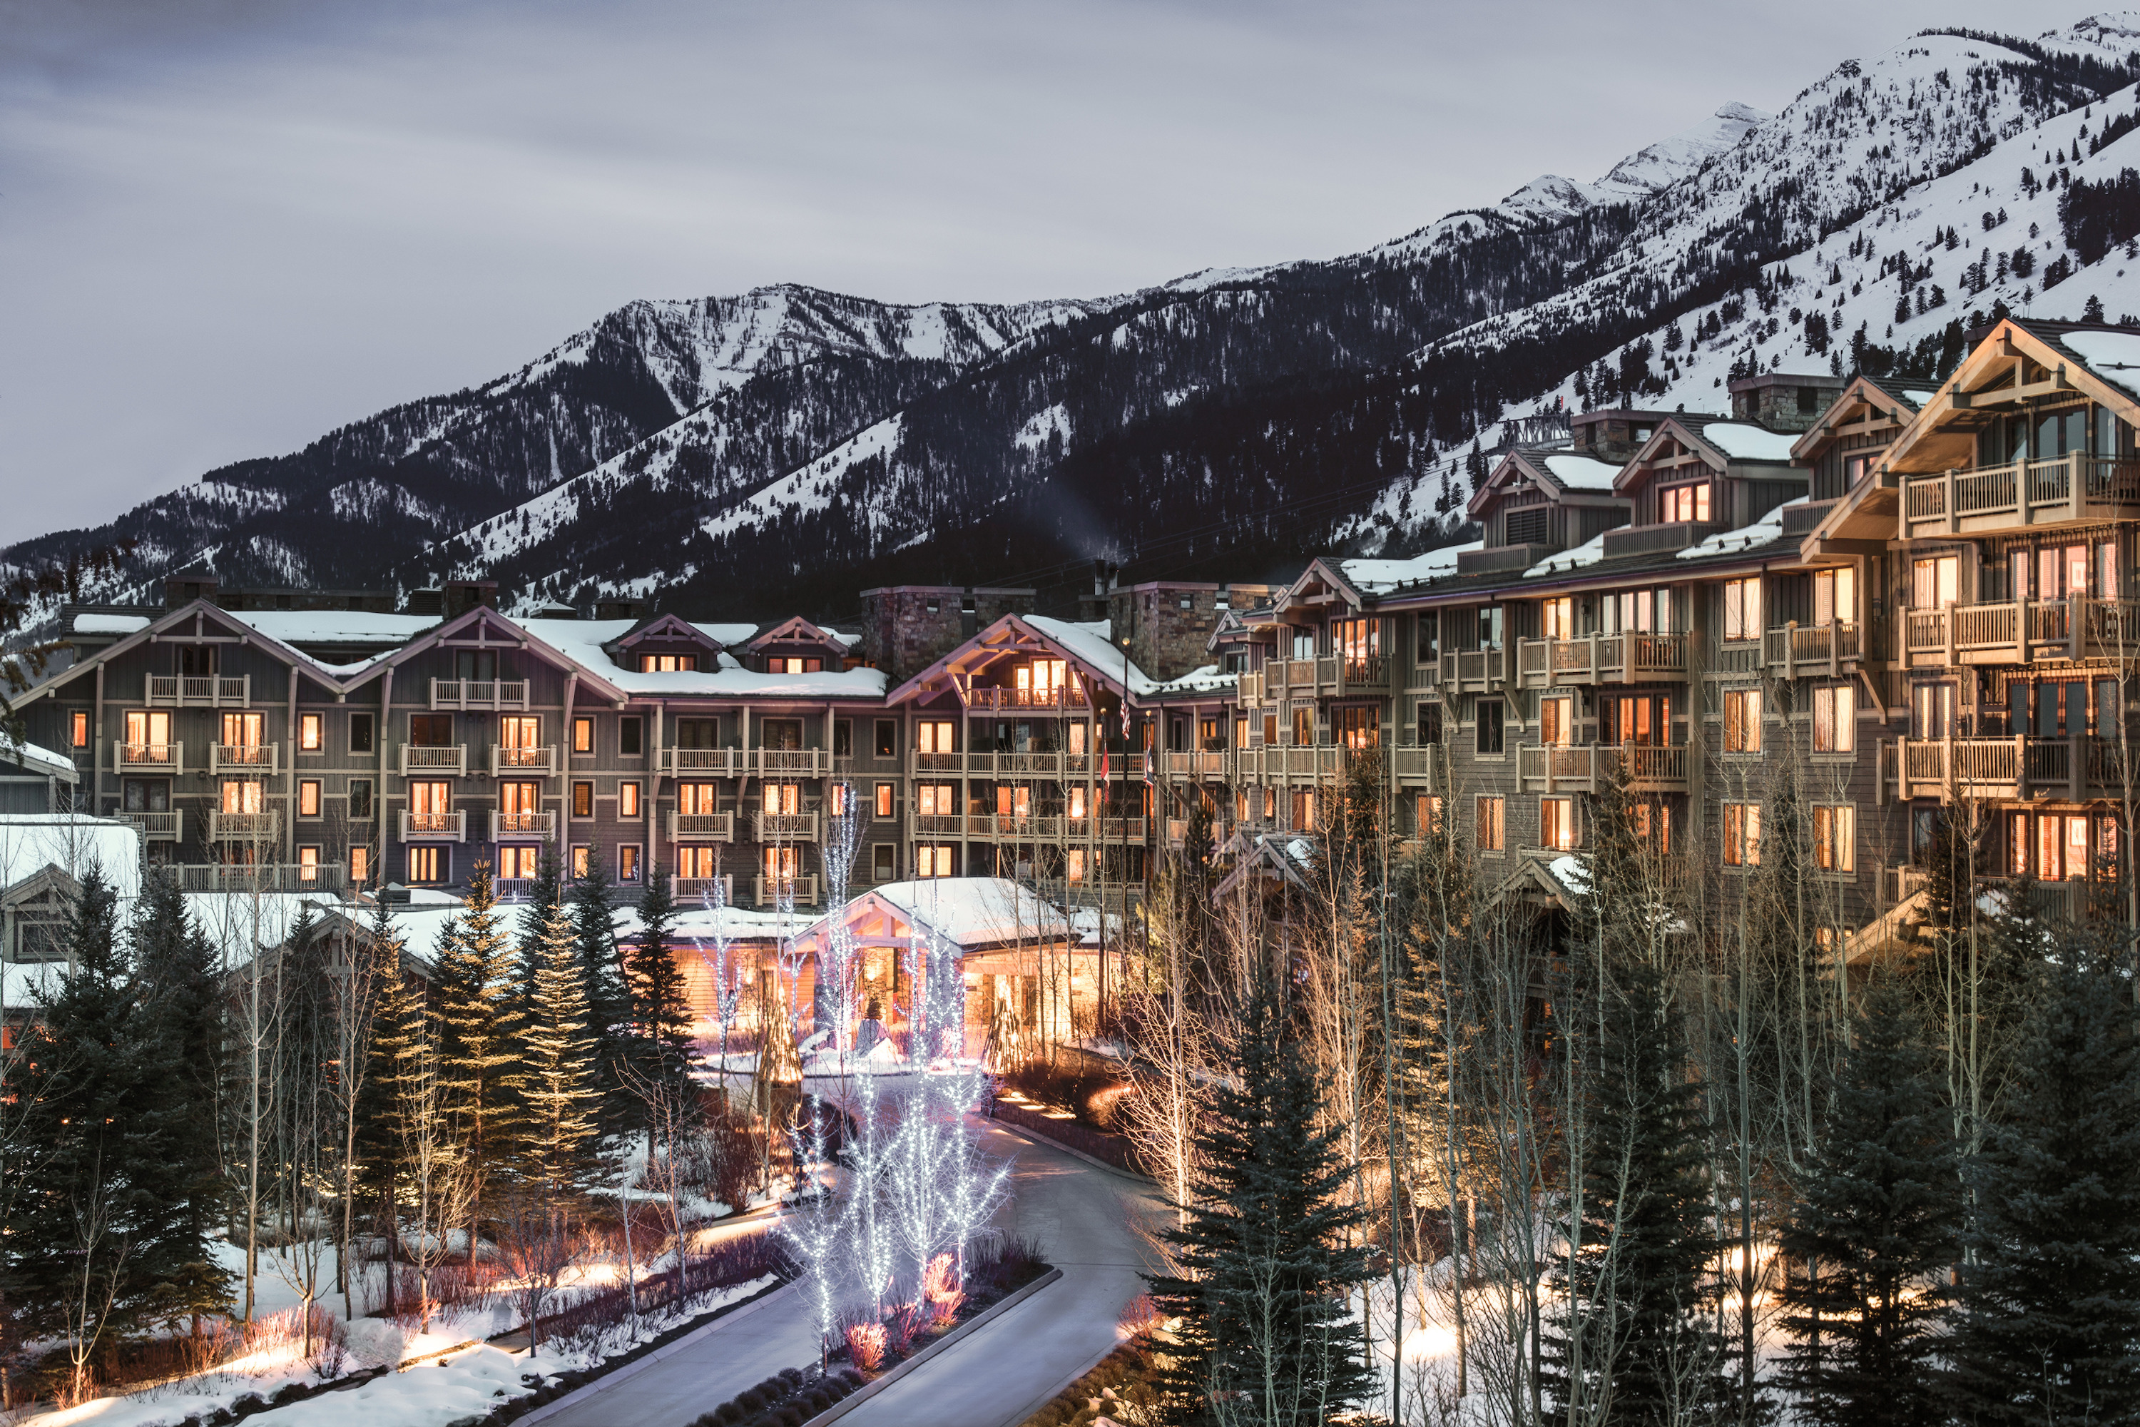 | November 22, 2022, Toronto, Canada  Experience a Bespoke Winter Wonderland with Four Seasons North America Mountain Collection  https://publish.url/news-releases/2022/mountain-collection-experiences.html
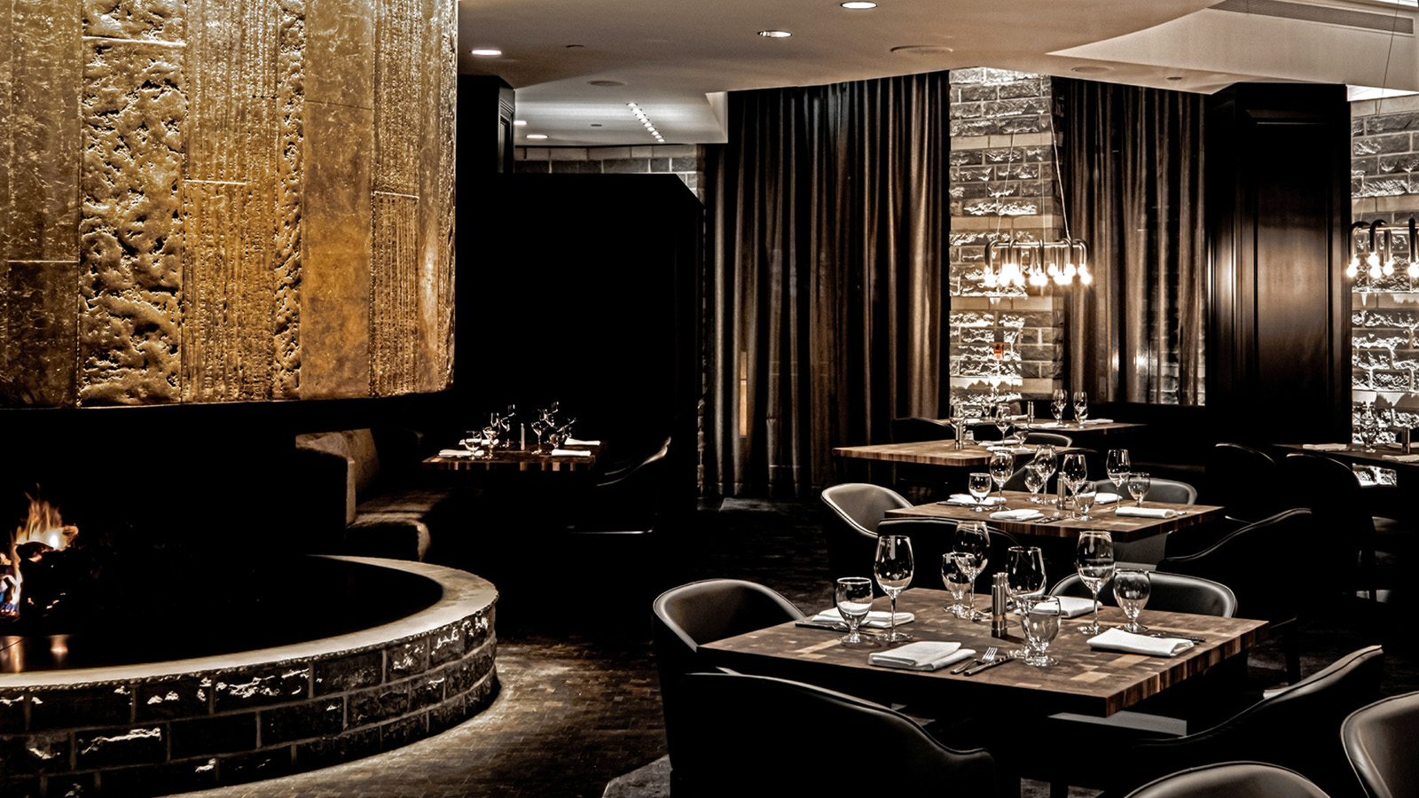 | October 25, 2022, Whistler, Canada  Cornucopia 2022: Four Seasons Resort and Residences Whistler Announces Highly Anticipated Sidecut x SLCC x Fort Berens Dinner  https://publish.url/whistler/hotel-news/2022/cornucopia-events.html

PRESS CONTACTS

Carolina Pires
Director of Public Relations and Communications
4591 Blackcomb Way
Whistler
Canada
carolina.pires@fourseasons.com

+1 604 967 1869

