Think Chill Courtyard Campers, Champagne Pool Cabanas, a Legendary Thursday BEER-B-Q and the Ultimate Weekly Vacation Rental in the Glam and Spacious Residences of Four Seasons Resort Whistler

Make Four Seasons Resort and Residences Whistler the star of summer vacation
May 25, 2018, Whistler, Canada

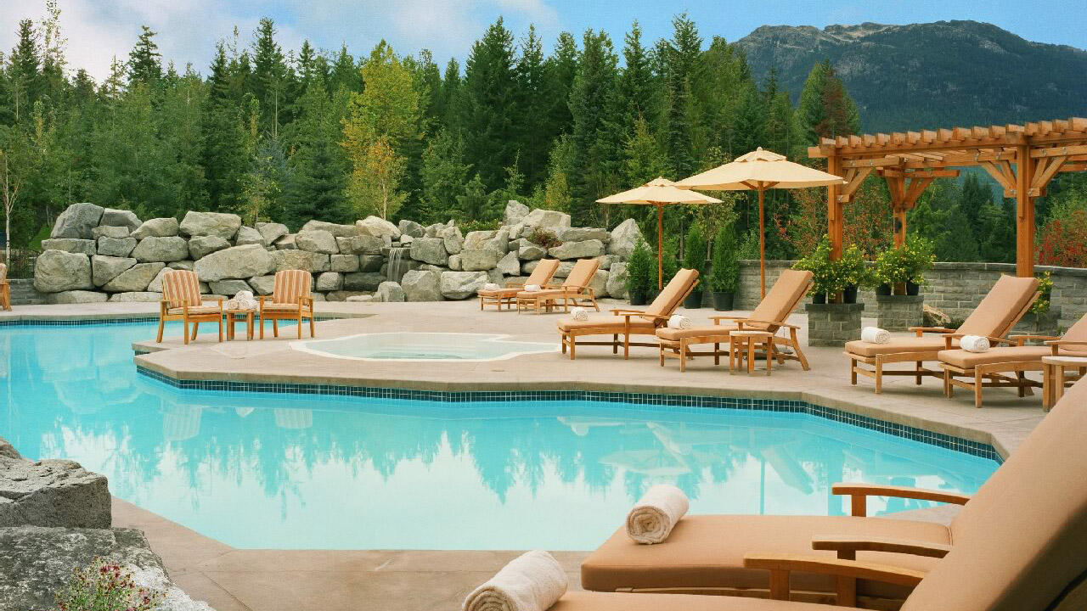
Summers in Whistler are simply dreamy thanks to warm, long and sunny days setting the perfect backdrop for enjoying the line up of activities offered at
Four Seasons
Resort and Residences Whistler. Action seekers will find their adrenaline fix during an action-packed day of mountain and trail biking, hiking, golfing, swimming or zip-lining. And all guests will find something to love within the multitude of festivals, events, pool lounging, courtyard sipping, patio dining, Thursday BBQs, farmers markets, favourable exchange rates and recharging at the Spa.
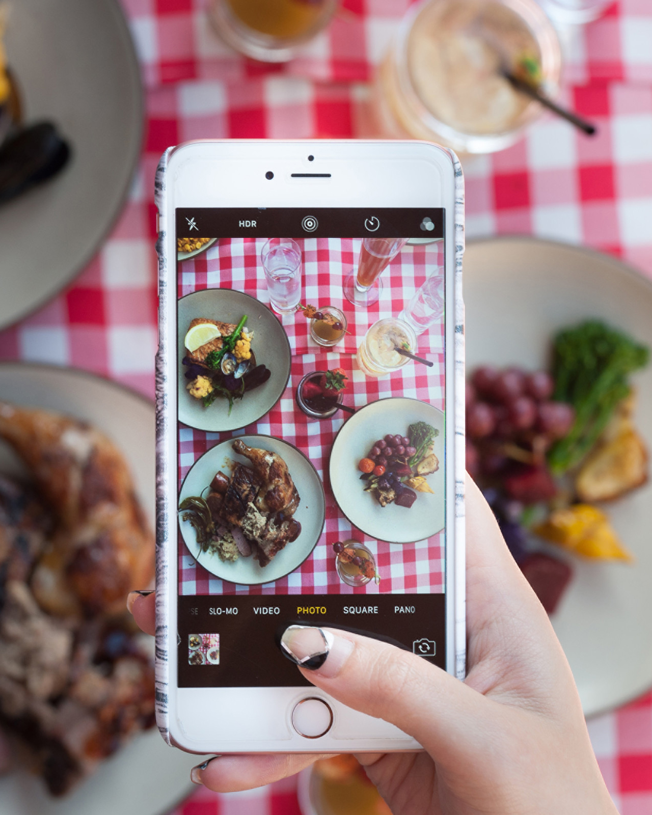 | 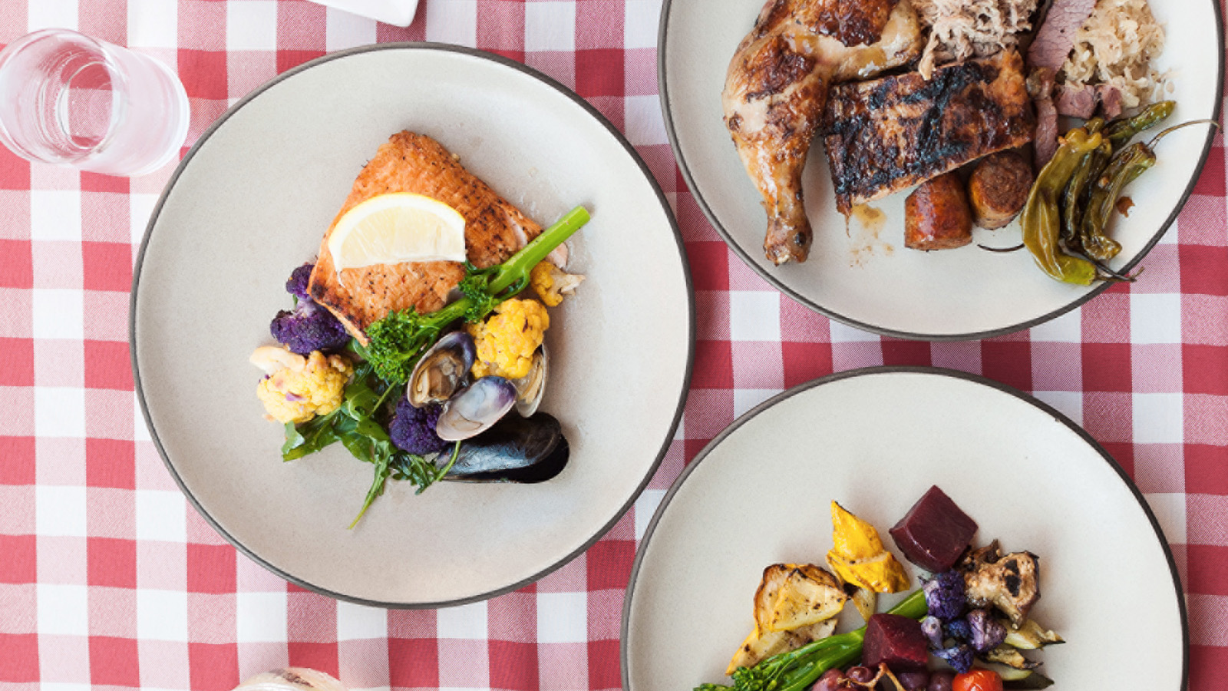
Save
- More for the Money - Not only are Canadians considered some of the nicest people in the world, with some of the most beautiful scenery, exciting activities and delicious food and drink, Canada is also highly affordable. Guests can trade in their euros, pounds, US dollars, pesos, yuan and yen for lots of loonies. Checking the exchange rate before planning a summer holiday will make this already intoxicating destination even more delightful.
Stay
Four Seasons
Resort and Residences Whistler proves the perfect home base for friends and family alike with all the perks of a Five Star resort thanks to the new Weekly Vacation Rental Residences package. With 35 percent savings on the Resort’s spacious and modern residential-style accommodations plus CAD 500 worth of groceries pre-stocked for two-bedroom residences, daily wine reception and complimentary WiFi, this seven-night package invites guests to settle in. Guests will enjoy a dedicated residence pool and patio to soak up the summer rays pre or post swimming, exploring, hiking, biking, golfing, ziplining, sightseeing along the Peak-to-Peak gondola and cocktail sipping.
- Weekday Advantage - Save 20 Percent -
Four Seasons
Resort and Residences Whistler invites guests to savour Whistler weekdays with savings of 20 percent on all rooms, suites and residences. Enjoy quieter days on the mountain and throughout the village, and get more value on adventures. Arrive and depart between Sunday and Thursday to take advantage of this special rate, for a two-night minimum. Click here for more details.
Sip and Savour
Summer Happenings at Four Seasons Resort Whistler
SIDECUT and the Resort’s outdoor courtyard and posh pool will be buzzing with all kinds of tasty and social events this summer.
- Thursday Summer “Beer” BQ’s - 5:00 to 9:00 pm - Whistler’s favourite BBQ is back. This summer, SIDECUT will be partnering with different BC craft breweries every week, weaving beer into classic recipes and offering guests interesting pours and a wide selection of barbequed proteins, bright salads and satisfying sides. Rotating live local musicians and featured breweries make Thursdays everyone’s favourite day of the week. Tickets are CAD 39 for adults, CAD 19 for kids (5-12) and CAD 12 for kids under 5. Starts Thursday, June 28, 2018.
- Step Up to the Patio Camper - Introducing a new extension to SIDECUT restaurant this summer at the courtyard starring refreshing beverages and tasty ice creams inspired by the Great Canadian Road Trip. Starts late June 2018.
Splash
The Spa Pool Offerings
Guests are invited to get deep into vacation mode while relaxing next to the Resort’s freeform outdoor swimming pool. This fully heated oasis offers panoramic vistas of Whistler and Blackcomb mountains and is flanked by three hot spring-style whirlpools. The pool is a destination in and of itself – an ideal one-stop flop on hot summer days and nights. Adults may prefer a leisurely swim, some serious lounging and spending quality time catching up over handcrafted cocktails and tasty bites on the spacious pool deck. A DJ will playing the soundtrack to the weekend at one of Whistler’s best outdoor pools all summer long.
- New for 2018: Poolside DJ and Private Moët Ice Cabanas - It’s all about the pool this summer thanks to an al fresco DJ every Saturday, mountain views, seamless service, a chill vibe, and great food and drink. Guests looking to keep things cool will enjoy the new Moët Ice Cabanas that come with Champagne, garnishes, a refreshing fruit place, savvy service and additional privacy - CAD 190 for two hours.
Spa
A relaxing escape from life’s stresses and strains, The Spa is all about making guests feel good. One of Resort guests’ favourites is the 80-minute Sea-to Sky-massage, which includes locally made seaweed salt scrub and the use of heated mountain stones.
The Spa team has also upped the level of customisation for all services by offering in-treatment enhancements. Guests can choose different options to personalise their treatments such as the addition of the very popular house-blended peppermint and argon scalp oil to facial and massage treatments. During summer, The Spa will also offer a sunscreen enhancement for sun-bound guests, finishing treatments with an application of sunscreen.
Kids
- Summer Snow Cones - To keep the Resort’s littlest guests cool in the summer sun, the 4:00 to 6:00 pm daily treat in the outdoor courtyard will be snow cones – featuring hand-shaved ice with a rotating range of fun and inviting flavours.
Families also enjoy daily lemonade in the lobby, pint-sized bathrobes and friendly welcome “stuffies.”
Activities
- Stay Fit, Stay Relaxed - The Resort offers summer guests a wealth of experiences designed to enhance body, mind and spirit. Every day, Resort guests can choose from a complimentary array of fitness options including spin, yoga ad Pilates classes, scenic walks and jogs with Resort managers, wine tastings, movie nights, live music, “Moments with Maola” the Resort dog, a weekly ping pong tournament and more. Guests can also sign up for painting classes for an additional fee.
Festivals
Whistler’s Summer Festivals and Events
Whistler offers an epic line up of festivals and events drawing people from around the globe year round.
Four Seasons
Resort Whistler is an awesome home base for these summer events.
- Tough Mudder - June 16 to 18, 2018 - Tough Mudder is a military-style obstacle course at Whistler’s Olympic Park that takes participants through gruelling man-made obstacles that test endurance, fears and teamwork.
- Canada Day - July 1, 2018 - Whistler is putting on a weeklong Canada Day party worthy of its 150 plus years that includes street entertainment, special events, free concerts, a parade and more.
- Outdoor Concert Series - May 18, 19, 20 - June 30 - July 1, 13, 14, 20, 21 - Aug 2, 3 4, 24, 25, 31- September 1, 2018 - Whistler Olympic Plaza is the place to be this summer. Free outdoor concerts are offered on select days throughout the summer featuring classical music, chilled out beats and local folk bands.
- Whistler’s Children’s Festival - July 6 to 8, 2018 - Families love the annual Children’s Festival that brings together hands-on art workshops, crafts, theatre, multi-media, dance, music and magical performers to Whistler Olympic Plaza.
- Ironman - July 29, 2018 - Athletes descend on Whistler and Pemberton to compete in the 2018 Subaru Ironman Canada triathlon. Taking up the challenge to swim, bike and run through Whistler’s beautiful lakes, roads and trails. Ask the concierge for tips on the best places to watch the race.
- Wanderlust - August 2 to 5, 2018 - Yogis and wellness enthusiasts descend on Whistler for the annual Wanderlust festival that brings the world’s leading yoga teachers, top musical acts, speakers, chefs and performers together to transform, journey and explore with event goers over this packed weekend.
- Crankworks Mountain Bike Festival - August 10 to 19, 2018 - Crankworks is a world-famous mountain bike festival that sees the best riders and biggest bike fans from around the globe make the trek to Whistler.
Now is the perfect time to book a vacation at Four Seasons Resort and Residences Whistler. Contact the Reservations Department at +1 604 9843500 or book online.

RELATED

May 23, 2018, Whistler, Canada
Four Seasons Resort and Residences Whistler Celebrates Global Wellness Day June 9, 2018
https://publish.url/whistler/hotel-news/2018/global-wellness-day.html

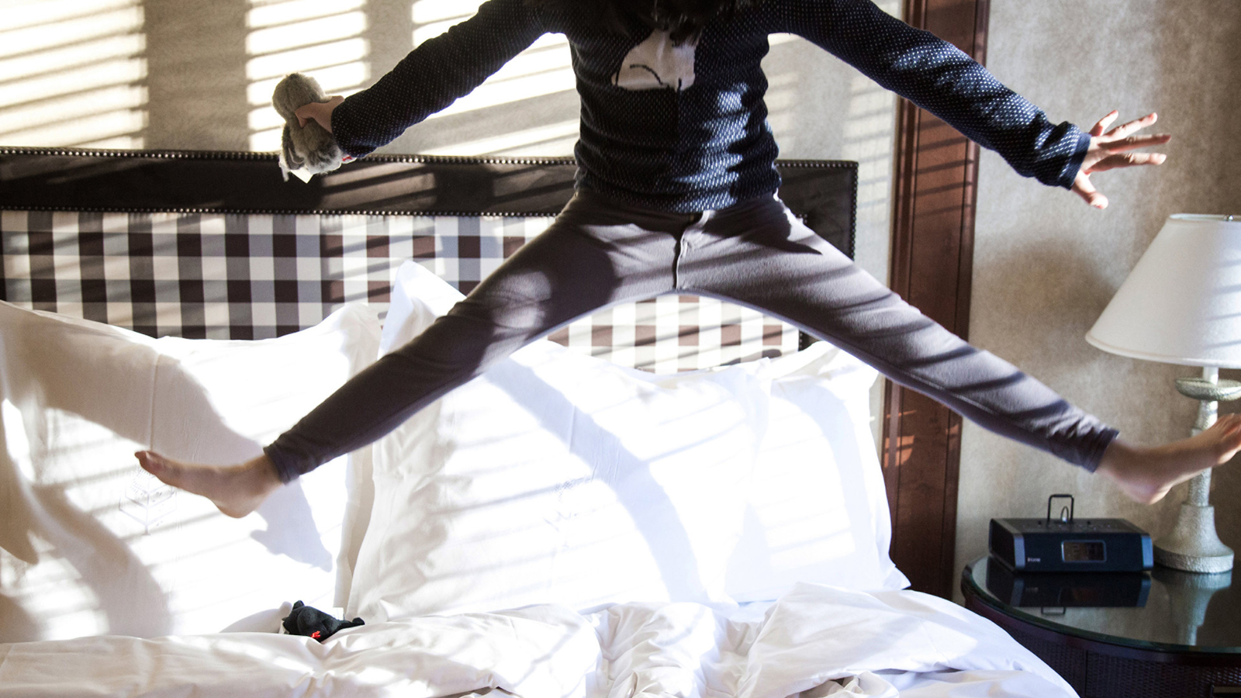 | April 20, 2018, Whistler, Canada  Bici Gusti + Four Seasons Resort and Residences Whistler Promises a Dreamy Weekend of Fun, Food and Fitness with a Pink Twist  https://publish.url/whistler/hotel-news/2018/bici-gusti-culinary-cycling-event-2.html

PRESS CONTACTS

Christine Kim
Public Relations and Communications Manager
4591 Blackcomb Way
Whistler
Canada
christine.kim@fourseasons.com

+1 (604) 966-2666

Kate Colley
Director of Public Relations and Communications
4591 Blackcomb Way
Whistler
Canada
kate.colley@fourseasons.com

+1 (604) 844-6769

