Walk and Paddle for Education: Four Seasons Resort Langkawi Gives Back to the Community

Four Seasons supports local education with a cross-island team walk and a solo kayak journey
March 18, 2021, Langkawi, Malaysia

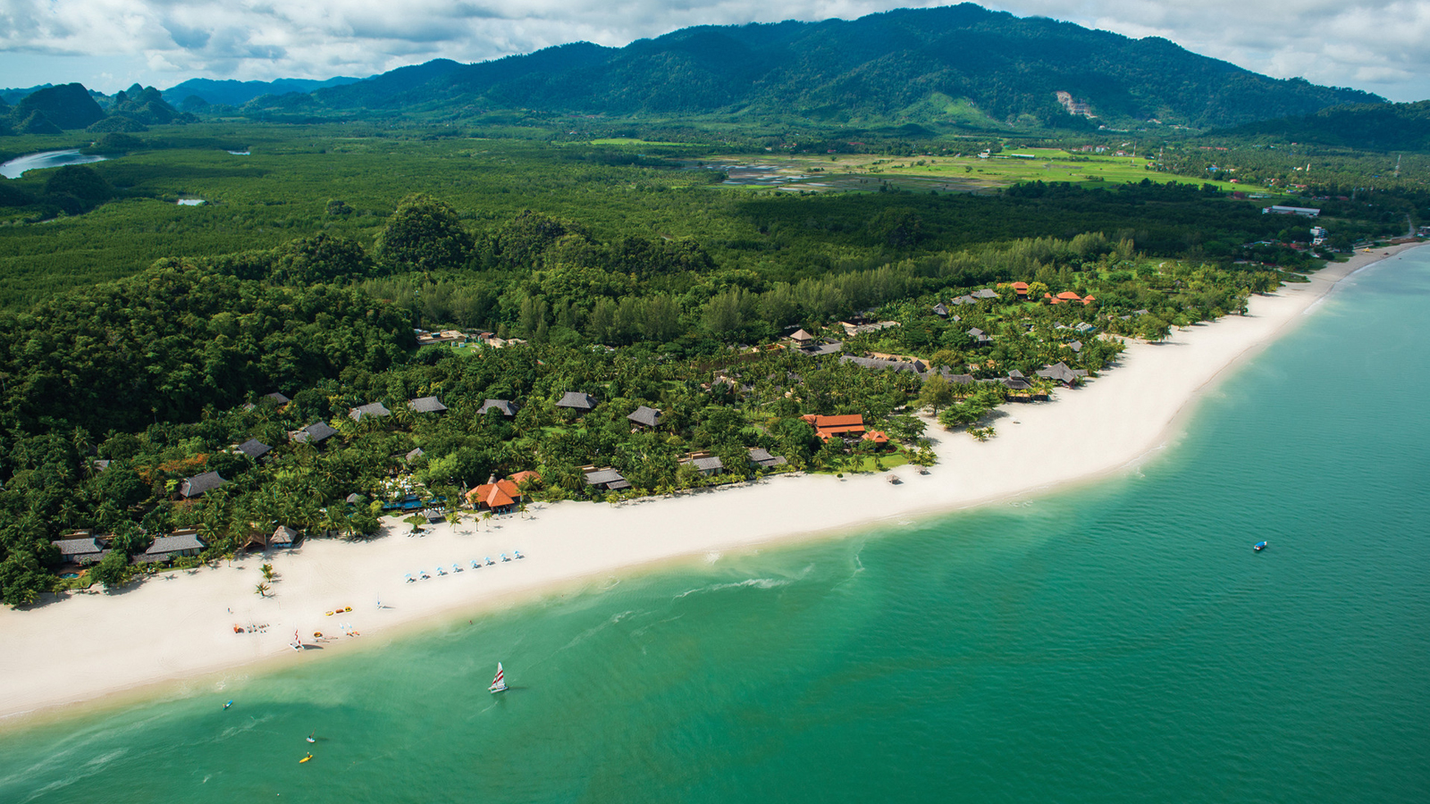
What happens when you bring together purpose, passion and action? At Four Seasons Resort Langkawi, you get a General Manager who kayaks for 17 hours and a team that walks from one end of island to the other – all with the intent of giving back to the local community.
When the going gets tough, Four Seasons gets going. Led by General Manager David Macklin, the team has launched two inspiring initiatives with the aim of improving education for children on the island. “It’s been a difficult year all round. Langkawi is our home, and we wanted to do something that would make a real difference for our community,” explains David.
Meaningful Change
Due to the pandemic-driven restrictions on going to school, Langkawi’s educational system has moved largely online. However, many students still don’t have access to vital resources needed for distance learning, such as appropriate reading materials and stable internet. This prompted the Resort’s leadership to ask themselves: How can we help? The answer came in the form of twin initiatives – Paddle for Education and Walk for Education – to create awareness around critical educational hurdles and raise donations for local high school students.
“Every child has the right to education. I have two kids in high school, so I know how important and life-defining those years can be,” says David. “In challenging times such as these, it’s even more important for the community to come together and support one another.”
Paddle for Education
On February 27, 2021 David paddled his hand-built wooden kayak around the entire circumference of Langkawi – a solo journey of 105 kilometres (65 miles) that took him 17 hours. People around the world were able to follow David’s voyage with real-time updates at the Paddle for Education website.
“This experience has been a truly memorable one. I enjoyed every moment of this journey from building the kayak to paddling around the island. I would definitely do it again,” says David.
Walk for Education
The second event will take place on March 27, 2021. Taking the lead from their energetic captain, a group of Four Seasons team members will embark on a brisk 26-kilometre (16 mile) walk – from the iconic Eagle Square in the south, to Four Seasons Resort Langkawi located at the northern end of the island. The Walk for Education will begin at 7:30 am, with local residents welcome to join for the last 6 kilometres (3.75 miles).
Get Involved
The funds raised from both events will be used to purchase vital items for local high school students at SMK Ayer Hangat in Langkawi, Malaysia. As of today, the Resort has raised more than MYR 12,000. Join the initiative in any of the following ways:
- Visit simplygiving.com or click here.
- Transfer monetary donations to (CIMB a/c number: 707 551 9763, swift code: CIBBMYKL).
The team is also accepting donations of learning supplies as well as books, preferably in English, Arabic and Chinese. Please contribute any fiction and non-fiction books that are suitable for children up to the age of 18 years.
For more information, contact Four Seasons Resort Langkawi via Four Seasons App.

RELATED

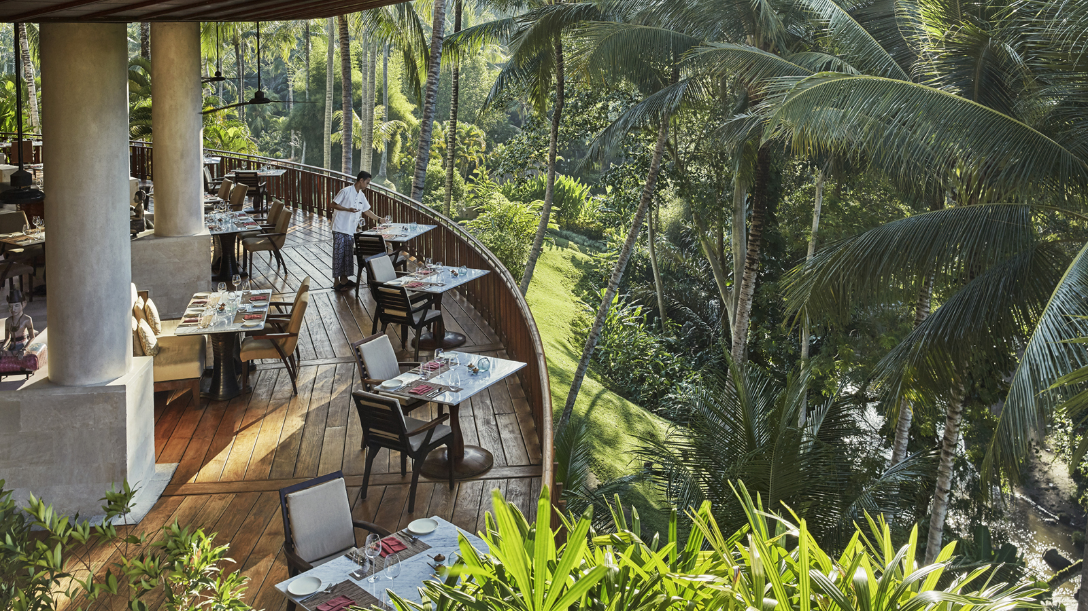 | March 18, 2021, Bali at Sayan, Indonesia  Four Seasons Resort Bali at Sayan Continues to Rejuvenate with New Dining Experiences  https://publish.url/sayan/hotel-news/2021/new-dining-experiences.html
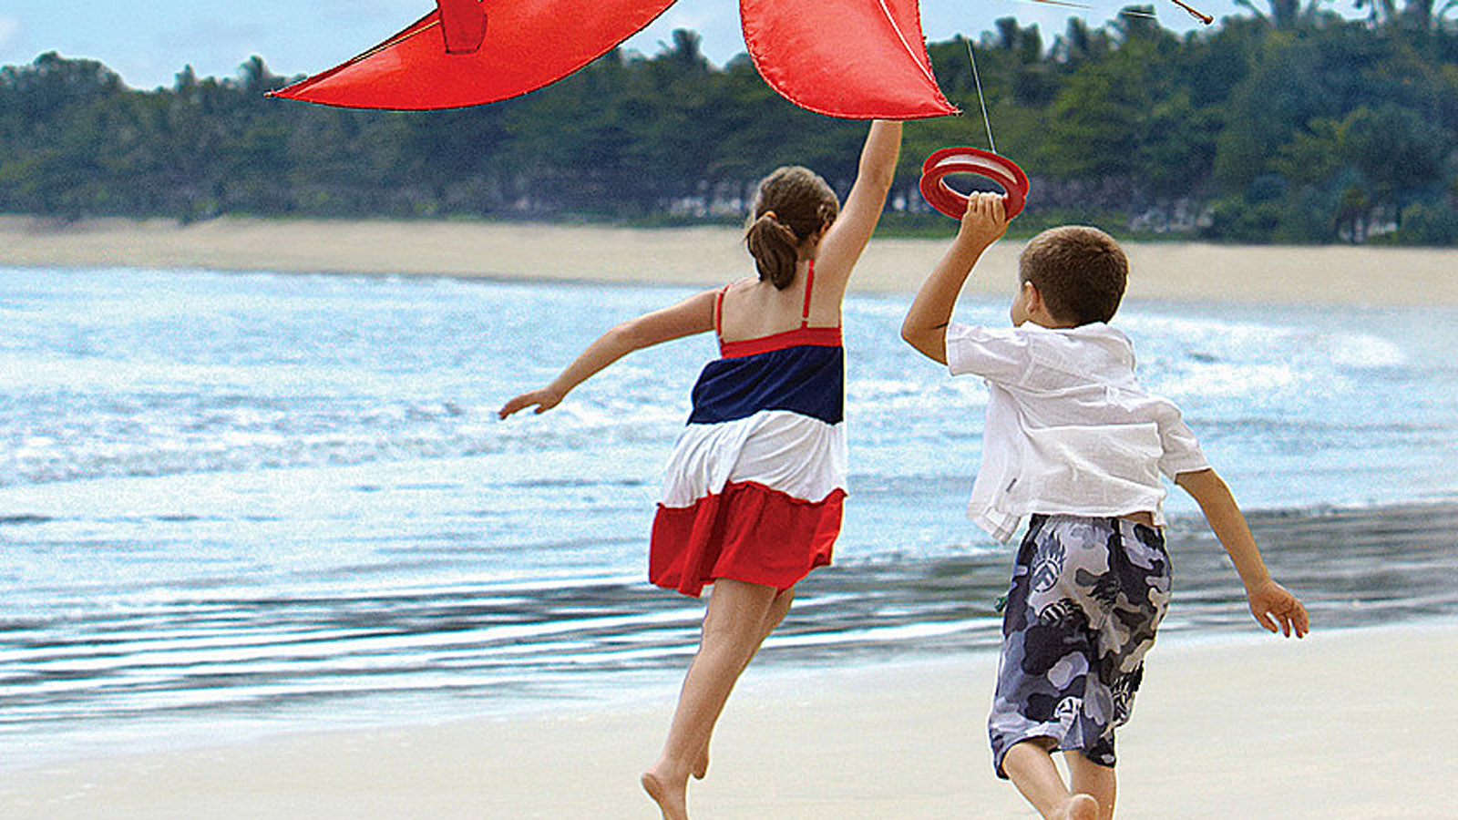 | March 9, 2021, Singapore  Vacation in a Four Seasons Home with Four Seasons Resorts of Asia  https://publish.url/resortsofasia/hotel-news/2021/family-holidays.html

PRESS CONTACTS

Kanchana Ganglani
Director of Public Relations
145 Jalan Ampang
Kuala Lumpur
Malaysia
kanchana.ganglani@fourseasons.com

+6(03) 2382 8740

