Four Seasons Resort Marrakech Welcomes Guests for Easter Weekend

March 29, 2018, Marrakech, Morocco

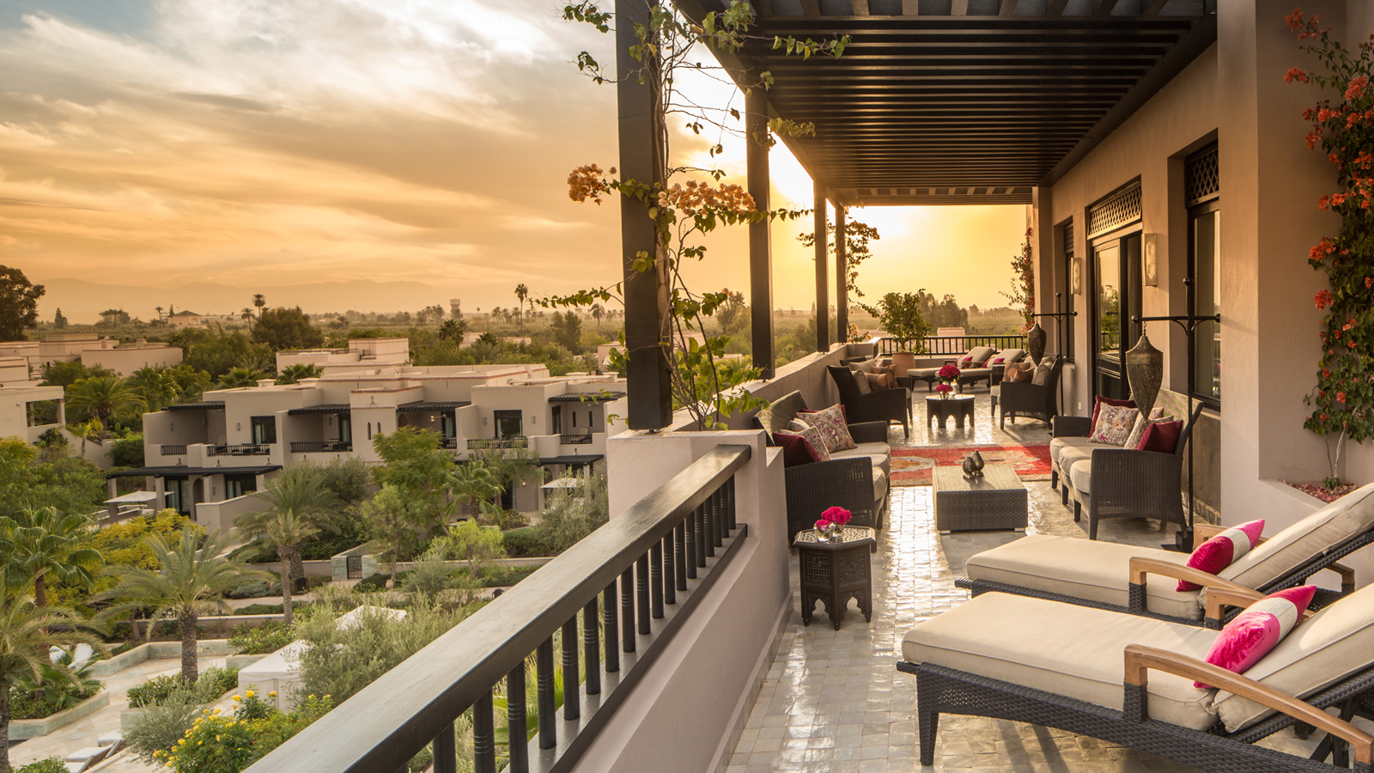
Four Seasons
Resort Marrakech invites its guests to a weekend of festivity honouring the celebration of Easter.
Pop up Gourmet Truck
Through Monday, April 2, 2018, indulge in conviviality discovering new culinary experiences at
Four Seasons
Resort Marrakech. On the occasion of the extended Easter weekend, the Resort will surprise its guests with an exciting culinary lunch program by the family pool. Served every afternoon from 12:00 noon to 4:00 pm, guests can taste Executive Chef Thierry Papillier’s favourite comfort food recipes. While lounging by the pool, customers will have the pleasure to enjoy a gourmet truck satisfying their cravings for burgers, paninis, hot dogs and other favourites, for MAD 110 per person.
Azzera in the Easter Mood
At Azzera Easter festivities will begin on Good Friday, March 30, 2018. In the heart of the Resort's lavish gardens, guests will appreciate a la carte barbecue highlighting the best of seafood produce. Settle cosily on the shaded terrace and enjoy a delightful moment with family and friends, while treating oneself with delicately grilled dishes by the Chef’s team.
The not-to-miss Easter Brunch will be held on Sunday April 1, 2018 by the pool. Guests will be taken on a culinary journey of international flavours, from Moroccan signature delights to an Italian live station and more. Under a radiant sun and with the ideal musical atmosphere, Pastry Chef Anouar Ait Abdelaali offers the perfect ending to brunch with his decadent desserts collection. Brunch is MAD 720 per person.
For Easter Holy Monday, the Azzera team will put a fresh spin on Easter feasting by embracing the traditional barbecue lamb recipes. A unique opportunity for guests to discover different ways to taste the Easter lamb.
Kids for All Seasons
During the Easter holidays, kids will be awed with special surprises throughout the day. Spreading the spring magic around the Resort, the Kids Club team has prepared a collection of Easter-themed crafts and activities including a traditional Easter egg hunt in the gardens, a cooking class and a painting workshop on chocolate eggs. Little ones will definitely have fun and create lasting memories in Marrakech.
The entire team of
Four Seasons
Resort Marrakech looks forward to welcoming guests for Easter and share an exceptional spring break.

RELATED

February 12, 2018, Marrakech, Morocco
Four Seasons Resort Marrkech Lance sa Premiere Golf Cup
https://publish.url/fr/marrakech/hotel-news/2018/first-annual-golf-cup-2.html

February 12, 2018, Marrakech, Morocco
Four Seasons Resort Marrkech Announces First Annual Golf Cup
https://publish.url/marrakech/hotel-news/2018/first-annual-golf-cup.html

PRESS CONTACTS

Virginie Vaillant
Public Relations Manager
1 Boulevard de la Menara
Marrakech
Morocco
virginie.vaillant@fourseasons.com

+212 524 359 200

