Prohibition Times and Concours d’Elegance at Four Seasons Hotel Jakarta

September 10, 2019, Jakarta, Indonesia

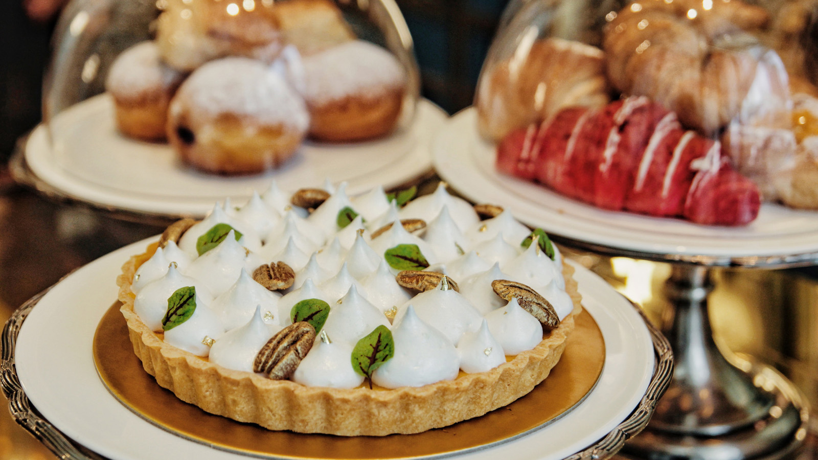
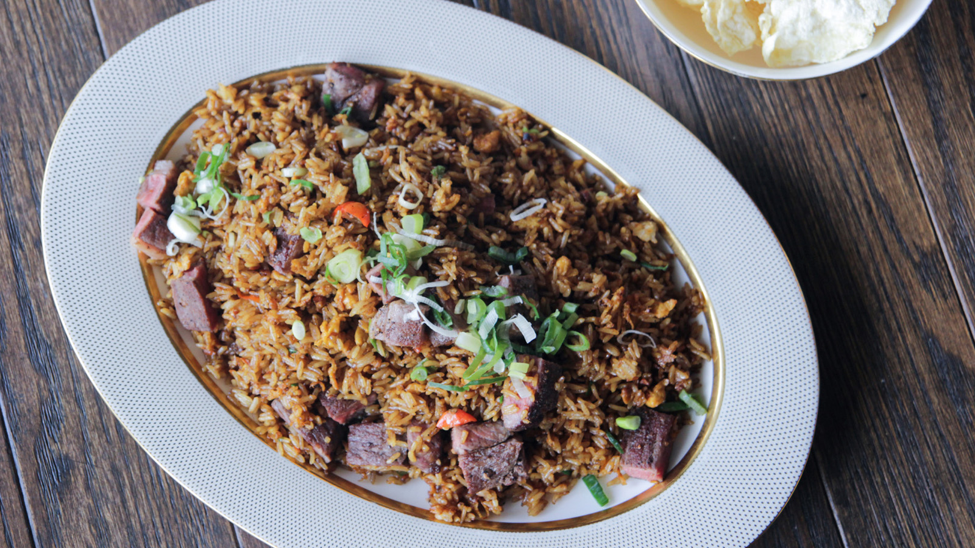 | 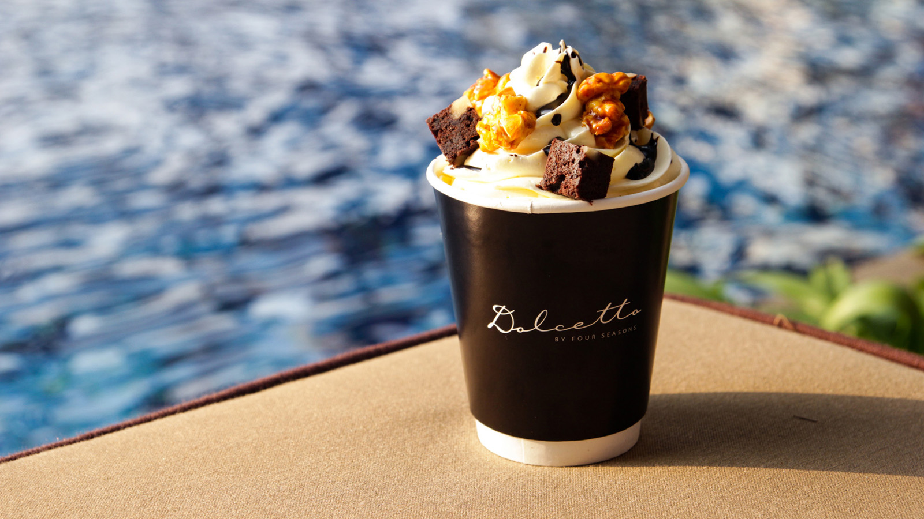 | 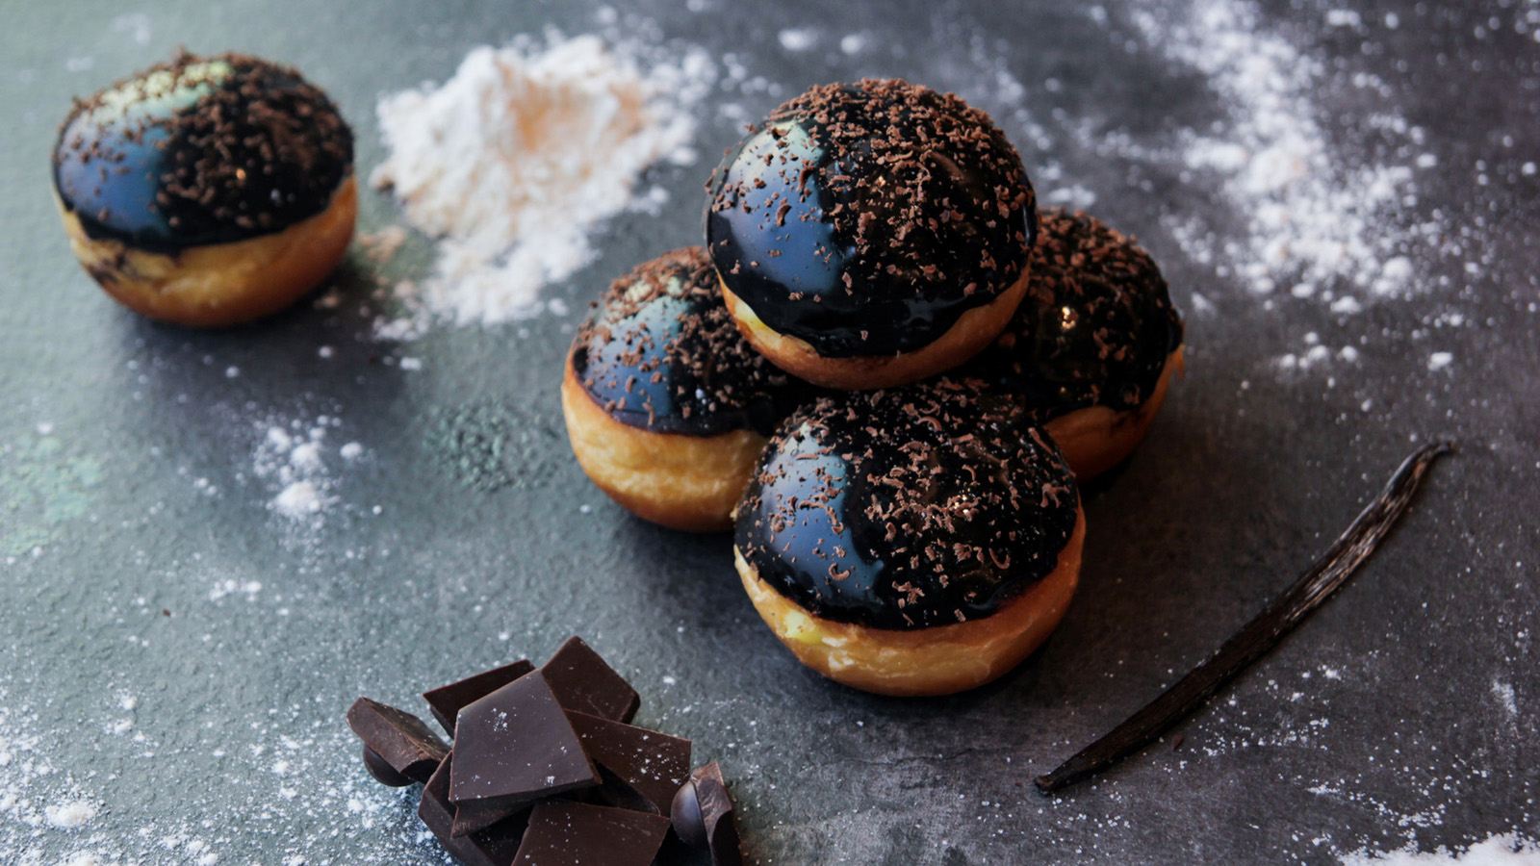
This September, Four Seasons Hotel Jakarta has lined up a series of extravagant events that pay homage to the Prohibition Era of the 1920s. The highlights start from the Hotel’s lobby area where it showcases numerous classic cars to welcome guests, and which culminates in the inaugural Concours d’Elegance. This exquisite event really brings the Prohibition-era aesthetic to life, and continues with various unique dining experiences at each of food the Hotel's beverage outlets throughout the month.
“It is exciting to work for such an amazing project,” says Yonatan Kachko, General Manager. “I am very excited to see how the team blends these classic influences with our style of Four Seasons hospitality and dining.”
Four Seasons Hotel Jakarta Presents Concours d’Elegance
Experience the impeccable sights of more than thirty vintage and exclusive automobiles. Join the showcase of rare mint condition cars and witness the Concours d‘Elegance and Classic Car Awards. Enjoy Four Seasons food and beverage offerings and make a delightful weekend out of it. Moreover, take advantage of the Concours d’Elegance staycation package, which can be booked online.
The event is on September 21 and 22, 2019 and tickets are priced at IDR 500,000 net per person and available for purchase at the Hotel Concierge. For more information, call or WhatsApp +62 21 2277 1888, or download the Four Seasons App on iTunes or Google Play Store and use #FSChat.
Alto Restaurant & Bar
Mario Libreght Aipassa, Chef de Cuisine of the Hotel’s award winning Italian restaurant Alto Restaurant & Bar, has curated a five-course set menu inspired by the legendary Chicago crime boss Al Capone. Begin the experience with the Red Chicago Tower, a homemade crispy eggplant dishe with tomato sauce, mozzarella, ricotta cheese gratin, and mesclun salad; Mama’s White Soup Alcatraz, a warm cream cannellini soup with ditalini pasta, pearl vegetables, served with garlic and truffle crouton; Spaghetti Meat Bullet, a creamy alfredo pasta with wagyu meatballs; Brooklyn Chicken Custody, roasted chicken with sautéed mixed mushrooms, served with herb roasted potato, and Marsala wine sauce; and end with the decadent Flare Bomb in Brooklyn, an American cheesecake served ala baked Alaska with fresh tropical fruit, coconut gelato and a graham cracker crust.
The Al Capone Set Menu is available for lunch and dinner and priced at IDR 920,000++ per person; individual items can also be ordered ala carte.
Nautilus Bar
Old world glamour, contemporary style and timeless sophistication, Nautilus Bar is the perfect setting to unwind after work or for a weekend night out. This September, soak in the ambience of the prohibition era, as the three Nautilus expert mixologists have handcrafted six unique cocktails, inspired from the dark time. Guests are invited to come and explore these unique flavours and the intriguing stories behind them.
Prohibition Cocktails start from IDR 185,000++.
La Patisserie
It might be too early for a Thanksgiving treat, but who doesn’t love this American favourite? Executive Pastry Chef Lorenzo Sollecito and his team presents the perfect pie, expertly combining the two vastly different ingredients, pumpkin and pecan. A soft almond tart base with pumpkin and pecan pudding covered in Italian meringue. Not only is it delicious, but also pleasing to the eye and highly Instagrammable. It also makes an excellent gift for team or family.
Pumpkin Pecan Pie available at La Patisserie for IDR 250,000++ for whole cake.
Dolcetto
This September, Dolcetto offers the perfect combination for coffee, Boston's Famous Donut. Made from scratch in-house by the Hotel's bakery team, this is the decadent sin everyone must indulge in. Fun Fact: Boston was founded in September 1630 and so we are celebrating 389 years of its history this month!
Boston's Famous Donut available daily from 7:00 am to 6:00 pm at IDR 15,000++ per piece.
Pool
Four Seasons Hotel Jakarta invites guests to complement their Urban Retreat at the Bill Bensley-designed resort-style pool area. Cool off with with a special treat as a reward - a perfect combination of brownies and caramel popcorn to top off a delicious American classic sundae. Who can resist?
Popcorn Caramel Banana Sundae available from 9:00 am to 5:00 pm at IDR 85,000++ per cup.
Palm Court
Palm Courts Chef de Cuisine Asep Hamdani presents an audacious new take on the eternal nasi goreng, with Miyazaki beef as the key ingredient. Served in a generous portion, this dish is meant to be shared. Whether for a quick working lunch or a more elaborate and intimate dinner, this is the perfect accompaniment to any meal.
Miyazaki Nasi Goreng available daily for lunch and dinner at IDR 950,000++.

RELATED

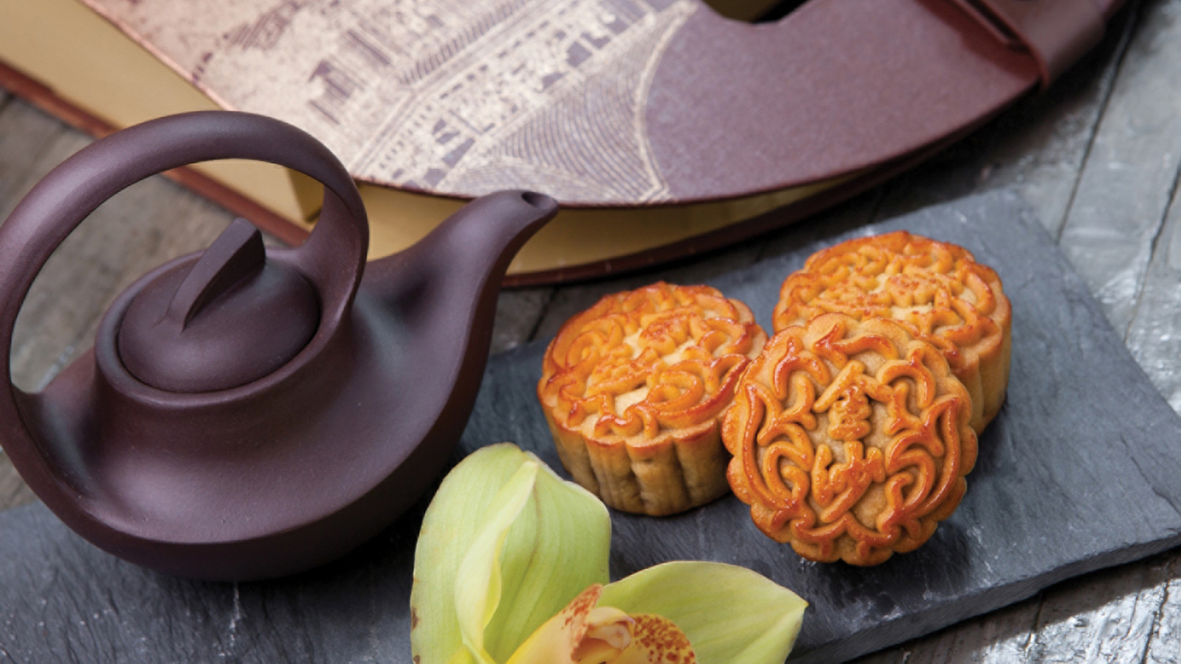 | August 22, 2019, Jakarta, Indonesia  Four Seasons Hotel Jakarta Celebrates Mid-Autumn Festival with Exquisite Mooncakes  https://publish.url/jakarta/hotel-news/2019/mooncakes.html
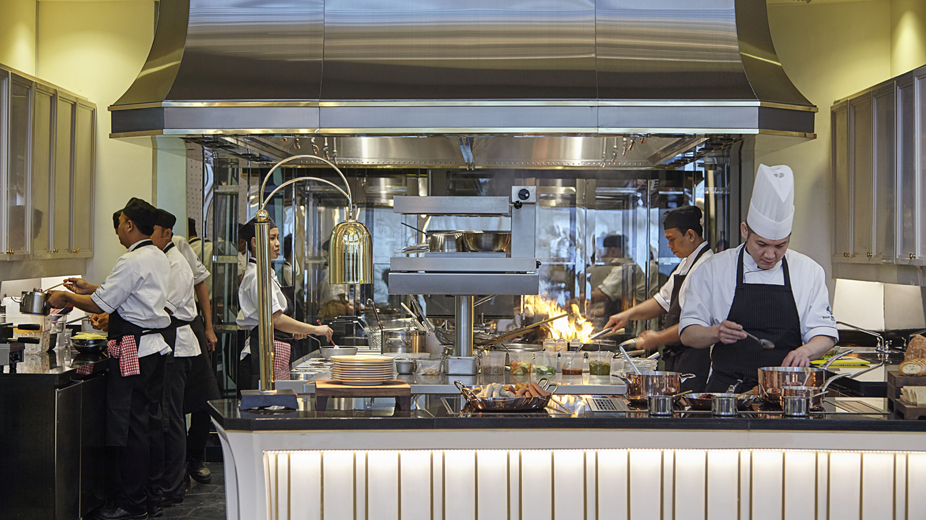 | July 29, 2019, Jakarta, Indonesia  Celebrating Indonesia’s 74th Independence Day with a Taste of Noesantara at Four Seasons Hotel Jakarta  https://publish.url/jakarta/hotel-news/2019/independence-day-celebrations.html

PRESS CONTACTS

Rumman Amanda
Director of Public Relations and Communications
Jalan Jenderal Gatot Subroto Kav. 18
Jakarta
Indonesia
rumman.amanda@fourseasons.com

+62 21 227 71888

Cindy Yuwono
Public Relations and Communications Executive
Jalan Jenderal Gatot Subroto Kav. 18
Jakarta
Indonesia
cindy.yuwono@fourseasons.com

+62 812 80940637

