Grand-Hôtel du Cap-Ferrat, A Four Seasons Hotel Offers its New Festive Edition of Le Cap’s Gourmet Holiday, Ready-Made Meals

Michelin-starred Chef Yoric Tièche and Pastry Chef Florent Margaillan have created a delectable menu of culinary delights for guests to enjoy during the festive season in the comfort of their own home
November 18, 2021, Saint-Jean Cap-Ferrat, France

 | 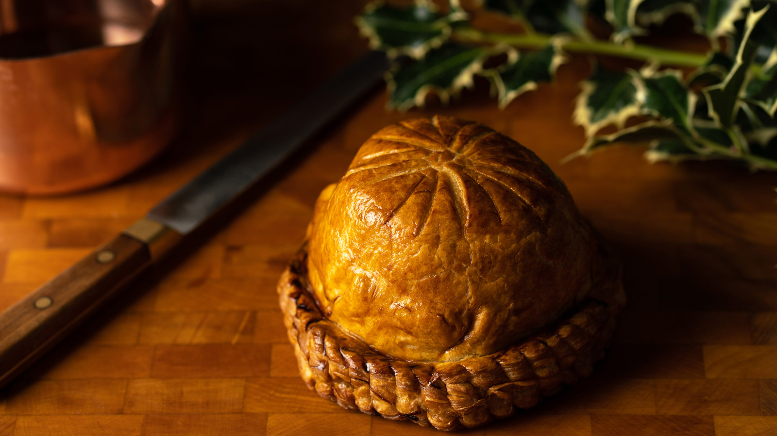 | 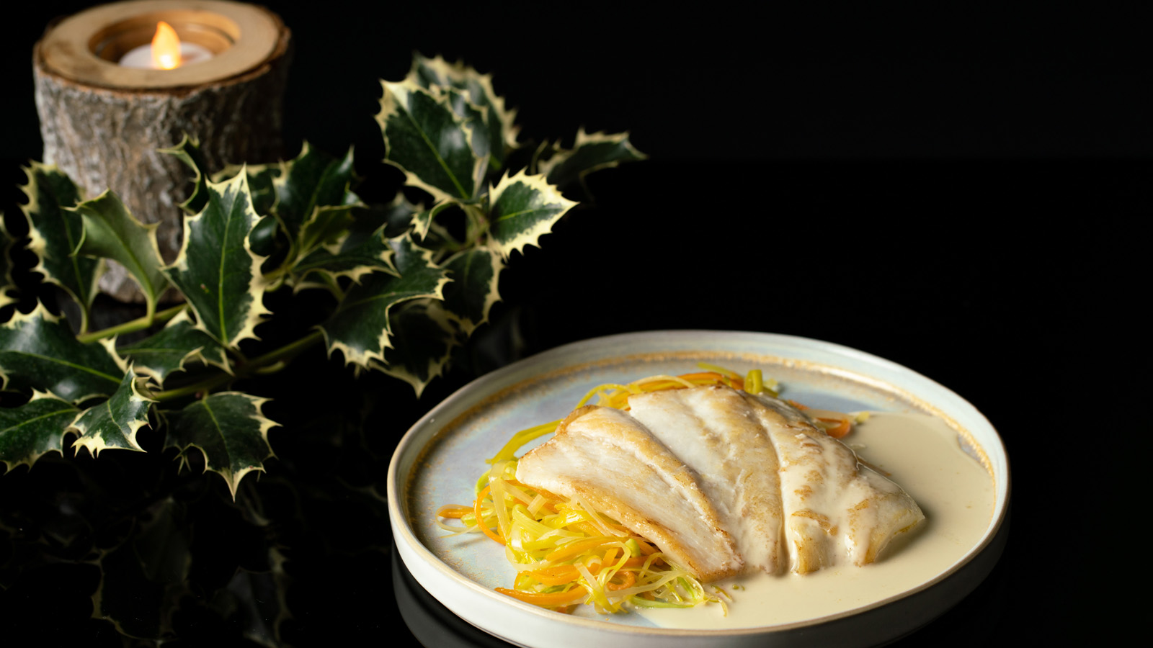
While the Grand-Hôtel du Cap-Ferrat, A Four Seasons Hotel, will close its doors on November 28 for the 2021 season, the Hotel’s celebrated chefs will continue to work their culinary magic, creating a gastronomic offer for the holiday season. Dishes can be enjoyed at home, with delivery service available, within a selected area between Nice and Monaco.
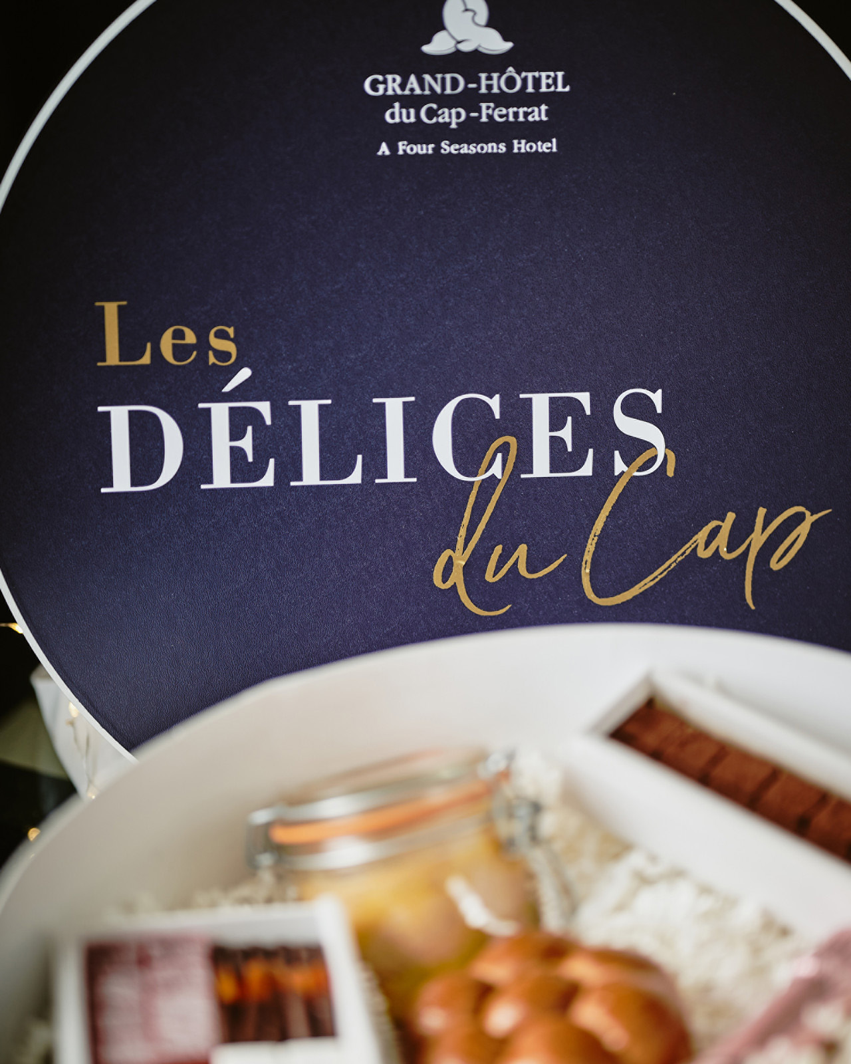 | 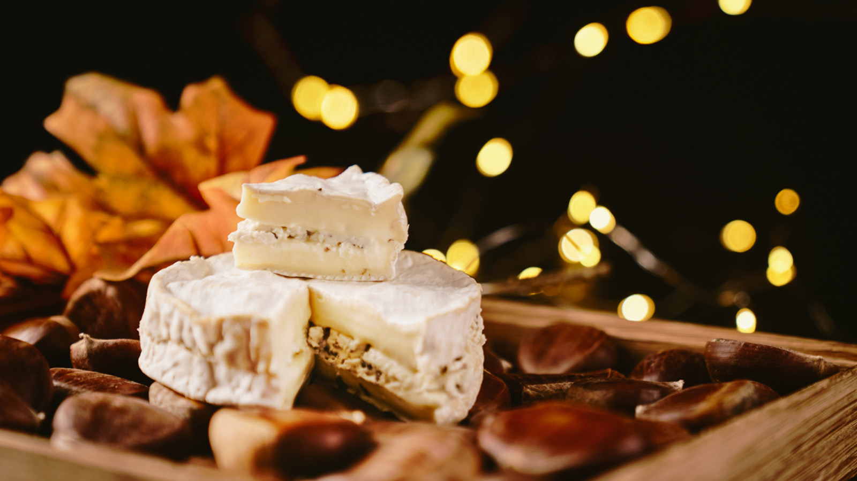 | 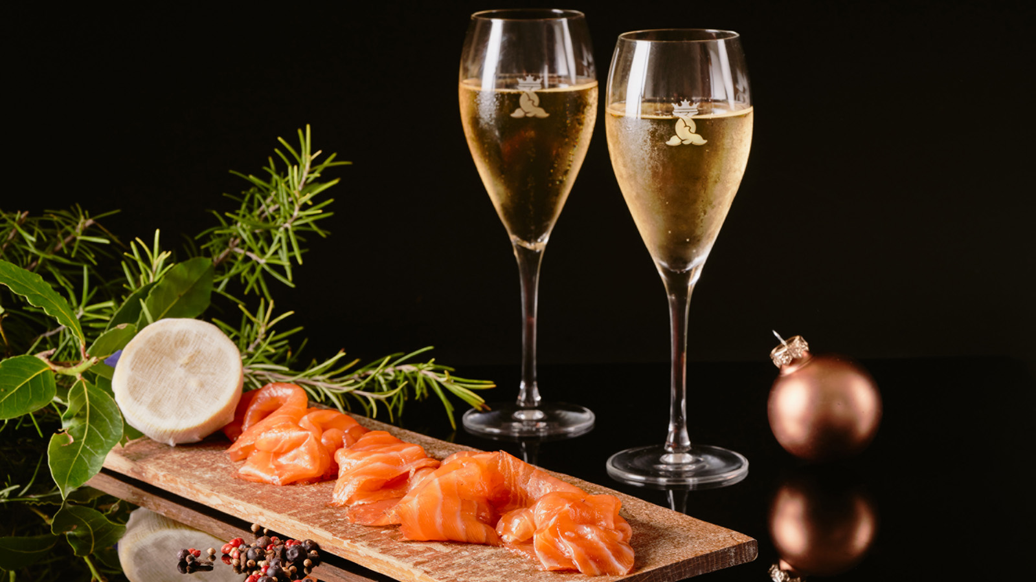
Chef Yoric Tièche wishes to make end-of-year celebrations more convivial than ever, with joyous family gatherings, fully embracing the spirit of the holidays. Featuring seafood and Provençal specialties, Tièche’s festive menu is home delivered, with detailed dish descriptions provided, to enhance the gastronomic experience. Dishes are portioned and are accompanied by easy-to-assemble trimmings, making them very simple to put together at home.
The menu includes a number of traditional festive dishes, such as homemade IGP certified French duck foie gras, and a smoked-salmon from Bömlo, Norway. The Chef’s much-loved fish and seafood dishes take pride of place, including a half Breton blue lobster served with green beans and citrus vinaigrette, Breton scallops with Champagne buttered leeks, and a braised fillet of John Dory with butter and yuzu sauce. Meat lovers can opt for the free-range chicken breast with truffles.
Pastry Chef Florent Margaillan has created a splendid Yule log, inspired by the Christmas flower - the traditional poinsettia - to create an artful dessert made up of 100 hand-shaped chocolate petals sprinkled with gold dusting, carefully assembled on a soft almond cookie. The interior consists of a feuillantine crunch, a morello cherry confit and a duo of vanilla and chocolate mousse.
Traditional Christmas sweets include a platter of 13 Provençal desserts and a gingerbread with candied fruit. Also available are an assortment of gourmet chocolate truffles, made with a bespoke blend of ingredients, specially made for the Grand-Hôtel du Cap-Ferrat by renowned French chocolate manufacturer Valrhona.
Le Cap’s holiday menu is available by pre-order only. Orders must be placed before December 20, 2021. Delivery service is available within selected areas between Nice and Monaco.
Complimentary delivery is offered for orders over EUR 100, with dishes delivered before 12:00 noon on December 23 and 24, 2021.
Orders can also be collected directly at the Hotel, upon request.
Le Cap's Delights

RELATED

November 18, 2021, Saint-Jean Cap-Ferrat, France
Le Grand-Hôtel du Cap-Ferrat, A Four Seasons Hotel propose sa nouvelle édition festive « Les Délices du Cap »
https://publish.url/fr/capferrat/hotel-news/2021/festive-takeaways-2.html

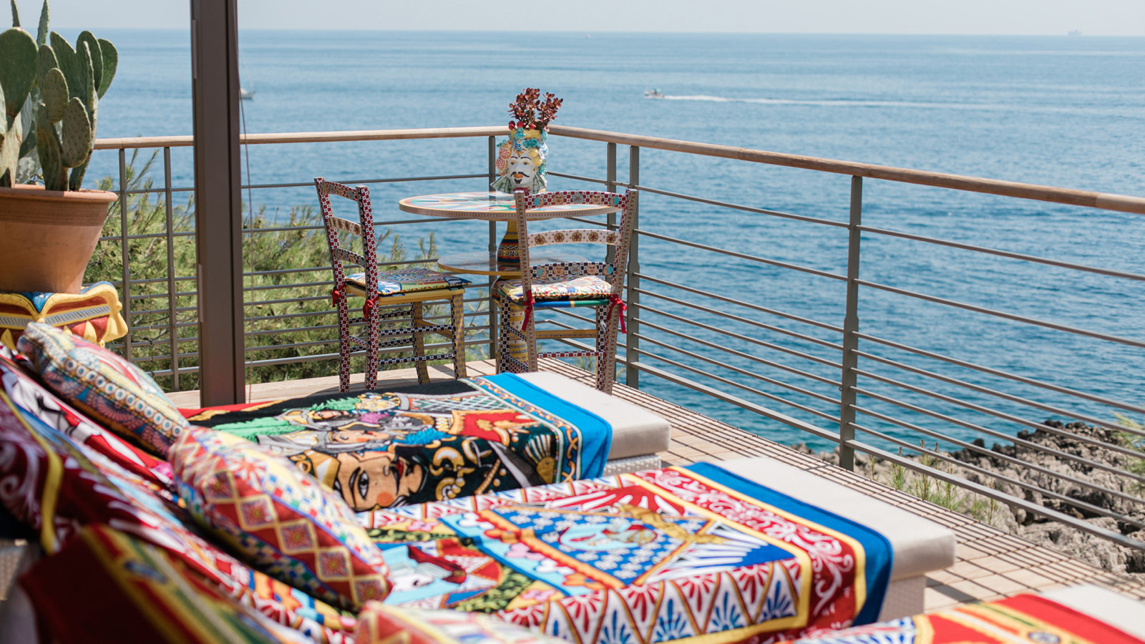 | July 12, 2021, Saint-Jean Cap-Ferrat, France  La mode s’invite au Grand-Hôtel du Cap-Ferrat, A Four Seasons Hotel  https://publish.url/fr/capferrat/hotel-news/2021/dolce-and-gabbana-cabanas-2.html

PRESS CONTACTS

Caroline Mennetrier
Director of PR and Marketing Communication
71 Boulevard du General de Gaulle
Saint-Jean Cap-Ferrat
France
caroline.mennetrier@fourseasons.com

+33 6 26 39 96 76

