Dine, Spa and Stay: Celebrate the Magic of Early Summer at Four Seasons Hotel Tokyo at Otemachi

May 26, 2021, Tokyo, Japan

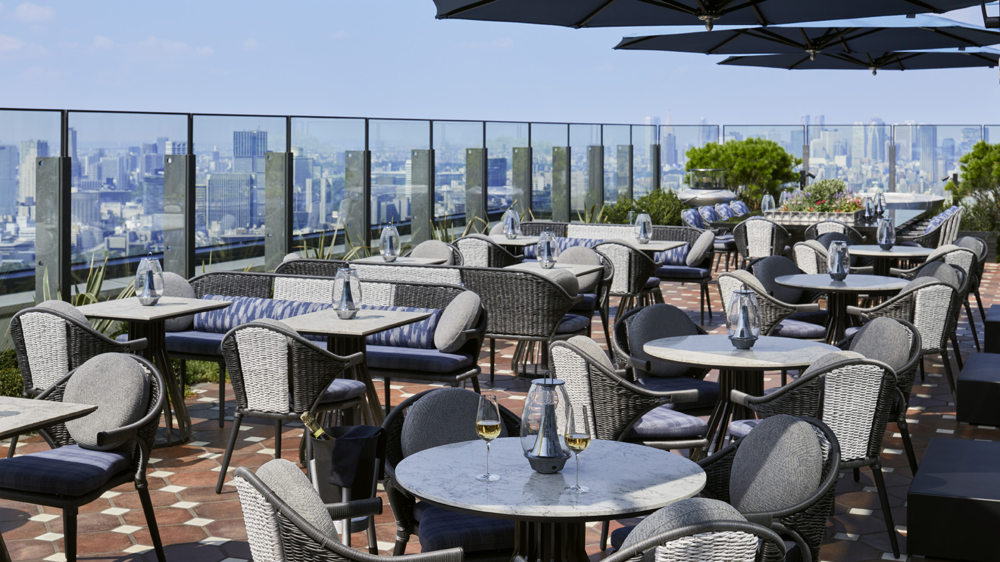
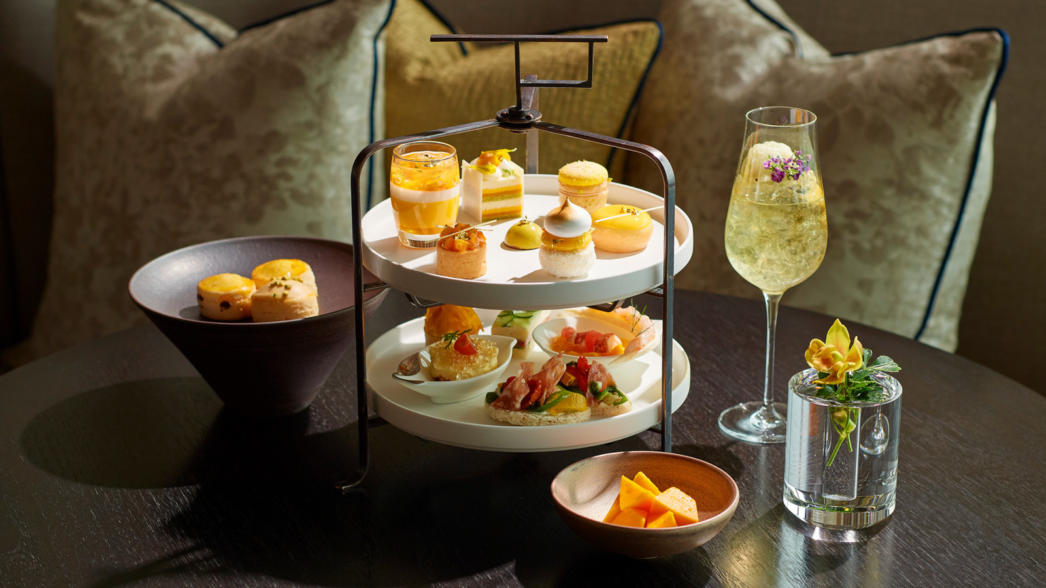 | 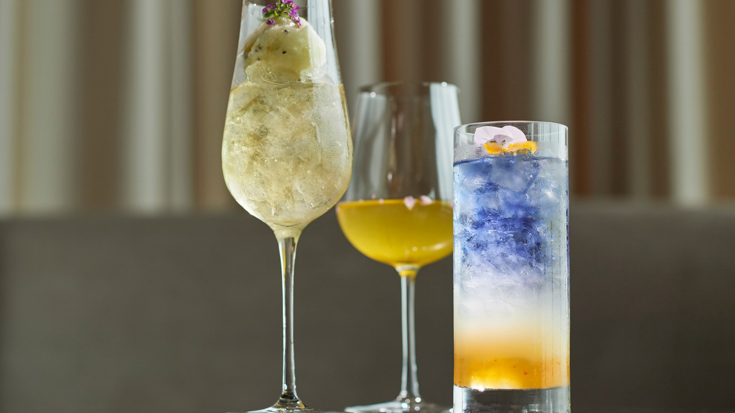 | 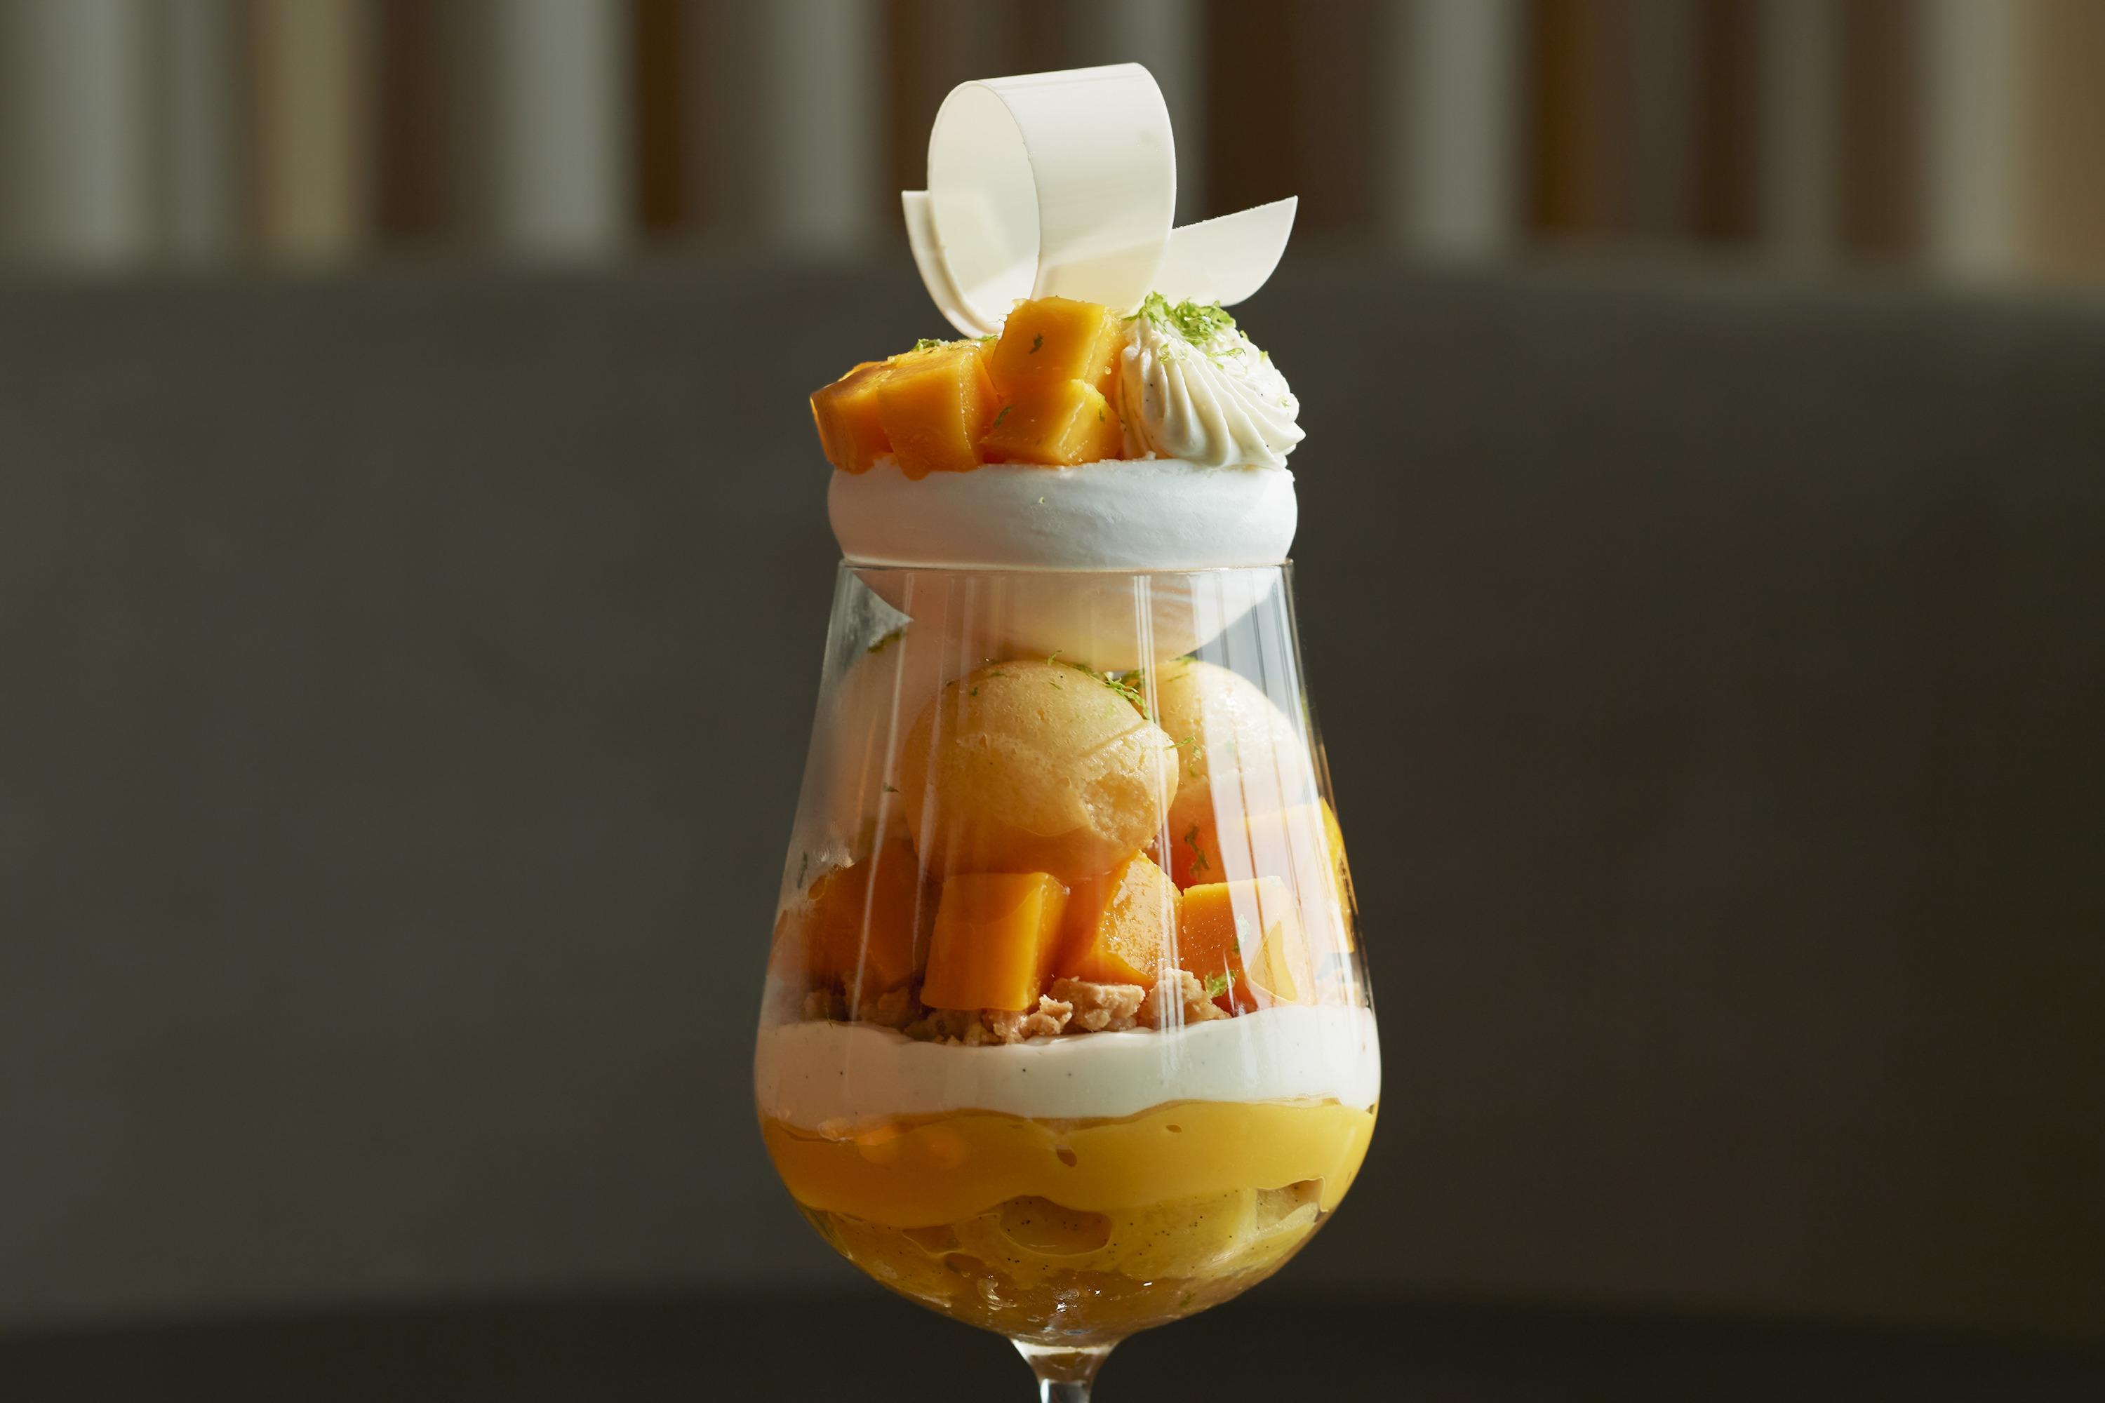
As June arrives, summer comes to Tokyo – a season of lush green landscapes and invigorating breezes that uplift the city’s spirits. Four Seasons Hotel Tokyo at Otemachi pays homage to early summer with an inspiring program of gastronomy, healing treatments and accommodation offers. Located on the 39th floor, the Hotel’s sky-high settings overlook greenery of the Imperial Palace Gardens as well as breath-taking views of Tokyo city.
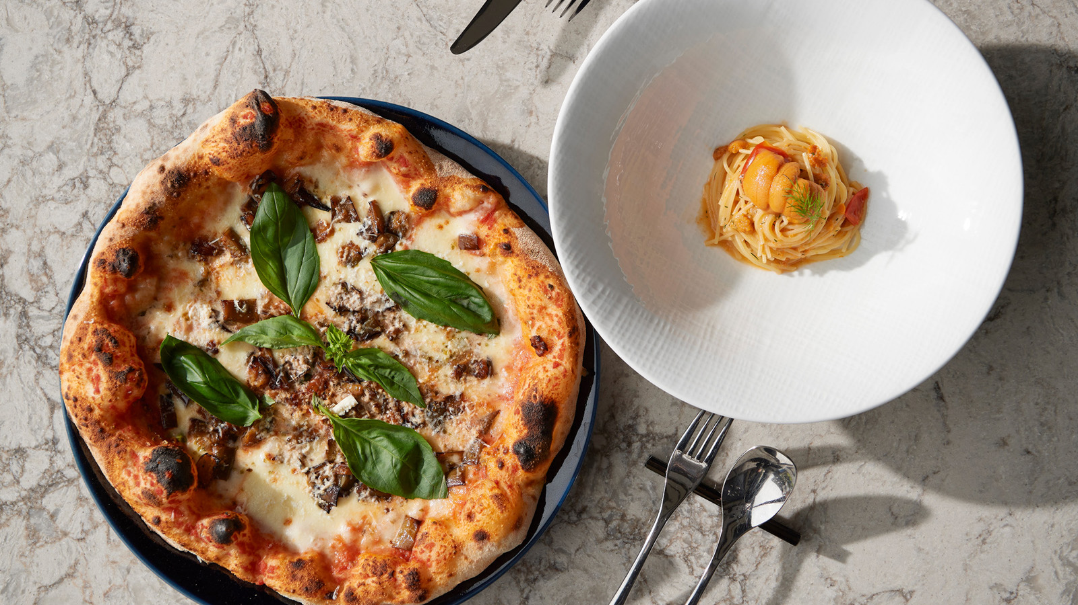 | 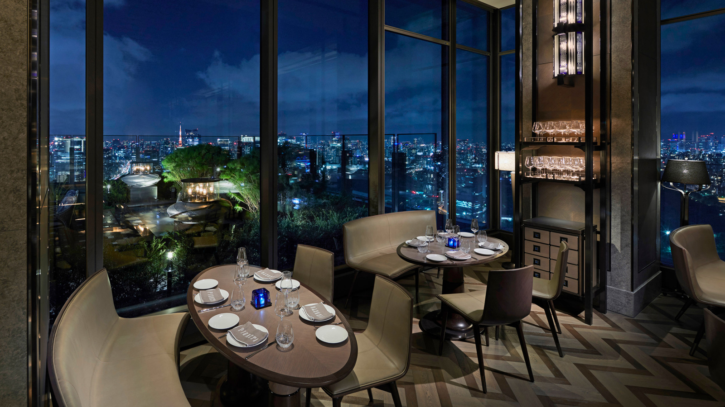 | 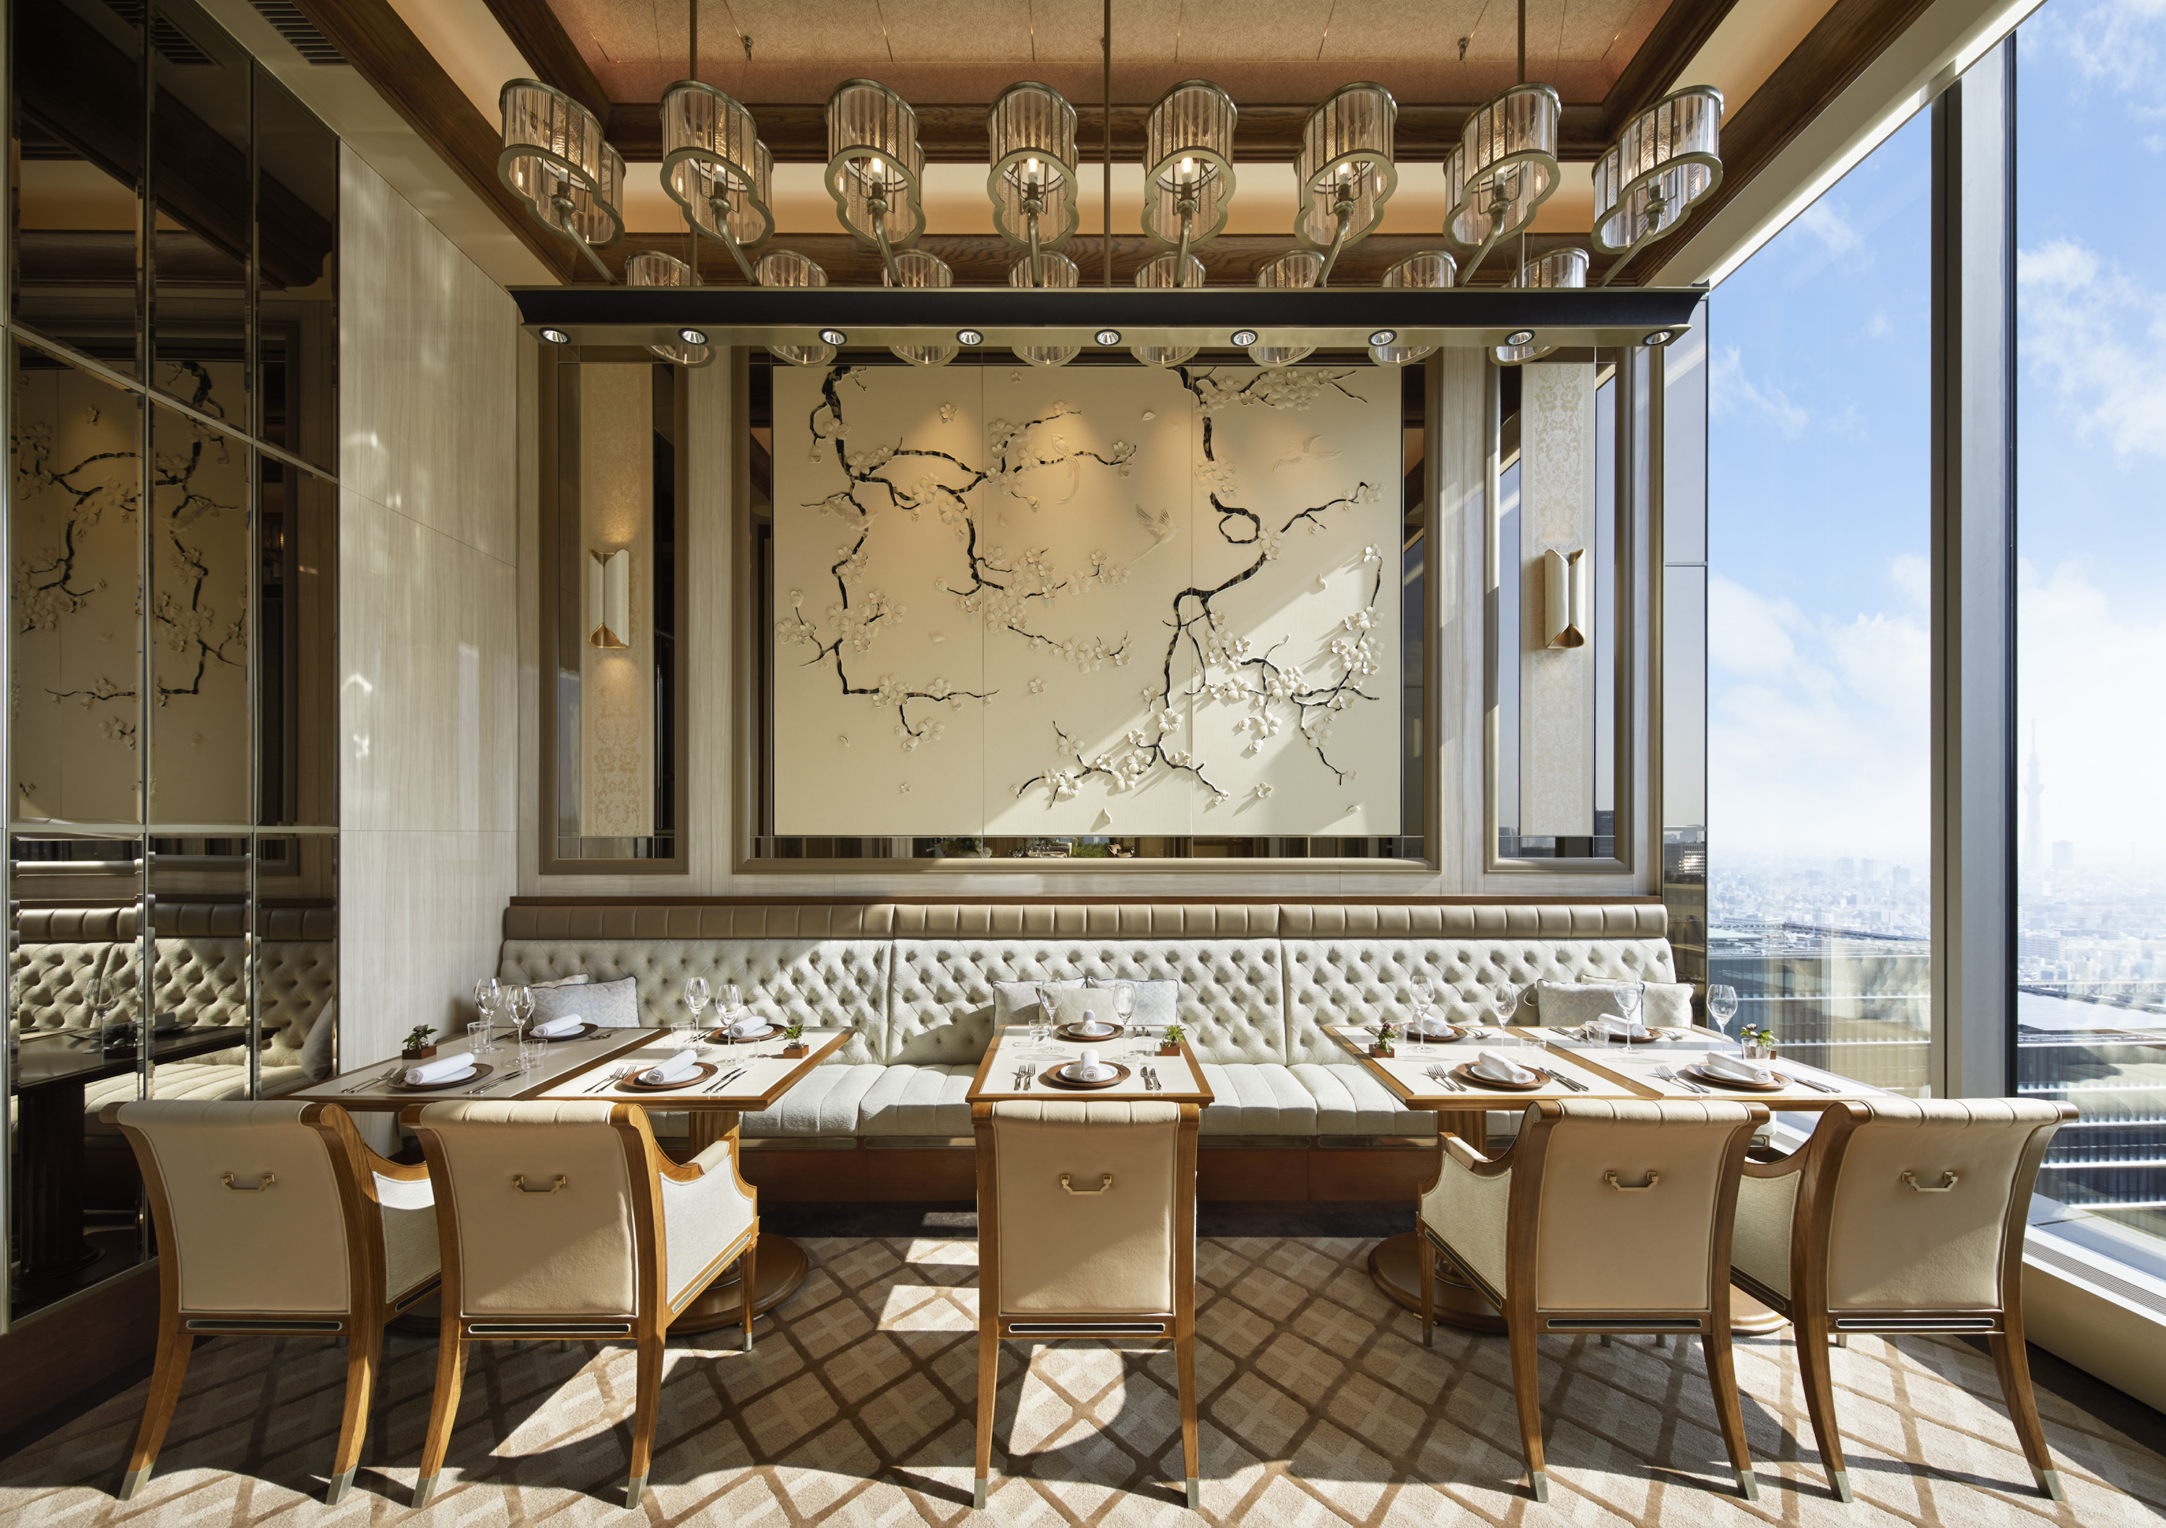
THE LOUNGE
Mango Summer Afternoon Tea
This multisensory Afternoon Tea features twelve signature sweets and savouries, vibrant with tropical fruits and fine detailing. Taking centre stage are luscious Japanese mangoes, in season during the early summer months, with pineapple, lime and passionfruit adding their bright flavours. The desserts are crafted by Executive Pastry Chef Yusuke Aoki, who mastered the art of making elegant pastries with tropical fruits during his time in Bali.
- Seating at 11:00 am, 1:00 pm and 3:30 pm
- Weekday JPY 6,800, weekend JPY 8,855
Exotic Mango Parfait
Decorated like a work of art, this two-layered summer-only mango parfait spells love at first sight. Floating like a cloud in the glass is a vacherin, filled with lime cream and delicately tethered to fresh mango. The lower layer features an abundance of mango on a moist rum-soaked baba, topped with refreshing coconut sorbet – a medley of different flavours to surprise and delight the taste buds.

RELATED

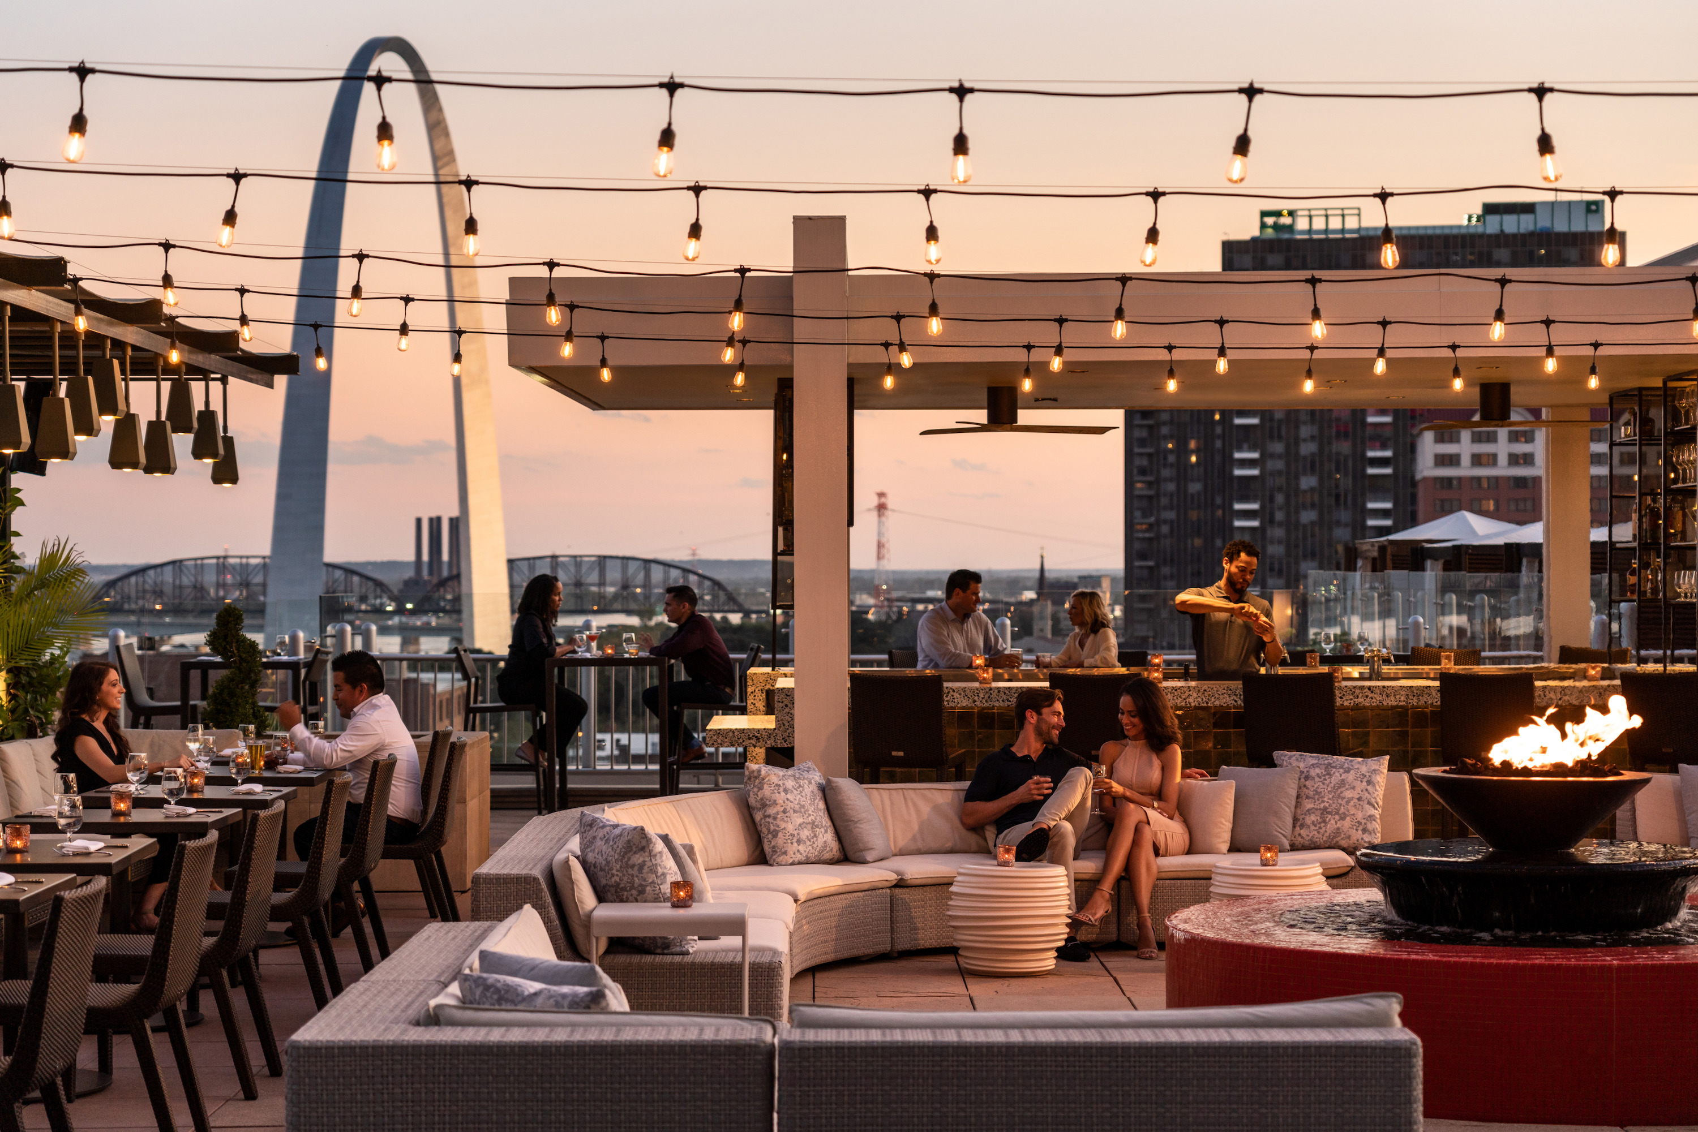 | June 8, 2021, Toronto, Canada  Four Seasons Hotels and Resorts, Tokyo Tatemono and HPL Announce Plans for Brand New Hotel in Osaka, Japan  https://publish.url/news-releases/2021/new-four-seasons-in-osaka.html
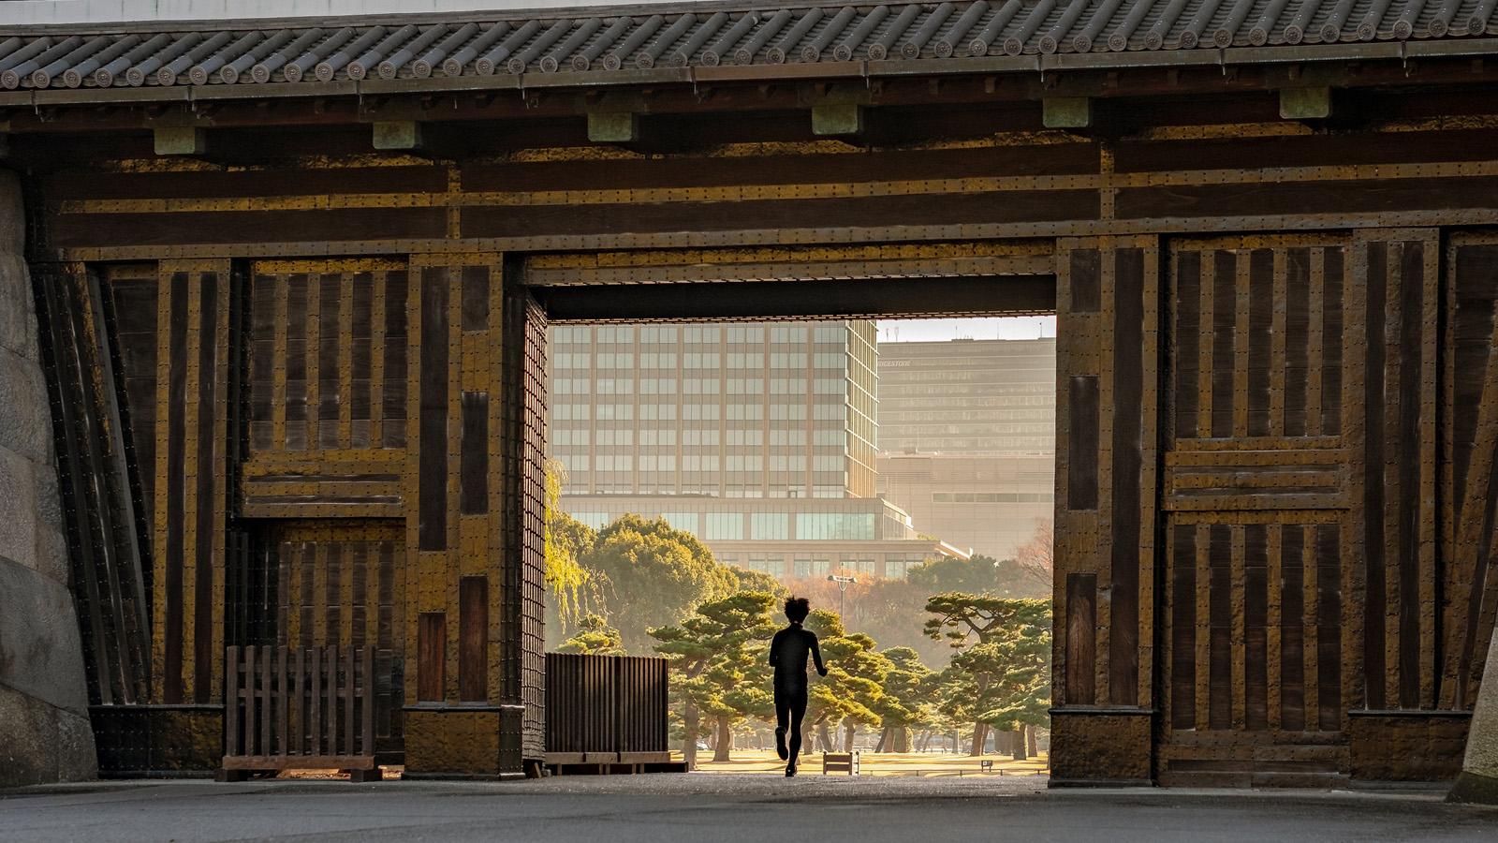 | June 4, 2021, Tokyo, Japan  Celebrate Global Wellness Day with Four Seasons Hotel Tokyo at Otemachi  https://publish.url/otemachi/hotel-news/2021/global-wellness-day.html

PRESS CONTACTS

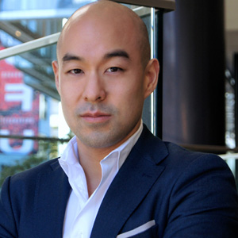 | Shingo Kido  Director of Public Relations and Communications  1-2-1 Otemachi  Chiyoda-ku, Tokyo  Japan  shingo.kido@fourseasons.com

