Let Love Win with Romantic Experiences Created for Two at Four Seasons Hotel Seattle

Renew and restore connections with a special someone with a staycation getaway
February 4, 2022, Seattle, U.S.A.

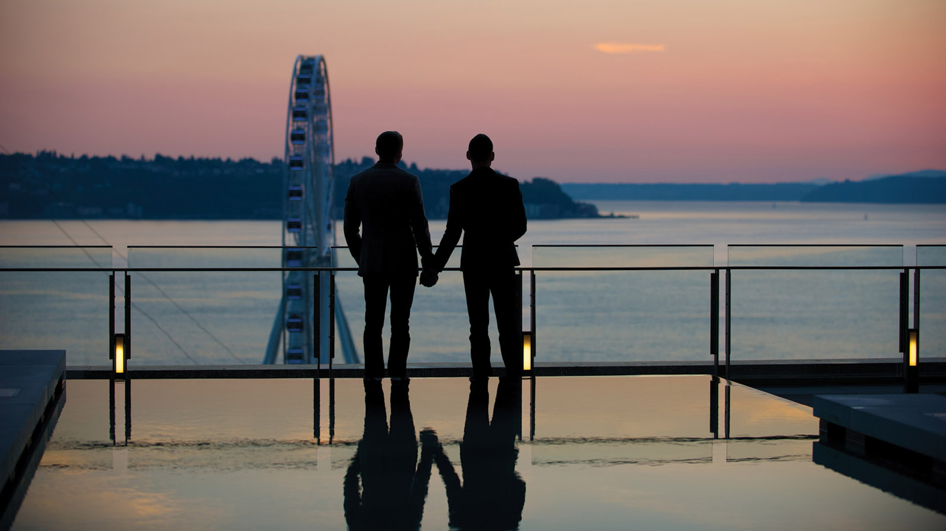
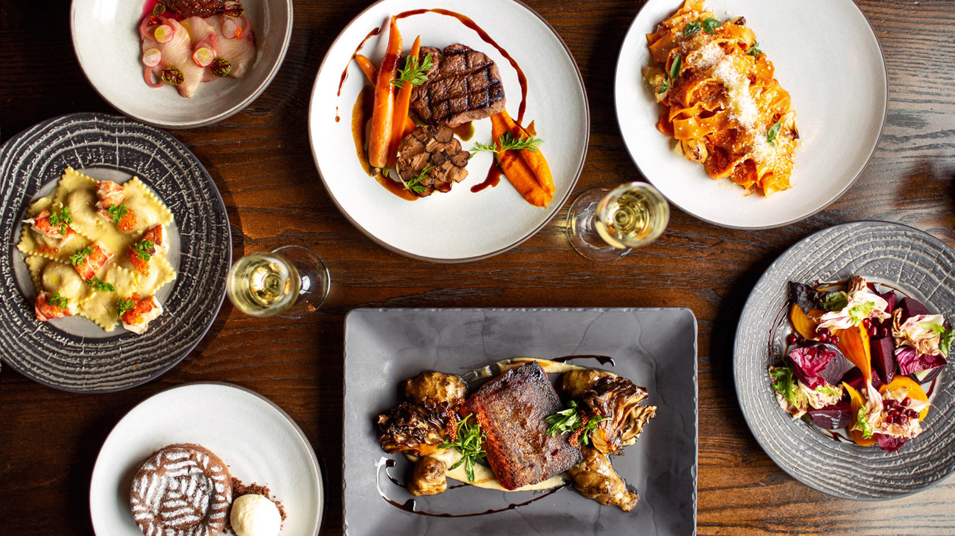 | 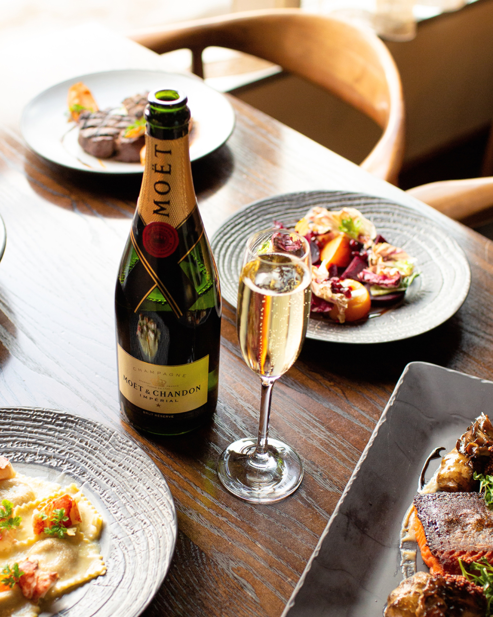 | 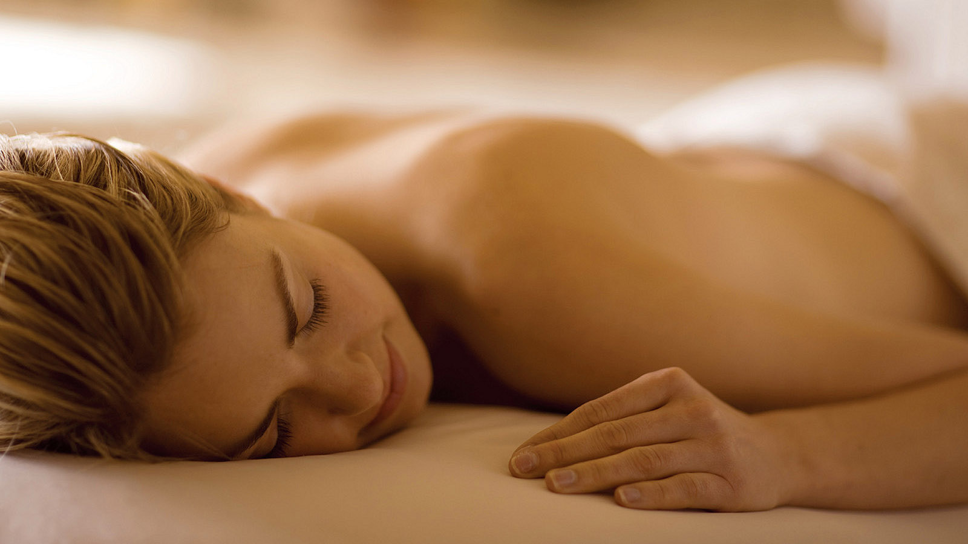
Four Seasons Hotel Seattle gives guests multiple ways to celebrate their love this February with culinary and spa offerings from downtown Seattle’s only Forbes Five-Star Hotel.
The beautiful refractions of light from Elliott Bay creates a romantic water pattern in Goldfinch Tavern, setting the stage for a culinary journey for couples. Delight in a special four-course menu while the hand-blown glass light fixtures throughout the restaurant capture the sparkle of the glowing fireplace.
The menu includes a choice of appetizer, pasta and entrée signature dishes highlighting the best Pacific Northwest ingredients. Valentine’s Day is not complete without sweets for one’s sweet and Pastry Chef Danielle Grogan delivers a duo of desserts to select from. Add a wine pairing for a full experience.
Fully indulge and escape the day-to-day stresses with The Spa’s Seattle Mocha Massage, inspired by the aroma of the mocha-scented butter bar that melts as it’s massaged onto the skin with long soothing strokes. The pure coco butter and monoi oils provide the ultimate hydrating and anti-ageing benefits. Each therapist at the award-winning Spa tailors the massage to meet the guest’s unique needs.
Allow the man in one’s life to feel pampered as well with a purifying treatment specifically designed for the male complexion. The Gentleman’s Facial decongests pores and balances hydration while generating smoother, cleaner skin.
For those searching for a meaningful last-minute gift, a gift card from the Forbes Travel Guide Four-Star Spa is sure to please. Spa gift cards are available for purchase online and at The Spa. Be pampered with all the extra luxuries, from the Relaxation Lounge to the eucalyptus steam rooms.
Reservations for The Spa and Goldfinch Tavern are required and can be made by calling 206 749 7000, or online for dinner.

RELATED

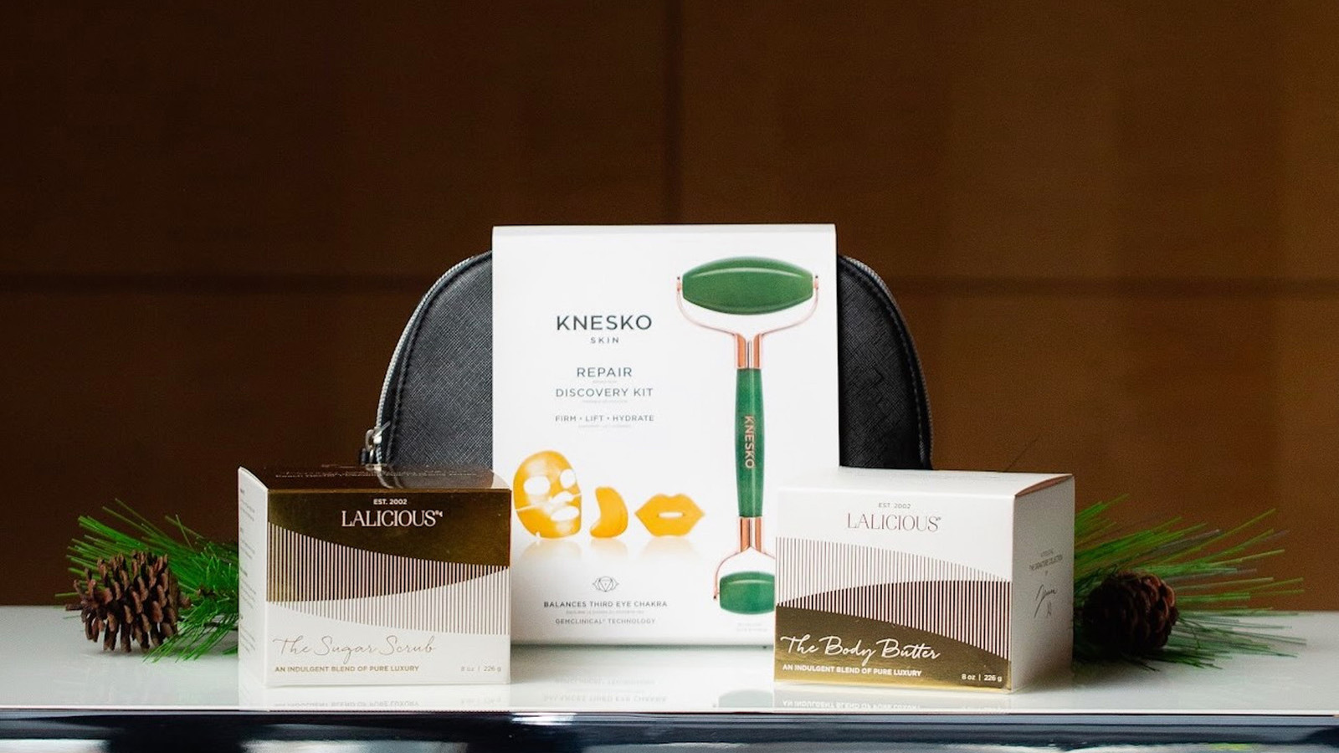 | December 9, 2021, Seattle, U.S.A.  Explore the Ultimate Holiday Gift Guide from The Spa at Four Seasons Hotel Seattle  https://publish.url/seattle/hotel-news/2021/holiday-gift-guide.html
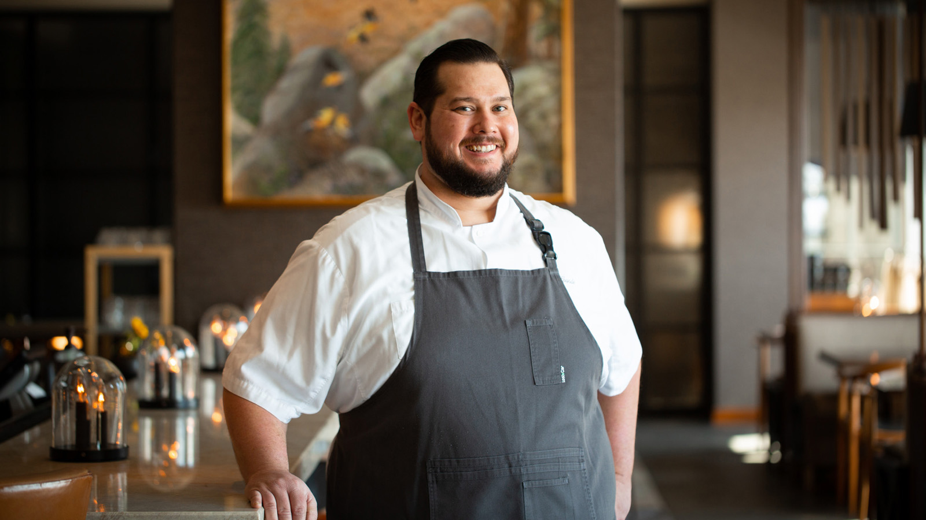 | September 9, 2021, Seattle, U.S.A.  Michael Grande Named Executive Chef at Four Seasons Hotel Seattle  https://publish.url/seattle/hotel-news/2021/new-executive-chef-michael-grande.html

PRESS CONTACTS

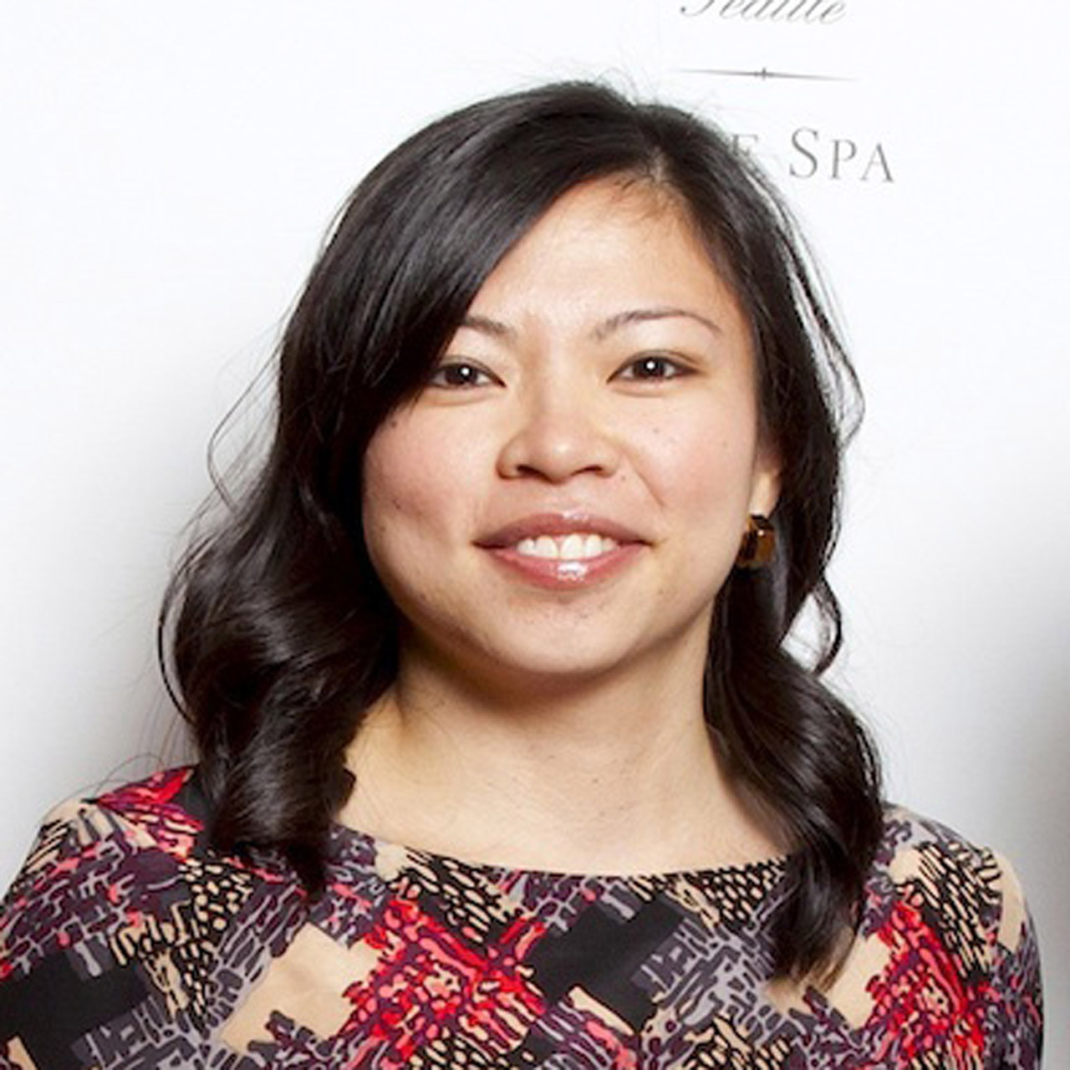 | Meg Paynor  PR Consultant  99 Union Street  Seattle  USA  meg@paynorpr.com  +1 206 913 3848
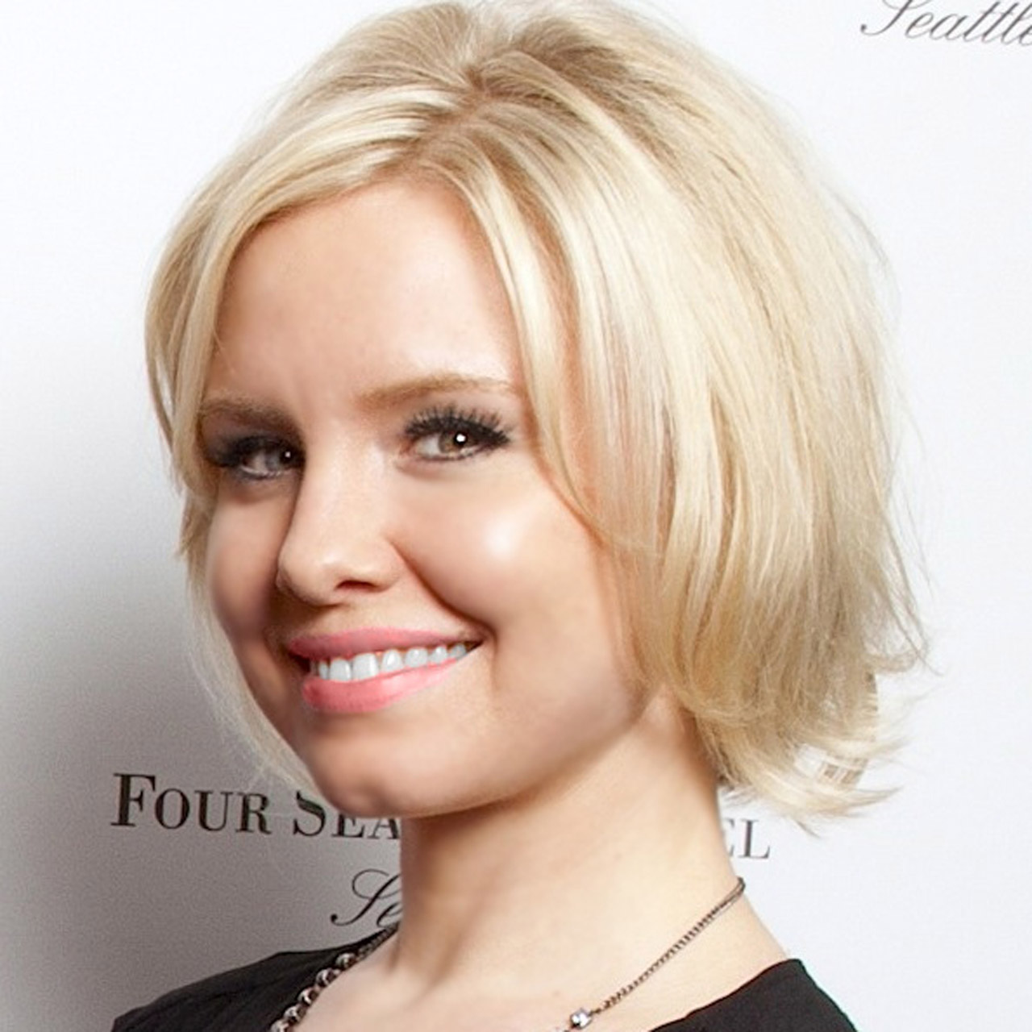 | Crystal Southcote  Digital Media Manager  99 Union Street  Seattle  U.S.A.  crystal.southcote@fourseasons.com  +1 (206) 749-3909

